SOFTWARE ARCHITECTURE
AND DESIGN SPECIFICATION
Customer Relationship Management (CRM)
Reach • Acquire • Convert • Retain • Loyalty
Document detail | Value
Version | 1.0
Authors / Team Members | Shweta; Avaneesh N; Vishwas V Angadi; Krishna Pai
Date | 16-10-2026
Status | Draft — for academic review
Application | Web-based CRM prototype

Revision History
Version | Date | Author | Change Summary
1.0 | 16-10-2026 | CRM Project Team | Initial CRM architecture and design specification.

Approvals
Role | Name | Signature / Date
Team member | Shweta
Team member | Avaneesh N
Team member | Vishwas V Angadi
Team member | Krishna Pai
Instructor / Reviewer | To be completed

1. Introduction

1.1 Purpose
This SAD describes the CRM application's architecture, components, conceptual data model, interactions, API responsibilities, and security considerations. It guides implementation, testing, and review.

1.2 Scope
The CRM supports lead capture/qualification, lead-to-customer conversion, customer profiles, interactions, follow-ups, sales, feedback/issues, retention, loyalty, dashboards and reports. Access is role-based.

1.3 Audience
The audience includes the project team, instructor/reviewer, developers, testers, and maintainers.

1.4 Definitions
Term | Meaning
CRM | Customer Relationship Management
RBAC | Role-Based Access Control
API | Application Programming Interface
JWT | JSON Web Token
SRS / SAD / STP | Software Requirements Specification / Software Architecture and Design Specification / Software Test Plan
NFR | Non-functional requirement

2. Document Overview

2.1 How to use this document
Sections 3 and 4 explain architecture, modules, interactions, and API expectations. Diagrams are design-level views; confirm exact routes and fields against the final code.

2.2 Related Documents
- CRM Software Requirements Specification (SRS), Version 1.1.
- CRM Software Test Plan (STP), Version 1.0.
- GitHub Project backlog and sprint plan.

3. Architecture

3.1 Goals & Constraints
- Modular frontend, backend, business logic, and data models.
- Secure authentication, server-side role permissions, validated inputs, and safe errors/logs.
- Persistent records and consistent lead conversion and sale/loyalty updates.
- Clear, responsive UI and testable modules.
Constraints: academic prototype for development/testing. Real payment gateway processing, ERP integrations, and production operations are outside the prototype scope.

3.2 Stakeholders & Concerns
Stakeholder | Main concerns
Admin | User management, oversight, reports, access control.
Sales Staff | Assigned leads/customers, follow-ups, sales.
Support Staff | Interactions, feedback/issues, follow-ups, retention.
Developers | Clear modules, API contracts, maintainability.
Tester / QA | Traceability, security and regression coverage.
Instructor / Reviewer | Requirements, diagrams, documentation and process.

3.3 Component (UML) Diagram
Layered modular design: React UI calls Express REST APIs, which apply authentication, authorization and validation before accessing MongoDB through Mongoose.
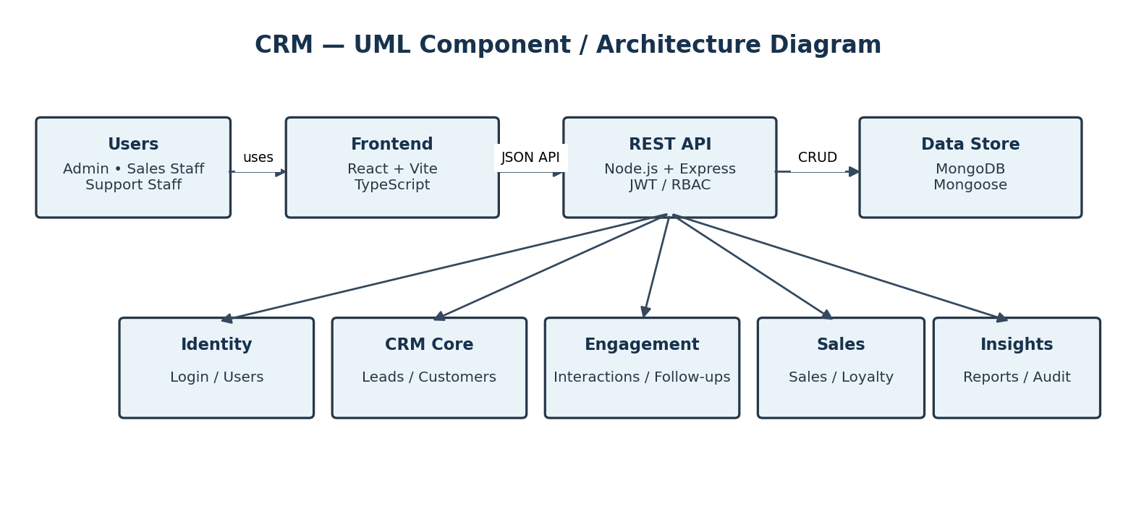

3.4 Component Descriptions
Component | Responsibilities
React + Vite + TypeScript | Pages/forms, API calls, role-appropriate views.
Authentication / users | Login/logout, user records, token and role checks.
Lead / customer management | Capture, qualify, assign, convert, update profiles.
Interactions / follow-ups | Communication history and follow-up lifecycle.
Sales / loyalty | Sales records; paid sale earns 1 point per ₹100.
Feedback / retention | Issues, priorities/status and retention activities.
Dashboards / reports / audit | Summary data, reports and relevant event records.
Node.js + Express | Routes, middleware, validation and JSON responses.
MongoDB + Mongoose | Persistent storage and models.

3.5 Chosen Architecture Pattern and Rationale
A layered architecture is selected: presentation (React), API/business logic (Express routes, middleware and controllers), and persistence (Mongoose/MongoDB). It supports local development, separation of concerns and module-level testing. Microservices are unnecessary for the current prototype.

3.6 Technology Stack & Data Stores
Layer | Technology
Frontend | React, Vite, TypeScript
Backend | Node.js, Express REST APIs
Database | MongoDB, Mongoose
Authentication | JWT-based authentication and server-side role checks
Data exchange | JSON over HTTP locally; HTTPS/TLS in a suitable deployment
Tools | VS Code, browser developer tools, MongoDB Compass, API/manual testing

3.7 Risks & Mitigations
Risk | Mitigation
Backend/database unavailable | Verify service/configuration; show clear error.
Unauthorized access | Enforce permissions on backend routes.
Incorrect lead conversion | Validate lead state and fields before conversion.
Sale/loyalty inconsistency | Apply points rule consistently and test end-to-end.
Secrets in logs | Never log passwords/tokens; return safe errors.
Sprint scope exceeds capacity | Track backlog, raise blockers, document deviations.

3.8 Traceability to Requirements
Requirement area | Component | Verification focus
Login, RBAC, staff users | Identity/API middleware | Invalid login, roles, protected APIs.
Lead capture/assignment | Lead module | Required fields, status, assignment.
Conversion/customer profiles | Lead/customer modules | Conversion, create/update/search.
Interactions/follow-ups | Engagement module | Record, schedule, complete, reschedule.
Sales/loyalty | Sales/loyalty modules | Payment status and paid-sale points.
Feedback/retention | Support/retention modules | Priority/status and workflows.
Dashboards/reports | Reporting module | Correct summaries and loading time.
Security/persistence/usability | Middleware/data/UI | Access, persistence, responsive UI, safe errors.

3.9 Security Architecture
Backend routes enforce identity and permissions; frontend role navigation does not replace backend checks. Passwords must be hashed. Validate inputs and do not expose passwords, tokens, stack traces or secrets in logs/responses.
Threat | Mitigation
Credential misuse | Password hashing, credential validation, token checks.
Broken access control | Server-side role and resource-ownership checks.
Invalid input | Request validation and business rules.
Information disclosure | Safe responses/logs; HTTPS/TLS when deployed.
Availability | Controlled errors; consider rate limiting.
Auditability | Record relevant events without secrets.

4. Design

4.1 Design Overview
The frontend handles presentation; the backend is authoritative for permissions, validation and business rules. Related records should be validated before persistence to reduce partial updates.

4.2 UML Sequence Diagrams
These diagrams illustrate staff login, lead conversion, and a paid sale updating loyalty points.
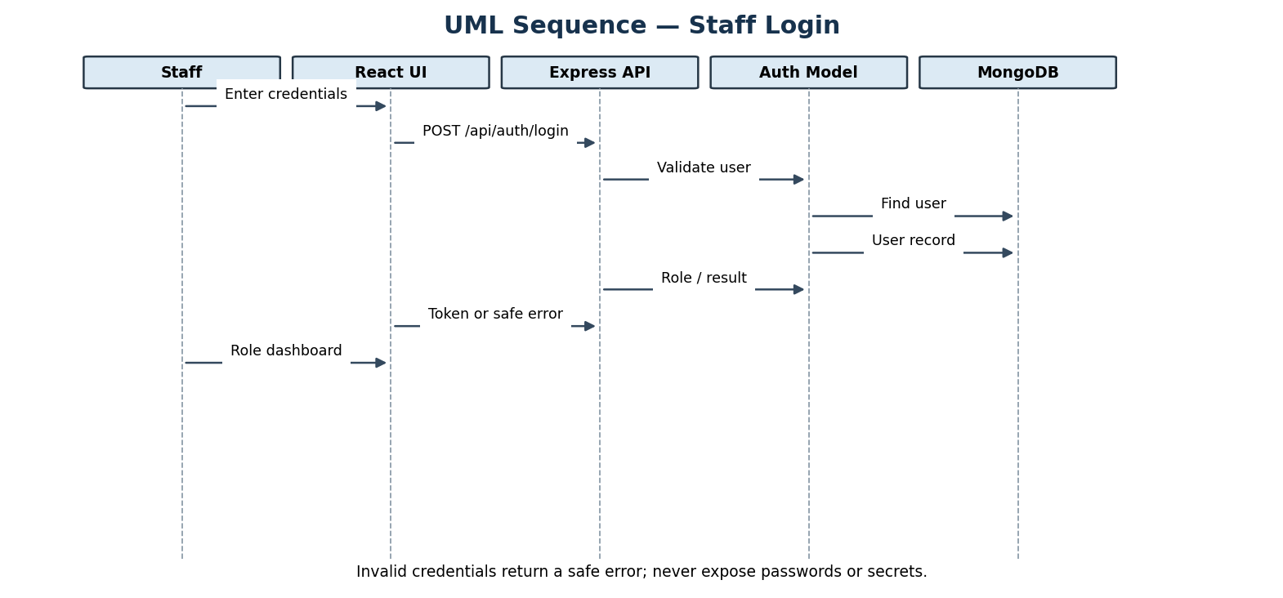

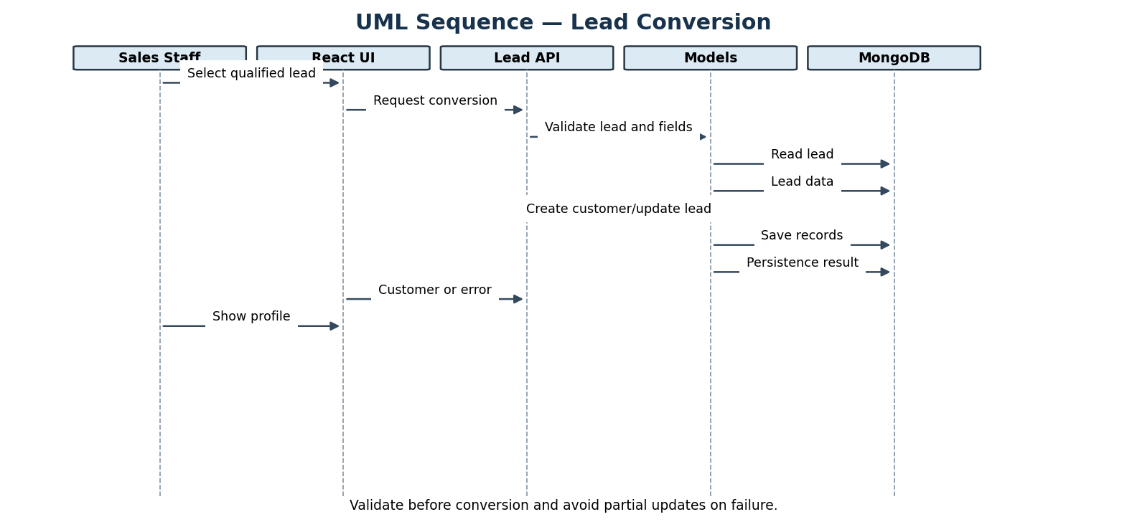
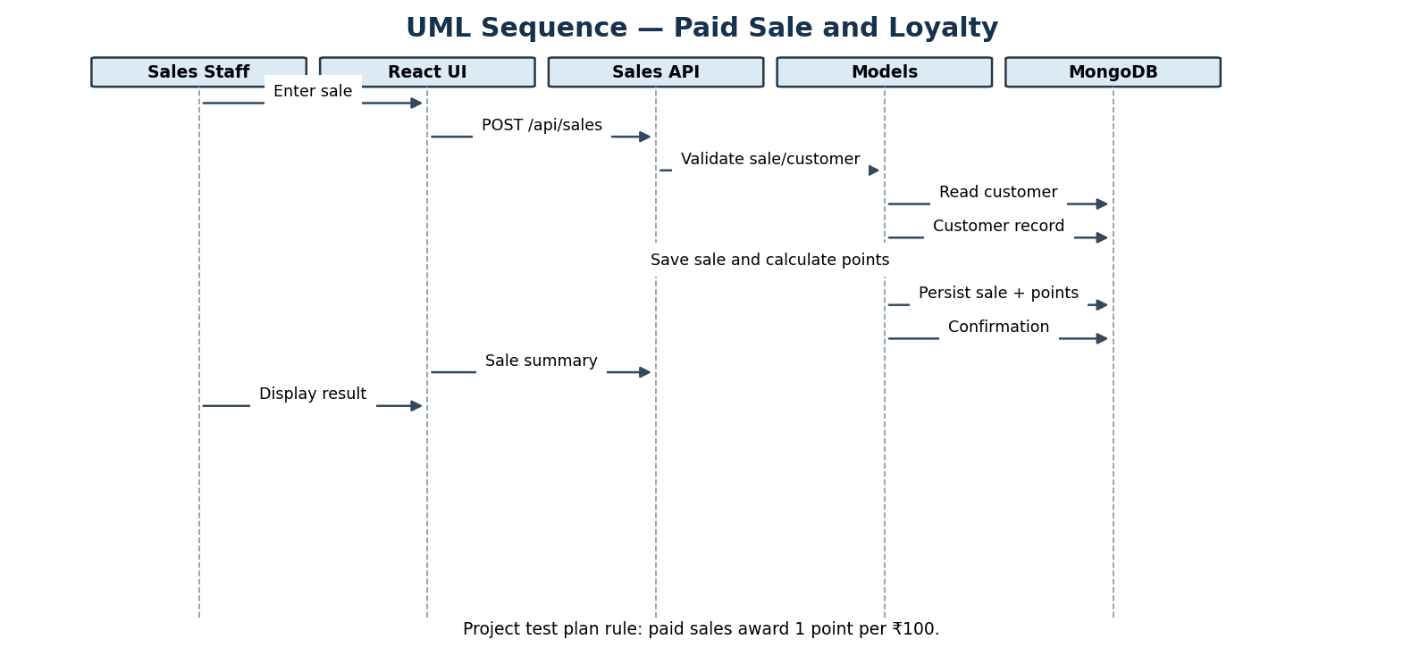

4.2.1 UML Class Diagram
Conceptual domain model of users, leads, customers, interactions, follow-ups, sales, and feedback/issues. The final schema may differ from this design view.
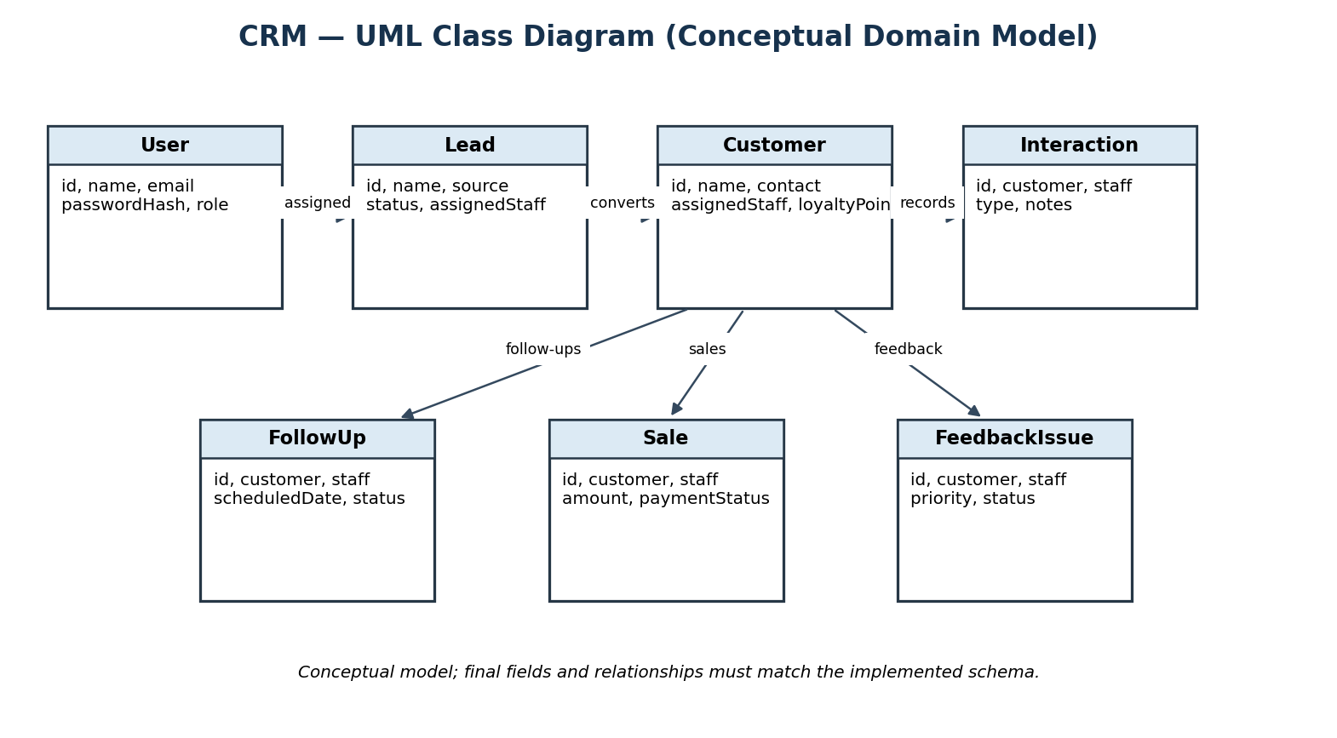

4.3 API Design
The examples define intended responsibilities. Confirm exact route paths and response fields against the implementation.
Endpoint example | Method | Purpose
/api/auth/login | POST | Validate credentials; return token/role or safe 401.
/api/leads | GET / POST | List authorized leads or create validated lead.
/api/leads/:id/convert | POST | Validate lead; create customer and update lead status.
/api/customers/:id | GET / PUT/PATCH | Read/update after role and ownership checks.
/api/follow-ups | GET / POST | List or schedule authorized follow-ups.
/api/sales | GET / POST | List/record sales and apply paid-sale points rule.
/api/reports | GET | Return role-appropriate dashboard/report data.

4.3.1 Common API behavior
- Use JSON requests and responses.
- Require authentication and authorization for protected routes.
- Typical codes: 200/201 success, 400 invalid input, 401 unauthenticated, 403 forbidden, 404 missing resource, 500 unexpected server error.
- Errors must not reveal secrets or stack traces.

4.4 Error Handling, Logging & Monitoring
Validate requests at the API boundary. Handle missing records, invalid fields, conflicting actions, unauthorized access and database failures gracefully. Logs can include operation and timestamp, but never passwords, tokens or secrets. Monitor API failures, access-control failures, persistence errors, response time and end-to-end workflow success.

4.5 UX Design
- Use consistent navigation, labelled forms, tables and status indicators.
- Show views and data appropriate to Admin, Sales Staff and Support Staff.
- Provide loading, empty, success, validation and error states.
- Keep core pages usable on desktop, tablet and mobile widths.
- Confirm sensitive actions and prevent duplicate submissions where possible.

4.6 Open Issues & Next Steps
- Confirm exact routes, fields and model relationships against implemented code.
- Complete unit, integration, system, regression, security, responsive UI and basic performance tests.
- Keep GitHub backlog, sprint work, code and documentation aligned.
- Document deviations from SRS or planned scope.
- Do not claim production readiness without deployment and operational evaluation.

5. Appendices

5.1 Glossary
Term | Definition
Admin | Role for permitted administration and oversight.
Sales Staff | Role focused on assigned leads/customers and sales.
Support Staff | Role focused on support, interactions, follow-ups and feedback.
Mongoose | ODM for defining schemas and accessing MongoDB from Node.js.
REST API | HTTP interface for frontend-to-backend communication.
RBAC | Role-Based Access Control.

5.2 References
- CRM Software Requirements Specification (SRS), Version 1.1.
- CRM Software Test Plan (STP), Version 1.0.
- Provided SAD template, adapted from the ATM example.

5.3 Tools
Microsoft Word; draw.io-style UML diagrams; GitHub Projects and Actions; VS Code; browser developer tools; MongoDB Compass; API/manual testing tools.

