**AMTH 308 Homework 1**

**Name: Shweta Kharat**

**Haar2DEncoding.m**

%Read image

A = imread('image.jpg');

A = imresize(A,[256,256],'bicubic');

figure,image(A);

%Convert to gray scale

A = rgb2gray(A);

A = double(A);

figure,image(A);colormap gray(256);

N = 256;

%Haar Matrix

IN = eye(N);

IN2 = eye(N/2);

Q = [1,1;1,-1];

T = (1/sqrt(2))*kron(IN2,Q);

Ttrans = T.';

%Permutation Matrix

P1 = IN(1:2:N,:);

P2 = IN(2:2:N,:);

P = [P1;P2];

Ptrans = P.';

%disp(P);

%Calculate PTAT'P'

level = log2(N);

disp(level);

B = P * T * A * Ttrans *Ptrans;

B = double(B);

figure,image(B);colormap gray(16);

%Forward Processing

n = N;

for i = 1:level

B(1:n,1:n) = P(1:n,1:n) * T(1:n,1:n) * A(1:n,1:n) * Ttrans(1:n,1:n) * Ptrans(1:n,1:n);

n = n/2;

end

%Inverse Processing

n = 2;

for i = 1:level

Anew(1:n,1:n) = Ttrans(1:n,1:n) * Ptrans(1:n,1:n) * B(1:n,1:n) * P(1:n,1:n) * T(1:n,1:n);

n = n*2;

end

%Forward Haar Transform of Vector [2,7,1,8,2,8,1,8]

V = [2 7 1 8 2 8 1 8];

Vtrans = V.';

%Forward Processing Vector

n = 8;

for i = 1:3

PTVnew(1:n) = P(1:n,1:n) * T(1:n,1:n) * Vtrans(1:n);

disp(PTVnew(1:n));

n = n/2;

end

**Output:**

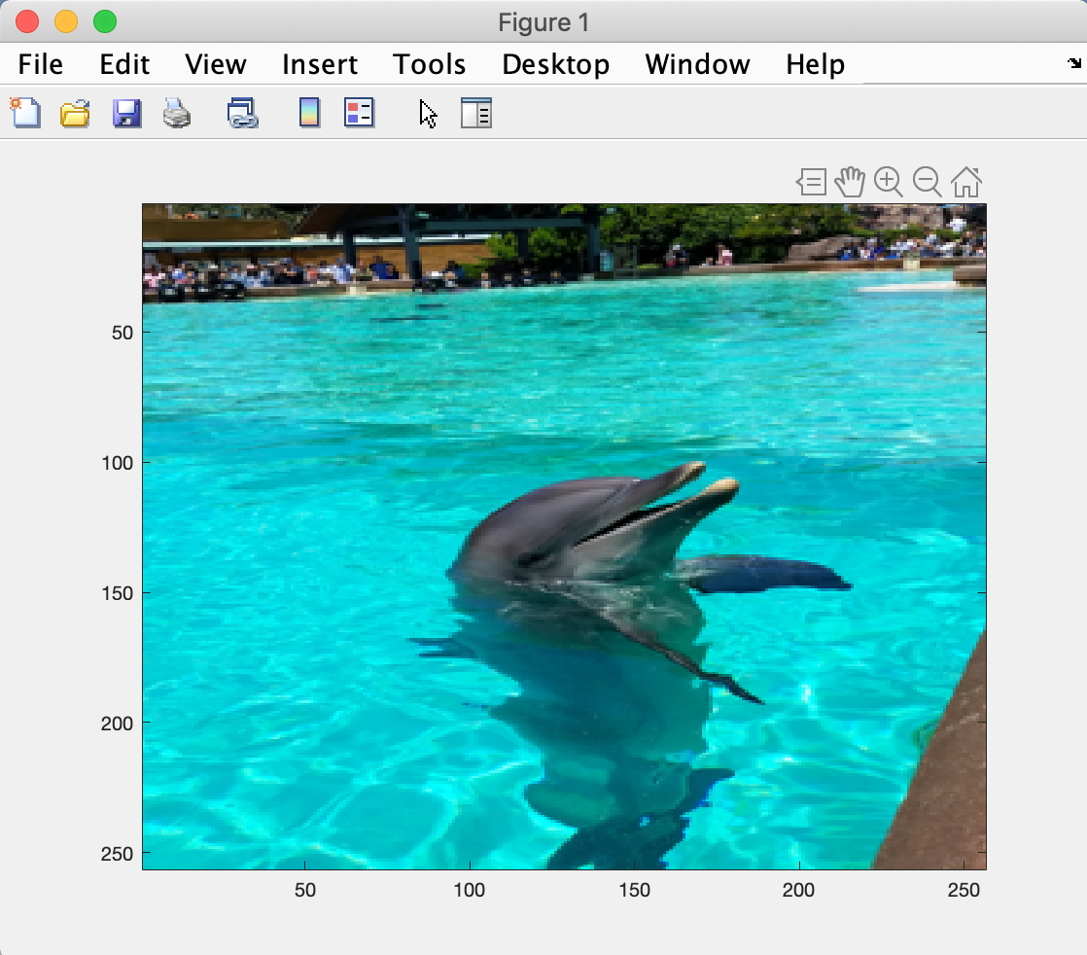

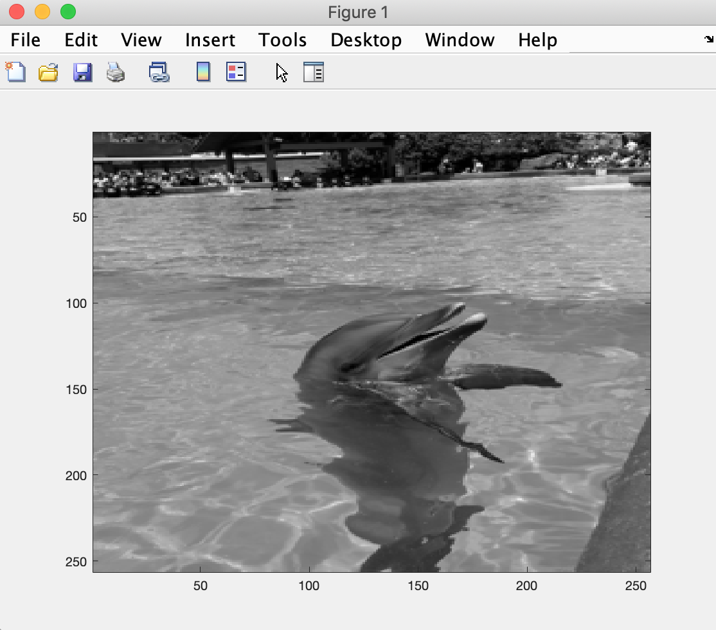

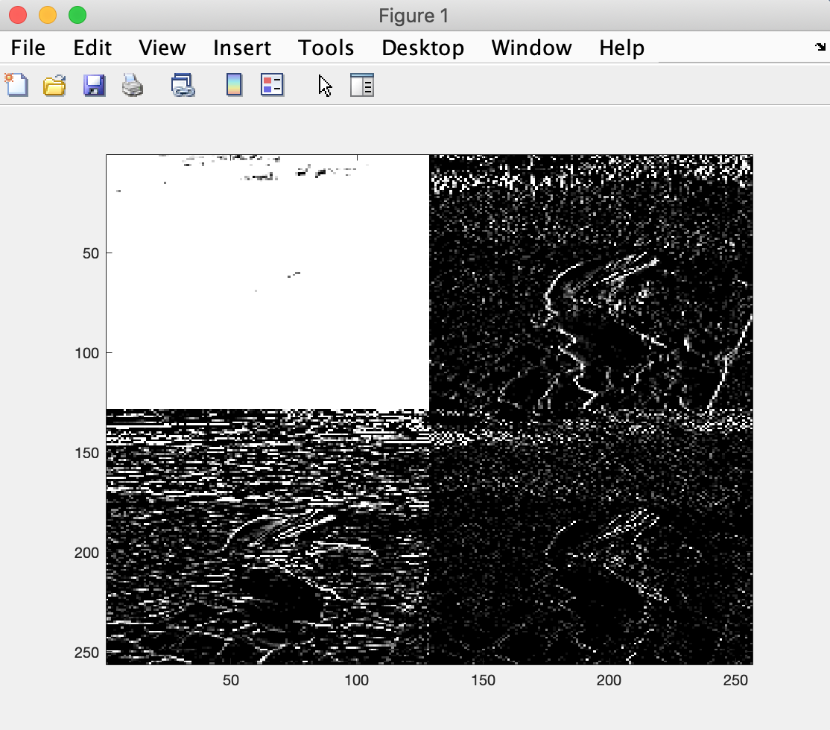

6.3640 6.3640 7.0711 6.3640 0 0 0 0

6.3640 6.3640 0 0

6.3640 0