Sentient: Abstractive Text Summarization using Sequence-to-sequence RNNs

Anitha Ranganathan

CISE Department

University of Florida

anitha19r@ufl.edu

Saugat Chetry

CISE Department

University of Florida

saugatpchetry@ufl.edu

Sweta Thapliyal

CISE Department

University of Florida

sthapliyal@ufl.edu

*Abstract*— Text summarization is the process in which we take a large text file and then produce a shorter summary of the same input text based on its context. The process is usually automatic and the output is in any human understandable language while maintaining the main idea of the document. The extractive text summarization models are quite predominant. But they fail to capture the semantics of a document. The abstractive models involve learning the sequence in the input. Although it is quite convoluted it captures the actual essence of the document in the generated summary. These models are very difficult to design but are quiet easily achievable using deep learning. In this project, we are going to develop a news summarizer service which we will deploy on cloud. At the core of this news summarizer will be attentional encoder decoder neural network. The android platform for the application will also be provided. The information gathered by summarizing the data will also be analyzed and will be used to give a better user experience.

Keywords—abstractive models; neural networks; attentional;

# Introduction And Motivation

Abstractive text summarization is the task of generating a headline or a short summary consisting of a few sentences that captures the salient ideas of an article or a passage. We use the adjective ‘abstractive’ to denote a summary that is not a mere selection of a few existing passages or sentences or key words extracted from the source, but a compressed and salient paraphrasing of the main contents of the document [1].

This task can also be described as mapping an input sequence of words in a source document to a target sequence of words called summary. Such problems which involves taking input as a sequence of words and generating output of sequence of words is called as sequence to sequence models in deep learning. This particular model has been quite successful in solving convoluted deep learning problems such as speech recognition and video captioning and NLP. The essence of text summarization is that the length of output is independent of the length of input. This means that even though the input is a large document not necessarily implies that the output summary generated should be large. A large text might have a short summary that can capture all the key ideas of the large input.

In this project, we are going to use attentional RNN with encoder and decoder. For encoder and decoder, we are going to use bidirectional LSTM. Our overall system will be based on the cloud and will use freely available news API.

# Related Work

There has been a lot of work in the past related to extractive summarization, which involves using words from the paraphrase for summarization. However, when humans are made to comprehend something they use their own vocabulary and come up with simpler words for the same task. In the last decade Banko et al. 2000 [14] used a traditional phase table based mechanism, Cohn and Lapta, 2008 used weighted tree-transformations for abstractive summarization. However, it was not until, Rush et al. (2015)[15] that modern neural networks with NLP were used for abstractive text summarization. They used convolutional neural networks, centered on the feed-forward attention mechanism, and improvised the decoder using a recurrent model on the Gigaword and DUC datasets to provide astounding results. There have been several attempts built up on the same work including (Chopra et al., 2016),[15] Abstract Meaning Representations (Takase et al., 2016)[16], hierarchical networks (Nallapati et al., 2016)[11], variational auto-encoders (Miao and Blunsom, 2016) [17], and direct optimization of the performance metric (Ranzato et al., 2016)[18], further improving performance on those datasets.

All the above work has been performed on the corpus involving smaller dataset. The current CNN/Daily Mail dataset however, is a huge collection to work on and can be used for large-scale data summarization. Nallapati et al. (2016) came up with the CNN/Daily Mail dataset, and provided the first abstractive baselines. A comparison could easily be drawn out between hierarchical RNNs, pointer generator networks and feature rich encoders which handle abstractive, combination of abstractive an extractive and extractive summarization respectively. The neural extractive approach (Nallapati et al., 2017) [12], which uses hierarchical RNNs to select sentences, significantly outperforms other abstractive methods when compared with ROUGE metrics.

The pointer network first came to light in (Vinyals et al., 2015). This model combines extractive and abstractive summarizations as discussed in 4.2.B. It is an end-to-end model which solves the problem of rare words and OOV words in the context of machine translation. This sequence-to- sequence model uses Bahdanau et al. (2015) [2] soft attention strategy to produce an output sequence consisting of elements from the input sequence. This work has been extended to various approaches by NMT (Gulcehre et al., 2016)[11], language modeling (Merity et al., 2016), and summarization (Gu et al., 2016; Gulcehre et al., 2016; Miao and Blunsom, 2016; Nallapati et al., 2016 [11]; Zeng et al., 2016).

The ideology behind this whole implementation is inspired by the essence of approach specified in Forced-Attention Sentence Compression model of Miao and Blunsom (2016) and the CopyNet model of Gu et al. (2016). Although our design sheds light on this model, we have implemented some major and minor transformations which provides a guaranteed optimized result when tested on ROUGE scores. Some major highlights which we will further discuss in section 4 are shortly described as below: [i]. In their implementation, Gu et al. have used soft-max as their squashing function which as we know produces a normalized output. However, we have tried to avoid the soft-max function and replaced it with an exclusive switching function for probability generation which is described in much detail in the following sections. [ii] Unlike Gu et al., that exploits two disparate distributions as attention distribution and copy distributions respectively, we have tried to recycle the attention distribution to act as the copy distribution function. (iii) Since words can appear intermittently and have multiple occurrences it can so happen that the word might be trivial, yet it could have a higher probability distribution resulting in wrong output sequences provided by the attention mechanism. We, thus sum the probability mass from all parts of attention distribution as compared to that of Miao and Blunsom, who do not reflect this idea. There are additional reasons for doing this modification as mentioned in the subsequent lines: [i] The pointer network models tend to replicate a word when it comes across multiple appearance of the same word in the source sequence provided as an input, this can tremendously affect the performance, [ii] we have also observed that these approaches individually calculate the probabilities of generated words and/or copy words, which adds up to the runtime complexity of the process, eventually affecting the performance of the whole system. Alternatively, if we use an explicit probability generator function we can make modifications to the probability of generated and/or copy words in one go. This further enhances the performance of the system as a whole, [iii] Having two separate distribution does not solve any purpose other than additional calculations and increasing the complexity. Since they have similar properties and functions we have tried to settle down for one distribution as it simplifies the design and solves the desired purpose.

Our approach is built on that of Gulcehre et al. (2016) and Nallapati et al. (2016). However, it is different from them as we recommend our pointer to be activated whenever needed whereas they train the network to use pointers only for OOV or rare words. Mixing copy and vocabulary distribution, is better for abstractive summarization. This will enable us to reproduce rare but in-vocabulary words, also the mixture model enables the language model and copy mechanism to work together to perform abstractive copying.

Coverage vectors are another important addition to our proposed solution. Coverage was originally used for NMT by Tu et al. (2016)[10] and Mi et al. (2016), they used a GRU to obtain these coverage vectors. For summarization in longer text having such calculations is tedious and memory intensive. Hence, we found a simpler approach Xu et al. (2015), which uses coverage mechanism for image captioning, and the “distraction” coverage like mechanism in Chen et al. (2016) come to the rescue. We therefore, have adapted quite similar yet a new technique. In order to obtain the coverage vector suffixes, we end up adding the attention distributions as discussed in 4.2.

Attention mechanism can be applied in various techniques. There have approaches like NMT (Sankaran et al., 2016) and summarization (Nallapati et al., 2016) [11] who have explored temporal attention as an alternative. These work the previous attention distribution is summed up to attain the current distribution, which effectively dampens repeated attention. Having researched on it we came to a consensus that this method introduces some distortions thereby affecting the attention resulting in a poor performance. We hypothesize that an early intervention method such as coverage is preferable to a post hoc method such as temporal attention – it is better to inform the attention mechanism to help it make better decisions, than to override its decisions altogether. We performed evaluations using ROUGE scores using temporal attention for the same task (Nallapati et al., 2016) [11] which gave a smaller boost as compared to that of the coverage theory.

# System Architecture

We propose a system design which can capture the key ideas of current news articles and provide the summary of the latest news to the end user. The current news will be fetched from various news web APIs as well as from the RSS feeds of the leading newspaper. All the incoming data will be preprocessed and cleansed. Preprocessing involves the removal of unwanted links, images, etc.

Once the data is preprocessed it will be fetched to our Abstractive Text Summarization model based on Sequence-to-sequence RNNs [2]. We propose to make this summarizer independent and automated so that it can begin its processing without any manual intervention. This will give us scope to schedule the operation of summarizer based on events, timings, etc. Once the summarizer has completed the task of summarizing the latest news its output will be sent to our application server which in turn will store it in the database. The application server will be responsible for pushing out the summarized content to the end user using various mechanism such as push notification, web API calls etc.

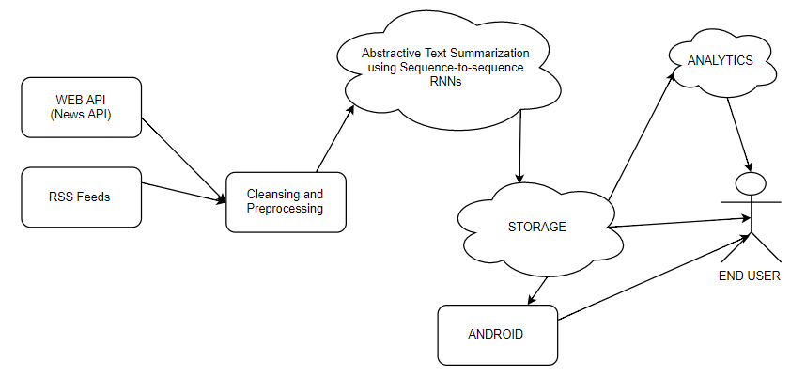

1. *Our proposed system design*

# System design and Implementation

In this section, we dive deep into our system modules and their interaction in a point to point basis. We are dividing the system into 4 modules namely – 1) Sentient Data Collector and preprocessor, 2) Sentient “the smart” Summarizer, 3) Sentient News Server, 4) Sentient “Smart” Storage.

*4.1 Sentient Data Collector and Preprocessor*

For the purpose of mode training and testing we would be using the CNN/ Daily Mail dataset (Nallapati et al. 2016) having online news articles and their summaries in multiple sentences. This dataset has 781 tokens and the summaries have an average of 3.75 sentences and 56 tokens, consisting of 287,226 training pairs, 13,368 validation pairs and 11,490 test pairs. This can be easily extracted using the scripts provided by Nallapati et al. 2016.

Post training and model deployment, our application will use the latest news articles which we can obtain from the news provides’ API such as the CNN/ Daily Mail APIs etc. Sentient Data preprocessor will then cleanse and preprocess the news to remove the non-relevant data like links and advertisements thereby making it usable by “Sentient Summarizer".

*4.2 Sentient “The Smart” Summarizer*

In the recent past, deep-learning based models that map an input sequence into another output sequence, called sequence-to- sequence models, have been successful in many problems such as machine translation [2], speech recognition [3] and video captioning [4]. This section describes the basic structure of our model. It is divided into three subsections – Sequence-to-sequence unit, pointer generator model, coverage mechanism.

## Sequence to sequence unit:

Sequence to sequence models are the models which takes an input sequence and returns an output sequence. In our project, the input sequence refers to the original text and output sequence is the summary generated. We can use any RNN for this purpose, however, we choose to feed the article tokens *wi,* into a single bidirectional LSTM which acts as our encoder. Like all other feed forward networks, the encoder provides an output encoder hidden state *hi*. Since we are using a decoder with attention mechanism as described in Bahdanau et al. (2015)[2], at any time step *t,* the decoder takes the previous decoder output, the decoder state *st* and the encoder hidden state *hi* as input in order to produce the output word embedding. The attention distribution is as below where *v, Wh, Ws* and *battn are learnable parameters.*

*eti* = *vT* tanh(*Whhi*+*Wsst* +*battn*) (1)

*at* =softmax(*et*) (2)

As discussed in related work, the attention distribution to obtain context vector is as below:

*ht∗* =∑*iatihi*  (3)

We have modified the concatenated pairs in the Bahdanau et al to:

*Pvocab* = softmax(*V′(V[st,ht∗]+b)+b′*) (4)

During training, the loss for time-step *t* is the negative log likelihood of the target word *wt∗* for that time-step and the overall loss is the weighted average of the individual losses.

## Pointer generater unit

As discussed in related work we use a pointer generator unit which is well known for its hybrid functionality between extractive and abstractive summarization capabilities. At every time-step at the decoder we use the sigmoid distribution on the context vector, decoded state and the decoder input to obtain a probability generation *pgen.* As a result of this we allowcopy and vocabulary distribution from a fixed vocabulary.

*pgen=*σ*(wTh∗ht∗+wTsst+wTxxt+bptr)*  (5)

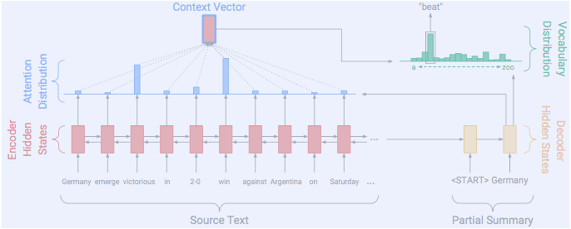

1. *Sequence to sequence model with soft attention. Model generates OOV words too. For eg. It scans the iput sequence ‘Germany emerge victorious in 2-0 win against Argentina on Sunday’ and generates the word ‘beat’ as part of its abstractive summary by using attention on the word ‘victorious’.[9]*

## Coverage Mechanism

To solve the problem of repetition which is present in the sequence-to-sequence model, a coverage vector is maintained. The coverage vector represents the degree of coverage the words in the source document have received so far from the attention mechanism. This coverage vector is fed to the attention mechanism as an additional input which ensures that the current decision of the attention mechanism is based on its previous decision which will in-turn help generating repetitive text. To penalize for repeatedly attending the same location, a coverage loss is defined as:

covloss*t* =∑imin(a*ti*,c*ti*) (5)

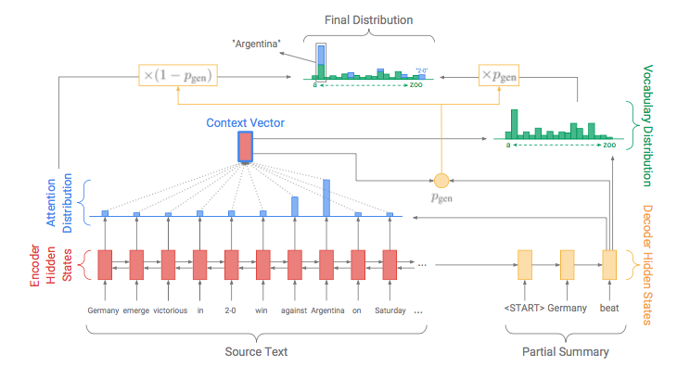

1. *In this pointer generator etwork model, each decoder time-step the words are generated using the probability generator function which calculates using the below equations .[9]*

In our final application, we will have the trained model deployed in this module so that our system can provide the summarized news to the Sentient News Server which is discussed in next.

*4.3 Sentient News Server*

The Sentient News Server in our application will be mainly responsible for providing the summarized news to the client of our application. The Sentient News Server will receive the summarized news from the Sentient “the smart” Summarizer as an input. The input will be received by making a Rest API call to the summarizer module and once the server receives the input, it will save it to the database for future use.

In addition to getting response from the summarizer, the Sentient News Server will also act as the server for all the client applications. Whenever the end user makes a request for latest news, the news server will first check for the validity of the request and then will query the database for the latest news. The result of the query to the database will be made available to the client as a response to its API request.

This design will help us keep the different module loosely coupled which will in-turn facilitate in making out application scalable.

*4.4 Sentient “Smart” Storage.*

The Sentient “Smart” Storage is the fourth module of our application. In this module, we will be saving all the summarized news which the Sentient News Server will receive from the Sentient Summarizer. Storing the summarized news is important to make the news available to the end user whenever required. Also, saving the summary will allow us to use this to create new dataset which can be used to train the summarizer further. Further, the stored news can be used when the user request for older news and also during the time when latest news summaries may not be available due to system downtime or system upgrades.

*4.5 Class Diagram*

Our system involves four main classes as stated in section 4. The class diagram gives a brief idea about the properties and members of these four classes and highlights how these classes interact with each other.

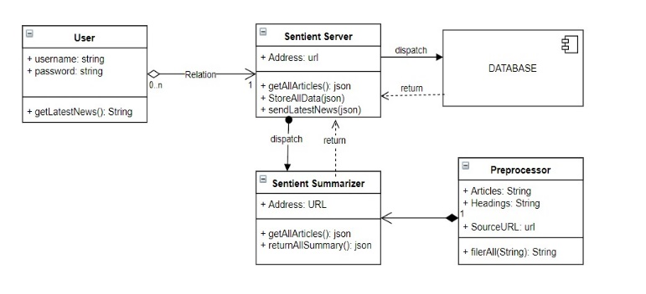

1. *Class diagram for the proposed system.*

*4.6 Interaction Diagram*

Below we have shown the Interaction diagram for Sentient System. The Sentient server will request the text summarizer to provide summaries of the latest happenings across the world. The Sentient Smart text summarizer will begin the background process – (1) query the news providing service APIs such as CNN, Daily Mail, BBC etc., (2) the response of these services will then be passed on to our preprocessing module of the summarizer, (3) the Sentient data preprocessor will cleanse the data as described in section 4.1, (4) this preprocessed data will then be queried onto the trained model “Sentient ‘The Smart’ Summarizer”, which in turn would return the summarized output sequence, (5) this output from the Sentient summarizer will be redirected to the Sentient server, (6) the Sentient server would then will be stored in the Sentient smart storage, (7) On receiving request for summaries from the user, the Sentient server will query this storage for summaries and return the same to the user. We propose to make our system’s interaction via Rest APIs. Each module in the system will exist as independent and standalone system and all interaction will be done over HTTP calls. This architecture will make the entire application loosely coupled and hence will lead to increase scalability. Also, this architecture will facilitate further improvement by addition of additional (or replacement) of modules.

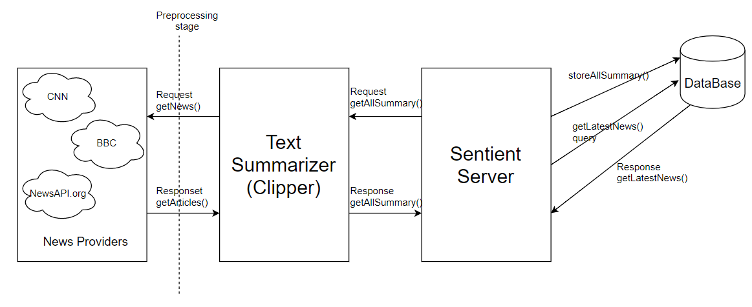

1. *System Interation between different modules*

# Experimental results

## Experimental Setting:

We are planning to have 256-hidden states on a 128-dimensional word embedding and train on smaller vocab size compared to Nallapati et al.’s (2016). But these figures are subject to change post training and experiments. We are going to test these using RMS propogation, Stochastic gradient descent and Adam optimizer and later narrow down to the one that suits best for better results. After having researched about parameters for training we have shortlisted learning rate as 0.15 and accumulator to 0.1.

## Evaluation metrics:

Similar to [7] and [8], this model uses the full length F1 variant of Rouge6 to evaluate our system. Although limited length recall was the preferred metric for most previous work, one of its disadvantages is choosing the length limit which varies from corpus to corpus, making it difficult for researchers to compare performances.

## Experimental Results:

Even when the model differs from the target summary, its summaries tend to be very meaningful and relevant, a phenomenon not captured by word/phrase matching evaluation metrics such as Rouge. On the other hand, the model sometimes ‘misinterprets’ the semantics of the text and generates a summary with a comical interpretation as shown in the poor-quality examples in the table. Clearly, capturing the ‘meaning’ of complex sentences remains a weakness of these models.

# Current progress and project management

This section highlights the project progress and work allocation. Its divided into sections to provide some clear and transparent idea about the work done so far.

*6.1 Current Status*

We are concurrently working on all the modules discussed in section4. We have been able to complete a basic model and started to train our summarizer. We have been training the summarizer for three days and monitoring the logs. The dataset that we are using is the CNN/Daily Mail dataset which is approximately 2GB in size. Also, we are building the backend server and database system in parallel. We have been able to hit the intended milestones and have approximately covered 50% of the task.

*6.2 Team Coordination*

We had divided the tasks equally among our team into 3 parts as discussed below:

1. Saugat had been assigned the task of developing and setting up the backend server along with the database and RESTful APIs. Since he had worked with Tensorflow in the past, he performed peer review.
2. Shweta was responsible for preprocessing and cleansing the data, design and construction of training model.
3. Anitha had to set up the environment for model development, construct and code the model and run training data.

Apart from the aforementioned tasks, each one of us was responsible for paper reviews and individual documentation.

*6.3 Milestones, Weekly Plans, and Deliverables*

There are approximately five weeks remaining for the final demo and we have split the plan into five short plans:

Week 1: Complete the basic training for the model completed so far.

Week 2: Tweak and twist learnable parameters mentioned in section 5.1 and try obtaining a better result.

Week 3: Perform evaluations and obtain experimental results after finalizing the model and its parameters.

Week 4: Deploy the model in cloud and in the server. Perform testing for the application as a whole.

Week 5: Complete documentation for the final presentation and demo day.

The github link is <https://github.com/saugatchetry/T1-Sentient>

##### References

1. Ramesh Nallapati, Bowen Zhou, C¸ a glar Gulc¸ehre, and Bing Xiang. 2016. Abstractive text summarization using sequence-to-sequence rnns and beyond.
2. Dzmitry Bahdanau, Kyunghyun Cho, and Yoshua Bengio. 2014. Neural machine translation by jointly learning to align and translate. CoRR, abs/1409.0473.
3. Dzmitry Bahdanau, Jan Chorowski, Dmitriy Serdyuk, Philemon Brakel, and Yoshua Bengio. 2015. End-to-end attentionbased large vocabulary speech recognition. CoRR, abs/1508.04395.
4. Subhashini Venugopalan, Marcus Rohrbach, Jeff Donahue, Raymond J. Mooney, Trevor Darrell, and Kate Saenko. 2015. Sequence to sequence - video to text. CoRR, abs/1505.00487.
5. ] Junyoung Chung, Çaglar Gülçehre, KyungHyun Cho, and Yoshua Bengio. 2014. Empirical evaluation of gated recurrent neural networks on sequence modeling. CoRR, abs/1412.3555.
6. Sébastien Jean, Kyunghyun Cho, Roland Memisevic, and Yoshua Bengio. 2014. On using very large target vocabulary for neural machine translation. CoRR, abs/1412.2007..
7. Ramesh Nallapati, Bing Xiang, and Bowen Zhou. 2016. Sequence-to-sequence rnns for text summarization. ICLR workshop, abs/1602.06023.
8. Sumit Chopra, Michael Auli, and Alexander M. Rush. 2016. Abstractive sentence summarization with attentive recurrent neural networks. In HLT-NAAC
9. Abigail See, Peter J. Liu ,Christopher D. Manning. 2017. Get To The Point: Summarization with Pointer-Generator Networks
10. [Zhaopeng Tu](https://arxiv.org/find/cs/1/au:+Tu_Z/0/1/0/all/0/1), [Zhengdong Lu](https://arxiv.org/find/cs/1/au:+Lu_Z/0/1/0/all/0/1), [Yang Liu](https://arxiv.org/find/cs/1/au:+Liu_Y/0/1/0/all/0/1), [Xiaohua Liu](https://arxiv.org/find/cs/1/au:+Liu_X/0/1/0/all/0/1), [Hang Li](https://arxiv.org/find/cs/1/au:+Li_H/0/1/0/all/0/1). 2016.Modeling Coverage for Neural Machine Translation
11. Caglar Gulcehre,Sungjin Ahn,Ramesh Nallapati,Bowen Zhou,Yoshua Bengio. 2016. Pointing the Unknown Words
12. Ramesh Nallapati, Feifei Zhai, and Bowen Zhou. 2017. SummaRuNNer: A recurrent neural network based sequence model for extractive summarization of documents. In *Association for the Advancement of Artificial Intelligence*.
13. Ramesh Nallapati, Bowen Zhou, Cicero dos Santos, C ̧aglar Gulc ̧ehre, and Bing Xiang. 2016. Abstrac- tive text summarization using sequence-to-sequence RNNs and beyond. In *Computational Natural Lan- guage Learning*.
14. Banko, Michele and Mittal, Vibhu O and Witbrock, Michael J, Headline generation based on statistical translation
15. Chopra, Sumit and Auli, Michael and Rush, Alexander M, Abstractive sentence summarization with attentive recurrent neural networks
16. Sho Takase, Jun Suzuki, Naoaki Okazaki, Tsutomu Hi- rao, and Masaaki Nagata. 2016. Neural headline generation on abstract meaning representation. In *Empirical Methods in Natural Language Process- ing*.
17. Yishu Miao and Phil Blunsom. 2016. Language as a latent variable: Discrete generative models for sen- tence compression. In *Empirical Methods in Natu- ral Language Processing*.
18. Marc’Aurelio Ranzato, Sumit Chopra, Michael Auli, and Wojciech Zaremba. 2016. Sequence level train- ing with recurrent neural networks. In *International Conference on Learning Representations*.