Sentient: Abstractive Text Summarization using Sequence-to-sequence RNNs

Anitha Ranganathan
CISE Department
University of Florida
anitha19r@ufl.edu

Saugat Chetry
CISE Department
University of Florida
saugatpchetry@ufl.edu

Sweta Thapliyal
CISE Department
University of Florida
sthapliyal@ufl.edu

Abstract— Text summarization is the process of automatically generating natural language summaries from an input document while maintaining the key idea of the document. The extractive text summarization models are quite predominant. But they fail to capture the semantics of a document. The abstractive models involve learning the sequence in the input. Although it is quite convoluted it captures the actual essence of the document in the generated summary. These models are very difficult to design but are quiet easily achievable using deep learning. In this project, we are going to develop a news summarizer service which we will deploy on cloud. At the core of this news summarizer will be attentional encoder decoder neural network. The android platform for the application will also be provided. The information gathered by summarizing the data will also be analyzed and will be used to give a better user experience.
Keywords—abstractive models; neural networks; attentional;

Introduction
Abstractive text summarization is the task of generating a headline or a short summary consisting of a few sentences that captures the salient ideas of an article or a passage. We use the adjective ‘abstractive’ to denote a summary that is not a mere selection of a few existing passages or sentences or key words extracted from the source, but a compressed and salient paraphrasing of the main contents of the document [1].
This task can also be described as mapping an input sequence of words in a source document to a target sequence of words called summary. Such problems which involves taking input as a sequence of words and generating output of sequence of words is called as sequence to sequence models in deep learning. This particular model has been quite successful in solving convoluted deep learning problems such as speech recognition and video captioning and NLP. The essence of text summarization is that the length of output is independent of the length of input. This means that even though the input is a large document not necessarily implies that the output summary generated should be large. A large text might have a short summary that can capture all the key ideas of the large input.
In this project, we are going to use attentional RNN with encoder and decoder. For encoder and decoder, we are going to use LSTM. Our overall system will be based on the cloud and will use freely available news API.

System design
We propose a system design which can capture the key ideas of current news articles and provide the summary of the latest news to the end user. The current news will be fetched from various news web APIs as well as from the RSS feeds of the leading newspaper. All the incoming data will be preprocessed and cleansed. Preprocessing involves the removal of unwanted links, images, etc.
Once the data is preprocessed it will be fetched to our Abstractive Text Summarization model based on Sequence-to-sequence RNNs [2]. We propose to make this summarizer independent and automated so that it can begin its processing without any manual intervention. This will give us scope to schedule the operation of summarizer based on events, timings, etc. Once the summarizer has completed the task of summarizing the latest news its output will be sent to our application server which in turn will store it in the database. The application server will be responsible for pushing out the summarized content to the end user using various mechanism such as push notification, web API calls etc.

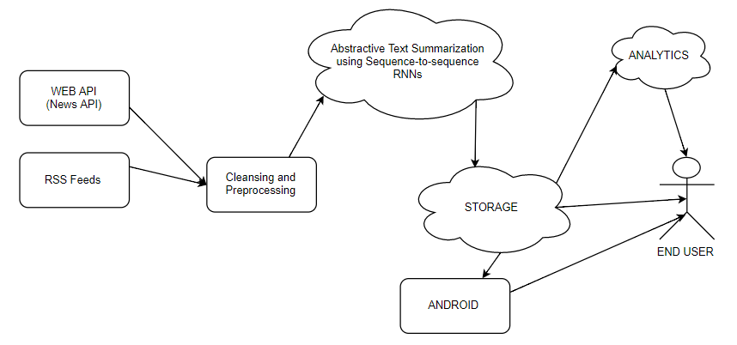

- Our proposed system design

Models
In this section, we are going to describe out deep learning models for converting word to vec, LSTM, sequence2sequence RNN and attention mechanism. Sequence prediction is a problem that involves using historical sequence information to predict the next value or values in the sequence. Recurrent Neural Networks, like Long Short-Term Memory (LSTM) networks, are designed for sequence prediction problems.

Word2Vec
This model consists of one hidden layer neural network that converts a word in text to a vector representation. This vector component represent the weight of each word in the document. The similarity between these words can be represented using cosine similarity.

LSTM
LSTM is Long Short-Term Memory. It basically consists of multiple single memory cell with logistic and linear units with multiplicative interactions. There are three gates namely keep, read and write to this memory cell which are determined by the rest of the network.

Sequence to sequence unit:
Sequence to sequence models are the models which takes an input sequence and returns an output sequence. In our project, the input sequence refers to the original text and output sequence is the summary generated. y. In the recent past, deep-learning based models that map an input sequence into another output sequence, called sequence-to-sequence models, have been successful in many problems such as machine translation [2], speech recognition [3] and video captioning [4].

Encoder decoder RNN with a slight modification:
The base line model we will be using corresponds to neural machine translation model used in [1]. The encoder consists of a bidirectional GRU-RNN [5] while decoder consist of unidirectional GRU-RNN with the same hidden state size as that of the encoder. We will try to implement the large vocabulary ‘trick’ (LVT) described in [6]. In our approach, the decoder-vocabulary of each mini-batch is restricted to words in the source documents of that batch. In addition, the most frequent words in the target dictionary are added until the vocabulary reaches a fixed size.
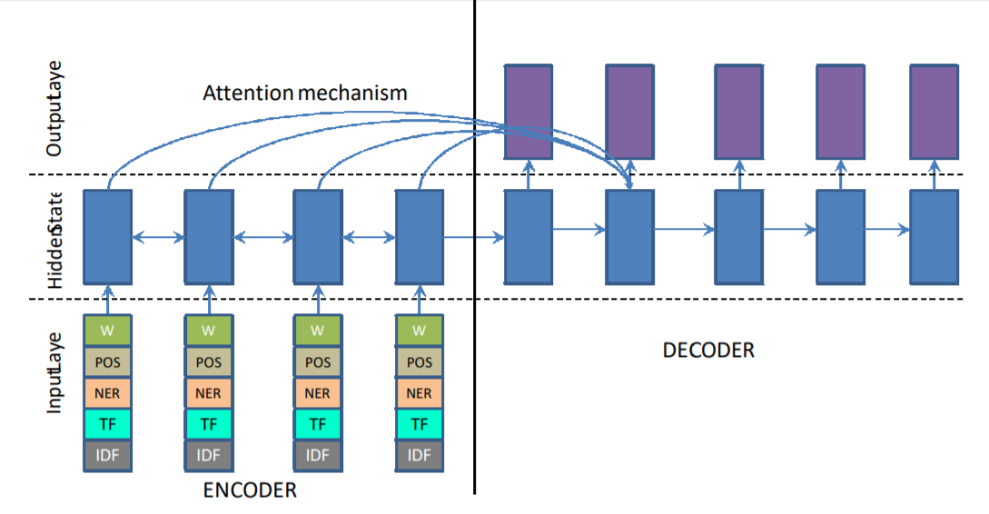

Experimental results

Evaluation metrics:
Similar to [7] and [8], this model uses the full length F1 variant of Rouge6 to evaluate our system. Although limited length recall was the preferred metric for most previous work, one of its disadvantages is choosing the length limit which varies from corpus to corpus, making it difficult for researchers to compare performances.

Results:
Even when the model differs from the target summary, its summaries tend to be very meaningful and relevant, a phenomenon not captured by word/phrase matching evaluation metrics such as Rouge. On the other hand, the model sometimes ‘misinterprets’ the semantics of the text and generates a summary with a comical interpretation as shown in the poor-quality examples in the table. Clearly, capturing the ‘meaning’ of complex sentences remains a weakness of these models.

References

- Ramesh Nallapati, Bowen Zhou, C¸ a glar Gulc¸ehre, and Bing Xiang. 2016. Abstractive text summarization using sequence-to-sequence rnns and beyond.
- Dzmitry Bahdanau, Kyunghyun Cho, and Yoshua Bengio. 2014. Neural machine translation by jointly learning to align and translate. CoRR, abs/1409.0473.
- Dzmitry Bahdanau, Jan Chorowski, Dmitriy Serdyuk, Philemon Brakel, and Yoshua Bengio. 2015. End-to-end attentionbased large vocabulary speech recognition. CoRR, abs/1508.04395.
- Subhashini Venugopalan, Marcus Rohrbach, Jeff Donahue, Raymond J. Mooney, Trevor Darrell, and Kate Saenko. 2015. Sequence to sequence - video to text. CoRR, abs/1505.00487.
- ] Junyoung Chung, Çaglar Gülçehre, KyungHyun Cho, and Yoshua Bengio. 2014. Empirical evaluation of gated recurrent neural networks on sequence modeling. CoRR, abs/1412.3555.
- Sébastien Jean, Kyunghyun Cho, Roland Memisevic, and Yoshua Bengio. 2014. On using very large target vocabulary for neural machine translation. CoRR, abs/1412.2007..
- Ramesh Nallapati, Bing Xiang, and Bowen Zhou. 2016. Sequence-to-sequence rnns for text summarization. ICLR workshop, abs/1602.06023.
- Sumit Chopra, Michael Auli, and Alexander M. Rush. 2016. Abstractive sentence summarization with attentive recurrent neural networks. In HLT-NAACL.

Fig. 2 Feature rich Encoder and Decoder[1]

