SERVERLESS AWS LAMBDA

Serverless architectures refers to applications that significantly depend on third-party services (knows as Backend as a Service or “BaaS”) or on custom code that’s run in ephemeral containers (Function as a Service or “FaaS”).

Despite the name, Serverless does not mean running the code without servers. The name “serverless computing” is used because the business or person that owns the system does not have to purchase, rent or provision servers or virtual machines for the backend code to run on.

Advantages of serverless:

Pros:
- No configuration or management - just write code and deploy it
- Self-healing - if any processes hit uncaught exceptions, etc., only a single container will go down and the rest of your web requests will process uninterrupted.
- Unlimited scalability - Any type of application or bakend service can be built, as everything required to run and scaling application with high availability is handled.
- Reduced operational costs - AWS Lambda bills you only for the time when the function is called.

Cons:
- Performance issue - Vendor control, multitenancy problems, vendor lock-in and security concerns are some of the problems due to the use of 3rd party APIs.
- Lack of operational tools - The debugging and monitoring of serverless computing is tricky, as a single server resource is utilized for this.
- Inefficient for long running applications - Long tasks can be much more expensive than, for example, running a workload on a dedicated server or virtual machine.
- Cold Start Problem - A platform needs to initialize internal resources and the platform may also release such resources (such as stopping the container) if there have been no requests to your function for a long time.

When to use:
One can use serverless architecture when cost is a critical factor since billing is done only when function is executed.
Serverless is a good option when the functions are event driven and continuous running of server is not required.
When not to use:
Whenever you need a long running task that can’t be split into multiple compute cycles.
Whenever you need complex compute with high memory/compute requirements.

Create a new service:

Pre-requisites:
- Node.js and npm with latest stable verison.
- An AWS account with provider credentials set-up.

Installing Serverless Framework:
Serverless Framework is a CLI tool that allows users to build & deploy auto-scaling, pay-per-execution, event-driven functions. Install serverless globally using following command.

npm install -g serverless

Create a new template:

- List all available templates

serverless create --help

- Create a template of required language, by specifyning unique name and optional directory path.

serverless create --template aws-nodejs --path myService

- Move to newly created directory

cd my-service

You will see following files in working directory
- serverless.yml
serverless.yml file manages service configuration. The file contains service name, provider configuration and the function inside the functions definition which points to the handler.js file. Any further service configuration will be done in this file.
- handler.js
The handler.js file contains function code. The function definition in serverless.yml will point to this handler.js file and the function exported here.

Local function invocation
Use following command to invoke function locally
serverless invoke local --function functionName

Use one of the following commands to invoke function locally with data
serverless invoke local --function functionName --data "hello world"

serverless invoke local --function functionName --data '{"a":"bar"}'

Use following command for local function invocation with data passing.

serverless invoke local --function functionName --path dir/data.json

Above command passes json data in dir/data.json file (relative to the root of the service) while invoking the specified function.

Example :
handler.js

def signUp(event, context)
{
#event will have request parameters
console.log(event.body);
context.succeed('Success');
}

data.json

{
"body":
{
"email": "abc@xyz.com",
"idToken": "jadshads"
},
"headers": {}
}

serverless.yml

functions:
signUp:
handler: handler.signUp
events:
- http:
path: /user/signup
method: post
cors: true

Note: Currently, invoke local only supports the NodeJs and Python runtimes.

Configure Credentials:
Create an Identity and Access Management(IAM) User with Admin access to let the Serverless Framework access cloud provider's account(AWS) for creating and managing resources on users' behalf. Here are the steps for creating and configuring aws credentials.
- Create or login to AWS account and go to IAM page.
- If IAM user is not created click on Users and then Add user. Enter a name and enable Programmatic access. Click Next and Attach existing policies. Click Next and Review then Create user.
- Copy API Key and Secret to a temporary place. Skip steps (2) and (3) if IAM user is already created.
- Click Policies Check AdministorAccess then Policy actions and attach. Check users for whom policy has to be attached then Click Attach policy.

Serverless framework can be configured in CLI in following ways:
- Quick Setup
For quick setup, API Key and Secret can be exported as environment variables
export AWS_ACCESS_KEY_ID = <accessKey>
export AWS_SECRET_ACCESS_KEY = <secretKey>

- Setup with serverless config
serverless config credentials --provider aws --key <> --secret <secret>

- Setup with aws-cli

$ aws configure
AWS Access Key ID [None]: <accessKey>
AWS Secret Access Key [None]: <secretKey>
Default region name [None]: us-west-2
Default output format[ [None]: ENTER

Serverless Code Deploy:
Use following command when any function, event or resource configuration is added or updated in serverless.yml and changes have to be deployed to AWS.

serverless deploy / sls deploy

Working:
- An AWS CloudFormation template is created from serverless.yml
- If a Stack has not yet been created, then it is created with no resources.
- Code of functions is packaged into zip files.
- Serverless fetches the hashes for all the files of the previous deployment (if any) and compares them against the hashes of the local files.
- Serverless terminates the deployment process if all files hashes are same.
- If not, zip files of function code are uploaded to S3 Bucket.
- Any IAM Roles, Functions, Events and Resources are added to CloudFormation template.
- CloudFormation stack is updated with new CloudFormation template.
- Each deployement publishes a new version for each function in the service.

For deploying a single function use:

serverless deploy function --function functionName

This method does not update AWS Cloud Formation Stack, instead it simply overwrites the zip file of the current function on AWS.

Working:
- Serverless packages the targeted lambda function into a zip file.
- Fetches the hash of uploaded function's .zip file and compares with local zip file hash.
- Terminates if both hashes are same.
- Zip file is uploaded to S3 bucket using the same name as the previous function, which CloudFormation stack is poiniting to.

Serverless Remove:
sls remove method will remove the deployed service from AWS provider.

serverless remove / sls remove

Note: Base URL will change when service is removed and re-deployed.

Enable CORS:

Here are the steps to be followed to enable cross origin resource sharing(CORS) for the methods
- set cors to true in serverless.yml and deploy the updated function.
- Include Access-Control-Allow-* headers in your response headers object as shown below.
- Go to AWS API Gateway console choose API under APIs.
- Choose resource under Resources. Select method (GET,POST,DELETE or any other) of any resource(ex:- POST of signup API) for which CORS has to be enabled.
- Click on Integration Request of the selected method.
- Uncheck Use Lambda Proxy integration and save changes.
- Select the resource(ex:- /signup) and Enable CORS from Actions dropdown
- Click on Enable CORS and replace existing CORS headers then Yes, overwrite existing values.
- Select Deploy API from Actions dropdown.

Including Access-Control-Allow-* headers in response object is as shown below

module.exports.hello = function(event, context, callback) {
const response = {
httpStatusCode: 200,
headers: {
"Access-Control-Allow-Origin" : "*", // Required for CORS support to work
"Access-Control-Allow-Credentials" : true // Required for cookies, authorization headers //with HTTPS
},
body: JSON.stringify({ "message": "Hello World!" })
};
callback(null, response);

Request Mapping:

- Go to AWS API Gateway console choose API under APIs.
- Click on Intergration Request.

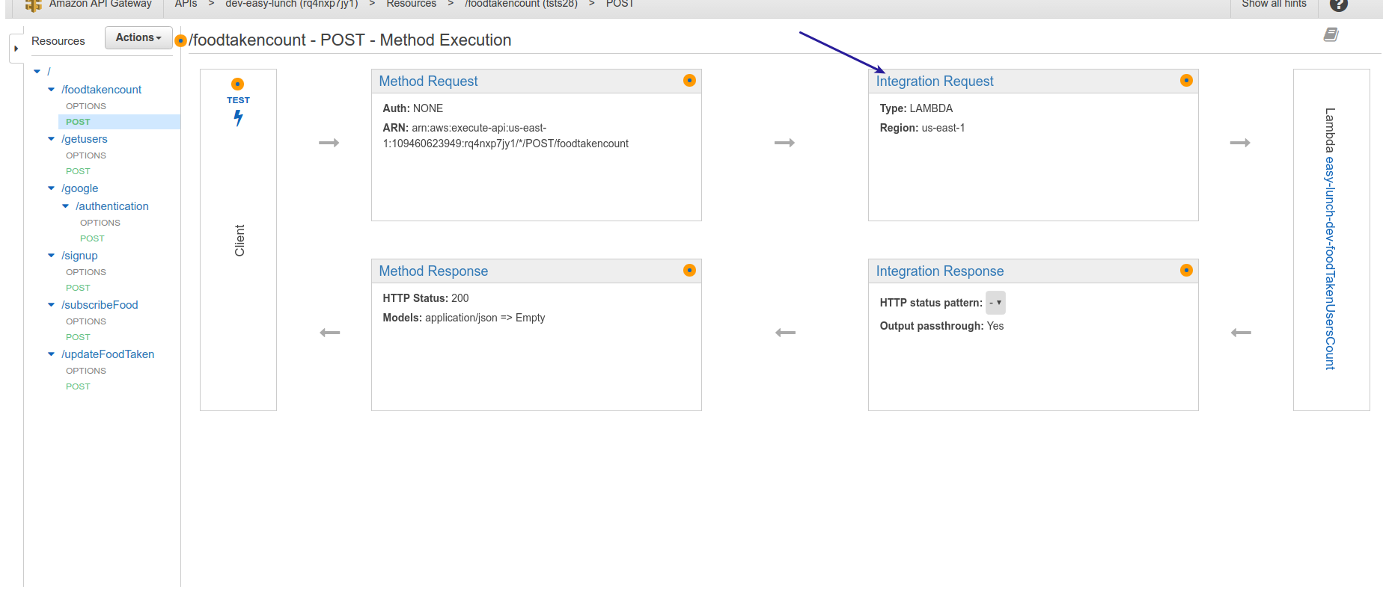
- For Request mapping, select Body Mapping Templates then Add mapping template.
- Enter Content-Type(application/json) in the text box.
- Click on the Content-Type that you have created.
- Select Method Request passthrough from the Generate template dropdown.
- Clear the generated template and add the following template.
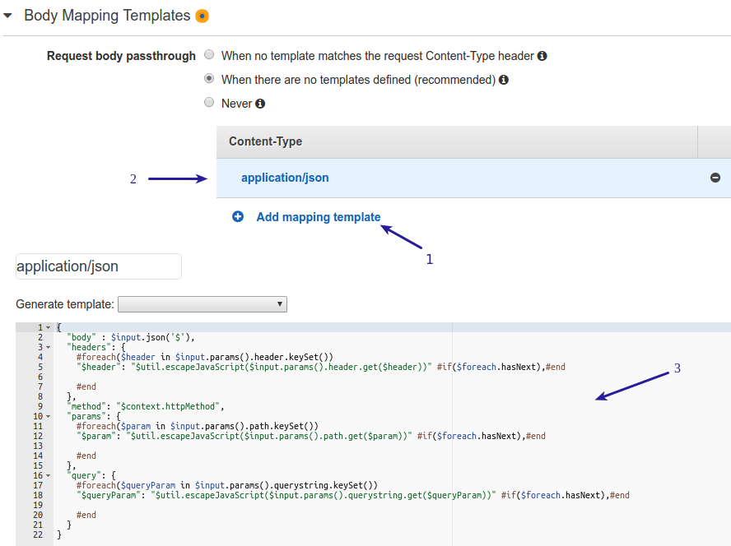

{
"body" : $input.json('$'),
"headers": {
#foreach($header in $input.params().header.keySet())
"$header": "$util.escapeJavaScript($input.params().header.get($header))" #if($foreach.hasNext),#end
#end
},
"method": "$context.httpMethod",
"params": {
#foreach($param in $input.params().path.keySet())
"$param": "$util.escapeJavaScript($input.params().path.get($param))" #if($foreach.hasNext),#end
#end
},
"query": {
#foreach($queryParam in $input.params().querystring.keySet())
"$queryParam": "$util.escapeJavaScript($input.params().querystring.get($queryParam))" #if($foreach.hasNext),#end
#end
}
}

Response Mapping:

- Go to AWS API Gateway console choose API under APIs.
- Navigate to Method Response.
- Add Response then add 200 and 400 status response.

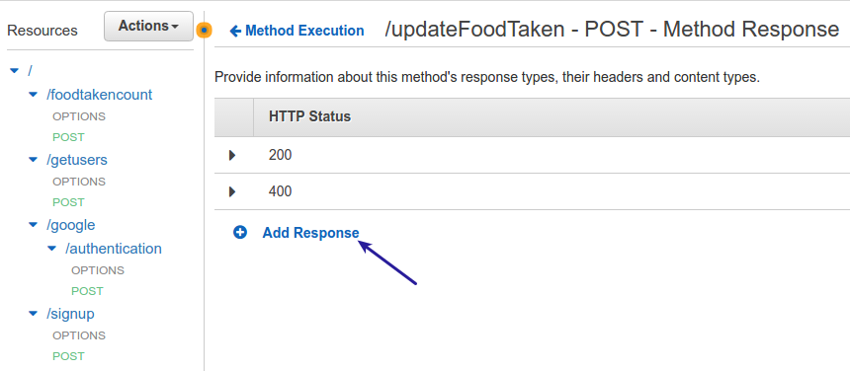

- Next navigate to Integration Response, select application/json in Body Mapping Templates of 200 response status. Then click on application/json.
- Select Request Method Passthrough from Generate template dropdown.
- Clear the generated template and add the following template and save.

$input.path('$.body')

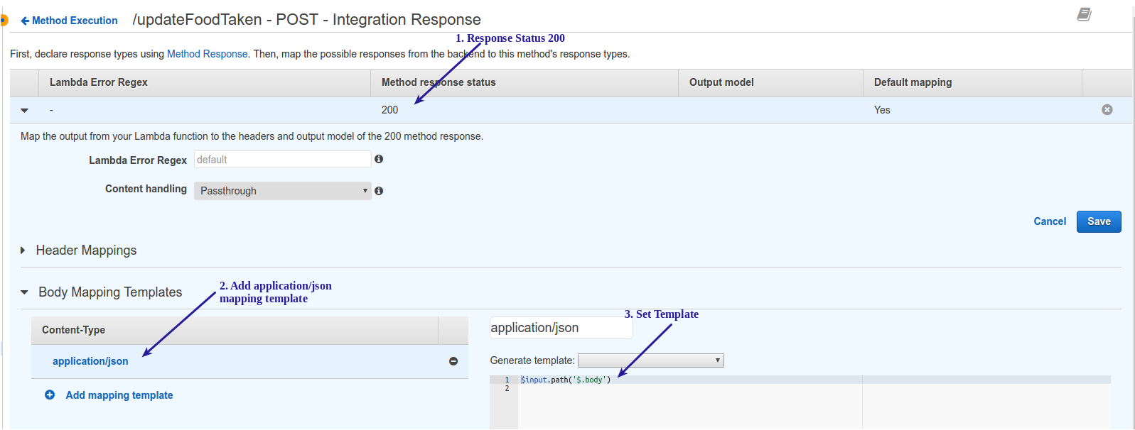

- Now, click on 400 response status code and add .*"httpStatusCode":.*400.* in Lambda Error Regex text box.
- Select application/json in Body Mapping Templates and then Request Method Passthrough from Generate template dropdown.
- Clear the generated template and add the following template and save.

$input.path('$.errorMessage')

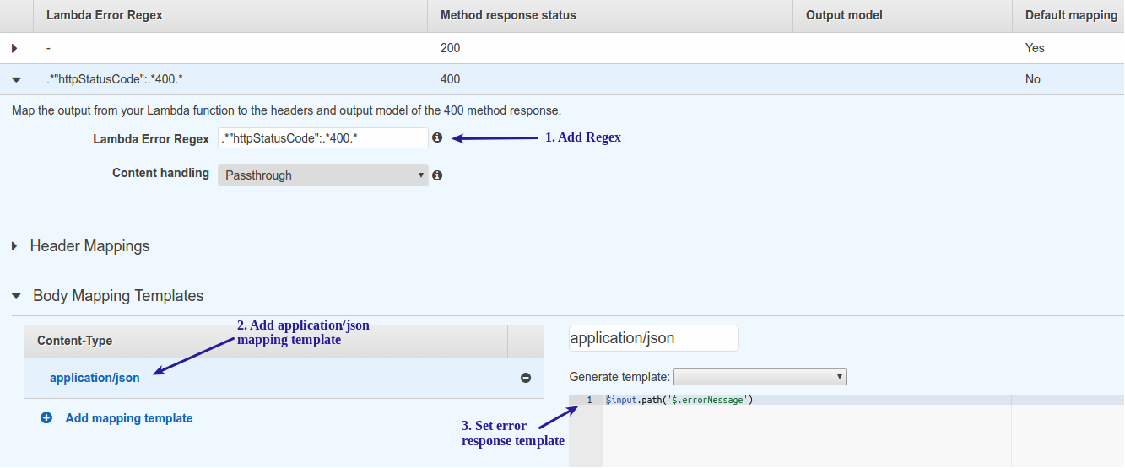
- Select updated resource under Resources and Deploy API from Actions dropdown.

Serverless in Python:
Follow these steps for basic setup of the project in Python after creating a serverless template.

- Create a virtual environment for the project using following command.

cd project_folder
virtualenv project_venv

virtualenv project will create a folder, in the current directory which will contain Python executable files and copy of pip library which you can use to install other packages. project_venv is the name of virtual environment.

- To begin using virtual environment, it needs be activated.

source project_venv/bin/activate

- Create a requirements.txt inside yout serverless project folder to include package names.
- Install packages using pip install “package name” command.
- To install any package from requirements.txt use the following command

pip install -r requirements.txt

6. If any new package is installed in the virtualenv, add it to requirements.txt file using
the following command

pip freeze > production.txt

7. Once done, deactivate the virtual environment using deactivate command.

Serverless in Go:

Currently, AWS Lambda supports Node.js, Python and Java. There are two ways to run go lang function in AWS Lambda.

1. By Creating Deployment Package
You have to create a deployement package which includes binary of the go function and a wrapper for the binary in one of programming languages supported by Lambda. Here are the steps for creating a deployment package.

- Create a simple go function to print a statement in hello.go file.
Example :
hello.go

package main

import (
"fmt"
"os"
"strconv"
)

func main() {
fmt.Printf("HELLO FROM GOLANG WITH ARGS %v\n", os.Args)
const PtrSize = 32 << uintptr(^uintptr(0)>>63)
fmt.Println(strconv.IntSize, PtrSize)
}

- Compile it using following command. If you are using native binaries, ensure that they are either statically linked or built for the matching version of Amazon Linux (i.e., compiled in Amazon Linux environment).

go build hello.go

- Write a binary wrapper that spawns a child process hello, sends the JSON event and then exit as follows.
index.js

var child_process = require('child_process');
process.env['PATH']=process.env['PATH']+ ':' + process.env['LAMBDA_TASK_ROOT'];
exports.handler = function(event, context) {
var proc = child_process.spawn('./hello', [ JSON.stringify(event) ], { stdio: 'inherit' });

proc.on('close', function(code) {
if(code !== 0) {
return context.done(new Error("Process exited with non-zero status code"));
return 0;
}
context.done(null,"hello world");
});
}

Ensure that you include the following at the start of your wrapper function code.

process.env['PATH']=process.env['PATH']+ ':' + process.env['LAMBDA_TASK_ROOT'];

- Package both binary and JS file in ZIP file, upload it using AWS Lambda console and
test it.
- Create an http endpoint for the created lambda function using Amazon Gateway console as follows.
- Go to Amazon API Gateway console, click on create API select New API enter API name and desciption then create API.
- Select Create Resource from Actions dropdown and then Create Resource by entering resource name and resource path.
- Now select Create Method from Actions dropdown.
- From the newly generated dropdown, select the type of method for the lambda function you have created.
- Choose the lambda region where you have created lambda function and enter function name which should be called for this resource in the Setup page then Save.
- You can test the lambda function by clicking on TEST.
- Select Deploy API from Actions dropdown, enter deployment details and Deploy.
- Now, you can test the API using the Invoke URL generated.
Note: Enabling CORS, Request mapping and Response mapping can be done as described above.

2. Using Apex
Apex is similar to Serverless framework which allows to build, deploy and manage AWS Lambda function with ease. For a quick guide for deploying Golang to AWS Lambda refer http://www.starkandwayne.com/blog/quick-guide-to-deploying-golang-to-aws-lambda-using-apex/ .
For a detailed guide you can refer http://apex.run/ .

