1. What exactly is []?

Ans: [] represents list with no element . In other words it is an empty list.

1. In a list of values stored in a variable called spam, how would you assign the value 'hello' as the third value? (Assume [2, 4, 6, 8, 10] are in spam.)

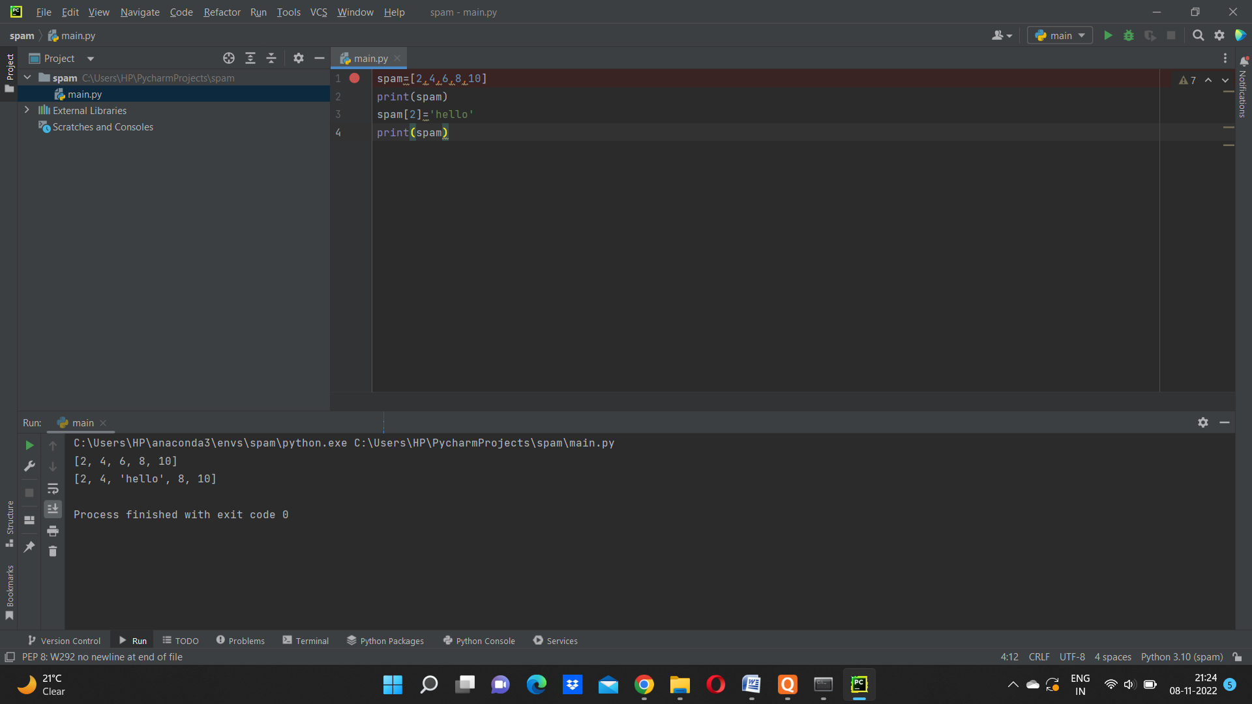

Let's pretend the spam includes the list ['a', 'b', 'c', 'd'] for the next three queries.

1. What is the value of spam[int(int('3' \* 2) / 11)]?
2. What is the value of spam[-1]?



1. What is the value of spam[:2]?
2. 

Let's pretend bacon has the list [3.14, 'cat,' 11, 'cat,' True] for the next three questions.

1. What is the value of bacon.index('cat')?
2. 

7. How does bacon.append(99) change the look of the list value in bacon?



1. How does bacon.remove('cat') change the look of the list in bacon?
2. 

9. What are the list concatenation and list replication operators?

Ans: The operators for list concatenation is +. This operation is used to concatenate between two strings.

The operators for list replication is \*

What is difference between the list methods append() and insert()?

Ans: There is a major difference between append() and insert().

In case of append() it will add only values at the end of list for eg:

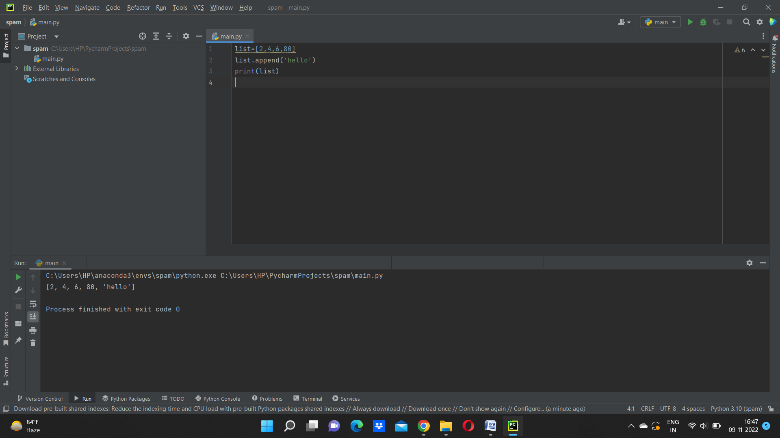

In case of insert() this can insert the value anywhere in between or in the end .



11.What are the two methods for removing items from a list?

Ans: We use clear(), pop(), remove() to remove items from a list.

11.Describe how list values and string values are identical.

Ans:list and string values are identical in many ways.

a.Both of them are having indexes as well as slices

b.Both of them can be used in for loop.

c.Both of them can be concatenated.

d.Both of them can be replicated.

e.Both of them can be to len()

f.Both of them can be used with “not” operators.

13. What's the difference between tuples and lists?

Ans: Major difference between list and tuple is that list are MUTABLE while tuple are IMMUTABLE.

Lists are represented by [] but tuples are represented by ().

14. How do you type a tuple value that only contains the integer 42?



15. How do you get a list value's tuple form? How do you get a tuple value's list form?

Ans: the tuple() and list()functions, respectively are used to convert a list to tuple and vice versa

16. Variables that "contain" list values are not necessarily lists themselves. Instead, what do they contain?

Ans: They contain references to list values.

17. How do you distinguish between copy.copy() and copy.deepcopy()?

ANs: The copy.copy() function will do only a light copy of a lsit while copy.deepcopy() with do exact duplicate copy of a list.