1. What does an empty dictionary's code look like?

Ans: An empty dictionary looks like:

d={}

or d=dict()

1. What is the value of a dictionary value with the key 'foo' and the value 42?

Ans: {‘foo’:42’}

1. What is the most significant distinction between a dictionary and a list?

Ans: A list is represented by [] whereas dictionary is represented by curly bracket{}

Also Items stored in list are ordered while in dictionary items are unordered.

1. What happens if you try to access spam['foo'] if spam is {'bar': 100}?

Ans: it will show key erroe:’foo’

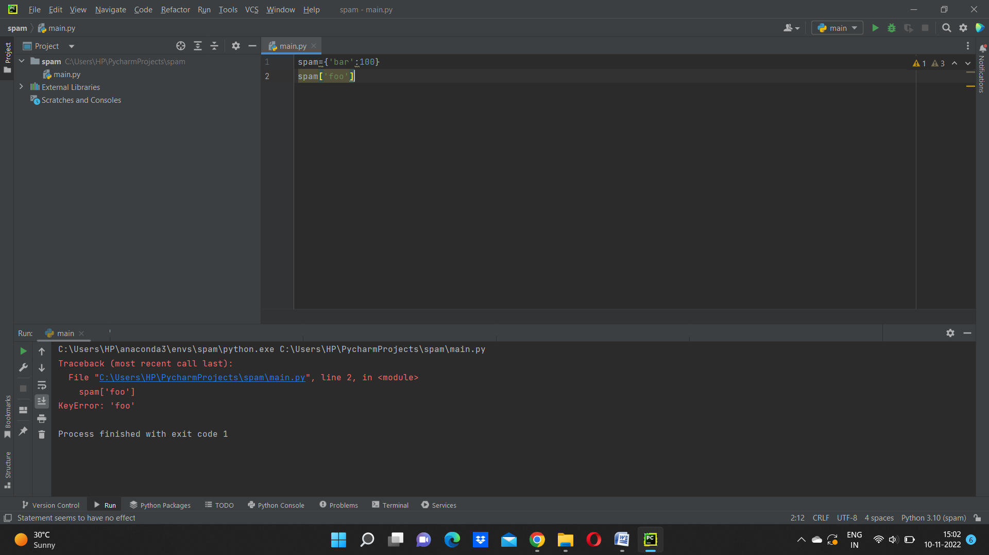

5. If a dictionary is stored in spam, what is the difference between the expressions 'cat' in spam and 'cat' in spam.keys()?

6. If a dictionary is stored in spam, what is the difference between the expressions 'cat' in spam and 'cat' in spam.values()?

Ans: There is no difference,The operators will check whether the value exist as key in dictionary or not

7. What is a shortcut for the following code?

if 'color' not in spam:

spam['color'] = 'black'

Ans: spam.setdefault (‘colour’,’black’)

8. How do you "pretty print" dictionary values using which module and function?

ANs: This can be done by importing pprint function

