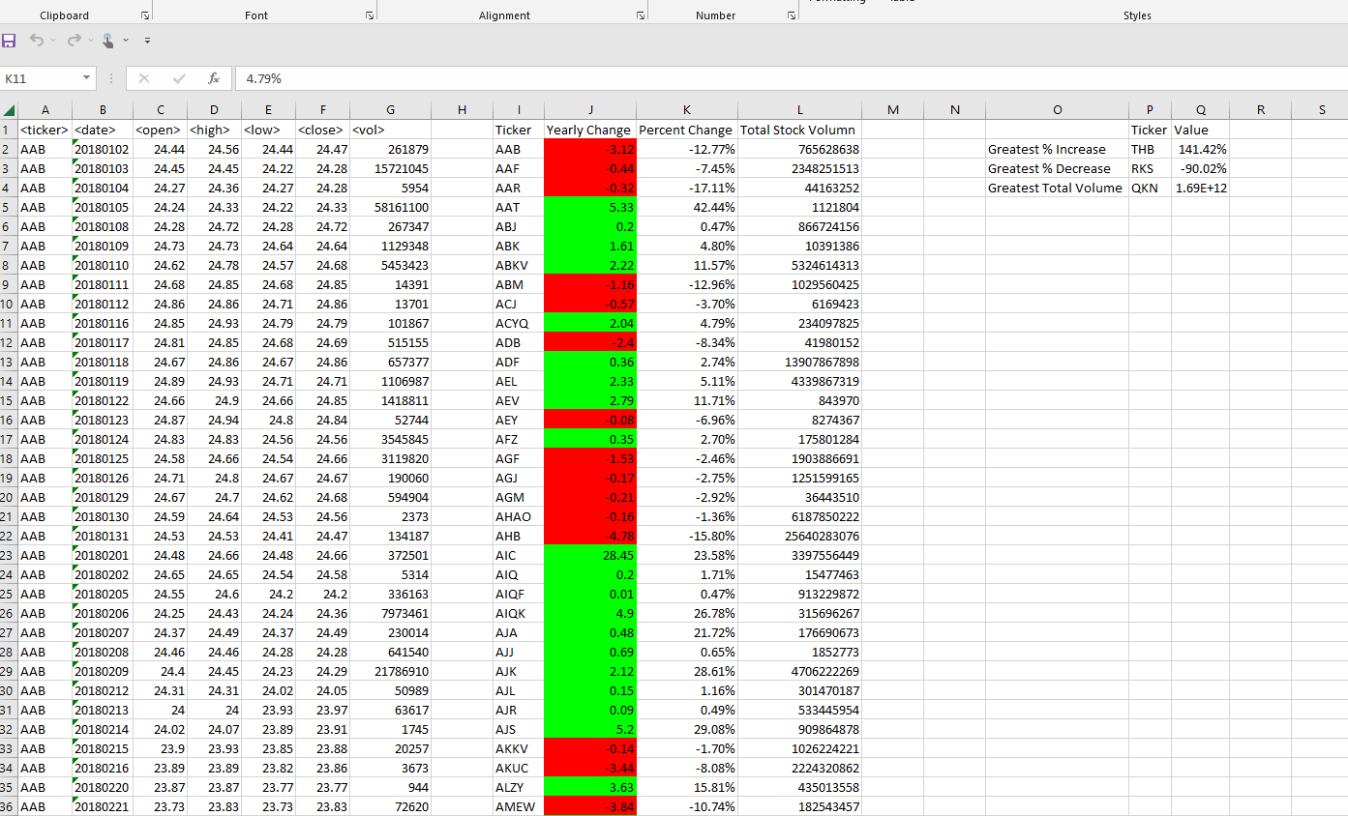

Image 1 : Result of 2018 Stock Data

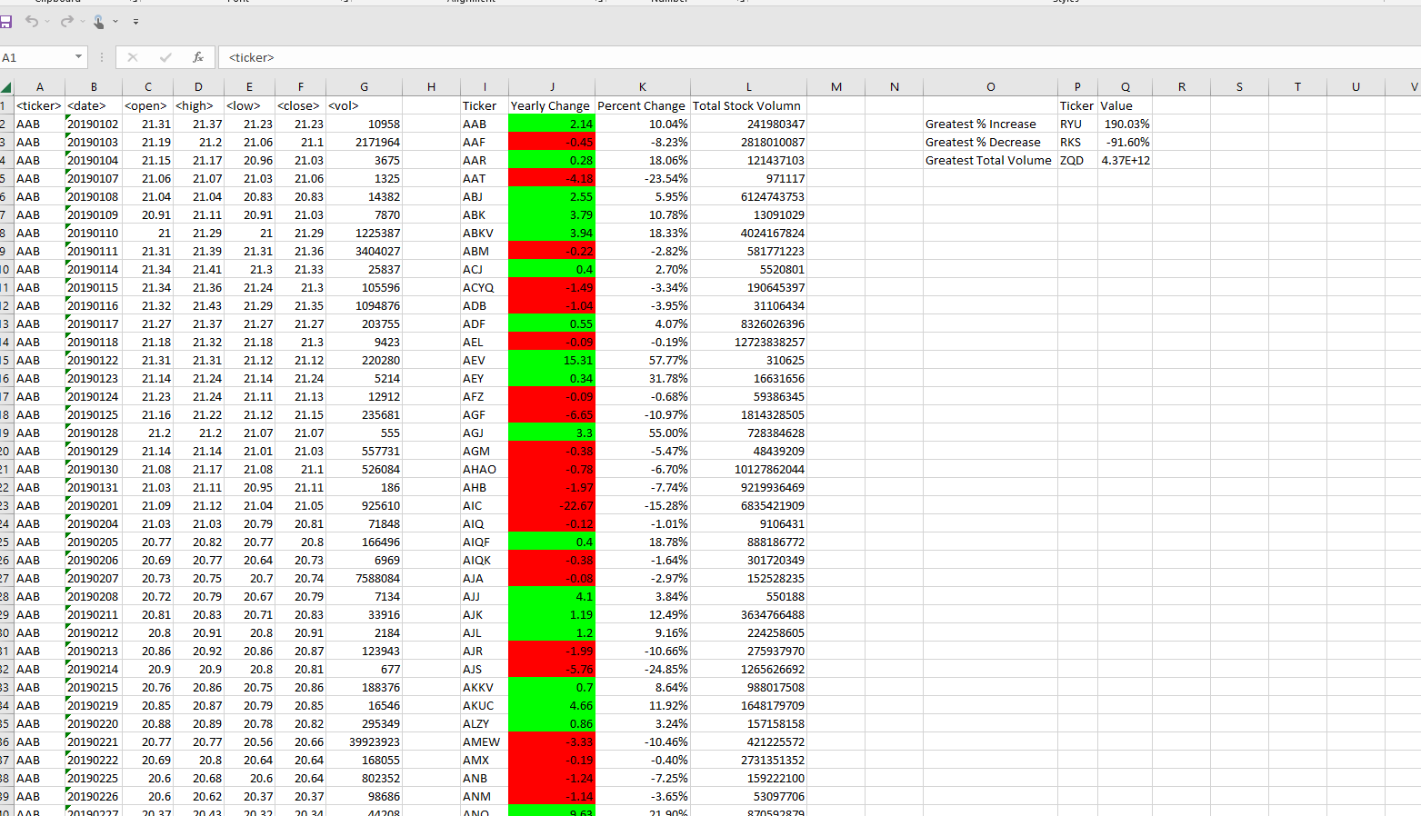

Image 2 : Result of 2019 Stock Data

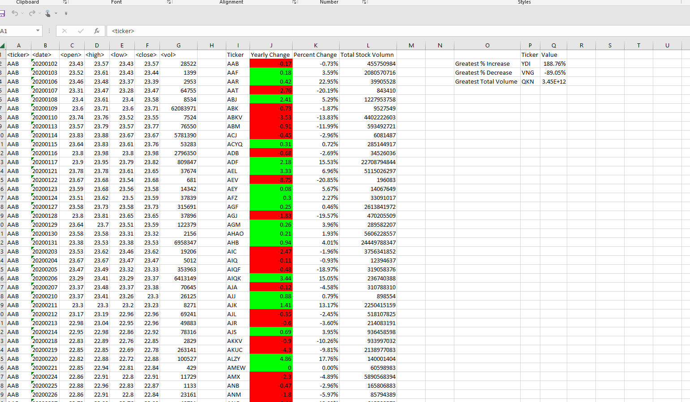

Image 3 : Result of 2020 Stock Data