**Pseudo Code:**

* Create a table for grades mapping for various countries to corresponding US grade.

Table name is Grades_mapping & it has columns country, min original grade (for minimum threshold of original grade), maximum original grade (for maximum threshold of original grade), original grade (for grade in words like excellent, good), corresponding US grade.

Table should look like this:

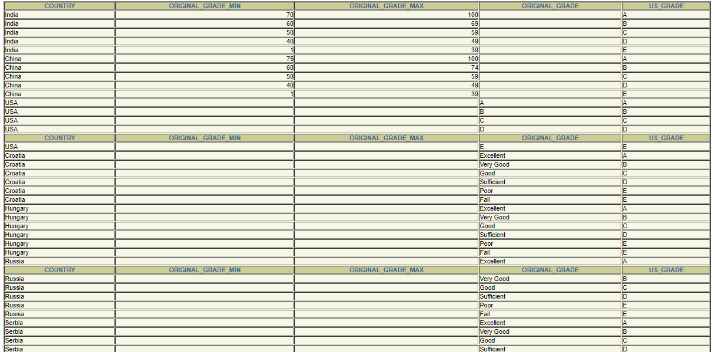



The mapping of grades of different counties to the corresponding US grade is as below:

|  |  |  |  |
| --- | --- | --- | --- |
| USA | India | China | Croatia, Russia, Slovakia, Hungary, Serbia, Czech Republic |
| A | 70%-100% | 75%-100% | Excellent |
| B | 60%-69% | 60%-74% | Very Good |
| C | 50%-59% | 50%-59% | Good |
| D | 40%-49% | 40%-49% | Sufficient |
| E | 1%-39% | 1%-39% | Poor/ Fail |

* Create a function for mapping grades to US grades. Function name is map_grade_to_us_equiv (country, original_grade). Input parameters are country, original_grade.

**Note:** (For maintaining modularity of code, I am taking only country and original grade as inputs of this function and later on procedure that will call this function, can have student name as input.)

// Select US grade from final_grade table where country name is same as input country name, and grade is same as original grade.

// Grade that is being passed as an input could be between defined grade ranges or could be exact match with original grade column for different countries.

// throw an exception when input country name is not present in the table.

// this function will return corresponding US grade as an output.

* Create a procedure CALL_FUNCTON () with student_name, country and original_grade as inputs. US grade, student_name and country are as outputs.

//This procedure will call map_grade_to_us_equiv () function.

//Print student name, country name and corresponding US grade.

* Write a code to call the above procedure CALL_FUNCTON ().

// declare country, student name and original grade as input parameters and us grade as output parameters.

//call procedure CALL_FUNCTON ().

**Code:**

**For creating table:**

create table Grades_mapping (

Country varchar (100),

original_grade_min float,

original_grade_max float,

original_grade varchar (100),

US_grade varchar (100)

);

**For inserting values into the table:**

insert into Grades_mapping values ('India', 70, 100, null, 'A');

insert into Grades_mapping values ('India', 60, 69, null, 'B');

insert into Grades_mapping values ('India', 50, 59, null, 'C');

insert into Grades_mapping values ('India', 40, 49, null, 'D');

insert into Grades_mapping values ('India', 1, 39, null, 'E');

insert into Grades_mapping values ('China', 75, 100, null, 'A');

insert into Grades_mapping values ('China', 60, 74, null, 'B');

insert into Grades_mapping values ('China', 50, 59, null, 'C');

insert into Grades_mapping values ('China', 40, 49, null, 'D');

insert into Grades_mapping values ('China', 1, 39, null, 'E');

insert into Grades_mapping values ('USA', null, null, 'A', 'A');

insert into Grades_mapping values ('USA', null, null, 'B', 'B');

insert into Grades_mapping values ('USA', null, null, 'C', 'C');

insert into Grades_mapping values ('USA', null, null, 'D', 'D');

insert into Grades_mapping values ('USA', null, null, 'E', 'E');

insert into Grades_mapping values ('Croatia', null, null, 'Excellent', 'A');

insert into Grades_mapping values ('Croatia', null, null, 'Very Good', 'B');

insert into Grades_mapping values ('Croatia', null, null, 'Good', 'C');

insert into Grades_mapping values ('Croatia', null, null, 'Sufficient', 'D');

insert into Grades_mapping values ('Croatia', null, null, 'Poor', 'E');

insert into Grades_mapping values ('Croatia', null, null, 'Fail', 'E');

insert into Grades_mapping values ('Hungary', null, null, 'Excellent', 'A');

insert into Grades_mapping values ('Hungary', null, null, 'Very Good', 'B');

insert into Grades_mapping values ('Hungary', null, null, 'Good', 'C');

insert into Grades_mapping values ('Hungary', null, null, 'Sufficient', 'D');

insert into Grades_mapping values ('Hungary', null, null, 'Poor', 'E');

insert into Grades_mapping values ('Hungary', null, null, 'Fail', 'E');

insert into Grades_mapping values ('Russia', null, null, 'Excellent', 'A');

insert into Grades_mapping values ('Russia', null, null, 'Very Good', 'B');

insert into Grades_mapping values ('Russia', null, null, 'Good', 'C');

insert into Grades_mapping values ('Russia', null, null, 'Sufficient', 'D');

insert into Grades_mapping values ('Russia', null, null, 'Poor', 'E');

insert into Grades_mapping values ('Russia', null, null, 'Fail', 'E');

insert into Grades_mapping values ('Serbia', null, null, 'Excellent', 'A');

insert into Grades_mapping values ('Serbia', null, null, 'Very Good', 'B');

insert into Grades_mapping values ('Serbia', null, null, 'Good', 'C');

insert into Grades_mapping values ('Serbia', null, null, 'Sufficient', 'D');

insert into Grades_mapping values ('Serbia', null, null, 'Poor', 'E');

insert into Grades_mapping values ('Serbia', null, null, 'Fail', 'E');

insert into Grades_mapping values ('Slovakia', null, null, 'Excellent', 'A');

insert into Grades_mapping values ('Slovakia', null, null, 'Very Good', 'B');

insert into Grades_mapping values ('Slovakia', null, null, 'Good', 'C');

insert into Grades_mapping values ('Slovakia', null, null, 'Sufficient', 'D');

insert into Grades_mapping values ('Slovakia', null, null, 'Poor', 'E');

insert into Grades_mapping values ('Slovakia', null, null, 'Fail', 'E');

insert into Grades_mapping values ('Czech Republic', null, null, 'Excellent', 'A');

insert into Grades_mapping values ('Czech Republic', null, null, 'Very Good', 'B');

insert into Grades_mapping values ('Czech Republic', null, null, 'Good', 'C');

insert into Grades_mapping values ('Czech Republic', null, null, 'Sufficient', 'D');

insert into Grades_mapping values ('Czech Republic', null, null, 'Poor', 'E');

insert into Grades_mapping values ('Czech Republic', null, null, 'Fail', 'E');

**To view the table:**

select * from Grades_mapping;



Note: I haven’t attached screenshots of whole table. This is just one screenshot (some part of the table).

=================================

**Function for grade mapping:**

show errors;

Create or replace function map_grade_to_us_equiv (e_country in varchar, o_grade in varchar)

return varchar IS final_grade varchar (100);

BEGIN

select US_GRADE into final_grade from Grades_mapping where e_country= COUNTRY AND ((to_number(o_grade) BETWEEN original_grade_min AND original_grade_max) OR o_grade= original_grade);

return final_grade;

exception

when no_data_found then

dbms_output.put_line ('no such country');

return null;

End;

**=====================================================================================**

**Procedure to call above function:**

Create or replace procedure CALL_FUNCTON (s_name IN OUT varchar, cntry IN OUT varchar, orig_grade IN varchar, us_g OUT varchar) IS

Begin

us_g: = map_grade_to_us_equiv (cntry, orig_grade);

dbms_output.put_line ('student name is: ' || s_name || ' country name is: ' || cntry || ' Corresponding US grade is: ' || us_g);

End;

**=================================================================================**

**Call above procedure:**

set SERVEROUTPUT on;

show errors;

Declare

param1 varchar (100): = 'shweta';

param2 varchar (100): = 'Russia';

param3 varchar (100): = 'Poor';

us_g varchar (100);

Begin

CALL_FUNCTON (param1, param2, param3, us_g);

End;

**=====================================================================================**

**Screenshots of queries & their outputs for obtaining US grade corresponding to grades of various countries present in the table:**

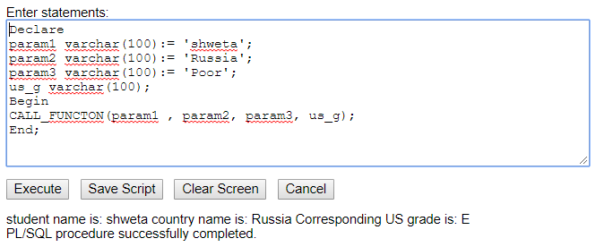

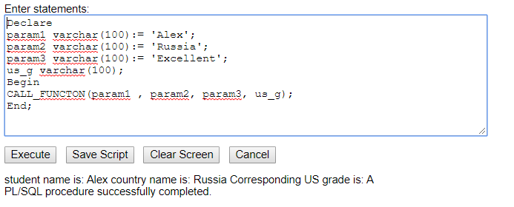

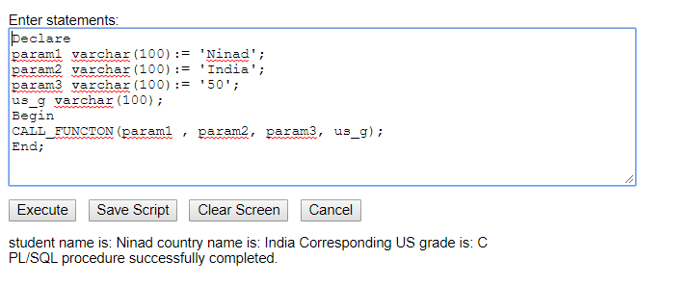

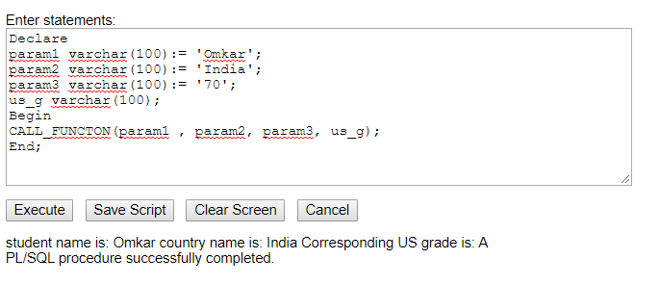

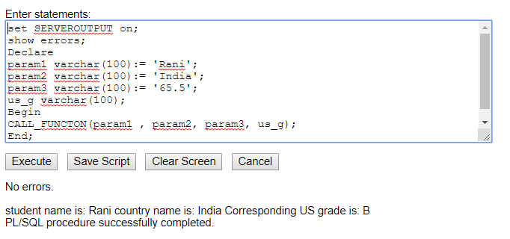

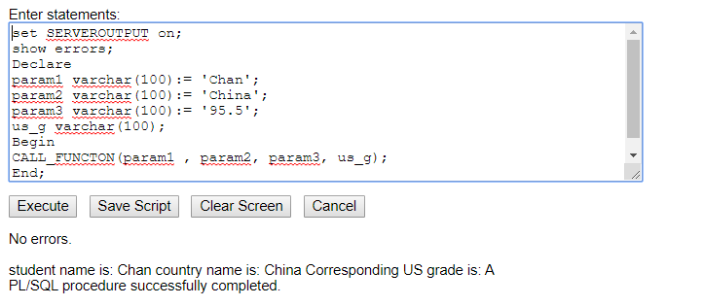

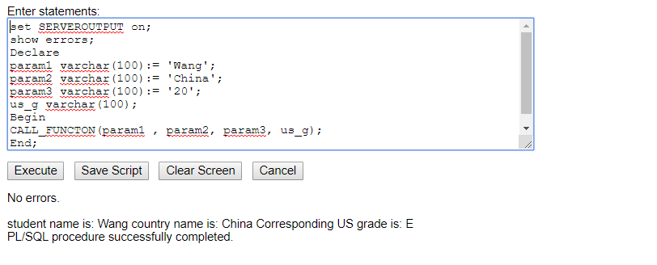

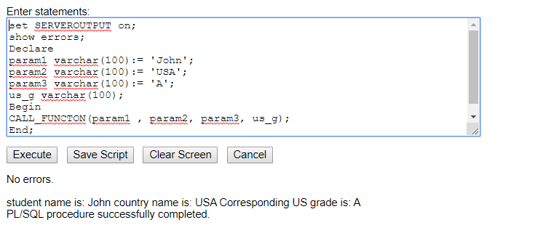

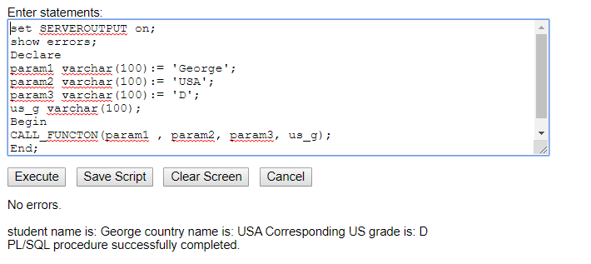

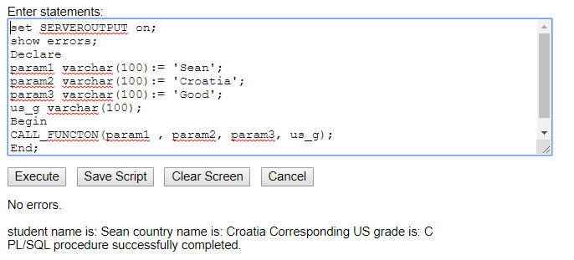

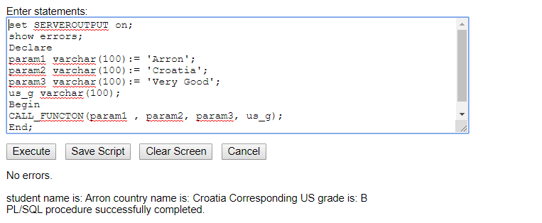

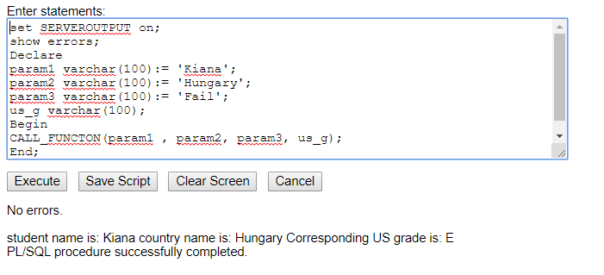

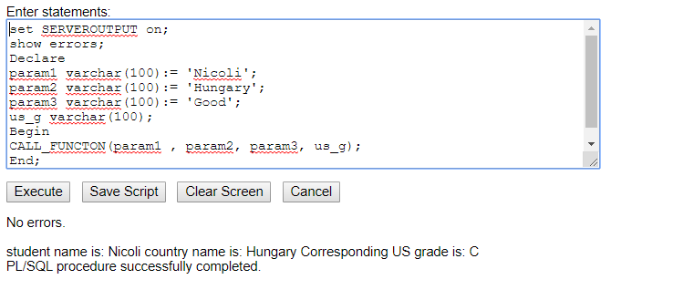

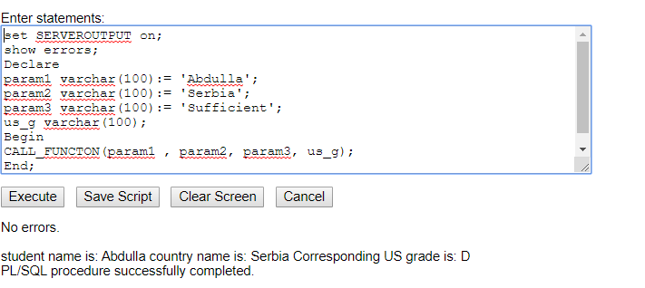

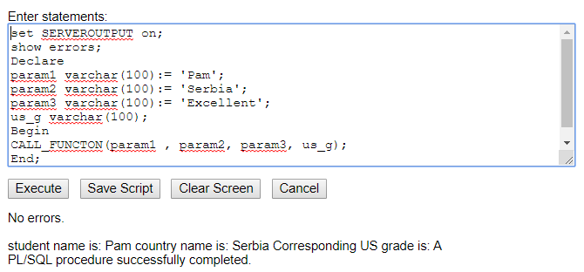=====================================================================================

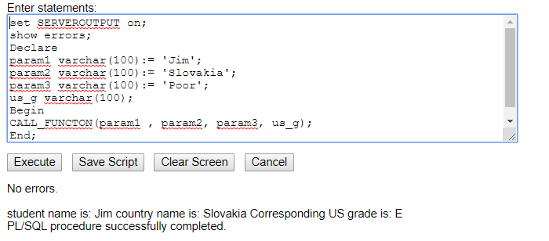

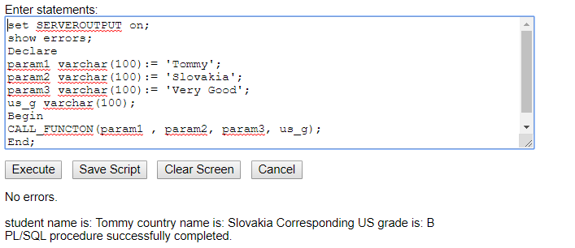

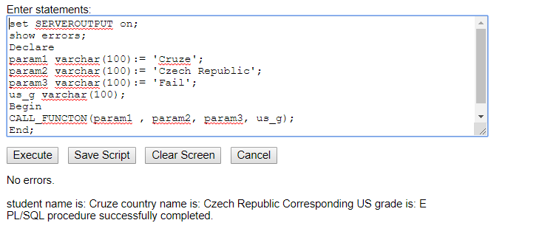

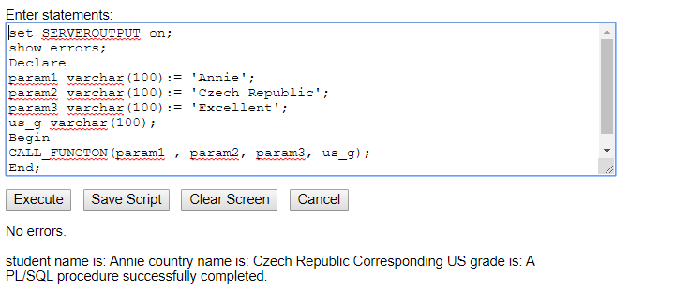

**Screenshot of query & its output for obtaining US grade corresponding to the grade of the country which is not present in the table:**



