NAME:SHWETA LOMATE
ROLL NO:72
DIVISION:SY3
SUBJECT:AAP PBA2

Q.25 Develop a Python program using regex substitutions to replace multiple consecutive spaces in a text file with a single space.

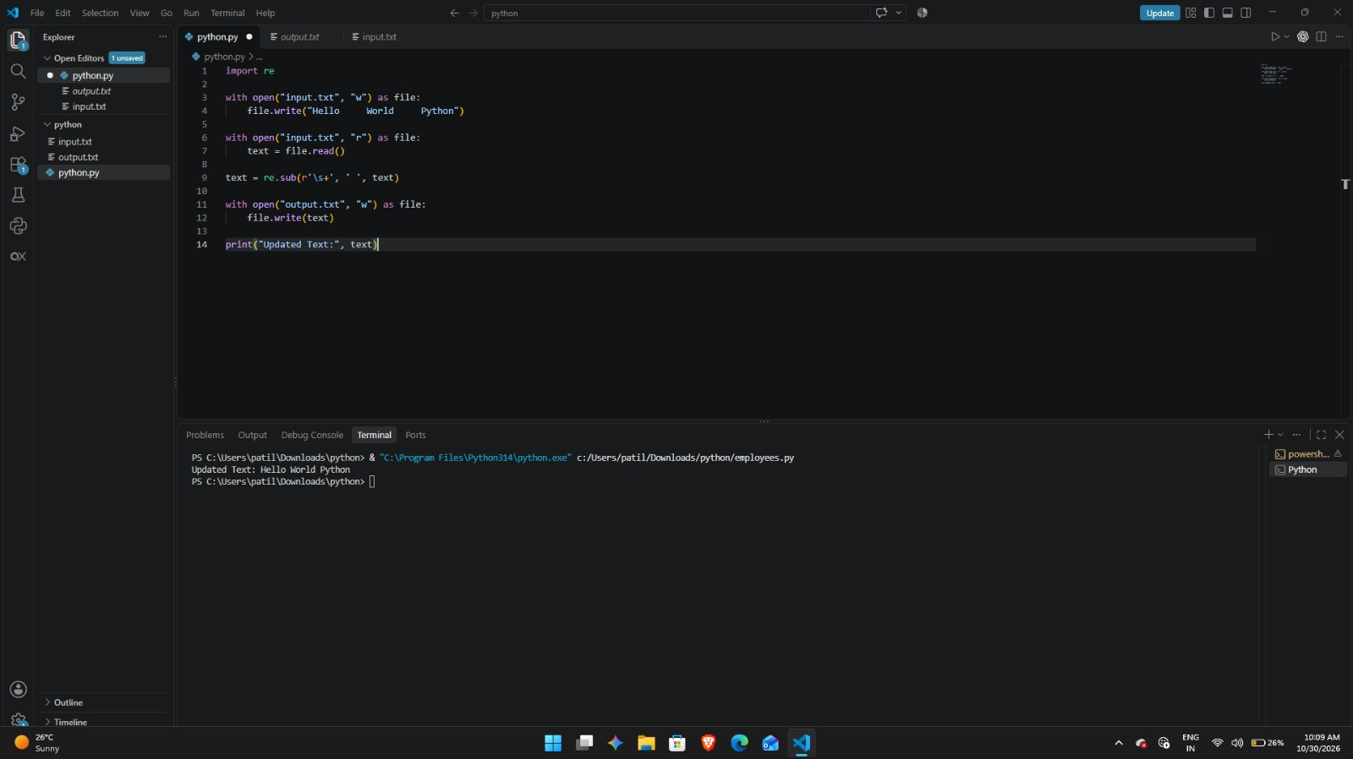

Q.2 Sales Data Analysis
Problem Statement: Write a Python program using Pandas and Matplotlib to analyze monthly sales data stored in sales.csv.
