**ShopBridge** POC covers basic requirements as

1. List
2. Add
3. Edit
4. Delete

Inventories using API Calls. Used .Net Core with C# and SQL server to build this assignment

**Covers**

1. All API calls are asnychronus
2. Include data validations
3. Used Middleware to handle exception handling

**Time to spent on**

1. Data store design: 10 mins

2. API and service logic: 1hour

**List of inventories**

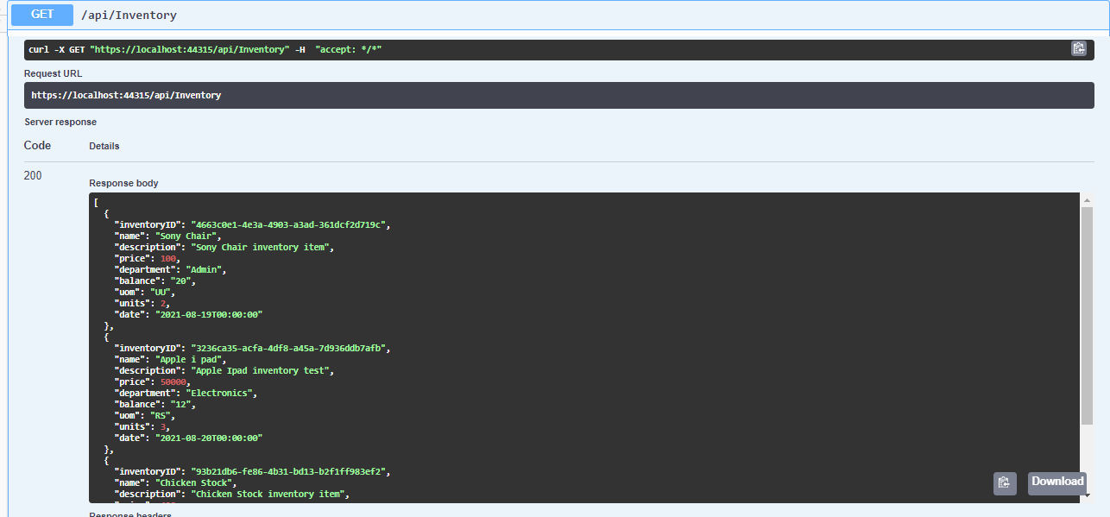

**Add Inventory**

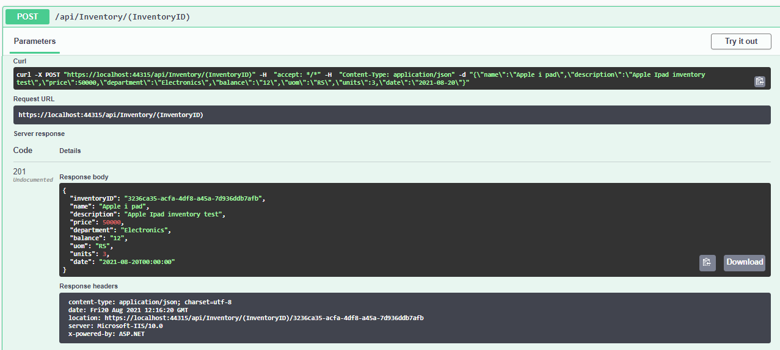

**Update Inventory**

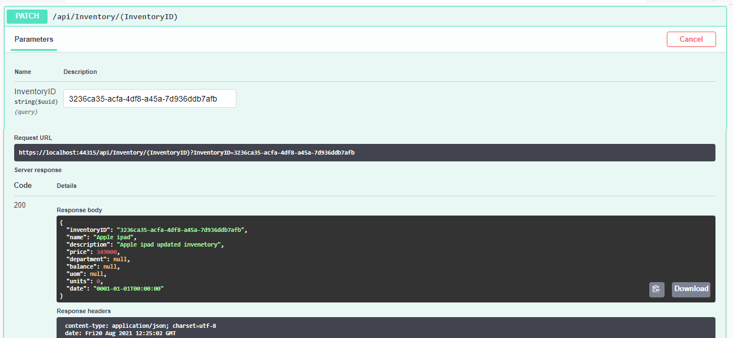

**Delete Inventory**

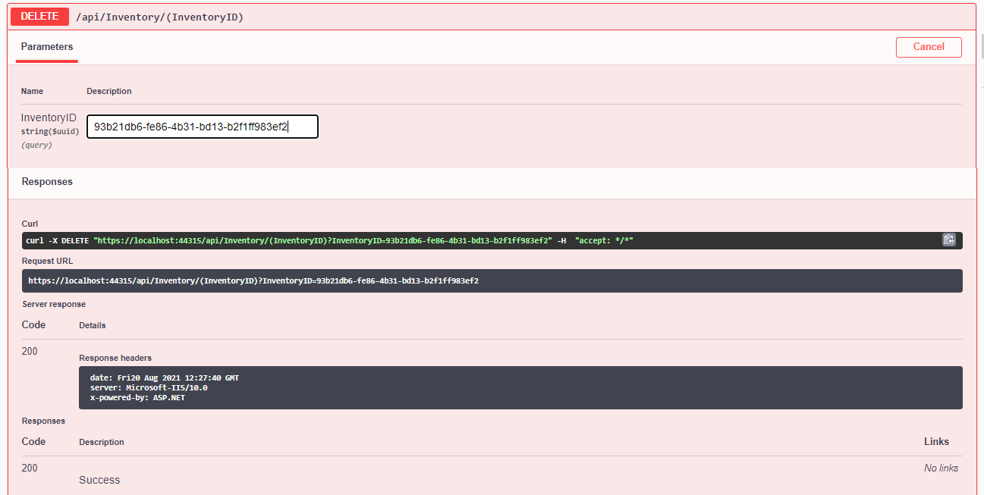

**After Deletion List of Inventories**

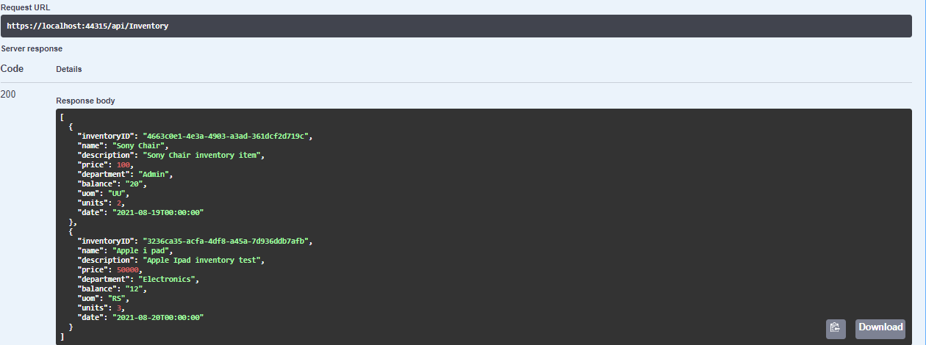

1. **All API calls are Asnychronus**

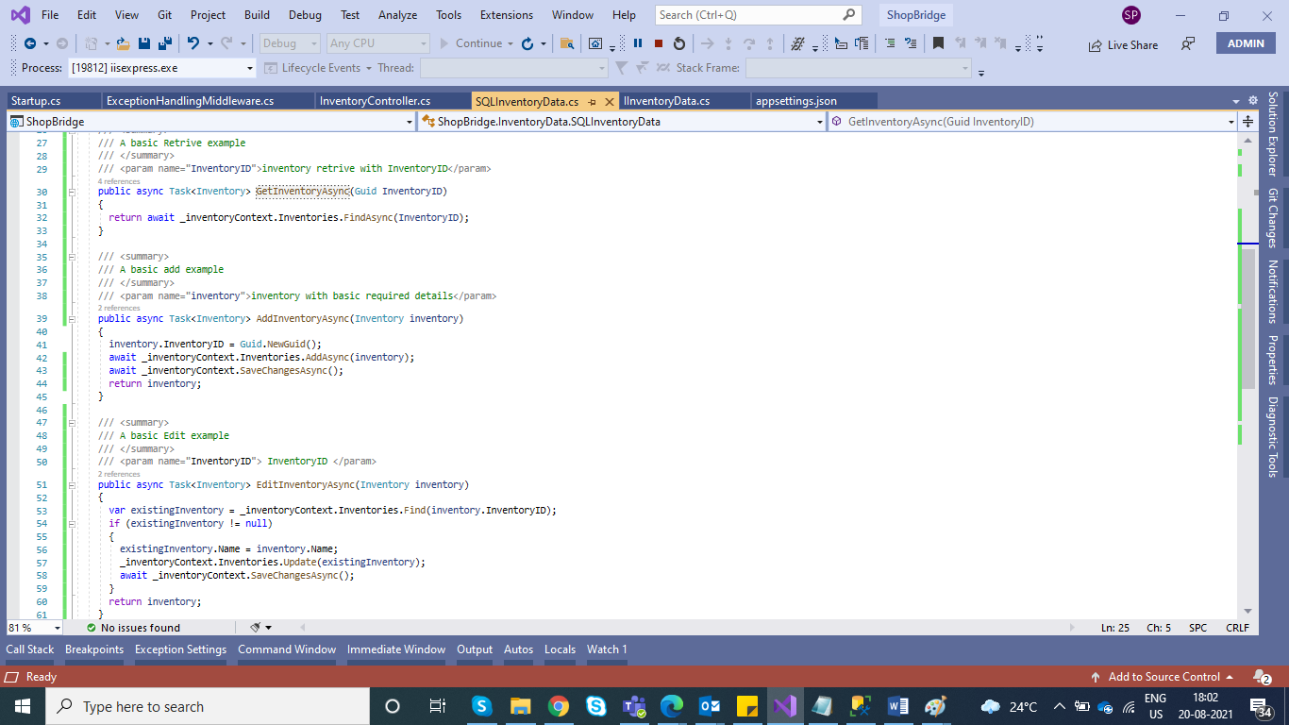

1. **Include Data Validation**

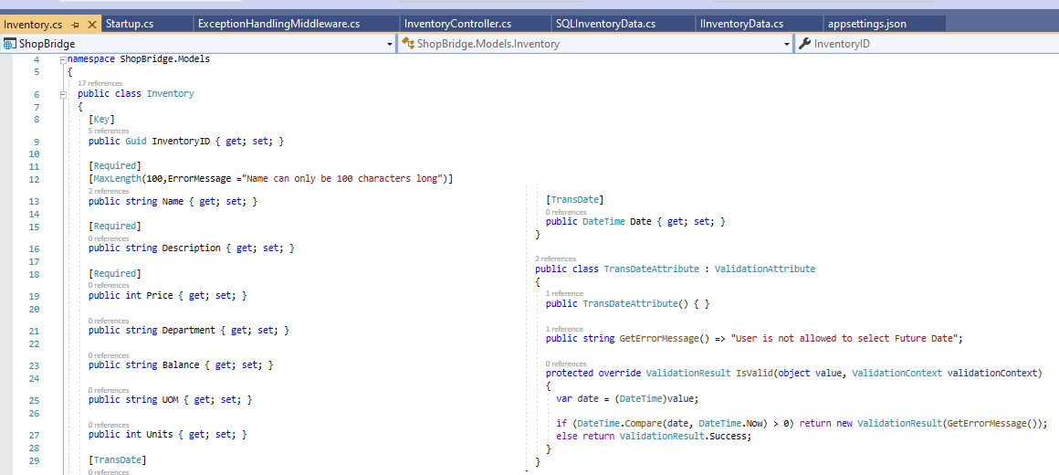

1. **Used middleware for Exception Handling**

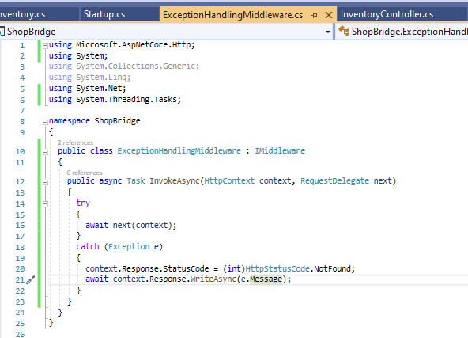

**Data stored SQL Server database**

