DYPIU
Batch: CC1; PRN: 20220802278
LAB-1: Merkle Root

Objective:
Write a program to implement hash functions and create a Merkle tree. Verify the integrity of data using the Merkle root.
Prerequisites:
- VS Code with python installed
Code:
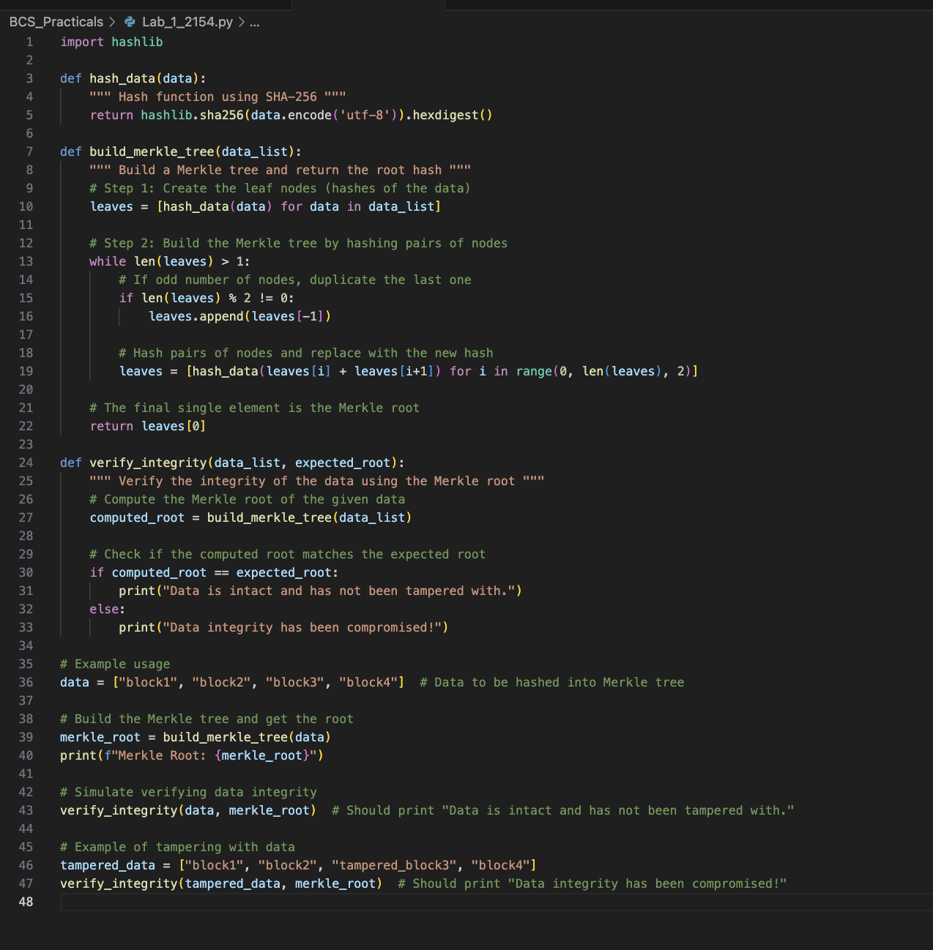

Output:
