Project: Diamond Prices

Complete each section. When you are ready, save your file as a PDF document and submit it here: [https://classroom.udacity.com/nanodegrees/nd008/parts/235a5408-0604-4871-8433-a6d670e37bbf/project#](https://classroom.udacity.com/nanodegrees/nd008/parts/235a5408-0604-4871-8433-a6d670e37bbf/project)

# Step 1: Understanding the Model

*Answer the following questions:*

1. According to the model, if a diamond is 1 carat heavier than another with the same cut, how much more should I expect to pay? Why?
   1. The one diamond carat would result in an additional $8887.4 in price. The formula created by the regression determined that the coefficient for a carat is 8887.4$, so for every increase in the number of carats the price will increase by the amount of the coefficient.
2. If you were interested in a 1.5 carat diamond with a **Very Good** cut (represented by a 3 in the model) and a **VS2** clarity rating (represented by a 5 in the model), how much would the model predict you should pay for it?

**Weightage:**

Intercept) -7382.3

carat 8887.4

cutGood 682.2

cutIdeal 1017.1

cutPremium 889.3

cutVery Good 867.1

colorE -205.2

colorF -298.7

colorG -498.6

colorH -966.2

colorI -1441.4

colorJ -2321.4

clarityIF 5421.8

claritySI1 3570.6

claritySI2 2616.9

clarityVS1 4534.7

clarityVS2 4217.1

clarityVVS1 5057.8

clarityVVS2 4953.7

* 1. The formula is price = -7382.3 + 8887.4* carat + 867.1+ 4217.1
     1. so now we will plug in the values for the different variables.
     2. Price = -7382.3 + 8887.4* 1.5 + 867.1+ 4217.1
     3. Price = 11,033

# Step 2: Visualize the Data

Make sure to plot and include the visualizations in this report. For example, you can create graphs in Excel and copy and paste the graphs into this Word document.

1. Plot 1 - Plot the data for the diamonds in the database, with carat on the x-axis and price on the y-axis.

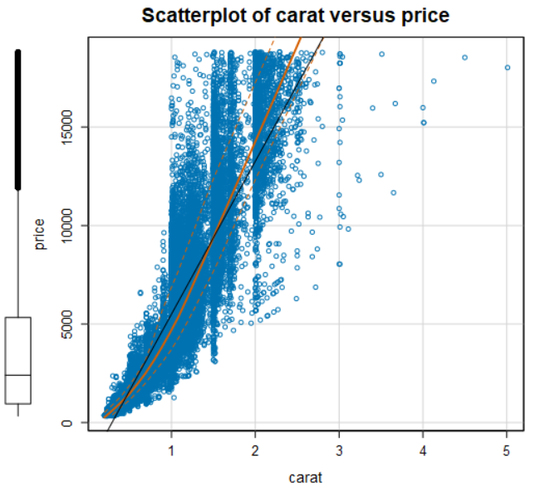

1. Plot 2 - Plot the data for the diamonds for which you are predicting prices with carat on the x-axis and predicted price on the y-axis.

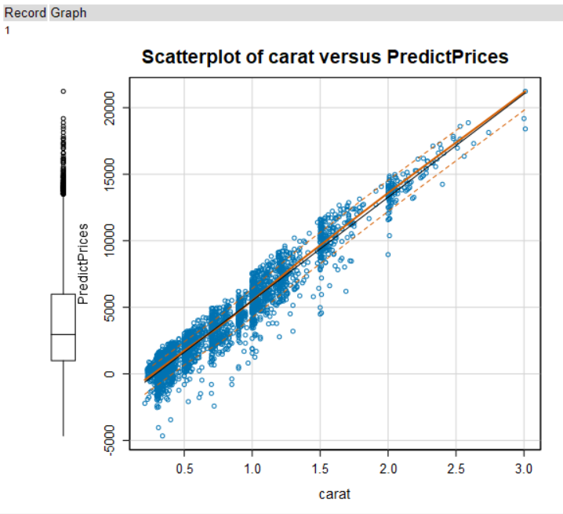

1. What strikes you about this comparison? After seeing this plot, do you feel confident in the model’s ability to predict prices?

The predicted prices are more linear than actual price. We can predict 91.62% of the test data. Adjusted R squared value is 91.62.

# Step 3: Make a Recommendation

*Answer the following questions:*

1. What price do you recommend the jewelry company to bid? Please explain how you arrived at that number.

Total price of 3000 diamonds are : 11758136.70$

70% of the price would be : 0.7 * 11758136.70$ = 8230695.69$