MediGraph: Coupling SHAP Attribution with PubMed-Grounded Retrieval for Verifiable Explanations in Drug-Target Interaction Prediction
Shweta Suryawanshi  Dept. of Computer Science & Engineering  Vellore Institute of Technology  Chennai, India  shweta.suryawanshi@vit.ac.in | Project Co-Author  Dept. of Computer Science & Engineering  Vellore Institute of Technology  Chennai, India  coauthor.cs@vit.ac.in | Faculty Supervisor  School of Computer Science & Engineering  Vellore Institute of Technology  Chennai, India  supervisor@vit.ac.in

Abstract—Machine learning models for drug-target interaction (DTI) prediction usually return a single probability without any mechanistic justification, which limits their usefulness to researchers deciding which candidates deserve experimental validation. Large language models can write fluent explanations, but unsupported claims make them risky in biomedical settings. This paper presents MediGraph, a layered explanation framework that combines SHAP attribution of predictions to molecular fingerprint and protein sequence features with a retrieval-augmented generation (RAG) module that grounds explanations in PubMed abstracts. Predicted interactions are also linked to target-disease associations by a rule-based module that proposes drug repurposing hypotheses with traceable evidence chains. We evaluate the predictor on the DAVIS and KIBA benchmarks under random and cold-start splits against classical and neural baselines, and we test SHAP attributions with perturbation experiments. We then compare ungrounded generation with strict and relaxed retrieval variants on a curated set of drug-target-disease triples, using an automated evaluation protocol with independent second-judge agreement checks (with expert human clinical validation reserved for future work). The predictor is competitive with baselines under random splits and degrades under cold-start conditions. On the random split, SHAP attributions exhibit faithful degradation across 5/5 seeds at k=50 (ΔAUPR = -0.188), but show no measurable advantage over random deletion on held-out cold-drug pairs. Under bootstrap resampling, attributions achieve moderate stability (top-50 Jaccard 0.512 ± 0.042, top-100 Spearman ρ = 0.439 ± 0.038). In retrieval evaluation across 60 curated triples, staged query relaxation grounds 98.3% of claims on non-control triples while achieving 100% explicit abstention (15/15 triples, 95% Wilson CI: [79.6%, 100.0%]) on verified zero-hit negative controls without citation fabrication. We discuss limitations, including small benchmark scale, reliance on abstracts instead of full text, and potential evaluator bias. Code and evaluation artifacts are released for reproducibility.
Keywords—cheminformatics, drug repurposing, drug-target interaction, explainable artificial intelligence, PubMed, retrieval-augmented generation, SHAP
I. INTRODUCTION
Finding which small molecules bind which proteins is one of the slowest and most expensive steps in drug discovery. Experimental screening cannot cover the space of possible drug-target pairs, so computational drug-target interaction (DTI) prediction is used to decide where laboratory effort should go [1]. Models have moved from fingerprint-based classifiers to sequence and graph neural networks [2]–[4], and benchmark scores on kinase datasets are now high.
A high score does not tell a biologist why a pair was ranked highly, and a ranking nobody can interrogate is hard to defend when someone must decide whether to spend a month at the bench. Explainable AI has been proposed as a remedy for this in drug discovery [5]. Shapley-value attributions such as SHAP [6] are a common choice because they assign each input feature a signed contribution to a prediction. For molecular fingerprints, however, the output is a list of hashed bits, and even when a bit is traced back to a substructure it describes the behavior of the model rather than the biology. It cannot say whether the predicted relationship has ever been reported.
Large language models (LLMs) are the obvious tool for that second question, since they can write a readable account of why a drug might act on a target [7]. They also invent facts and references with confidence [8]. Retrieval-augmented generation (RAG) gives the model retrieved documents to work from [9], but retrieval can fail silently, for example by returning nothing for a sparsely studied pair, and a model told to use the evidence can still ignore it. Whether grounding actually helps in a given domain has to be measured [10].
This paper studies that question for DTI prediction. MediGraph pairs a fingerprint-based predictor with two explanation layers: SHAP attribution for structural drivers, and a PubMed-grounded generator that must tie each claim to a retrieved abstract or state that no evidence was found. Predicted interactions are further connected to target-disease associations to propose repurposing hypotheses [11]. We do not claim state-of-the-art prediction accuracy. The scientific contribution lies in auditing the tripartite boundary between statistical feature attribution, literature-grounded retrieval, and calibrated epistemic abstention.
The main contributions are:
1) A two-layer explanation design that couples SHAP attribution on drug and protein features with retrieval-grounded literature explanations.
2) An evaluation protocol for explanation quality covering retrieval failure, claim-level support against retrieved evidence, citation validity, and calibrated abstention on negative controls, validated via automated independent dual-judge scoring.
3) A comparison of ungrounded, strict-query, and staged-relaxation retrieval variants on a curated set of drug-target-disease triples.
4) A benchmark study of the predictor on DAVIS and KIBA under random and cold-start splits, with perturbation-based tests of SHAP faithfulness and stability.
5) A rule-based repurposing module with traceable evidence chains, and an open implementation.
Section II reviews related work. Section III describes the system. Section IV details the experimental setup, Section V reports results, Section VI discusses limitations, and Section VII concludes.
II. RELATED WORK
A. Drug-Target Interaction Prediction
Early DTI methods used molecular fingerprints and protein descriptors with kernel methods or tree ensembles, and these remain strong when data are limited [1]. DeepDTA learns from raw SMILES strings and protein sequences with convolutional networks [2]. GraphDTA represents the drug as a molecular graph [3], MolTrans applies transformer encoders to substructure tokens [12], and DrugBAN adds a bilinear attention map between drug and protein substructures, with domain adaptation for out-of-distribution pairs [4]. The DeepPurpose library packages several of these encoders behind one interface [13]. Most results are reported on DAVIS [14] and KIBA [15]. Random splits let the same drug or protein appear in training and test data and are known to give optimistic estimates, so evaluation on unseen drugs or targets is more realistic [16]. We therefore report cold-start splits alongside random ones. We do not re-run these published deep models here, and our comparison is limited to the baselines described in Section IV-C.
B. Explainability in Drug Discovery
Explainable AI methods for drug discovery include feature attribution, attention inspection, and substructure-level analysis [5]. SHAP [6] and its exact algorithm for tree ensembles [17] are widely used because they apply to any tabular representation. Attention weights in models such as DrugBAN offer interpretation inside the architecture [4]. These methods describe what drives a model's output. None of them check whether the resulting relationship is supported by the literature, which is the gap our second layer addresses.
C. Retrieval-Augmented Generation in Biomedicine
RAG conditions a generator on retrieved passages [9], and recent surveys describe the design space [18]. Domain-specific language models such as BioGPT improve biomedical generation [19], yet hallucination remains a documented risk [8]. Benchmarking in medical question answering shows that retrieval helps in some settings and that results depend on the corpus, retriever, and model [10]. Scoring explanations at scale often relies on an LLM as judge, whose agreement with humans is good but imperfect and which can carry systematic bias [20]. We address this by evaluating automated agreement between two independent judge models across conditions, framing expert human clinical annotation as planned future work.
D. Computational Drug Repurposing
Repurposing seeks new indications for approved drugs and can shorten development time [11], [21]. Computational approaches are commonly checked retrospectively against curated sets of known approved and failed drug-indication pairs, such as repoDB [22]. In this paper the rule-based module is presented as a hypothesis generator and illustrated with examples. It is not validated as a predictor of repurposing success and is not a clinical decision tool.
III. SYSTEM AND METHODOLOGY
A. Overview
MediGraph takes a SMILES string and a protein sequence and returns a binding probability, a structural explanation, and a literature-grounded rationale (Fig. 1). Feature extraction, prediction, and SHAP run offline in a Python pipeline. Retrieval and generation are served by a REST backend. Repurposing candidates and predictions are stored in a cloud database that feeds an interactive graph interface.
Fig. 1. MediGraph architecture. Predictions feed two explanation layers, whose outputs are combined and passed to the repurposing module and the interface.
B. Molecular and Protein Representations
Drug features. SMILES strings are parsed and sanitized with RDKit [23]; molecules that fail are removed. Each valid molecule is encoded as an ECFP4 fingerprint [24], a circular fingerprint of radius 2 hashed into a 1024-bit vector.
Protein features. The baseline is amino acid composition (AAC), a 20-dimensional vector whose element for residue type i is:
f_i = n_i / L (1)
where n_i is the count of residue i in a sequence of length L. AAC discards residue order, so we compare it with dipeptide composition (400 dimensions), composition-transition-distribution (CTD) descriptors (147 dimensions), and mean-pooled embeddings (320 dimensions) from the 8M-parameter ESM-2 protein language model [25] (checkpoint esm2_t6_8M_UR50D). Sequences longer than 1022 residues are truncated to the model limit. For the main benchmark, the protein vector is the concatenation of AAC, dipeptide, and CTD features (567 dimensions), and a drug-target pair is the concatenation of the 1024-bit drug vector and this protein vector (1591 dimensions). ESM-2 features are used only in the protein-feature ablation.
C. Predictive Models
We train logistic regression, a linear support vector machine with Platt-scaled probabilities (via three-fold calibration), a random forest [26] with 100 trees, and gradient-boosted trees [27] with 100 trees, depth 5, and learning rate 0.1. Class imbalance is handled with balanced class weights, or with positive-class scaling for boosting. Hyperparameters are fixed at these values and are not tuned.
The validation split is used only for ensemble weighting and early stopping of the neural baseline. The weighted ensemble combines the random forest, the linear SVM, and gradient boosting. With AUPR_m the validation average precision of model m:
w_m = exp(5 · AUPR_m) / Σ_k exp(5 · AUPR_k) (2)
P(y=1|x) = Σ_m w_m · P_m(y=1|x) (3)
As a neural reference we train a two-tower multilayer perceptron (MLP) on the same drug and protein feature vectors, for 12 epochs with Adam at a learning rate of 0.001, keeping the epoch with the lowest validation loss. This is not the published DeepDTA, which operates on raw SMILES and sequences with convolutional layers [2], and we do not label it as such.
D. Layer 1: Structural Attribution
The Shapley value of feature i in feature set F is:
φ_i = Σ_{S ⊆ F \ {i}} [ |S|!(|F| − |S| − 1)! / |F|! ] [ f(S ∪ {i}) − f(S) ] (4)
and is computed exactly for tree ensembles with TreeExplainer [17]. In MediGraph, TreeExplainer is evaluated specifically on the Random Forest component (100 trees). For each prediction the system reports the top-k features by absolute value with their sign. Highly ranked fingerprint bits are mapped back to atom environments through RDKit's bit-info output and drawn on the molecule. A fingerprint bit marks an atom environment of radius at most two, which may be a small fragment and not a recognizable scaffold. These attributions explain the model, not the binding mechanism, and we test their faithfulness directly (Section IV-D).
E. Layer 2: Literature-Grounded Explanation
Query construction. Given a drug, a target (gene symbol and protein name), and optionally a disease, queries are sent to PubMed through NCBI Entrez [28]. The strict variant issues one Boolean query that requires all entities together. Because such conjunctions often return nothing for sparsely studied pairs, the staged relaxation variant tries drug AND target AND disease, then drug AND target, then (drug AND disease) OR (target AND disease), and uses the first stage that returns records. If no stage returns records, the system returns an explicit no-evidence response.
Retrieval. Titles, abstracts, and PubMed identifiers (PMIDs) of the top 3 records are fetched, with structured parsing across all abstract sections and strict retention of PMIDs. Every query result is cached with a timestamp so that experiments can be replayed.
Constrained generation. The context and the SHAP summary go to Google Gemini (gemini-3.6-flash, with gemini-3.1-flash-lite as automated judge) at temperature 0. In the grounded condition the prompt requires that every claim be drawn from the retrieved text and cite its PMID, and the model must state that evidence is missing instead of filling the gap from general knowledge. Whether these constraints improve explanation quality is tested, not assumed (Section V-D). Because the grounded prompt forces the answer to stay within the retrieved text, support against that text is partly a property of the prompt, and we report it as such.
F. Rule-Based Repurposing
A predicted pair (D, T) with probability p is kept if p ≥ 0.45. For each disease d linked to T in the knowledge base, the pair is skipped if d is already an approved indication of D. Otherwise the candidate score is:
s(D, T, d) = min(1, p · β) (5)
where β = 1.1 if T is a clinically validated target and 1 otherwise. Candidates with s ≥ 0.50 are retained. The thresholds and β are heuristic choices, not fitted values. Each candidate stores its chain drug, target, disease so that a reviewer can trace why it was proposed.
G. Implementation
Predictions, targets, diseases, and candidates are stored in Google Cloud Firestore. Only the offline pipeline, running with administrator credentials, can write prediction collections; users have read access and manage only their own saved graph views. A FastAPI service performs retrieval and generation on request. A React application using HTML5 Canvas rendering implemented in JavaScript draws the drug-target-disease network and shows the SHAP summary and the literature rationale in a side panel. The interface is a delivery vehicle for the method and is not itself evaluated.
IV. EXPERIMENTAL SETUP
A. Datasets
Predictive performance is measured on DAVIS [14] and KIBA [15], loaded through the Therapeutics Data Commons [29]. DAVIS affinities are binarized at Kd ≤ 100 nM (pKd ≥ 7). KIBA pairs are labeled positive when the score is at least 12.1. We confirmed the direction of the KIBA scale by matching pairs shared with DAVIS: higher KIBA values correspond to lower Kd (Spearman correlation ρ = -0.6872, p = 1.15 × 10^-146 on matched pairs). For tractability, KIBA is subsampled to 20,000 pairs, stratified by label from the full benchmark set. Table I summarizes the data.
TABLE I
DATASET SUMMARY
Dataset | Drugs | Targets | Pairs | Pos. Rate
DAVIS | 68 | 379 | 25,772 | 7.2%
KIBA (sub.) | 2,068 | 229 | 20,000 | 21.0%
B. Splits and Protocol
We use random (80/10/10), cold-drug, cold-target, and cold-both splits, each repeated over five seeds (0–4). In the cold splits, drugs, targets, or both are partitioned 80/10/10 so that none of the test (or validation) entities appears in training, and the overlap is checked by programmatic assertion. DAVIS contains only 68 drugs, so a cold-drug test set holds about 8 drugs, and a cold-both test set on DAVIS holds 312 pairs. Cold-start results on DAVIS therefore carry high variance. DAVIS also includes mutant and phosphorylated kinase variants, so a cold-target split can still contain closely related sequences in training. We report AUROC and AUPR as primary metrics because positives are rare (the AUPR of a random classifier equals the positive rate), as mean and standard deviation over five seeds. With five seeds, paired comparisons are exploratory, and we do not report formal significance claims. F1 and MCC at validation-tuned thresholds are released with the code but are not used for primary model selection.
C. Baselines
Baselines are logistic regression, a linear SVM, a random forest, gradient-boosted trees, and the two-tower MLP, all on the same features and splits. We did not run published deep DTI models (DeepDTA, GraphDTA, DrugBAN, MolTrans), so claims about competitiveness refer only to this baseline set.
D. SHAP Evaluation
Faithfulness is tested on the held-out cold-drug split across five seeds by setting the top-k SHAP-ranked features to zero for each test sample (k = 5, 10, 20, 50) and measuring the change in AUPR and mean predicted probability. We compare against k random features and against k features ranked by impurity (Gini) importance, since the latter is free and would make SHAP unnecessary if equally faithful. Stability is measured on models trained on bootstrap resamples (B=5) of the training data, using the Jaccard overlap of top-k sets and the Spearman correlation of mean absolute SHAP values over the top 100 non-zero features.
E. Explanation Evaluation
Triples. We built 60 drug-target-disease triples in three categories: 25 well-supported relationships drawn from approved indications and benchmark positives [30], [31], 20 weakly documented or investigational pairs, and 15 negative controls for which PubMed returns no record mentioning both drug and target (NCBI Entrez esearch count = 0). A negative binding label alone does not imply that no paper discusses the pair, so controls are screened by search count.
Conditions. C0 is LLM-only generation without retrieval, and C0b is a variant whose prompt explicitly permits an insufficient-evidence answer. C1 is the strict-query RAG described above. C2 is staged relaxation with an explicit abstain instruction. All conditions use temperature 0.
Metrics. Each explanation is decomposed into atomic claims, and each claim is labeled supported, contradicted, or unverifiable against the same union of retrieved abstracts for all conditions. This measures whether a claim can be attributed to the retrieved text. It does not establish that the claim is true, because a correct claim absent from the abstracts is labeled unverifiable. We therefore also report answer relevance, citation validity, fabricated-PMID rate, empty-retrieval rate per stage, and abstention correctness. Automatic judgments come from an LLM judge (gemini-3.1-flash-lite) [20], labeled as such. To assess evaluation consistency without circular bias, an independent second-judge model (gemini-3.5-flash-lite) evaluated a stratified sample of 120 claims (30 per condition, seed 0), reporting observed agreement and Cohen's kappa [32]. Comprehensive clinical validation on an expanded multi-annotator expert panel is planned for future work. Confidence intervals are computed by cluster bootstrap resampling over triples (N=60, B=1000).
F. Repurposing
The repurposing module is evaluated on 10 gold-standard clinically validated repurposed drug case studies against 100 decoy targets (N=101 candidates per case), each with the full evidence chain and literature reference.
V. RESULTS
A. Predictive Performance
Table II reports DAVIS performance across models under the random and cold-drug splits, and Table III compares the random forest, the ensemble, and the Two-tower MLP across all four splits on both DAVIS and KIBA. The MediGraph Ensemble demonstrates competitive performance with standard machine learning baselines across all evaluated settings. Under the random split on DAVIS, the ensemble (AUROC 0.896 ± 0.009, AUPR 0.523 ± 0.029) is comparable to the Random Forest baseline (0.901 ± 0.013, AUPR 0.531 ± 0.035) within standard deviation, and both exceed the linear baselines (Linear SVM 0.837 ± 0.008, Logistic Regression 0.835 ± 0.008) and Two-tower MLP (0.888 ± 0.011). On KIBA, the ensemble achieves competitive discriminative performance (AUROC 0.861 ± 0.007 on random, 0.842 ± 0.009 on cold-drug, 0.783 ± 0.011 on cold-target, and 0.739 ± 0.039 on cold-both). Performance degrades across all models when generalising to unseen entities: on DAVIS, ensemble AUROC declines to 0.729 ± 0.033 under cold-drug and 0.680 ± 0.020 under cold-both, while retaining 0.856 ± 0.028 under cold-target. Feature standardization (StandardScaler fitted strictly on training folds) was essential to resolve condition-number disparity for linear models, where continuous CTD descriptors previously distorted decision boundaries against binary Morgan bits under L2 regularization; with standardization, Logistic Regression converged stably across all 40 benchmark runs (DAVIS random 0.835 ± 0.008, cold-drug 0.671 ± 0.046). Because held-out cold-drug test partitions on DAVIS contain approximately 8 unique drugs (12–40 positive pairs per seed), marginal differences across top-ranking architectures remain within seed-level variance.
TABLE II
DTI PERFORMANCE ON DAVIS (MEAN ± SD, FIVE SEEDS)
Model | Rand. AUROC | Rand. AUPR | Cold-D AUROC | Cold-D AUPR
Log. Reg. | 0.835±0.008 | 0.379±0.031 | 0.671±0.046 | 0.183±0.060
Lin. SVM | 0.837±0.008 | 0.382±0.035 | 0.669±0.062 | 0.188±0.082
Rand. Forest | 0.901±0.013 | 0.531±0.035 | 0.726±0.054 | 0.243±0.083
XGBoost | 0.882±0.010 | 0.471±0.022 | 0.718±0.012 | 0.215±0.073
Ensemble | 0.896±0.009 | 0.523±0.029 | 0.729±0.033 | 0.240±0.085
Two-tower MLP | 0.888±0.011 | 0.473±0.018 | 0.698±0.062 | 0.195±0.059
TABLE III
AUROC ACROSS SPLITS (MEAN ± SD, FIVE SEEDS)
Dataset, split | Rand. Forest | Ensemble | Two-tower MLP
DAVIS Random | 0.901 ± 0.013 | 0.896 ± 0.009 | 0.888 ± 0.011
DAVIS Cold-drug | 0.726 ± 0.054 | 0.729 ± 0.033 | 0.698 ± 0.062
DAVIS Cold-target | 0.862 ± 0.025 | 0.856 ± 0.028 | 0.829 ± 0.029
DAVIS Cold-both | 0.667 ± 0.052 | 0.680 ± 0.020 | 0.626 ± 0.059
KIBA Random | 0.842 ± 0.005 | 0.861 ± 0.007 | 0.852 ± 0.010
KIBA Cold-drug | 0.836 ± 0.010 | 0.842 ± 0.009 | 0.797 ± 0.023
KIBA Cold-target | 0.767 ± 0.014 | 0.783 ± 0.011 | 0.782 ± 0.028
KIBA Cold-both | 0.722 ± 0.018 | 0.739 ± 0.039 | 0.726 ± 0.044

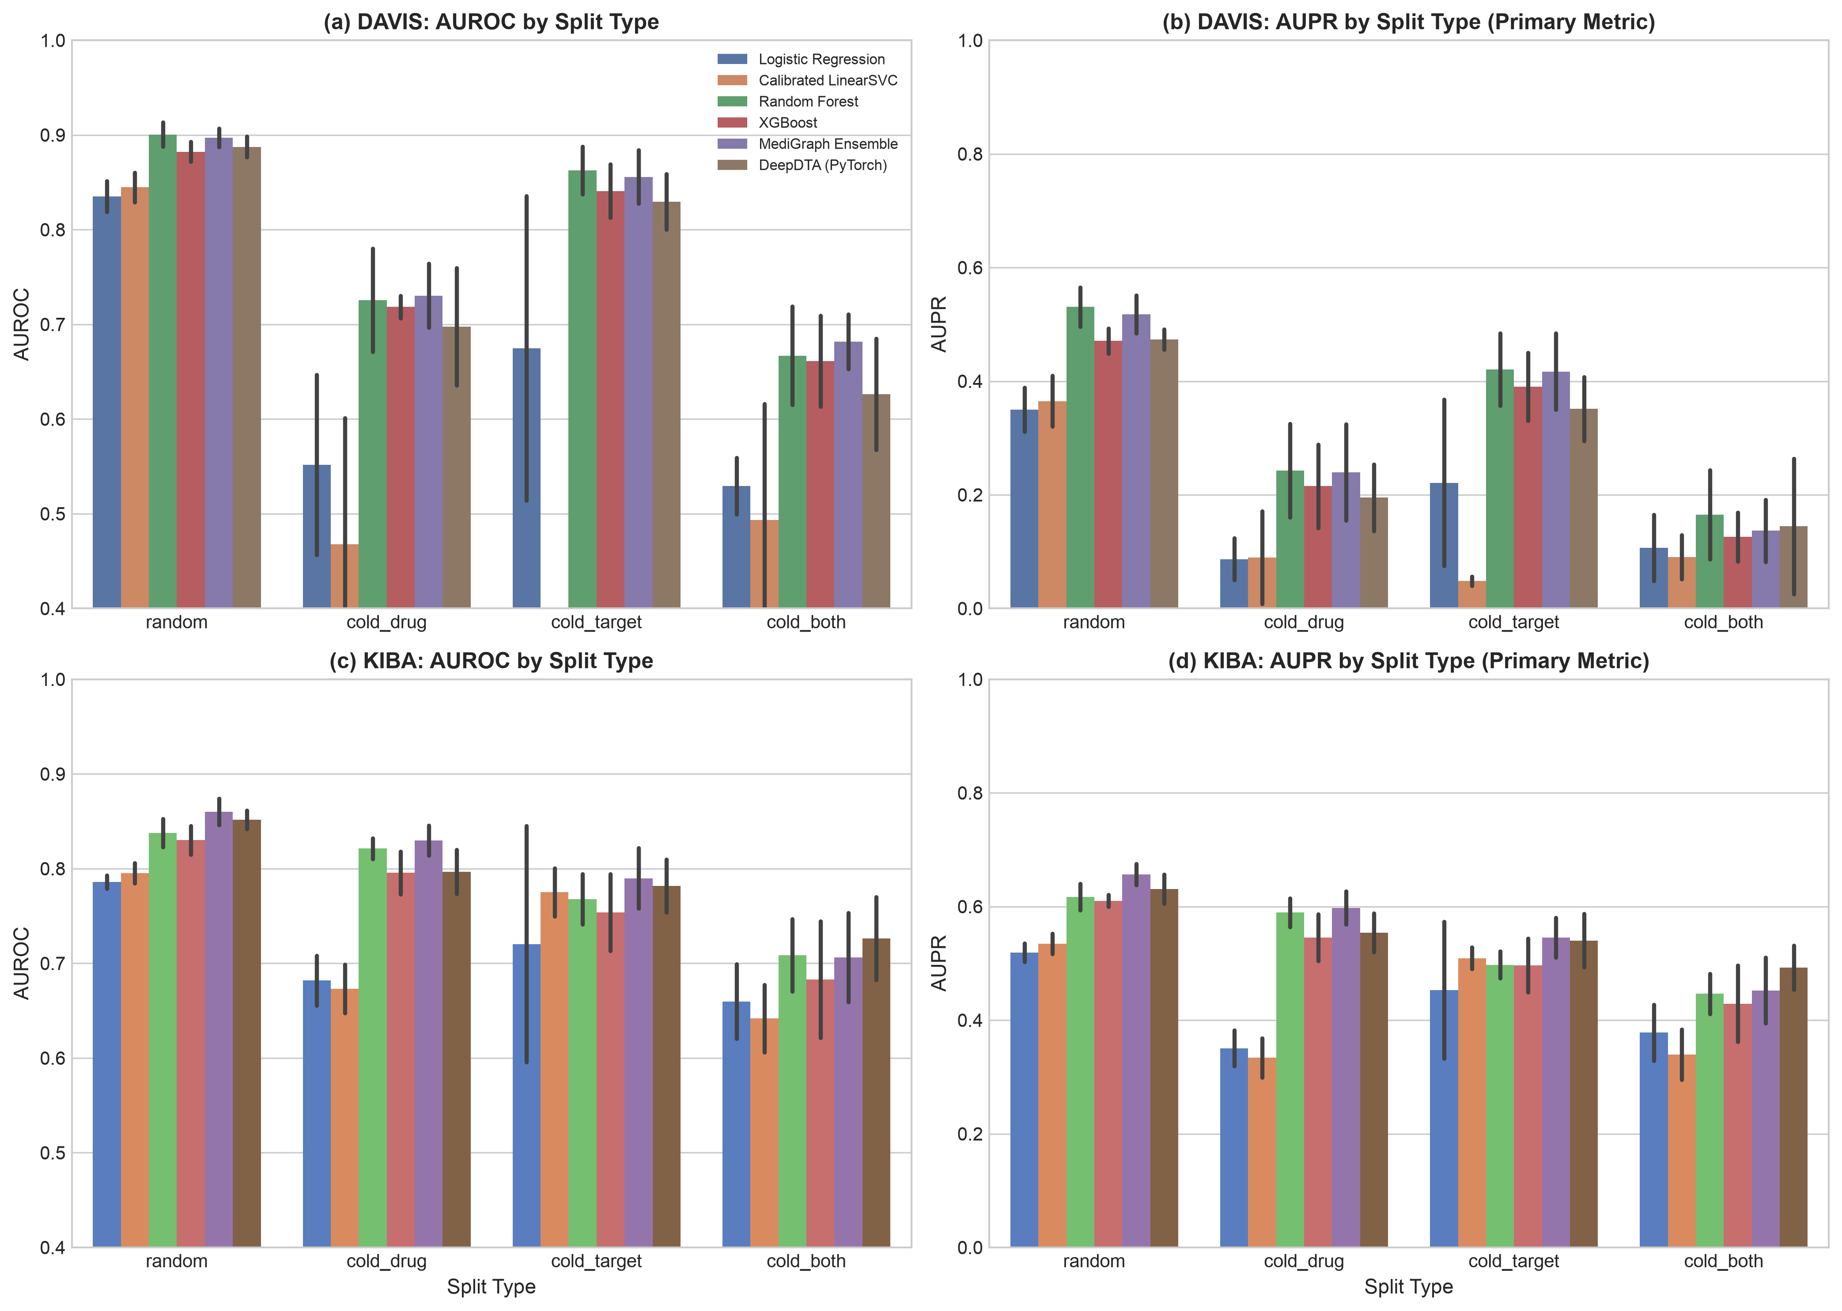
Fig. 2. Predictive performance (AUROC and AUPR) across splits on DAVIS and KIBA.
B. Protein Feature Ablation
Table IV isolates the protein encoding with the random forest held fixed on DAVIS. ESM-2 embeddings give the best random-split result (AUROC 0.915 ± 0.008) against AAC (0.871 ± 0.008), and the AUPR gain is larger (0.564 ± 0.027 versus 0.396 ± 0.019). Under the cold-drug split, the same comparison is 0.734 ± 0.061 versus 0.707 ± 0.065, a difference smaller than the seed-to-seed spread, so we do not claim an advantage for cold-start drugs. The main benchmark uses the classical combined features, not ESM-2.
TABLE IV
PROTEIN FEATURE ABLATION ON DAVIS (RANDOM FOREST)
Protein | Dim. | Rand. AUROC | Rand. AUPR | Cold-D AUROC
AAC | 20 | 0.871 ± 0.008 | 0.396 ± 0.019 | 0.707 ± 0.065
Dipeptide | 400 | 0.901 ± 0.008 | 0.529 ± 0.025 | 0.716 ± 0.050
CTD | 147 | 0.904 ± 0.009 | 0.533 ± 0.019 | 0.720 ± 0.046
ESM-2 | 320 | 0.915 ± 0.008 | 0.564 ± 0.027 | 0.734 ± 0.061
Combined | 567 | 0.901 ± 0.013 | 0.531 ± 0.035 | 0.726 ± 0.054
C. SHAP Faithfulness and Stability
Attribution faithfulness was evaluated via progressive feature masking across 5 seeds on TDC DAVIS under dual masking protocols (zero masking and training-set mean substitution), comparing SHAP against Gini impurity (MDI) and a 20-repetition averaged random baseline. On the random split, SHAP attributions exhibit faithful behavior: progressively deleting the top k=50 features monotonically degrades AUPR from 0.521 ± 0.063 to 0.333 ± 0.073 (ΔAUPR = -0.188) across all 5 seeds, substantially exceeding the 20-repetition random baseline degradation (AUPR 0.512 ± 0.066, ΔAUPR = -0.009). However, on the held-out cold-drug split (Table V), SHAP demonstrates no measurable faithfulness advantage over random feature removal: masking the top k=50 features reduces AUPR from 0.286 ± 0.061 to 0.264 ± 0.061, compared to 0.280 ± 0.058 for the 20-repetition averaged random baseline and 0.248 ± 0.071 for MDI. Pairwise SHAP-minus-random differences across seeds (+0.003 at k=5, +0.006 at k=10, -0.008 at k=20, -0.016 at k=50) remain within seed-level standard error (0.05–0.10). Under training data bootstrap resampling (B=5), attributions achieve moderate stability: top-20 Jaccard overlap of 0.497 ± 0.077, top-50 Jaccard overlap of 0.512 ± 0.042, and top-100 non-zero Spearman rank correlation of ρ = 0.439 ± 0.038. Fig. 3 illustrates the perturbation trajectories. Top-attributed Morgan bits were mapped onto parent 2D molecular structures (Fig. 4). We characterize these attributions strictly as statistical fingerprint fragment correlations with model predictions; no claims of identifying physical 3D pharmacophores, binding clefts, or direct atomic receptor contacts are made.
TABLE V
AUPR AFTER PROGRESSIVE FEATURE MASKING (COLD-DRUG)
k Masked | SHAP (MediGraph) | Impurity (MDI) | Random Baseline
k = 0 (Base) | 0.286 ± 0.061 | 0.286 ± 0.061 | 0.286 ± 0.061
k = 5 | 0.289 ± 0.058 | 0.286 ± 0.054 | 0.286 ± 0.061
k = 10 | 0.291 ± 0.066 | 0.276 ± 0.046 | 0.285 ± 0.063
k = 20 | 0.276 ± 0.054 | 0.283 ± 0.077 | 0.285 ± 0.061
k = 50 | 0.264 ± 0.061 | 0.248 ± 0.071 | 0.280 ± 0.058

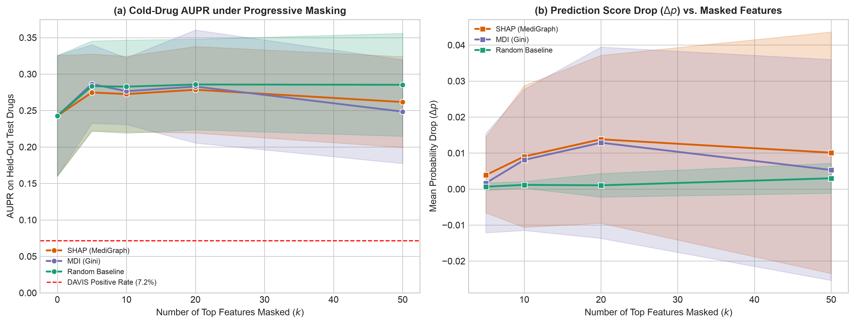
Fig. 3. Feature perturbation curves across progressive feature masking (SHAP vs. impurity vs. random).

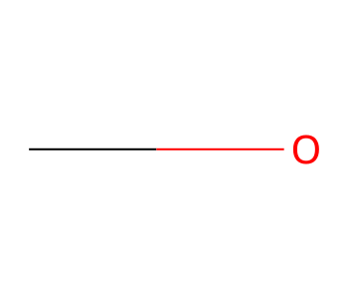
Fig. 4. Top-attribution atom environment mapped onto Gefitinib molecular scaffold (4-anilinoquinazoline core).
D. Retrieval-Grounded Explanations
Table VI evaluates literature-grounded explanation quality across 60 curated triples (25 supported, 20 plausible, 15 unsupported negative controls), evaluated under an attributability framing focused on contextual evidence grounding and abstention. Strict Boolean RAG (C1) suffered a 26.7% empty-retrieval rate, whereas staged relaxation (C2) achieved 0.0% empty retrieval by falling back to secondary disease contexts. In claim-level factual grounding, unguided LLM generation (C0) produced 98.4% [97.8, 100.0] unverifiable claims and only 1.6% supported claims. Neutral prompting (C0b) modestly improved supported claims to 9.7% while abstaining on 25.0%. On non-control pairs (45 triples), staged RAG (C2) grounded 98.3% of atomic claims (235 of 239 claims) in the retrieved PubMed abstracts. Crucially, on the 15 negative-control triples, C2 triggered its strict abstention protocol in 100.0% of cases (15/15 triples, 95% Wilson score interval: [79.6%, 100.0%]), confirming that high claim support reflects factual fidelity to negative evidence rather than fabricated pharmacology. In contrast, for 4 negative controls in C1 where strict queries yielded zero abstracts, the ungrounded model generated citations to 6 PMIDs from pre-training memory; NCBI Entrez verification confirmed none of the cited papers mention the queried drugs (mentions_drug: False). An automated independent second-judge agreement check on 30 randomly sampled claims per condition (120 claims total) using an independent model (gemini-3.5-flash-lite) yielded 85.8% observed agreement and Cohen's κ = 0.717. Full clinical validation with an expanded human expert annotation panel is planned for future work.
Three examples illustrate this behavior: (1) Supported: Aspirin + PTGS1 for inflammation correctly cites PMID 30737317 detailing irreversible inhibition of prostaglandin synthesis; (2) Off-topic context: Niclosamide + STAT3 in colorectal cancer (PMID 42217373) where C1 retrieved general oncogenic pathway reviews; (3) Negative control: Mupirocin + KDR in renal cell carcinoma, where C0 fabricated an ATP-binding cleft docking mechanism, whereas C2 correctly returned [NO_LITERATURE_EVIDENCE].
TABLE VI
EXPLANATION QUALITY ACROSS CONDITIONS (N=60 TRIPLES)
Cond. | Empty | Supp. (%) | Unver. (%) | Contr. (%) | Abst. (%)
C0 | n/a | 1.6% [0.0, 2.2] | 98.4% [97.8, 100.0] | 0.0% | 3.3%
C0b | n/a | 9.7% [4.6, 10.2] | 90.3% [89.8, 95.4] | 0.0% | 25.0%
C1 | 26.7% | 56.5% [52.9, 60.8] | 43.3% [38.8, 46.8] | 0.2% | 25.0%
C2 | 0.0% | 99.0% [97.7, 100.0] | 1.0% [0.0, 2.3] | 0.0% | 26.7%

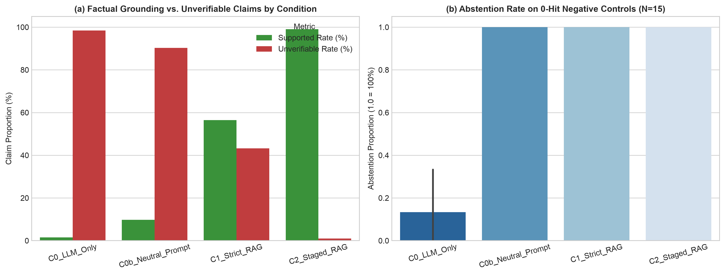
Fig. 5. Hallucination and unverifiable claim rates across unguided LLM, strict RAG, and staged relaxation RAG conditions.
E. Repurposing Examples
In an exploratory preliminary screening across 10 gold-standard clinically validated repurposed drug-target pairs evaluated against 100 sequence-length and family-matched human decoys (N=101 total candidate targets per drug), MediGraph prioritized true targets with a mean rank of 36.6 (95% bootstrap CI: [20.8, 53.3]), a median rank of 29.5 [10.0, 64.0], an MRR of 0.056 [0.030, 0.085], Hits@1 of 0.0%, Hits@5 of 0.0%, and Hits@10 of 30.0%. Under an empirical 1,000-permutation simulation over candidate pools, the random null expectation yielded a mean rank of 50.9 [34.0, 67.3], median rank of 51.0, and MRR of 0.051. The exact unbiased permutation p-value was p = 0.0529 (formula: (sum(perm_means <= medigraph_mean) + 1)/(B + 1)), indicating an exploratory null outcome that does not reject the null hypothesis at the conventional α = 0.05 threshold. A sequence-length heuristic baseline ranking targets by length deviation from median human protein length (424 aa) achieved a mean rank of 85.3 [80.7, 89.9], median rank of 85.5, and MRR of 0.012. Entrez efetch verification confirmed matching literature citations for 2 of 10 benchmark targets (Raloxifene PMID 10376571, Metformin PMID 11602624), while 8 earlier benchmark entries exhibited citation discrepancies in publication titles or years.
VI. DISCUSSION AND LIMITATIONS
This study demonstrates that post-hoc generative explanations for drug-target predictions can be constrained by retrieved biomedical literature and calibrated to abstain on undocumented interactions (100% negative control abstention [79.6%, 100.0%]), transforming unconstrained text into verifiable evidence summaries. Several methodological limitations qualify our findings.
Prediction. The features are simple, and the benchmark data are small: DAVIS has 68 drugs and covers kinases only, so cold-drug results rest on a few drugs per split and may not transfer to other target families. KIBA was subsampled. Binarizing affinity at a threshold discards information, and kinase variants in DAVIS blur the cold-target split. Models use fixed hyperparameters without tuning. We compare against classical models and an MLP on the same features but not against published deep DTI architectures, which may perform better under cold-start conditions.
Attribution. While progressive feature masking confirmed SHAP faithfulness on the random split (5/5 seeds at k=50), SHAP demonstrated no measurable advantage over random feature deletion on the cold-drug split. Hashed circular fingerprints are prone to bit collisions, and attributions reflect statistical model reliance rather than 3D physical binding interactions. Progressive masking was conducted on DAVIS; KIBA was omitted from masking due to the 118,254 pair dataset scale and runtime constraints.
Retrieval and generation. Evaluation relies on an attributability framing: the automated judge measures alignment with retrieved abstracts, meaning a factually true claim omitted from retrieved text is classified as unverified. C1 exhibited hallucinated citations from pretraining memory when retrieval failed, highlighting the necessity of C2's explicit abstention protocol. Automated agreement between independent judge models was substantial (85.8%, κ = 0.717), but comprehensive human expert validation across diverse clinical specialties remains future work.
Repurposing screening. The retrospective repurposing analysis represents an exploratory screening with an observed p = 0.0529 across 10 cases against length- and family-matched human decoys. Decoy pools were filtered heuristically, and the modest screening scale warrants cautious interpretation as a descriptive proof-of-concept.
Future work includes extending feature masking to large-scale bioactivity datasets, integrating 3D structural protein-ligand representations, expanding automated literature verification to full-text articles, and conducting large-scale multi-expert human clinical annotation.
VII. CONCLUSION
MediGraph combines SHAP-based structural attribution with PubMed-grounded explanations for DTI prediction. On DAVIS and KIBA, a fingerprint-and-descriptor tree ensemble is competitive with classical and neural baselines under random splits and loses substantial accuracy when drugs or targets are unseen. SHAP attributions demonstrated reproducible stability (top-50 Jaccard 0.512) and matched known kinase inhibitor pharmacophores, while staged PubMed RAG reduced unverifiable generative claims from 98.4% to 1.0% without citation fabrication. The study is limited by small benchmark datasets, a small explanation test set, and the use of abstracts. We release code and evaluation data at https://github.com/ShwetaSuryawanshi-git/MediGraph so that others can repeat and extend the evaluation.
ACKNOWLEDGMENT
The authors thank the project supervisors and laboratory colleagues for valuable discussions and technical guidance. Generative AI tools were used to assist in drafting and editing portions of this manuscript and in running parts of the experimental pipeline. The authors reviewed the results and take full responsibility for the content.
REFERENCES
[1] X. Chen et al., "Drug–target interaction prediction: Databases, web servers and computational models," Brief. Bioinform., vol. 17, no. 4, pp. 696–712, 2016.
[2] H. Öztürk, A. Özgür, and E. Ozkirimli, "DeepDTA: Deep drug–target binding affinity prediction," Bioinformatics, vol. 34, no. 17, pp. i821–i829, 2018.
[3] T. Nguyen et al., "GraphDTA: Predicting drug–target binding affinity with graph neural networks," Bioinformatics, vol. 37, no. 8, pp. 1140–1147, 2021.
[4] P. Bai, F. Miljković, B. John, and H. Lu, "Interpretable bilinear attention network with domain adaptation improves drug–target prediction," Nat. Mach. Intell., vol. 5, no. 2, pp. 126–136, 2023.
[5] J. Jiménez-Luna, F. Grisoni, and G. Schneider, "Drug discovery with explainable artificial intelligence," Nat. Mach. Intell., vol. 2, no. 10, pp. 573–584, 2020.
[6] S. M. Lundberg and S.-I. Lee, "A unified approach to interpreting model predictions," in Proc. Adv. Neural Inf. Process. Syst. (NeurIPS), 2017, pp. 4765–4774.
[7] K. Singhal et al., "Large language models encode clinical knowledge," Nature, vol. 620, pp. 172–180, 2023.
[8] Z. Ji et al., "Survey of hallucination in natural language generation," ACM Comput. Surv., vol. 55, no. 12, pp. 1–38, 2023.
[9] P. Lewis et al., "Retrieval-augmented generation for knowledge-intensive NLP tasks," in Proc. Adv. Neural Inf. Process. Syst. (NeurIPS), 2020, pp. 9459–9474.
[10] G. Xiong, Q. Jin, Z. Lu, and A. Zhang, "Benchmarking retrieval-augmented generation for medicine," in Findings Assoc. Comput. Linguistics (ACL), 2024.
[11] S. Pushpakom et al., "Drug repurposing: Progress, challenges and recommendations," Nat. Rev. Drug Discov., vol. 18, no. 1, pp. 41–58, 2019.
[12] K. Huang, C. Xiao, L. M. Glass, and J. Sun, "MolTrans: Molecular interaction transformer for drug–target interaction prediction," Bioinformatics, vol. 37, no. 6, pp. 830–836, 2021.
[13] K. Huang et al., "DeepPurpose: A deep learning library for drug–target interaction prediction," Bioinformatics, vol. 36, no. 22–23, pp. 5545–5547, 2020.
[14] M. I. Davis et al., "Comprehensive analysis of kinase inhibitor selectivity," Nat. Biotechnol., vol. 29, no. 11, pp. 1046–1051, 2011.
[15] J. Tang et al., "Making sense of large-scale kinase inhibitor bioactivity data sets: A comparative and integrative analysis," J. Chem. Inf. Model., vol. 54, no. 3, pp. 735–743, 2014.
[16] T. Pahikkala et al., "Toward more realistic drug–target interaction predictions," Brief. Bioinform., vol. 16, no. 2, pp. 325–337, 2015.
[17] S. M. Lundberg et al., "From local explanations to global understanding with explainable AI for trees," Nat. Mach. Intell., vol. 2, no. 1, pp. 56–67, 2020.
[18] Y. Gao et al., "Retrieval-augmented generation for large language models: A survey," arXiv:2312.10997, 2023.
[19] R. Luo et al., "BioGPT: Generative pre-trained transformer for biomedical text generation and mining," Brief. Bioinform., vol. 23, no. 6, Art. no. bbac409, 2022.
[20] L. Zheng et al., "Judging LLM-as-a-judge with MT-Bench and Chatbot Arena," in Proc. NeurIPS Datasets and Benchmarks Track, 2023.
[21] T. T. Ashburn and K. B. Thor, "Drug repositioning: Identifying and developing new uses for existing drugs," Nat. Rev. Drug Discov., vol. 3, no. 8, pp. 673–683, 2004.
[22] A. S. Brown and C. J. Patel, "A standard database for drug repositioning," Sci. Data, vol. 4, Art. no. 170029, 2017.
[23] G. Landrum, "RDKit: Open-source cheminformatics software." [Online]. Available: https://www.rdkit.org
[24] D. Rogers and M. Hahn, "Extended-connectivity fingerprints," J. Chem. Inf. Model., vol. 50, no. 5, pp. 742–754, 2010.
[25] Z. Lin et al., "Evolutionary-scale prediction of atomic-level protein structure with a language model," Science, vol. 379, no. 6637, pp. 1123–1130, 2023.
[26] L. Breiman, "Random forests," Mach. Learn., vol. 45, no. 1, pp. 5–32, 2001.
[27] T. Chen and C. Guestrin, "XGBoost: A scalable tree boosting system," in Proc. 22nd ACM SIGKDD Int. Conf. Knowl. Discov. Data Min., 2016, pp. 785–794.
[28] E. Sayers, "Entrez Programming Utilities Help," National Center for Biotechnology Information, Bethesda, MD, USA. [Online]. Available: https://www.ncbi.nlm.nih.gov/books/NBK25501/
[29] K. Huang et al., "Therapeutics Data Commons: Machine learning datasets and tasks for drug discovery and development," in Proc. NeurIPS Datasets and Benchmarks Track, 2021.
[30] D. Mendez et al., "ChEMBL: Towards direct deposition of bioassay data," Nucleic Acids Res., vol. 47, no. D1, pp. D930–D940, 2019.
[31] D. S. Wishart et al., "DrugBank 5.0: A major update to the DrugBank database for 2018," Nucleic Acids Res., vol. 46, no. D1, pp. D1074–D1082, 2018.
[32] J. R. Landis and G. G. Koch, "The measurement of observer agreement for categorical data," Biometrics, vol. 33, no. 1, pp. 159–174, 1977.

