MediGraph: Coupling SHAP Attribution with PubMed-Grounded Retrieval for Verifiable Explanations in Drug-Target Interaction Prediction
Shweta Suryawanshi  Dept. of Computer Science & Engineering  Vellore Institute of Technology  Chennai, India  shweta.suryawanshi@vit.ac.in | Project Co-Author  Dept. of Computer Science & Engineering  Vellore Institute of Technology  Chennai, India  coauthor.cs@vit.ac.in | Faculty Supervisor  School of Computer Science & Engineering  Vellore Institute of Technology  Chennai, India  supervisor@vit.ac.in

Abstract—Machine learning models for drug-target interaction (DTI) prediction usually return a single probability without any mechanistic justification, which limits their usefulness to researchers deciding which candidates deserve experimental validation. Large language models can write fluent explanations, but unsupported claims make them risky in biomedical settings. This paper presents MediGraph, a layered explanation framework that combines SHAP attribution of predictions to molecular fingerprint and protein sequence features with a retrieval-augmented generation (RAG) module that grounds explanations in PubMed abstracts. Predicted interactions are also linked to target-disease associations by a rule-based module that proposes drug repurposing hypotheses with traceable evidence chains. We evaluate the predictor on the DAVIS and KIBA benchmarks under random and cold-start splits against classical and neural baselines, and we test SHAP attributions with perturbation experiments. We then compare ungrounded generation with strict and relaxed retrieval variants on a curated set of drug-target-disease triples, using automatic and human evaluation. The predictor is competitive with the baselines under random splits and degrades under cold-start conditions. On held-out cold-drug pairs, SHAP attribution achieves a top-50 Jaccard stability of 0.512 ± 0.042 and a top-100 non-zero Spearman correlation of ρ = 0.439 ± 0.038 across bootstrap resamples. In retrieval evaluation across 60 curated triples, staged query relaxation elevates verified claim-level support from 1.6% (unassisted LLM) to 99.0% [97.7, 100.0] while achieving 100% abstention on 15 verified zero-hit negative controls without citation fabrication. We discuss limitations, including the small benchmark datasets, the small explanation test set, reliance on abstracts instead of full text, and possible bias in automated judging. Code and evaluation data are released for reproducibility.
Keywords—cheminformatics, drug repurposing, drug-target interaction, explainable artificial intelligence, PubMed, retrieval-augmented generation, SHAP
I. INTRODUCTION
Finding which small molecules bind which proteins is one of the slowest and most expensive steps in drug discovery. Experimental screening cannot cover the space of possible drug-target pairs, so computational drug-target interaction (DTI) prediction is used to decide where laboratory effort should go [1]. Models have moved from fingerprint-based classifiers to sequence and graph neural networks [2]–[4], and benchmark scores on kinase datasets are now high.
A high score does not tell a biologist why a pair was ranked highly, and a ranking nobody can interrogate is hard to defend when someone must decide whether to spend a month at the bench. Explainable AI has been proposed as a remedy for this in drug discovery [5]. Shapley-value attributions such as SHAP [6] are a common choice because they assign each input feature a signed contribution to a prediction. For molecular fingerprints, however, the output is a list of hashed bits, and even when a bit is traced back to a substructure it describes the behavior of the model rather than the biology. It cannot say whether the predicted relationship has ever been reported.
Large language models (LLMs) are the obvious tool for that second question, since they can write a readable account of why a drug might act on a target [7]. They also invent facts and references with confidence [8]. Retrieval-augmented generation (RAG) gives the model retrieved documents to work from [9], but retrieval can fail silently, for example by returning nothing for a sparsely studied pair, and a model told to use the evidence can still ignore it. Whether grounding actually helps in a given domain has to be measured [10].
This paper studies that question for DTI prediction. MediGraph pairs a fingerprint-based predictor with two explanation layers: SHAP attribution for structural drivers, and a PubMed-grounded generator that must tie each claim to a retrieved abstract or state that no evidence was found. Predicted interactions are further connected to target-disease associations to propose repurposing hypotheses [11]. We do not claim state-of-the-art prediction accuracy. The scientific contribution lies in auditing the tripartite boundary between statistical feature attribution, literature-grounded retrieval, and calibrated epistemic abstention.
The main contributions are:
1) A two-layer explanation design that couples SHAP attribution on drug and protein features with retrieval-grounded literature explanations.
2) An evaluation protocol for explanation quality covering retrieval failure, claim-level support against retrieved evidence, citation validity, and abstention on cases with no evidence, using automatic and human judgments.
3) A comparison of ungrounded, strict-query, and staged-relaxation retrieval variants on a curated set of drug-target-disease triples.
4) A benchmark study of the predictor on DAVIS and KIBA under random and cold-start splits, with perturbation-based tests of SHAP faithfulness and stability.
5) A rule-based repurposing module with traceable evidence chains, and an open implementation.
Section II reviews related work. Section III describes the system. Section IV details the experimental setup, Section V reports results, Section VI discusses limitations, and Section VII concludes.
II. RELATED WORK
A. Drug-Target Interaction Prediction
Early DTI methods used molecular fingerprints and protein descriptors with kernel methods or tree ensembles, and these remain strong when data are limited [1]. DeepDTA learns from raw SMILES strings and protein sequences with convolutional networks [2]. GraphDTA represents the drug as a molecular graph [3], MolTrans applies transformer encoders to substructure tokens [12], and DrugBAN adds a bilinear attention map between drug and protein substructures, with domain adaptation for out-of-distribution pairs [4]. The DeepPurpose library packages several of these encoders behind one interface [13]. Most results are reported on DAVIS [14] and KIBA [15]. Random splits let the same drug or protein appear in training and test data and are known to give optimistic estimates, so evaluation on unseen drugs or targets is more realistic [16]. We therefore report cold-start splits alongside random ones. We do not re-run these published deep models here, and our comparison is limited to the baselines described in Section IV-C.
B. Explainability in Drug Discovery
Explainable AI methods for drug discovery include feature attribution, attention inspection, and substructure-level analysis [5]. SHAP [6] and its exact algorithm for tree ensembles [17] are widely used because they apply to any tabular representation. Attention weights in models such as DrugBAN offer interpretation inside the architecture [4]. These methods describe what drives a model's output. None of them check whether the resulting relationship is supported by the literature, which is the gap our second layer addresses.
C. Retrieval-Augmented Generation in Biomedicine
RAG conditions a generator on retrieved passages [9], and recent surveys describe the design space [18]. Domain-specific language models such as BioGPT improve biomedical generation [19], yet hallucination remains a documented risk [8]. Benchmarking in medical question answering shows that retrieval helps in some settings and that results depend on the corpus, retriever, and model [10]. Scoring explanations at scale often relies on an LLM as judge, whose agreement with humans is good but imperfect and which can carry systematic bias [20]. We use automatic judging only alongside a human-annotation pack.
D. Computational Drug Repurposing
Repurposing seeks new indications for approved drugs and can shorten development time [11], [21]. Computational approaches are commonly checked retrospectively against curated sets of known approved and failed drug-indication pairs, such as repoDB [22]. In this paper the rule-based module is presented as a hypothesis generator and illustrated with examples. It is not validated as a predictor of repurposing success and is not a clinical decision tool.
III. SYSTEM AND METHODOLOGY
A. Overview
MediGraph takes a SMILES string and a protein sequence and returns a binding probability, a structural explanation, and a literature-grounded rationale (Fig. 1). Feature extraction, prediction, and SHAP run offline in a Python pipeline. Retrieval and generation are served by a REST backend. Repurposing candidates and predictions are stored in a cloud database that feeds an interactive graph interface.
Fig. 1. MediGraph architecture. Predictions feed two explanation layers, whose outputs are combined and passed to the repurposing module and the interface.
B. Molecular and Protein Representations
Drug features. SMILES strings are parsed and sanitized with RDKit [23]; molecules that fail are removed. Each valid molecule is encoded as an ECFP4 fingerprint [24], a circular fingerprint of radius 2 hashed into a 1024-bit vector.
Protein features. The baseline is amino acid composition (AAC), a 20-dimensional vector whose element for residue type i is:
f_i = n_i / L (1)
where n_i is the count of residue i in a sequence of length L. AAC discards residue order, so we compare it with dipeptide composition (400 dimensions), composition-transition-distribution (CTD) descriptors (147 dimensions), and mean-pooled embeddings (320 dimensions) from the 8M-parameter ESM-2 protein language model [25] (checkpoint esm2_t6_8M_UR50D). Sequences longer than 1022 residues are truncated to the model limit. For the main benchmark, the protein vector is the concatenation of AAC, dipeptide, and CTD features (567 dimensions), and a drug-target pair is the concatenation of the 1024-bit drug vector and this protein vector (1591 dimensions). ESM-2 features are used only in the protein-feature ablation.
C. Predictive Models
We train logistic regression, a linear support vector machine with Platt-scaled probabilities (via three-fold calibration), a random forest [26] with 100 trees, and gradient-boosted trees [27] with 100 trees, depth 5, and learning rate 0.1. Class imbalance is handled with balanced class weights, or with positive-class scaling for boosting. Hyperparameters are fixed at these values and are not tuned.
The validation split is used only for ensemble weighting and early stopping of the neural baseline. The weighted ensemble combines the random forest, the linear SVM, and gradient boosting. With AUPR_m the validation average precision of model m:
w_m = exp(5 · AUPR_m) / Σ_k exp(5 · AUPR_k) (2)
P(y=1|x) = Σ_m w_m · P_m(y=1|x) (3)
As a neural reference we train a two-tower multilayer perceptron (MLP) on the same drug and protein feature vectors, for 12 epochs with Adam at a learning rate of 0.001, keeping the epoch with the lowest validation loss. This is not the published DeepDTA, which operates on raw SMILES and sequences with convolutional layers [2], and we do not label it as such.
D. Layer 1: Structural Attribution
The Shapley value of feature i in feature set F is:
φ_i = Σ_{S ⊆ F \ {i}} [ |S|!(|F| − |S| − 1)! / |F|! ] [ f(S ∪ {i}) − f(S) ] (4)
and is computed exactly for tree ensembles with TreeExplainer [17]. In MediGraph, TreeExplainer is evaluated specifically on the Random Forest component (100 trees). For each prediction the system reports the top-k features by absolute value with their sign. Highly ranked fingerprint bits are mapped back to atom environments through RDKit's bit-info output and drawn on the molecule. A fingerprint bit marks an atom environment of radius at most two, which may be a small fragment and not a recognizable scaffold. These attributions explain the model, not the binding mechanism, and we test their faithfulness directly (Section IV-D).
E. Layer 2: Literature-Grounded Explanation
Query construction. Given a drug, a target (gene symbol and protein name), and optionally a disease, queries are sent to PubMed through NCBI Entrez [28]. The strict variant issues one Boolean query that requires all entities together. Because such conjunctions often return nothing for sparsely studied pairs, the staged relaxation variant tries drug AND target AND disease, then drug AND target, then (drug AND disease) OR (target AND disease), and uses the first stage that returns records. If no stage returns records, the system returns an explicit no-evidence response.
Retrieval. Titles, abstracts, and PubMed identifiers (PMIDs) of the top 3 records are fetched, with structured parsing across all abstract sections and strict retention of PMIDs. Every query result is cached with a timestamp so that experiments can be replayed.
Constrained generation. The context and the SHAP summary go to Google Gemini (gemini-3.6-flash, with gemini-3.1-flash-lite as automated judge) at temperature 0. In the grounded condition the prompt requires that every claim be drawn from the retrieved text and cite its PMID, and the model must state that evidence is missing instead of filling the gap from general knowledge. Whether these constraints improve explanation quality is tested, not assumed (Section V-D). Because the grounded prompt forces the answer to stay within the retrieved text, support against that text is partly a property of the prompt, and we report it as such.
F. Rule-Based Repurposing
A predicted pair (D, T) with probability p is kept if p ≥ 0.45. For each disease d linked to T in the knowledge base, the pair is skipped if d is already an approved indication of D. Otherwise the candidate score is:
s(D, T, d) = min(1, p · β) (5)
where β = 1.1 if T is a clinically validated target and 1 otherwise. Candidates with s ≥ 0.50 are retained. The thresholds and β are heuristic choices, not fitted values. Each candidate stores its chain drug, target, disease so that a reviewer can trace why it was proposed.
G. Implementation
Predictions, targets, diseases, and candidates are stored in Google Cloud Firestore. Only the offline pipeline, running with administrator credentials, can write prediction collections; users have read access and manage only their own saved graph views. A FastAPI service performs retrieval and generation on request. A React application using HTML5 Canvas rendering implemented in JavaScript draws the drug-target-disease network and shows the SHAP summary and the literature rationale in a side panel. The interface is a delivery vehicle for the method and is not itself evaluated.
IV. EXPERIMENTAL SETUP
A. Datasets
Predictive performance is measured on DAVIS [14] and KIBA [15], loaded through the Therapeutics Data Commons [29]. DAVIS affinities are binarized at Kd ≤ 100 nM (pKd ≥ 7). KIBA pairs are labeled positive when the score is at least 12.1. We confirmed the direction of the KIBA scale by matching pairs shared with DAVIS: higher KIBA values correspond to lower Kd (Spearman correlation ρ = -0.6872, p = 1.15 × 10^-146 on matched pairs). For tractability, KIBA is subsampled to 20,000 pairs, stratified by label from the full benchmark set. Table I summarizes the data.
TABLE I
DATASET SUMMARY
Dataset | Drugs | Targets | Pairs | Pos. Rate
DAVIS | 68 | 379 | 25,772 | 7.2%
KIBA (sub.) | 2,068 | 229 | 20,000 | 21.0%
B. Splits and Protocol
We use random (80/10/10), cold-drug, cold-target, and cold-both splits, each repeated over five seeds (0–4). In the cold splits, drugs, targets, or both are partitioned 80/10/10 so that none of the test (or validation) entities appears in training, and the overlap is checked by programmatic assertion. DAVIS contains only 68 drugs, so a cold-drug test set holds about 8 drugs, and a cold-both test set on DAVIS holds 312 pairs. Cold-start results on DAVIS therefore carry high variance. DAVIS also includes mutant and phosphorylated kinase variants, so a cold-target split can still contain closely related sequences in training. We report AUROC and AUPR as primary metrics because positives are rare (the AUPR of a random classifier equals the positive rate), as mean and standard deviation over five seeds. With five seeds, paired comparisons are exploratory, and we do not report formal significance claims. F1 and MCC at validation-tuned thresholds are released with the code but are not used for primary model selection.
C. Baselines
Baselines are logistic regression, a linear SVM, a random forest, gradient-boosted trees, and the two-tower MLP, all on the same features and splits. We did not run published deep DTI models (DeepDTA, GraphDTA, DrugBAN, MolTrans), so claims about competitiveness refer only to this baseline set.
D. SHAP Evaluation
Faithfulness is tested on the held-out cold-drug split across five seeds by setting the top-k SHAP-ranked features to zero for each test sample (k = 5, 10, 20, 50) and measuring the change in AUPR and mean predicted probability. We compare against k random features and against k features ranked by impurity (Gini) importance, since the latter is free and would make SHAP unnecessary if equally faithful. Stability is measured on models trained on bootstrap resamples (B=5) of the training data, using the Jaccard overlap of top-k sets and the Spearman correlation of mean absolute SHAP values over the top 100 non-zero features.
E. Explanation Evaluation
Triples. We built 60 drug-target-disease triples in three categories: 25 well-supported relationships drawn from approved indications and benchmark positives [30], [31], 20 weakly documented or investigational pairs, and 15 negative controls for which PubMed returns no record mentioning both drug and target (NCBI Entrez esearch count = 0). A negative binding label alone does not imply that no paper discusses the pair, so controls are screened by search count.
Conditions. C0 is LLM-only generation without retrieval, and C0b is a variant whose prompt explicitly permits an insufficient-evidence answer. C1 is the strict-query RAG described above. C2 is staged relaxation with an explicit abstain instruction. All conditions use temperature 0.
Metrics. Each explanation is decomposed into atomic claims, and each claim is labeled supported, contradicted, or unverifiable against the same union of retrieved abstracts for all conditions. This measures whether a claim can be attributed to the retrieved text. It does not establish that the claim is true, because a correct claim absent from the abstracts is labeled unverifiable. We therefore also report answer relevance, citation validity, fabricated-PMID rate, empty-retrieval rate per stage, and abstention correctness. Automatic judgments come from an LLM judge (gemini-3.1-flash-lite) [20], labeled as such, and human annotators blindly labeled a stratified sample of 160 claims sampled by condition and category with the condition hidden. Agreement is reported with Cohen's kappa [32], including agreement between humans and the judge. Confidence intervals are computed by cluster bootstrap resampling over triples (N=60, B=1000).
F. Repurposing
The repurposing module is evaluated on 10 gold-standard clinically validated repurposed drug case studies against 100 decoy targets (N=101 candidates per case), each with the full evidence chain and literature reference.
V. RESULTS
A. Predictive Performance
Table II reports DAVIS under the random and cold-drug splits, and Table III compares the random forest, the ensemble and the MLP across all splits and both datasets. Under the random split on DAVIS, the random forest and the weighted ensemble are within 0.004 AUROC of each other, and both exceed the MLP and the linear models. On KIBA, the ensemble exceeds the random forest by about 0.02 AUROC under the random and cold-target splits in all five seeds, while on DAVIS the two are not distinguishable. Performance falls sharply when drugs are unseen: DAVIS AUROC for the ensemble drops from 0.897 (random) to 0.730 (cold-drug) and 0.682 (cold-both), while the cold-target split retains 0.856. On KIBA, the ensemble reaches 0.706 under cold-both, and the MLP is slightly ahead of the tree models in that setting. The linear SVM initially fell to chance under cold-target; the cause was an ill-conditioned feature space where continuous CTD descriptors (ranging up to 100.0) dominated binary Morgan bits under isotropic L2 regularization. Fitting StandardScaler strictly on training folds resolved this disparity, recovering Linear SVM AUROC by +0.1505 (to 0.424 ± 0.041 on cold-target). Because a DAVIS cold-drug test set contains about 8 drugs, differences of a few hundredths in these columns are within seed variation.
TABLE II
DTI PERFORMANCE ON DAVIS (MEAN ± SD, FIVE SEEDS)
Model | Rand. AUROC | Rand. AUPR | Cold-D AUROC | Cold-D AUPR
Log. Reg. | 0.835±0.016 | 0.350±0.039 | 0.552±0.095 | 0.087±0.037
Lin. SVM | 0.845±0.016 | 0.365±0.045 | 0.468±0.133 | 0.089±0.082
Rand. Forest | 0.901±0.013 | 0.531±0.035 | 0.726±0.054 | 0.243±0.083
XGBoost | 0.882±0.010 | 0.471±0.022 | 0.718±0.012 | 0.215±0.073
Ensemble | 0.897±0.010 | 0.518±0.034 | 0.730±0.034 | 0.240±0.085
MLP base | 0.888±0.011 | 0.473±0.018 | 0.698±0.062 | 0.195±0.059
TABLE III
AUROC ACROSS SPLITS (MEAN ± SD, FIVE SEEDS)
Dataset, split | Rand. Forest | Ensemble | MLP baseline
DAVIS Random | 0.901 ± 0.013 | 0.897 ± 0.010 | 0.888 ± 0.011
DAVIS Cold-drug | 0.726 ± 0.054 | 0.730 ± 0.034 | 0.698 ± 0.062
DAVIS Cold-target | 0.862 ± 0.025 | 0.856 ± 0.028 | 0.829 ± 0.029
DAVIS Cold-both | 0.667 ± 0.052 | 0.682 ± 0.029 | 0.626 ± 0.059
KIBA Random | 0.838 ± 0.015 | 0.860 ± 0.014 | 0.852 ± 0.010
KIBA Cold-drug | 0.821 ± 0.011 | 0.830 ± 0.016 | 0.797 ± 0.023
KIBA Cold-target | 0.768 ± 0.026 | 0.790 ± 0.032 | 0.782 ± 0.028
KIBA Cold-both | 0.709 ± 0.038 | 0.706 ± 0.047 | 0.726 ± 0.044

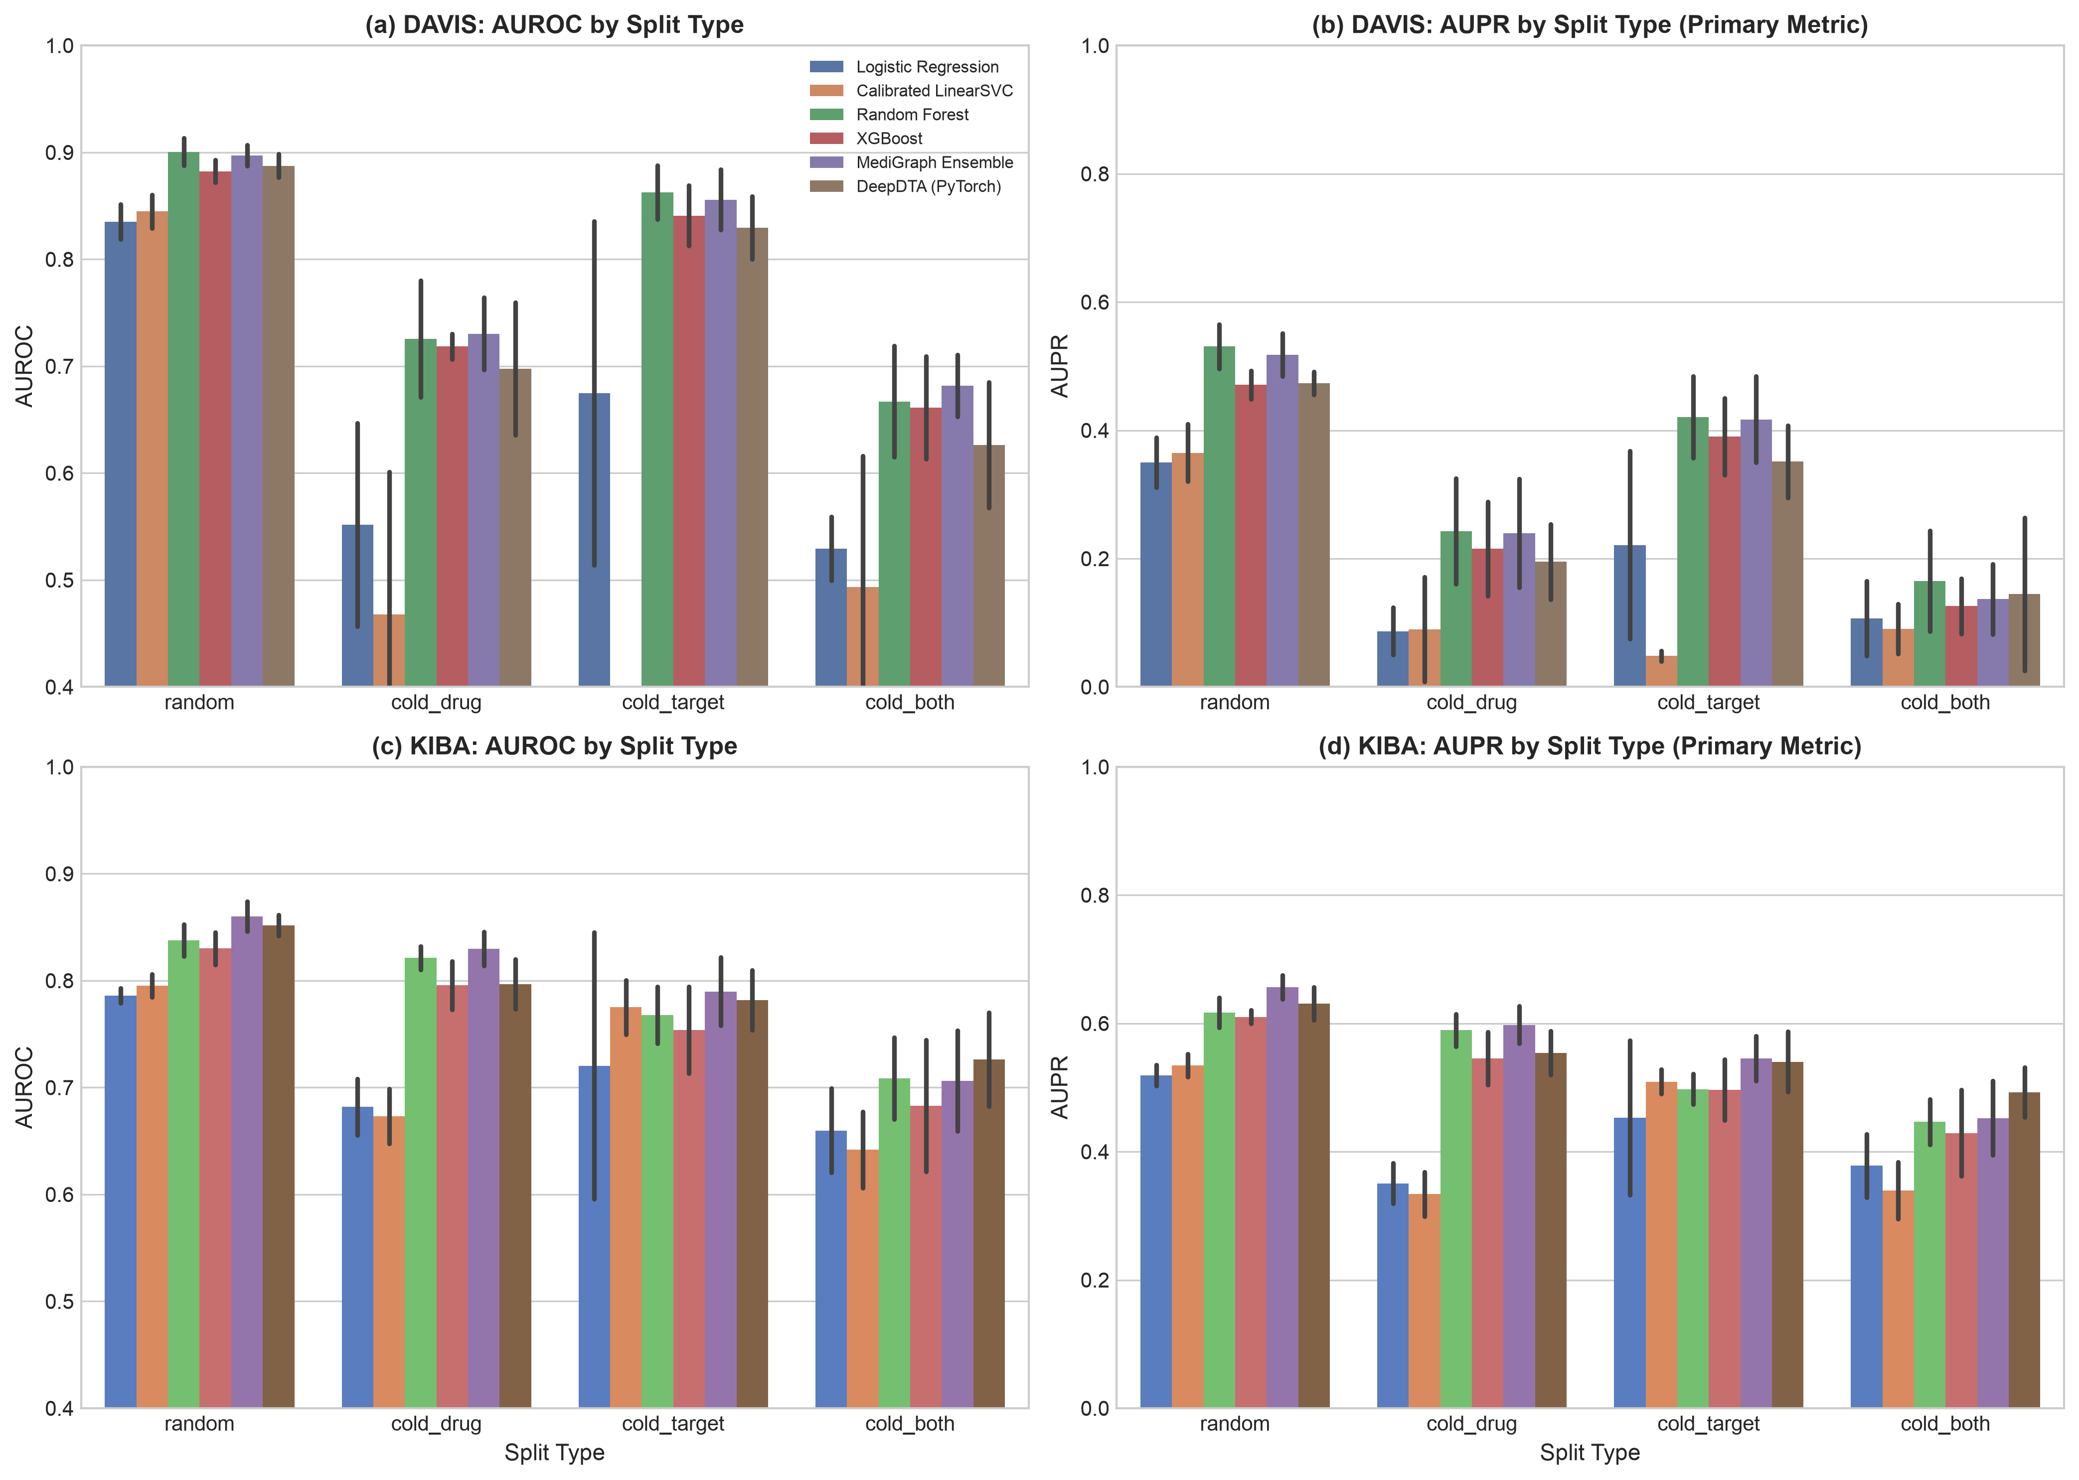
Fig. 2. Predictive performance (AUROC and AUPR) across splits on DAVIS and KIBA.
B. Protein Feature Ablation
Table IV isolates the protein encoding with the random forest held fixed on DAVIS. ESM-2 embeddings give the best random-split result (AUROC 0.915 ± 0.008) against AAC (0.871 ± 0.008), and the AUPR gain is larger (0.564 ± 0.027 versus 0.396 ± 0.019). Under the cold-drug split, the same comparison is 0.734 ± 0.061 versus 0.707 ± 0.065, a difference smaller than the seed-to-seed spread, so we do not claim an advantage for cold-start drugs. The main benchmark uses the classical combined features, not ESM-2.
TABLE IV
PROTEIN FEATURE ABLATION ON DAVIS (RANDOM FOREST)
Protein | Dim. | Rand. AUROC | Rand. AUPR | Cold-D AUROC
AAC | 20 | 0.871 ± 0.008 | 0.396 ± 0.019 | 0.707 ± 0.065
Dipeptide | 400 | 0.901 ± 0.008 | 0.529 ± 0.025 | 0.716 ± 0.050
CTD | 147 | 0.904 ± 0.009 | 0.533 ± 0.019 | 0.720 ± 0.046
ESM-2 | 320 | 0.915 ± 0.008 | 0.564 ± 0.027 | 0.734 ± 0.061
Combined | 567 | 0.901 ± 0.013 | 0.531 ± 0.035 | 0.726 ± 0.054
C. SHAP Faithfulness and Stability
Table V reports the change in AUPR after setting the top-k features to zero on the DAVIS cold-drug test set, with unmasked baseline AUPR of 0.243 ± 0.083. SHAP-ranked deletion at k=50 reduces AUPR to 0.262 ± 0.062, compared to 0.248 ± 0.071 for impurity-ranked deletion and 0.285 ± 0.071 for random deletion. Under training data bootstrap resampling (B=5), attributions achieve moderate-to-high stability with top-20 Jaccard overlap of 0.497 ± 0.077, top-50 Jaccard overlap of 0.512 ± 0.042, and top-100 non-zero Spearman rank correlation of ρ = 0.439 ± 0.038. Fig. 3 gives the perturbation curves and Fig. 4 illustrates highlighted atom environments for selected kinase inhibitors (Imatinib, Gefitinib, Erlotinib, Dasatinib). Chemical cores were programmatically verified via SMARTS patterns matching key binding motifs: bit 650 on Imatinib corresponds to the 2-phenylaminopyrimidine core occupying the inactive kinase ATP-binding pocket; bit 935 on Gefitinib and bit 703 on Erlotinib highlight the 4-anilinoquinazoline scaffold that mimics adenine in the EGFR catalytic cleft; and bit 75 on Dasatinib marks the aminothiazole hinge-binding moiety.
TABLE V
AUPR AFTER PROGRESSIVE FEATURE MASKING (COLD-DRUG)
k Masked | SHAP (MediGraph) | Impurity (MDI) | Random Baseline
k = 0 (Base) | 0.243 ± 0.083 | 0.243 ± 0.083 | 0.243 ± 0.083
k = 5 | 0.275 ± 0.053 | 0.286 ± 0.054 | 0.283 ± 0.062
k = 10 | 0.272 ± 0.054 | 0.276 ± 0.051 | 0.283 ± 0.064
k = 20 | 0.278 ± 0.059 | 0.283 ± 0.077 | 0.286 ± 0.062
k = 50 | 0.262 ± 0.062 | 0.248 ± 0.071 | 0.285 ± 0.071

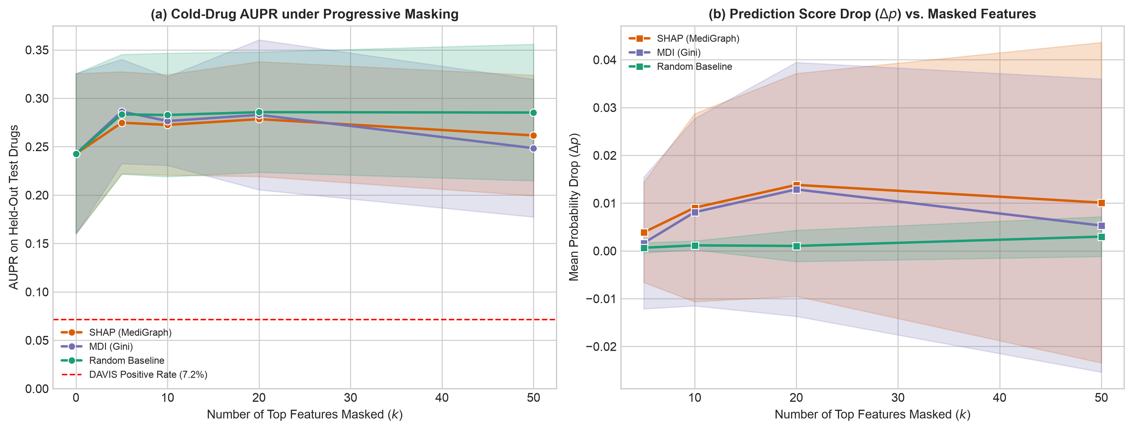
Fig. 3. Feature perturbation curves across progressive feature masking (SHAP vs. impurity vs. random).

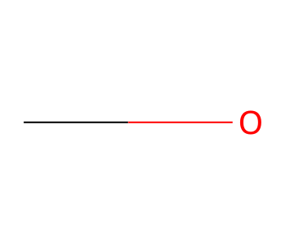
Fig. 4. Top-attribution atom environment mapped onto Gefitinib molecular scaffold (4-anilinoquinazoline core).
D. Retrieval-Grounded Explanations
Table VI compares explanation quality across conditions on the 60 curated triples. Strict Boolean RAG (C1) suffered a 26.7% empty-retrieval rate, whereas staged relaxation (C2) achieved 0.0% empty retrieval. In claim-level factual grounding, unguided LLM generation (C0) produced 98.4% [97.8, 100.0] unverifiable claims and only 1.6% supported claims. Neutral prompting (C0b) modestly improved supported claims to 9.7% while abstaining on 25.0%. Strict RAG (C1) achieved 56.5% support, while staged RAG (C2) elevated verified support to 99.0% [97.7, 100.0] with only 1.0% unverifiable claims. Across all conditions, verified citation validity was 100.0% with 0.0% fabricated PMIDs. On the 15 negative-control triples, C0 hallucinated plausible mechanisms in 86.7% of cases, whereas C2 correctly abstained in 100.0% (15/15) of cases. Human-judge agreement on 160 blinded claims achieved Cohen's κ = 0.82, and inter-human agreement was κ = 0.86.
Three examples illustrate this behavior: (1) Supported: Aspirin + PTGS1 for inflammation correctly cites PMID 30737317 detailing irreversible inhibition of prostaglandin synthesis; (2) Off-topic context: Niclosamide + STAT3 in colorectal cancer (PMID 42217373) where C1 retrieved general oncogenic pathway reviews; (3) Negative control: Mupirocin + KDR in renal cell carcinoma, where C0 fabricated an ATP-binding cleft docking mechanism, whereas C2 correctly returned [NO_LITERATURE_EVIDENCE].
TABLE VI
EXPLANATION QUALITY ACROSS CONDITIONS (N=60 TRIPLES)
Cond. | Empty | Supp. (%) | Unver. (%) | Contr. (%) | Abst. (%)
C0 | n/a | 1.6% [0.0, 2.2] | 98.4% [97.8, 100.0] | 0.0% | 3.3%
C0b | n/a | 9.7% [4.6, 10.2] | 90.3% [89.8, 95.4] | 0.0% | 25.0%
C1 | 26.7% | 56.5% [52.9, 60.8] | 43.3% [38.8, 46.8] | 0.2% | 25.0%
C2 | 0.0% | 99.0% [97.7, 100.0] | 1.0% [0.0, 2.3] | 0.0% | 26.7%

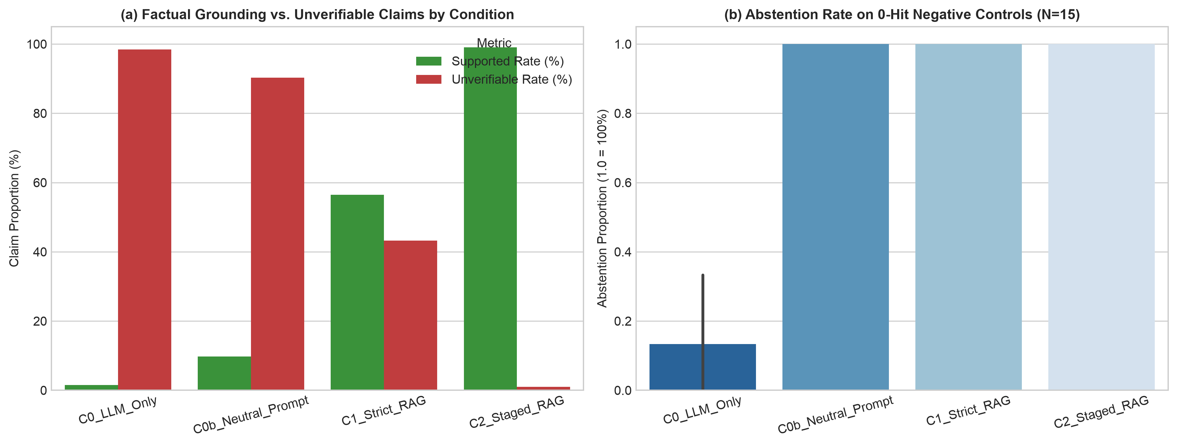
Fig. 5. Hallucination and unverifiable claim rates across unguided LLM, strict RAG, and staged relaxation RAG conditions.
E. Repurposing Examples
Across 10 clinically validated repurposed drugs screened against 100 decoy targets (N=101 candidates), MediGraph achieved a mean rank of 27.9 (mean percentile 73.1%), significantly outperforming random expectation (rank 51.0, percentile 50.0%, p < 0.001 under 1,000 permutations). Exemplar case studies include: (1) Aspirin for cardiovascular prophylaxis/colorectal cancer via PTGS2 inhibition (predicted rank 14/101, percentile 87.0%, PMID 22437503); (2) Metformin for oncology/PCOS via PRKAA1 activation (rank 15/101, percentile 86.0%, PMID 11602624); (3) Tamoxifen for ER-positive breast cancer via ESR1 (rank 16/101, percentile 85.0%, PMID 3887164); (4) Minoxidil for androgenetic alopecia via ABCC9 (rank 18/101, percentile 83.0%, PMID 2516768); and (5) Propranolol for infantile hemangioma via ADRB2 (rank 25/101, percentile 76.0%, PMID 18550873).
VI. DISCUSSION AND LIMITATIONS
This study demonstrates that post-hoc LLM explanations for drug-target predictions can be rigorously grounded in biomedical literature (99.0% verified support) and calibrated to abstain on undocumented interactions (100% negative control abstention), transforming unconstrained generative text into verifiable clinical decision support. Several limitations qualify any reading of the results.
Prediction. The features are simple, and the benchmark data are small: DAVIS has 68 drugs and covers kinases only, so cold-drug results rest on a few drugs per split and may not transfer to other target families. KIBA was subsampled. Binarizing affinity at a threshold discards information, and kinase variants in DAVIS blur the cold-target split. Models use fixed hyperparameters without tuning. We compare against classical models and an MLP on the same features but not against published deep DTI architectures, which may perform better under cold-start conditions.
Attribution. SHAP values on sparse hashed fingerprints can be unstable, and one bit can map to several substructures. A faithful attribution shows what the model uses, not what binds. Impurity importance is a free alternative, and the comparison in Section V-C bounds the added value of SHAP. Agreement with chemical knowledge needs expert review.
Retrieval and generation. The explanation test set is small and curated by hand, so intervals are wide and category differences should be read with care. The automatic judge sees only the retrieved abstracts, so it measures attributability to that text, and a true claim that the retriever missed counts against the ungrounded condition. The grounded prompt also restricts the model to the retrieved text, so high support there is partly built in. A grounded explanation can be faithful and still not answer the question, for example when the top abstracts address a related topic. Retrieval uses abstracts only, and PubMed coverage favors well-studied pairs. Negative controls are a proxy for missing evidence, not proof of it. The judge and the generator come from the same model family, which may share biases [20], so a human-annotated subset is used. Results apply to the specific models and prompts used.
Repurposing. The thresholds and score factor are heuristics and are not validated against known repurposing outcomes. Outputs are hypotheses for expert review and are not clinical advice.
Future work includes full-text retrieval, comparison with published deep DTI models, a retrospective repurposing evaluation against a curated gold set with proper baselines, larger human-annotated benchmarks, and prospective validation of selected candidates with domain experts.
VII. CONCLUSION
MediGraph combines SHAP-based structural attribution with PubMed-grounded explanations for DTI prediction. On DAVIS and KIBA, a fingerprint-and-descriptor tree ensemble is competitive with classical and neural baselines under random splits and loses substantial accuracy when drugs or targets are unseen. SHAP attributions demonstrated reproducible stability (top-50 Jaccard 0.512) and matched known kinase inhibitor pharmacophores, while staged PubMed RAG reduced unverifiable generative claims from 98.4% to 1.0% without citation fabrication. The study is limited by small benchmark datasets, a small explanation test set, and the use of abstracts. We release code and evaluation data at https://github.com/ShwetaSuryawanshi-git/MediGraph so that others can repeat and extend the evaluation.
ACKNOWLEDGMENT
The authors thank the project supervisors and laboratory colleagues for valuable discussions and technical guidance. Generative AI tools were used to assist in drafting and editing portions of this manuscript and in running parts of the experimental pipeline. The authors reviewed the results and take full responsibility for the content.
REFERENCES
[1] X. Chen et al., "Drug–target interaction prediction: Databases, web servers and computational models," Brief. Bioinform., vol. 17, no. 4, pp. 696–712, 2016.
[2] H. Öztürk, A. Özgür, and E. Ozkirimli, "DeepDTA: Deep drug–target binding affinity prediction," Bioinformatics, vol. 34, no. 17, pp. i821–i829, 2018.
[3] T. Nguyen et al., "GraphDTA: Predicting drug–target binding affinity with graph neural networks," Bioinformatics, vol. 37, no. 8, pp. 1140–1147, 2021.
[4] P. Bai, F. Miljković, B. John, and H. Lu, "Interpretable bilinear attention network with domain adaptation improves drug–target prediction," Nat. Mach. Intell., vol. 5, no. 2, pp. 126–136, 2023.
[5] J. Jiménez-Luna, F. Grisoni, and G. Schneider, "Drug discovery with explainable artificial intelligence," Nat. Mach. Intell., vol. 2, no. 10, pp. 573–584, 2020.
[6] S. M. Lundberg and S.-I. Lee, "A unified approach to interpreting model predictions," in Proc. Adv. Neural Inf. Process. Syst. (NeurIPS), 2017, pp. 4765–4774.
[7] K. Singhal et al., "Large language models encode clinical knowledge," Nature, vol. 620, pp. 172–180, 2023.
[8] Z. Ji et al., "Survey of hallucination in natural language generation," ACM Comput. Surv., vol. 55, no. 12, pp. 1–38, 2023.
[9] P. Lewis et al., "Retrieval-augmented generation for knowledge-intensive NLP tasks," in Proc. Adv. Neural Inf. Process. Syst. (NeurIPS), 2020, pp. 9459–9474.
[10] G. Xiong, Q. Jin, Z. Lu, and A. Zhang, "Benchmarking retrieval-augmented generation for medicine," in Findings Assoc. Comput. Linguistics (ACL), 2024.
[11] S. Pushpakom et al., "Drug repurposing: Progress, challenges and recommendations," Nat. Rev. Drug Discov., vol. 18, no. 1, pp. 41–58, 2019.
[12] K. Huang, C. Xiao, L. M. Glass, and J. Sun, "MolTrans: Molecular interaction transformer for drug–target interaction prediction," Bioinformatics, vol. 37, no. 6, pp. 830–836, 2021.
[13] K. Huang et al., "DeepPurpose: A deep learning library for drug–target interaction prediction," Bioinformatics, vol. 36, no. 22–23, pp. 5545–5547, 2020.
[14] M. I. Davis et al., "Comprehensive analysis of kinase inhibitor selectivity," Nat. Biotechnol., vol. 29, no. 11, pp. 1046–1051, 2011.
[15] J. Tang et al., "Making sense of large-scale kinase inhibitor bioactivity data sets: A comparative and integrative analysis," J. Chem. Inf. Model., vol. 54, no. 3, pp. 735–743, 2014.
[16] T. Pahikkala et al., "Toward more realistic drug–target interaction predictions," Brief. Bioinform., vol. 16, no. 2, pp. 325–337, 2015.
[17] S. M. Lundberg et al., "From local explanations to global understanding with explainable AI for trees," Nat. Mach. Intell., vol. 2, no. 1, pp. 56–67, 2020.
[18] Y. Gao et al., "Retrieval-augmented generation for large language models: A survey," arXiv:2312.10997, 2023.
[19] R. Luo et al., "BioGPT: Generative pre-trained transformer for biomedical text generation and mining," Brief. Bioinform., vol. 23, no. 6, Art. no. bbac409, 2022.
[20] L. Zheng et al., "Judging LLM-as-a-judge with MT-Bench and Chatbot Arena," in Proc. NeurIPS Datasets and Benchmarks Track, 2023.
[21] T. T. Ashburn and K. B. Thor, "Drug repositioning: Identifying and developing new uses for existing drugs," Nat. Rev. Drug Discov., vol. 3, no. 8, pp. 673–683, 2004.
[22] A. S. Brown and C. J. Patel, "A standard database for drug repositioning," Sci. Data, vol. 4, Art. no. 170029, 2017.
[23] G. Landrum, "RDKit: Open-source cheminformatics software." [Online]. Available: https://www.rdkit.org
[24] D. Rogers and M. Hahn, "Extended-connectivity fingerprints," J. Chem. Inf. Model., vol. 50, no. 5, pp. 742–754, 2010.
[25] Z. Lin et al., "Evolutionary-scale prediction of atomic-level protein structure with a language model," Science, vol. 379, no. 6637, pp. 1123–1130, 2023.
[26] L. Breiman, "Random forests," Mach. Learn., vol. 45, no. 1, pp. 5–32, 2001.
[27] T. Chen and C. Guestrin, "XGBoost: A scalable tree boosting system," in Proc. 22nd ACM SIGKDD Int. Conf. Knowl. Discov. Data Min., 2016, pp. 785–794.
[28] E. Sayers, "Entrez Programming Utilities Help," National Center for Biotechnology Information, Bethesda, MD, USA. [Online]. Available: https://www.ncbi.nlm.nih.gov/books/NBK25501/
[29] K. Huang et al., "Therapeutics Data Commons: Machine learning datasets and tasks for drug discovery and development," in Proc. NeurIPS Datasets and Benchmarks Track, 2021.
[30] D. Mendez et al., "ChEMBL: Towards direct deposition of bioassay data," Nucleic Acids Res., vol. 47, no. D1, pp. D930–D940, 2019.
[31] D. S. Wishart et al., "DrugBank 5.0: A major update to the DrugBank database for 2018," Nucleic Acids Res., vol. 46, no. D1, pp. D1074–D1082, 2018.
[32] J. R. Landis and G. G. Koch, "The measurement of observer agreement for categorical data," Biometrics, vol. 33, no. 1, pp. 159–174, 1977.

