**Project Name: - LockedMe.com**

This is project created by **SHWETA TANWAR**. In this project JAVA language has been used. This coding has been done on JDK 11. All the coding has available on My github account – shwetatanwar@github.com

**Simple Java Consol based Application:**

* Display list of Files in ascending order.
* Add/Read/Write/Delete file recursively.
* Exit

1. **Implementation:**

|  |  |
| --- | --- |
| Class | Functions |
| Lock_Main | In this class all methods has been called according to user choice. |
| Function  1.createFile  2. readFile | Using createFile function we are creating a new file , if file already exist then it will show, and it will give a option to write in that file.  Using readFile function we can show text from the file. |
| Dir_File | In this class , all available files has been showed with absolute path. |
| Write | In this class we can write in a file, if file doesn’t exist , then a new file will be created. |
| Delete | In this class we can see all files in directory and choose any file to delete. |
|  |  |

**3.Specification:-**

**3.1 Application Capabilities**:- As we know JAVA programming language is one of the most popular and widely used programming language. And we used JAVA to make our application more efficient and easy in the term of use.

With the use of this application we can handle all operation related to a file. User can choose according to his choice.

From the developer aspect with the uses of OOPS concept the application coding gets easy to do whereas the efficiency is high.

* 1. **User Interaction:-**

1. User can see all files
2. User can create a file
3. User can read a file
4. User can write in a file
5. User can delete a file

**3.3 Appearance:-**

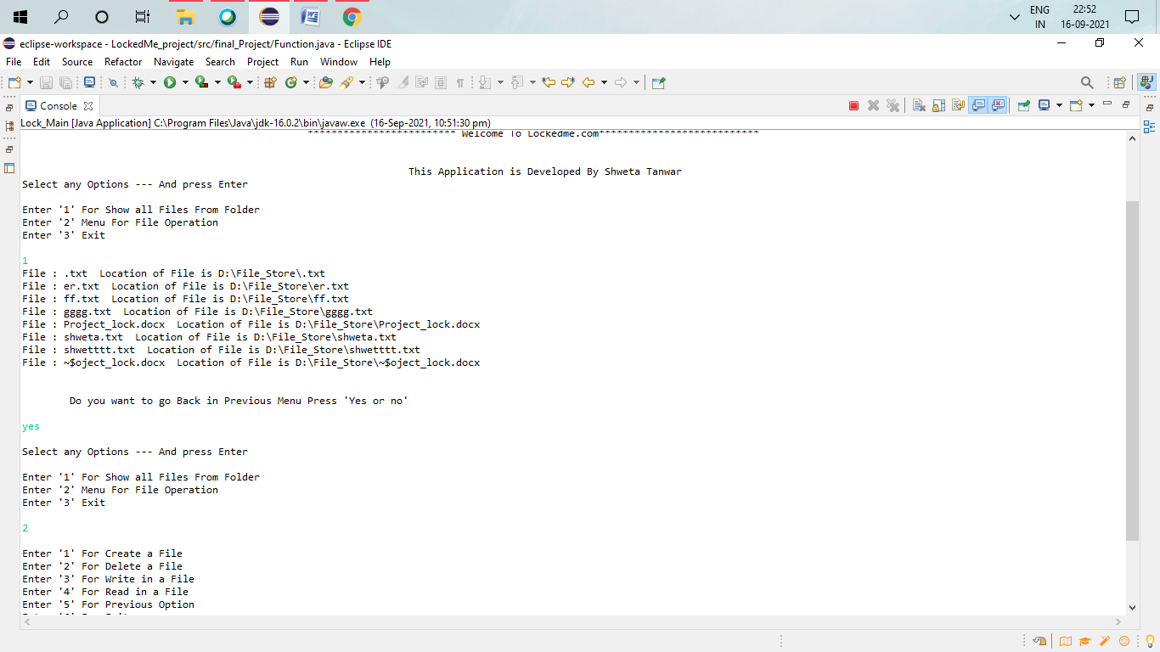

1. **Concepts used in coding**

Most common method has been used in this project. Some of them are Class, Object, Inheritance,Tread , Methods, Operators , Available class and Methods has been imported in this project.

Some of the Conditional statements, String related function has been used. OOPS concepts has been used in this project.

1. **Scrum**

During the scrum we do meeting with the product owner, sprint master , developer team members , and understood the requirements , user stories, product log and decided to make 2 sprints to complete this application.

* 1. **Sprint 1-**

1. Time Period for this sprint is 1 week. In this sprint individual person has been assigned different class to create.
2. 5 different classes has been assigned to different members according to there capabilities.
3. Daily scrum call has been scheduled , so that the members can coordinate with each other.
   1. **Sprint 2**-
4. Time period for this sprint is 3 days . In this sprint all different classes will be assemble into one project.
5. Developer team will assure that all function are working fine together.
6. By giving different type of inputs the functionality will be check in every condition.
7. Hence it’s an application based on coding , member will try to find bug and fix it.
8. Secure access to application , data security ,user access limitation , owner privileges will be assure in this sprints.
9. **Github-**

**https://github.com/ShwetaTanwar/Cal_java/tree/master/LockedMe_project/src/final_Project**

All the coding of this project is available on github for future reference to do any change or to take reference for a new project.

1. **Flow- chart**

|  |
| --- |
| Start  Main Menu  If else  1 3 2  Wrong input    Show file name    Exit    Go back  Yes no  Exit  Yes no  Go back  Operation menus  6  else  if  1 3 2 4 5 6    File Create  Delete  **Create**  Read  Write  Show Files  Show Files  Show File    No No No  Write  yes  yes  yes Yes  File list    File list  File list  no  yes  Read File  Delete File  Write File  Go back  yes  Exit  no |