Github link :- <https://github.com/ShwetaTanwar/codetest>

Binary exe link :- <https://github.com/ShwetaTanwar/codetest/blob/main/check.exe>

These are the result for given year-month

\* Fill in the results for the following inputs:

\* 2013-01: expected revenue: $8100.00, expected total capacity of the unreserved offices: 254

\* 2013-06: expected revenue: $15150.00, expected total capacity of the unreserved offices: 241

\* 2014-03: expected revenue: $37214.52, expected total capacity of the unreserved offices: 203

\* 2014-09: expected revenue: $86700.00, expected total capacity of the unreserved offices: 120

\* 2015-07: expected revenue: $76225.81, expected total capacity of the unreserved offices: 135

Below is an example. Once we download binary check.exe we need to place it at the current location. Then run cmd - .\check.exe

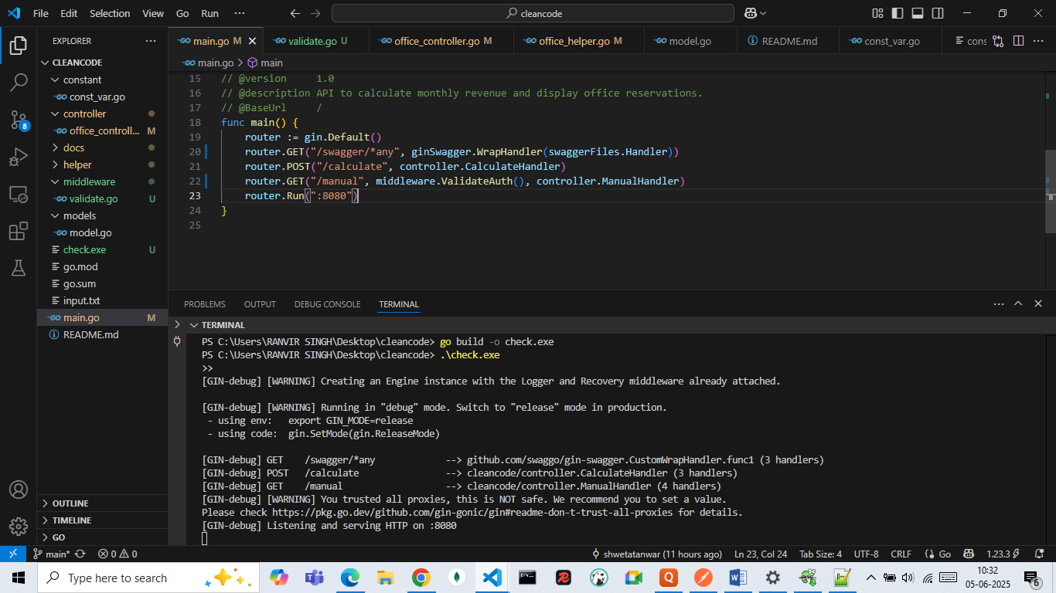

About the APis:-

By default it will run on port 8080, swagger is implemented. once application is up and running we can go to this url in browser

"http://localhost:8080/swagger/index.html"

2 REST api is implemented.

1. /calculate [POST api] :- This api is expecting {"month" : "yyyy-mm"} we can get output in expected format. Swagger example:-

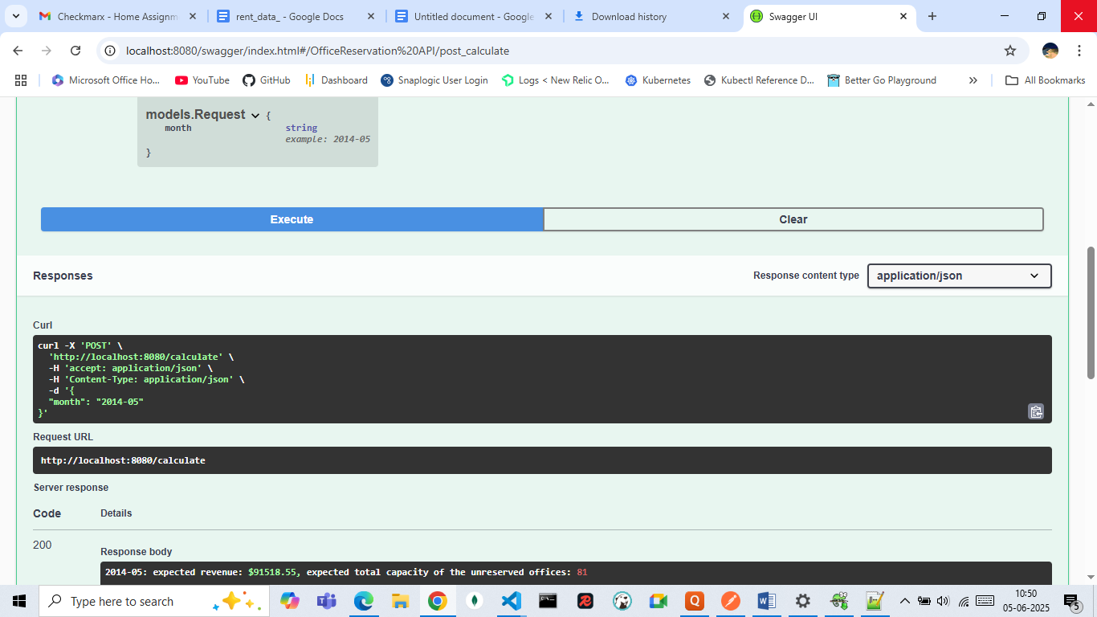

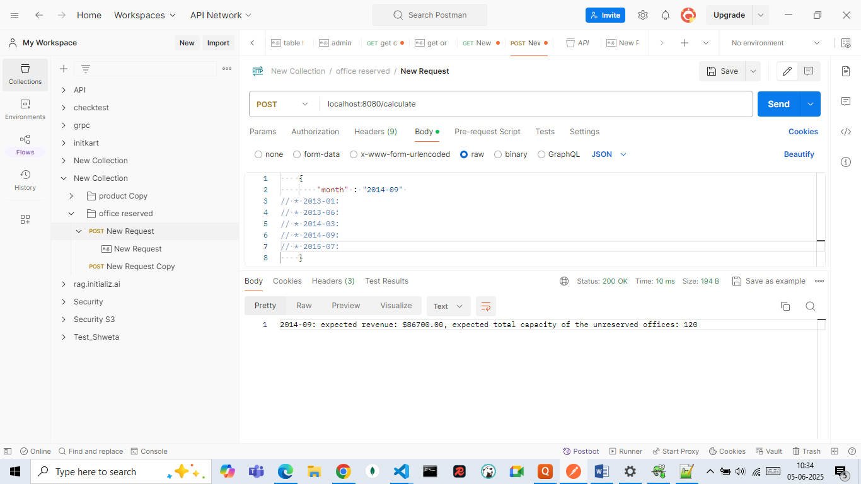

2. /manual [GET api] :- This api is for admin , to invoke the api we need to add authorization.

On swagger Authorization "Bearer" would be shown already don't delete that just add token "checkmarx" to access api.

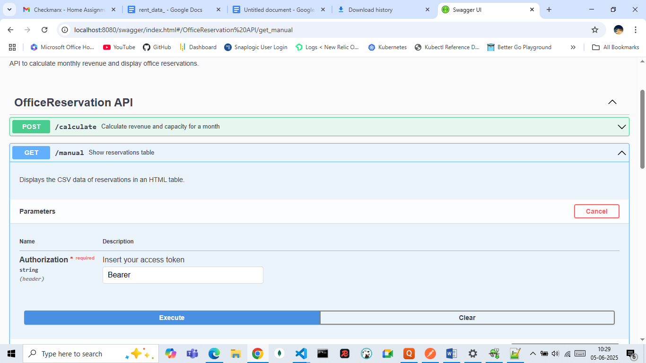

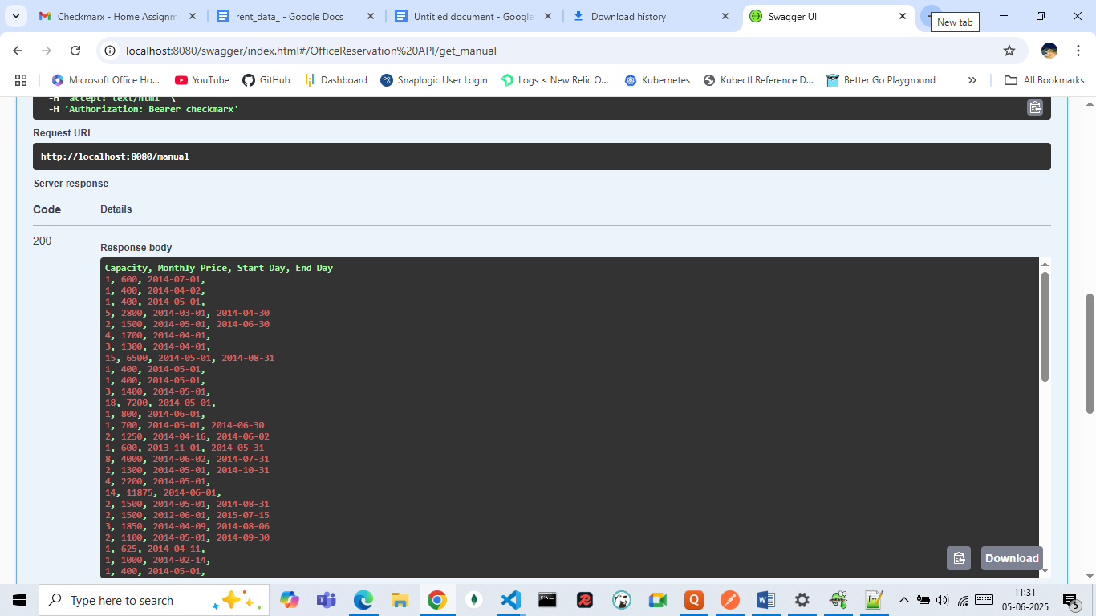

Sample unauthorize message when token is not correct

