REALATIONAL

DATABASE

MANAGEMNET

SYSTEM PROJECT

[Pantaloons Store management system]

ENROLLMENT NO: 1706027

SHWETA GABHANE

MARCH, 2019

Pantaloons Store Management System Project Report

A relational database management system(RDBMS) is a database management system based on the relational model invented by E.F.Codd . Most of the databases in widespread used today are based on his relational database model.

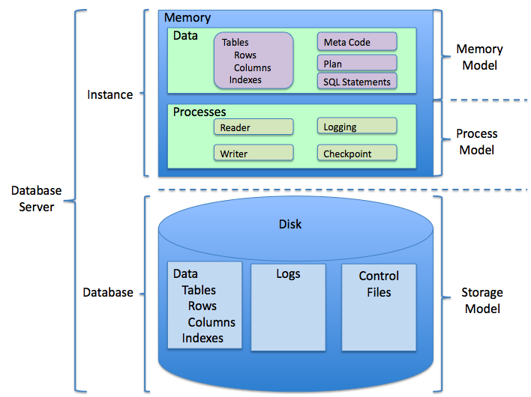

RDBMS have been a common choice for the storage of information in databases used for financial record, manufacturing and logistical information personal data and other application. Relational Databases have often replaced legacy hierarchical databases and network databases because they were easier to implement.

Functional Dependency

Functional Dependency is a set of constraints between two attributes in a relation. It says that if two tuples have same values for attributes A1,A2,..An, then same values for attributes B1,B2,..Bn. Functional Dependency by an arrow sign ( -> ) that X -> Y, where X functionally determines Y . The left hand side attributes determine the value of attributes on the right hand side.

Normalization

If a database design is not perfect it may contain anomalies , which are like a bad dream for any database administrator . Managing a database with anomalies is next to impossible.

* Update Anomalies
* Deletion Anomalies
* Insert Anomalies

Normalization is a method to remove all these anomalies and bring the database to a consistent state.

* First Normal Form

First normal form is defined in the defined in the definition of relations (tables) itself. This rule defines that all the attributes in a relation must have atomic values/domains .

* Second Normal Form

If we follow second normal form,then every non-prime attribute should be fully functional dependent on prime key attribute i.e. if X->A holds, then there should be not be any proper subset Y or X for which Y->A also holds true.

Entity Relationship Diagram for Pantaloons Clothing System

Create Table Women

create table women(women_id int not null,men_brand varchar(255),primary key(women_id));



Inserting Values in Table Women

insert into women values(1011,'Vero Moda');

insert into women values(1012,'Vero Moda');

insert into women values(1013,'Vero Moda');

insert into women values(1021,'Ginger');

insert into women values(1022,'Ginger');

insert into women values(1023,'Ginger');

insert into women values(1031,'Zara');

insert into women values(1032,'Zara');

insert into women values(1033,'Zara');

insert into women values(1041,'Max');

insert into women values(1042,'Max');

insert into women values(1043,'Max');

insert into women values(1051,'Agibe');

insert into women values(1052,'Agibe');

insert into women values(1053,'Agibe');

Describe Table Women

desc women;

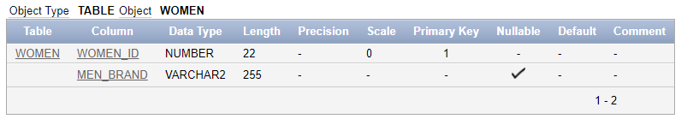

Display Table Women

select *from women;

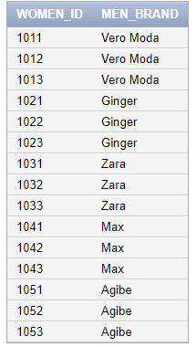

Create Table Men

create table men(men_id int not null,men_brand varchar(255),primary key(men_id));



Describe Table Men

desc men;

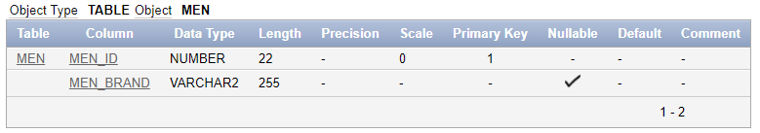

Inserting Values in Table Men

insert into men values(101,'Allen Solly');

insert into men values(102,'Allen Solly');

insert into men values(103,'Allen Solly');

insert into men values(201,'Louis Phillipe');

insert into men values(202,'Louis Phillipe');

insert into men values(203,'Louis Phillipe');

insert into men values(301,'Lee Cooper');

insert into men values(302,'Lee Cooper');

insert into men values(303,'Lee Cooper');

insert into men values(401,'Puma');

insert into men values(402,'Puma');

insert into men values(403,'Puma');

insert into men values(501,'Nike');

insert into men values(502,'Nike');

insert into men values(503,'Nike');

Display Table Men

select *from men;

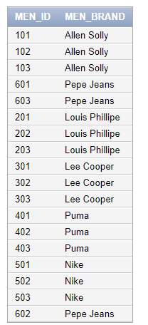

Create Table Kids

create table kids(kids_id int not null,kids_brand varchar(255),primary key(kids_id));



Describe Table Kids

Desc kids;

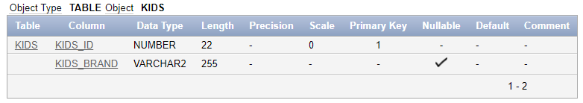

Inserting Values in Table Kids

insert into kids values(601,'Disney');

insert into kids values(602,'Disney');

insert into kids values(603,'Disney');

insert into kids values(701,'Gini and Jony');

insert into kids values(102,'Gini and Jony');

insert into kids values(703,'Gini and Jony');

insert into kids values(801,'Cartoon network');

insert into kids values(802,'Cartoon network');

insert into kids values(803,'Cartoon network');

insert into kids values(901,'Angry Birds');

insert into kids values(902,'Angry Birds');

insert into kids values(903,'Angry Birds');

insert into kids values(1001,'Aarika');

insert into kids values(1002,'Aarika');

insert into kids values(1003,'Aarika');

Display Table Kids

Select *from kids;

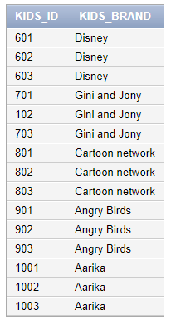

Create Table Women_Tees

create table women_tees(b_id int not null,b_name varchar(244),b_size varchar(2),foreign key(b_id) references women(women_id));



Describe Table Women_Tees

Desc women_tees;

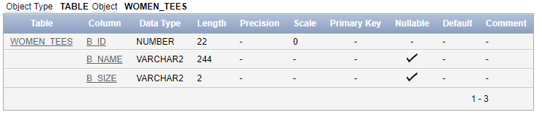

Inserting Values in Table Women_Tees

insert into women_tees values(1011,'Vero Moda','S');

insert into women_tees values(1011,'Vero Moda','M');

insert into women_tees values(1011,'Vero Moda','L');

insert into women_tees values(1021,'Ginger','S');

insert into women_tees values(1021,'Ginger','M');

insert into women_tees values(1021,'Ginger','L');

insert into women_tees values(1031,'Zara','S');

insert into women_tees values(1031,'Zara','M');

insert into women_tees values(1031,'Zara','L');

insert into women_tees values(1041,'Max','S');

insert into women_tees values(1041,'Max','M');

insert into women_tees values(1041,'Max','L');

insert into women_tees values(1051,'Agibe','S');

insert into women_tees values(1051,'Agibe','M');

insert into women_tees values(1051,'Agibe','L');

Display Table Women_Tees

select *from women_tees;

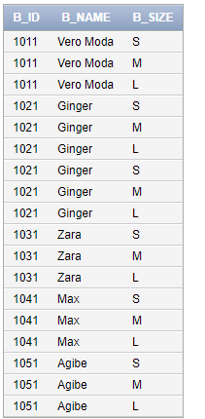

Create Table Women_Sweatshirts

create table women_sweatshirt(b_id int not null,b_name varchar(244),b_size varchar(2),foreign key(b_id) references women(women_id));



Describe Table Women_Sweatshirts

Desc women_sweatshirts;

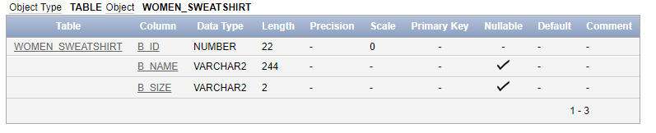

Inserting Values in Table Women_Sweatshirt

insert into women_sweatshirt values(1012,'Vero Moda','S');

insert into women_sweatshirt values(1012,'Vero Moda','M');

insert into women_sweatshirt values(1012,'Vero Moda','L');

insert into women_sweatshirt values(1022,'Ginger','S');

insert into women_sweatshirt values(1022,'Ginger','M');

insert into women_sweatshirt values(1022,'Ginger','L');

insert into women_sweatshirt values(1032,'Zara','S');

insert into women_sweatshirt values(1032,'Zara','M');

insert into women_sweatshirt values(1032,'Zara','L');

insert into women_sweatshirt values(1042,'Max','S');

insert into women_sweatshirt values(1042,'Max','M');

insert into women_sweatshirt values(1042,'Max','L');

insert into women_sweatshirt values(1052,'Agibe','S');

insert into women_sweatshirt values(1052,'Agibe','M');

insert into women_sweatshirt values(1052,'Agibe','L');

Display Table Women_Sweatshirt

select *from women_sweatshirt;

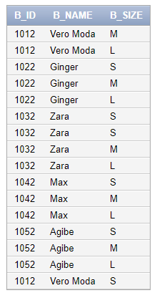

Create Table Women_Jeans

create table women_jeans(b_id int not null,b_name varchar(244),b_size varchar(2),foreign key(b_id) references women(women_id));



Describe Table Women_Jeans

Desc women_jeans;

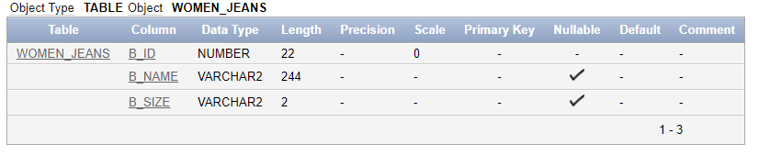

Inserting Values in Table Women_Jeans

insert into women_jeans values(1013,'Vero Moda','S');

insert into women_jeans values(1013,'Vero Moda','M');

insert into women_jeans values(1013,'Vero Moda','L');

insert into women_jeans values(1023,'Ginger','S');

insert into women_jeans values(1023,'Ginger','M');

insert into women_jeans values(1023,'Ginger','L');

insert into women_jeans values(1033,'Zara','S');

insert into women_jeans values(1033,'Zara','M');

insert into women_jeans values(1033,'Zara','L');

insert into women_jeans values(1043,'Max','S');

insert into women_jeans values(1043,'Max','M');

insert into women_jeans values(1043,'Max','L');

insert into women_jeans values(1053,'Agibe','S');

insert into women_jeans values(1053,'Agibe','M');

insert into women_jeans values(1053,'Agibe','L');

Display Table Women_Jeans

select *from women_jeans;

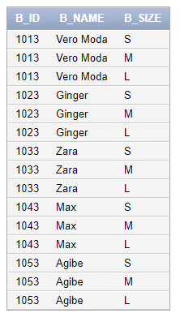

Create Table Men_Chinos

create table casual_chinos(b_id int not null,b_name varchar(244),b_size varchar(2),foreign key(b_id) references men(men_id));



Describe Table Men_Chinos

Desc casual_chinos;

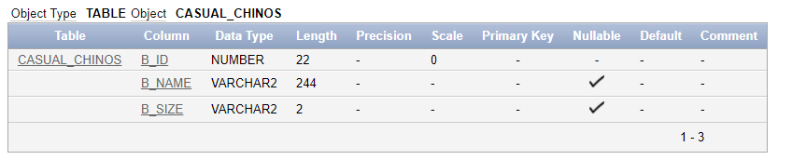

Inserting Values in Table Men_Chinos

insert into casual_chinos values(103,'Allen Solly','S');

insert into casual_chinos values(103,'Allen Solly','M');

insert into casual_chinos values(103,'Allen Solly','L');

insert into casual_chinos values(203,'Louis Phillipe','S');

insert into casual_chinos values(203,'Louis Phillipe','M');

insert into casual_chinos values(203,'Louis Phillipe','L');

insert into casual_chinos values(303,'Lee Cooper','S');

insert into casual_chinos values(303,'Lee Cooper','M');

insert into casual_chinos values(303,'Lee Cooper','L');

insert into casual_chinos values(403,'Nike','S');

insert into casual_chinos values(403,'Nike','L');

insert into casual_chinos values(403,'Nike','M');

insert into casual_chinos values(503,'Puma','S');

insert into casual_chinos values(503,'Puma','M');

insert into casual_chinos values(503,'Puma','L');

Display Table Men_Chinos

select *from casual_chinos;

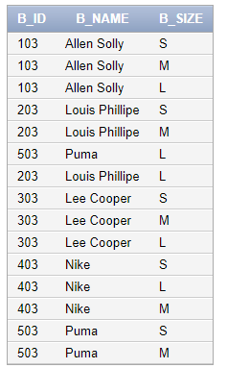

Create Table Men_Jeans

create table casual_jeans(b_id int not null,b_name varchar(244),b_size varchar(2),foreign key(b_id) references men(men_id));



Describe Table Men_Jeans

Desc casual_jeans;

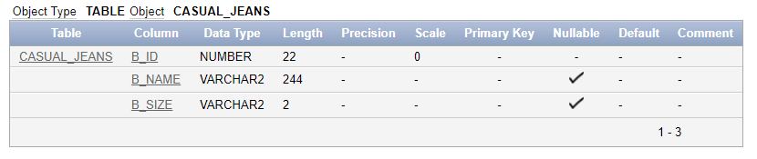

Inserting Values in Table Men_Jeans

insert into casual_jeans values(101,'Allen Solly','S');

insert into casual_jeans values(101,'Allen Solly','M');

insert into casual_jeans values(101,'Allen Solly','L');

insert into casual_jeans values(201,'Louis Phillipe','S');

insert into casual_jeans values(201,'Louis Phillipe','M');

insert into casual_jeans values(201,'Louis Phillipe','L');

insert into casual_jeans values(301,'Lee Cooper','S');

insert into casual_jeans values(301,'Lee Cooper','M');

insert into casual_jeans values(301,'Lee Cooper','L');

insert into casual_jeans values(401,'Nike','S');

insert into casual_jeans values(401,'Nike','L');

insert into casual_jeans values(401,'Nike','M');

insert into casual_jeans values(501,'Puma','S');

insert into casual_jeans values(501,'Puma','M');

insert into casual_jeans values(501,'Puma','L');

Display Table Men_Jeans

select *from casual_jeans;

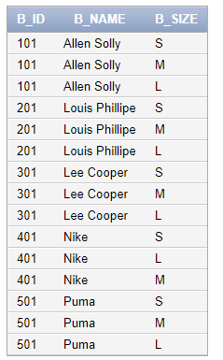

Create Table Kids_Jeans

create table kids_jeans(b_id int not null,b_name varchar(244),b_size varchar(2),foreign key(b_id) references kids(kids_id));



Describe Table Kids_Jeans

Desc kids_jeans;

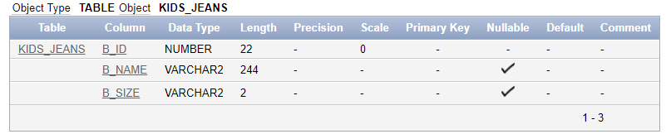

Inserting Values in Table Kids_Jeans

insert into kids_jeans values(601,'Disney','S');

insert into kids_jeans values(601,'Disney','M');

insert into kids_jeans values(601,'Disney','L');

insert into kids_jeans values(701,'Gini and Jony','S');

insert into kids_jeans values(701,'Gini and Jony','M');

insert into kids_jeans values(701,'Gini and Jony','L');

insert into kids_jeans values(801,'Cartoon Network','S');

insert into kids_jeans values(801,'Cartoon Network','M');

insert into kids_jeans values(801,'Cartoon Network','L');

insert into kids_jeans values(901,'Angry Birds','S');

insert into kids_jeans values(901,'Angry Birds','M');

insert into kids_jeans values(901,'Angry Birds','L');

insert into kids_jeans values(1001,'Aarika','S');

insert into kids_jeans values(1001,'Aarika','M');

insert into kids_jeans values(1001,'Aarika','L');

Display Table Kids_Jeans

select *from kids_jeans;

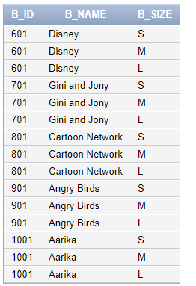

Create Table Kids_Dress

create table kids_dress(b_id int not null,b_name varchar(244),b_size varchar(2),foreign key(b_id) references kids(kids_id));



Describe Table Kids_Dress

Desc kids_dress;

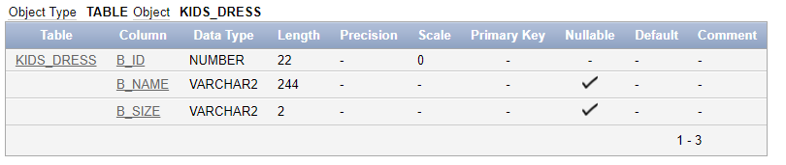

Inserting Values in Table Kids_Dress

insert into kids_dress values(602,'Disney','S');

insert into kids_dress values(602,'Disney','M');

insert into kids_dress values(602,'Disney','L');

insert into kids_dress values(102,'Gini and Jony','S');

insert into kids_dress values(102,'Gini and Jony','M');

insert into kids_dress values(102,'Gini and Jony','L');

insert into kids_dress values(802,'Cartoon Network','S');

insert into kids_dress values(802,'Cartoon Network','M');

insert into kids_dress values(802,'Cartoon Network','L');

insert into kids_dress values(902,'Angry Birds','S');

insert into kids_dress values(902,'Angry Birds','M');

insert into kids_dress values(902,'Angry Birds','L');

insert into kids_dress values(1002,'Aarika','S');

insert into kids_dress values(1002,'Aarika','M');

insert into kids_dress values(1002,'Aarika','L');

Display Table Kids_Dress

select *from kids_Dress;

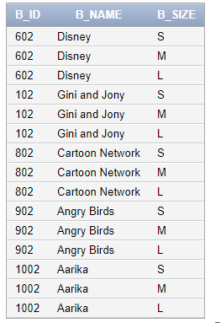

Create Table Kids_Shirt

create table kids_shirt(b_id int not null,b_name varchar(244),b_size varchar(2),foreign key(b_id) references kids(kids_id));



Describe Table Kids_Shirt

Desc kids_shirt;

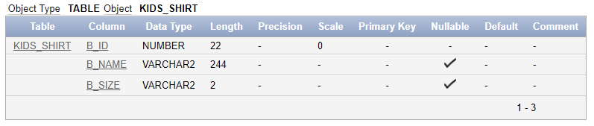

Inserting Values in Table Kids_Shirt

insert into kids_shirt values(602,'Disney','S');

insert into kids_shirt values(602,'Disney','M');

insert into kids_shirt values(602,'Disney','L');

insert into kids_shirt values(102,'Gini and Jony','S');

insert into kids_shirt values(102,'Gini and Jony','M');

insert into kids_shirt values(102,'Gini and Jony','L');

insert into kids_shirt values(802,'Cartoon Network','S');

insert into kids_shirt values(802,'Cartoon Network','M');

insert into kids_shirt values(802,'Cartoon Network','L');

insert into kids_shirt values(902,'Angry Birds','S');

insert into kids_shirt values(902,'Angry Birds','M');

insert into kids_shirt values(902,'Angry Birds','L');

insert into kids_shirt values(1002,'Aarika','S');

insert into kids_shirt values(1002,'Aarika','M');

insert into kids_shirt values(1002,'Aarika','L');

Display Table Kids_Shirt

select *from kids_shirt;

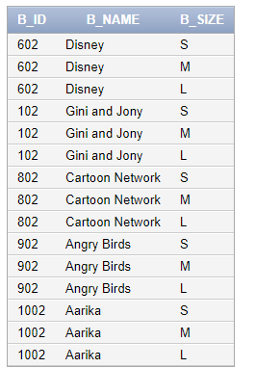

Create Table Shoes

create table shoes(shoe_no int not null,shoe_size int,shoe_brand varchar(255),primary key(shoe_no));



Describe Table Shoes

Desc shoes;

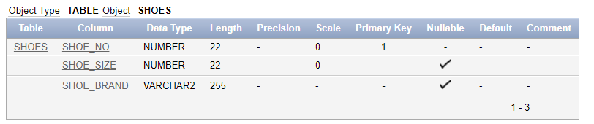

Inserting values in Shoes

insert into shoes values(1024,38,'Nike');

insert into shoes values(1025,39,'Nike');

insert into shoes values(1026,40,'Nike');

insert into shoes values(1027,41,'Nike');

insert into shoes values(1028,38,'Reebok');

insert into shoes values(1029,39,'Reebok');

insert into shoes values(1030,40,'Reebok');

insert into shoes values(1031,41,'Reebok');

insert into shoes values(1018,38,'Bata');

insert into shoes values(1019,39,'Bata');

insert into shoes values(1020,40,'Bata');

insert into shoes values(1021,41,'Bata');

insert into shoes values(128,38,'Metro');

insert into shoes values(129,39,'Metro');

insert into shoes values(130,40,'Metro');

insert into shoes values(131,41,'Metro');

insert into shoes values(1281,38,'Honey');

insert into shoes values(1291,39,'Honey');

insert into shoes values(1301,40,'Honey');

insert into shoes values(1311,41,'Honey');

Display Table Shoes

select *from shoes;

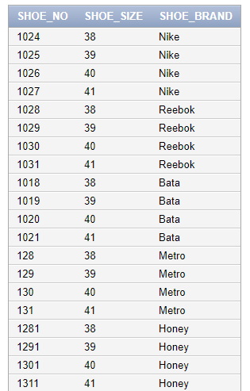

Arithmetic Operators

select *from shoes where shoe_size=38;

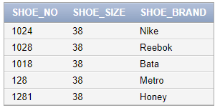

select *from shoes where shoe_size>38;

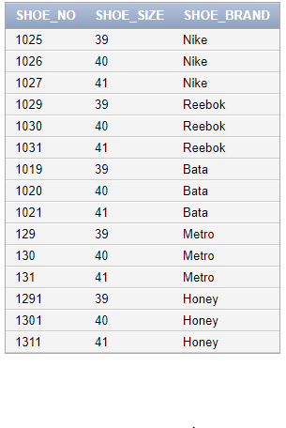

select *from shoes where shoe_size<38;

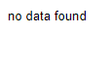

select *from shoes where shoe_size>=38;

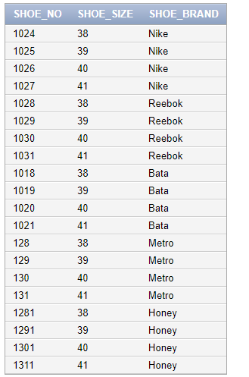

Set Operator

* Union All

select *from men union all select *from women;

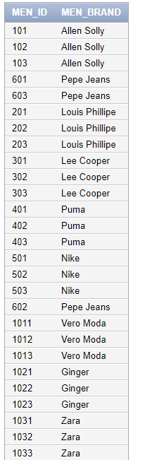

* Union

select *from kids union select *from men;

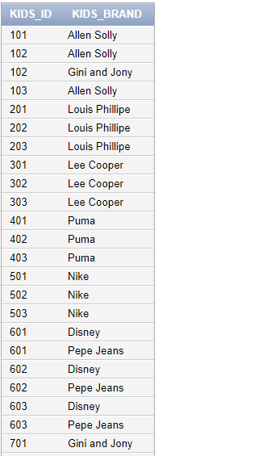

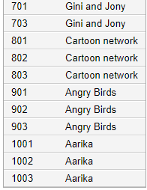

* Minus

select *from kids minus select *from men;

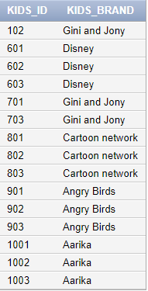

JOINS

* Inner Join

select men_id,men_brand

from men

inner join casual_chinos

on men.men_id=casual_chinos.b_id;

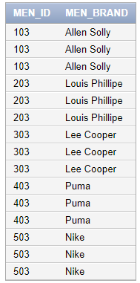

* Left Join

select women_id,men_brand

from women

left join women_sweatshirt

on women.women_id=women_sweatshirt.b_id;

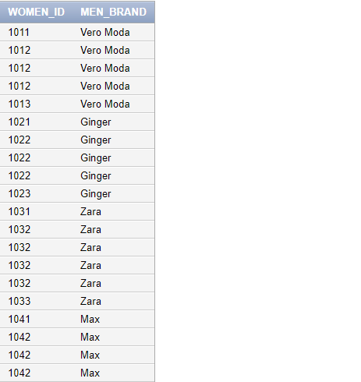

* Right Join

select kids_id,kids_brand

from kids

right join kids_dress

on kids.kids_id=kids_dress.b_id;

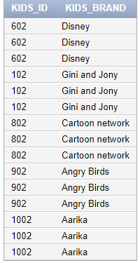

* Full Join

select kids_id,kids_brand

from kids

full join kids_dress

on kids.kids_id=kids_dress.b_id;

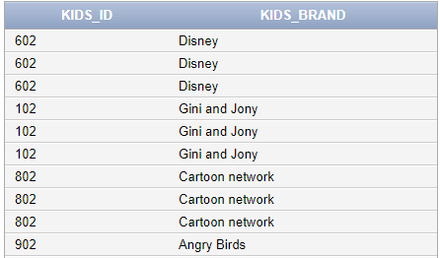

Clauses

* Order by Clause

select *from kids order by kids_id,kids_brand;

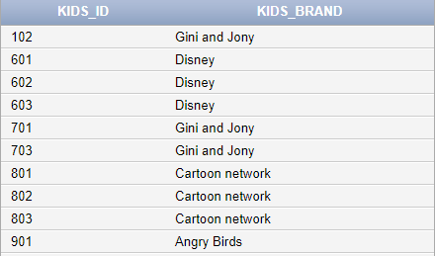

* Order by Clause (In Descending Order)

select *from kids_dress order by b_name DESC;

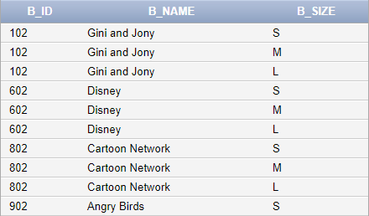

* Group by Clause

select b_name,sum(b_id) as b_id

from women_tees

group by b_name;

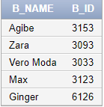

* Having Clause

select b_name

from women_tees

group by b_name

having count(b_id)=3;

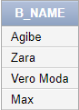

VIEWS

* Create View

create view men_v as

select men_id,men_brand

from men;



* Display View

select men_id,men_brand

from men_v

where men_brand='Allen Solly';

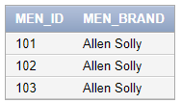

* Deleting Rows into a View

delete from men_v where men_id=104;

delete from men_v where men_id=105;



* Drop View

drop view men_v;



SEQUENCE

* Create Sequence

create sequence s2

start with 801

increment by 1

maxvalue 803;



* Inserting Values Using Sequence

insert into men values(s2.nextval,'Raymond');



insert into men values(s2.nextval,'Raymond');



insert into men values(s2.nextval,'Raymond');



* Drop Sequence

drop sequence s2;



INDEXES

* Create Index

create index w_index on women(men_brand);



* Drop Index

drop index w_index;

