Chapter 1

SYNOPSIS

TITLE
Information Fusion for multi-sensory data

1.4 TECHNICAL KEY WORDS (IN BRIEF)
- Information fusion
- Sensor fusion
- Supervised learning
- Unsupervised learning
- Machine learning
- Decision making

1.5 RELEVANT MATHEMATICS ASSOCIATED WITH THE DISSERTATION
Proposed mathematical model is based on TOC [Theory of computation], Averages and Probability. To do mathematical formation I have considered one simple scenario of space application; scenario- suppose astronaut wants to go outside the spaceship, he or she should check the temperature, pressure, oxygen, humidity outside the spaceship. Upon that calculations and analysis he or she can take accurate decision. For information fusion part mathematical formulation is done with averages and unsupervised decision making is done with probability. Here, Decision making and fusion process are unsupervised. That is it process its current inputs at every state and it requires output at every given input. Deterministic and nondeterministic finite automata give the output or decision only in YES or NO format i.e. in Boolean logic 1 or 0 logic. We require ranges of decisions as per inputs it’s just like human brain gives decisions. Because of that I consider mealy machine to frame the mathematical modeling with averages and probability.

A Mealy Machine is an FSM whose output depends on the present state as well as the present input.
It can be described by a 6 tuples (Q, ∑, O, δ, X, q₀) where −
1. Q is a finite set of states.
2.∑ is a finite set of symbols called the input alphabet.
3. O is a finite set of symbols called the output alphabet.
4.δ is the input transition function where δ: Q × ∑ → Q
5. X is the output transition function where X: Q → O
6. q₀ is the initial state from where any input is processed (q₀ ∈ Q).

1] Real time sensory data is generated from heterogeneous or homogeneous sensory resources.
Input-
∑- input alphabets
∑= {T_{S,} P_{S,}H_{S,} O_{S,} Total-average, Probability(P)}
Input data may contain some conflicts, ambiguity, uncertainty, incorrectness, and noisy data. This is denoted as
X_{n}-noisy data
X_{u}-uncertainty
X_{C}-conflicts
X_{incorrect-data}- incorrect-data
Simply total data collected or generated from sensors as
Sensor 1
S₁₌ ∑ S_{i} + X_{n}+ X_{u}+ X_{C}+ X_{incorrect-data}
Sensor 2
S₂ ₌ ∑ S_{i} + X_{n}+ X_{u}+ X_{C}+ X_{incorrect-data}
in the same way for n number of sensors.
Sensor n
S_{n =} ∑ S_{i} + X_{n}+ X_{u}+ X_{C}+ X_{incorrect-data}
Here consider 4 sensors as Temperature, Humidity, Pressure and Oxygen.
- Q={Data, Information, Knowledge, Decisions/actions}
- q0= Data (initial state)
- O= Decisions (Final state)
- δ is the input transition function where δ: Q × ∑ → Q
- X is the output transition function where X: Q → O
2] In the next phase some supervised or semi supervised processing is done on collected sensory data such as cleaning, monitoring, preprocessing etc.

3] After preprocessing and cleaning we get the information from collected sensory data. This information is input to the fusion process or algorithm. Fusion algorithm is based on deep unsupervised technique.

Total number of values to generate from temperature, humidity, pressure and oxygen sensors are = n
This can be set while generating data from sensors by using raspberry pi or aurdiuno kit.
A] Temperature sensor data-
1. T_{s} =∑⁰_{i=1} t_{si}
T_{s} = {t1, t2, t3….tn}
2. Average of temperature sensor data
A t_{si} = ∑⁰_{i=1} t_{si} / n
= T_{s} / n
B] Humidity sensor data-
1. H_{s} =∑⁰_{i=1} h_{si}
H_{s} = {h1, h2, h3….hn}
2. Average of Humidity sensor data
A h_{si}= ∑⁰_{i=1} h_{si} / n
= H_{s} / n
C] Pressure sensor data-
1. P_{s} =∑⁰_{i=1} p_{si}
P_{s} = {p1, p2, p3….pn}
2. Average of Pressure sensor data
A p_{si}= ∑⁰_{i=1} p_{si} / n
= A_{s} / n
D] Oxygen sensor data-
1. O_{s} =∑⁰_{i=1} o_{si}
O_{s} = {o1, 02, o3….on}
2. Average of Pressure sensor data
A o_{si}= ∑⁰_{i=1} o_{si} / n
= O_{s} / n

Total-average = A t_{si}+ A h_{si} + A p_{si}+ A o_{si}

4]After fusion process we will get the structured and formatted information , by analyzing this information we can generate single inference parameter. It is denoted as Inf.
5] we can use generated inference parameter Inf to take intelligent decisions as per applications.
6] Probability is used to formulate the unsupervised decisions.
Conditional probability is used to calculate the weights [wi] as denoted in figure[] assigned to random variables- it is calculated by using bays rule
P (A and B) = P (A) x P (B|A)
P (A) means "Probability of Event A"
P (B|A) means "Event B given Event A"
P (A) x P (B|A) = P (A and B)
P (B|A) = P (A and B) / P(A)
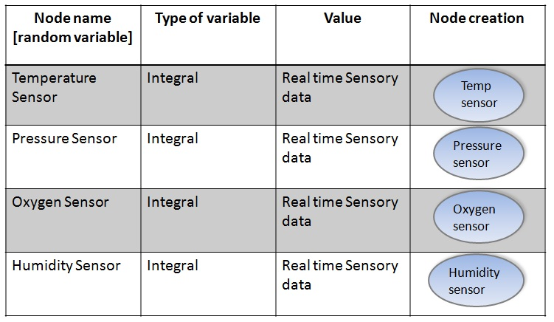
Table 3: Network creation

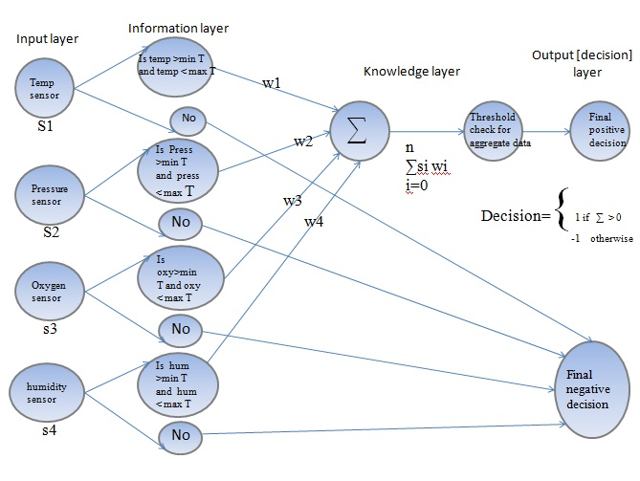
Figure: Mathematical Model
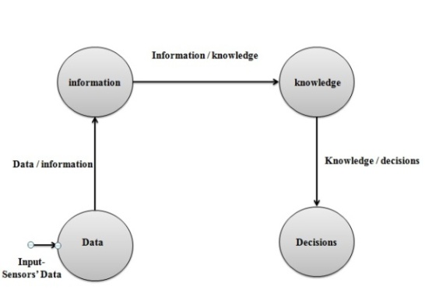
Figure 16: state transition diagram [mathematical model]

1.6 NAMES OF AT LEAST TWO CONFERENCES WHERE PAPER
(SEM I AND SEM II) CAN BE PUBLISHED
Table 1: List of publications
No. | TITLE | CONFERENCE/  JOURNAL | SUBMISSION  DETAILS
1. | Information fusion for multisensory data | The sixth Post Graduate Symposium of Computer En-  gineering, cPGCON 2017 | cPGCON, March,  2017.
2 | State of the art of Information fusion for multisensory data | International Journal of Advance Research in Science and Engineering (ISSN: 2319-8354). | ID:IJARSE/July 2017/699 Volume 06
3 | Mathematical modeleling and methodology of Information fusion for multisensory data | ICCUBEA 2017 | In process

REVIEW OF CONFERENCE/JOURNAL PAPERS SUPPORTING DISSERTATION IDEA
[1]Henrik Boström, Sten F. Andler, Marcus Brohede, Ronnie Johansson, Alexander Karlsson, Joeri van Laere, Lars Niklasson, Maria Nilsson, Anne Persson, Tom Ziemke, “On the Definition of Information Fusion as a Field of Research” , School of Humanities and Informatics University of Skövde.
[2] Olin H.Bray, “Information Integration for Data Fusion”, Strategic business development sandia national laboratories1997.
[3] Bahador Khaleghi, Alaa Khamis, Fakhreddine O. Karray, “Information Fusion:Multisensor data fusion: A review of the state-of-the-art” , sciverse sciencedirect ,Elsevier 2011.
[4] Eduardo f. Nakamura, antonio a. F. Loureiro federal university of minas gerais –ufmg and alejandro c. Frery federal university of alagoas – ufal , “information fusion for wireless sensor networks: methods, models, and classifications” , acm computing surveys, vol. 39, no. 3, article 9, publication date: august 2007.
[5] Ren C. Luo, Fellow, IEEE, and Chih-Chia Chang, “Multisensor Fusion and Integration: A Review on Approaches and Its Applications in Mechatronics” , IEEE transactions on industrial informatics, vol. 8, no. 1, february 2012.
[6] Feng Zhao,Leonidas J. Guibas, “Wireless Sensor Networks” , Elsevier.
[7] dr. Parikshit n. Mahalle **, prof. Saudagar s. Barde#, prof. Poonam n. Railkar*, “Information fusion towards multi-sensor data using cognitive computing approach.”
[8] Zhi-Jun Lua,b,*, Qian Xiangb , Lan Xub, “An Application Case Study on Multi-sensor Data fusion System for Intelligent Process Monitoring” , sciencedirect.
[9]Mourad Barkat, “Signal Detection and Estimation.
[10] The Role of Sensor Fusion in the Internet of Things | Mouser

1.8 PLAN OF DISSERTATION EXECUTION

summarizes various tasks being carried out in estimated duration of weeks.

Table 1.2: Timeline schedule of the Project Work Task Description D
Work Task | Description | Duration
Literature Research |  | 6 weeks
System Analysis |  | 3 weeks
Design and Planning | - Modeling and design of system  - Test plan and estimation  - Module wise complexity | 8 weeks
Implementation | Divided into phases
Phase A | Implementation of module 1 | 3 weeks
Phase B | Implementation of module 2 | 4 weeks
Phase C | Implementation of module 3 | 5 weeks
System Testing | Test system quality, fix errors if any and improve if needed. Test system for different datasets. | 3 weeks
Initial Report | Prepare and upload Initial Report | 2 weeks
Final Report | Prepare and upload Initial Report | 2 weeks

1.9 PROBLEM STATEMENT, SOLVING APPROACH AND EFFICIENCY ISSUES

1.9.1 Problem Statement

The objective of this research project is to address information fusion problem by investigating novel algorithm.
A] To collect data from heterogeneous sources
B] Aggregate data to one uniform resource
C] Fusion with primary focus on accuracy, reliability to make intelligent decisions
1.9.2 Solving Approach and Efficiency Issues

Mathematical Modeling
Mathematical modeling works as a very important tool in the research domain. There are various natural languages are spoken in the world. If researchers from various countries put their idea in the form of statements, the other researchers who want to read that idea may find some ambiguity. Every natural language has one major drawback is that some words in natural languages create ambiguity. Same words in natural languages are used different context so it will lead to confusion to the reader. It becomes very necessary to remove ambiguity to understand the concept. Mathematical modeling plays an important role in removing this ambiguity.

1.10 OUTCOMES
The performance of Information Fusion system is given below

1. Sensory data is generated from sensors by using arduino uno board
2. Data is collected in one resource sql server database.
3. Fusion is done by using mathematical formation
4. Decisions are made by using weka tool.

Chapter 2
TECHNICAL KEYWORDS

1. INFORMATION FUSION

Information Fusion is a technology which integrates the data from multiple heterogeneous or homogeneous sources and produces better result than sum of their individual results. Information Fusion or Sensor Fusion system is used to solve problems in various domains like Artificial Intelligence, Cognitive Computing, Neural Network, Machine Learning, and Soft Computing. Basically problem is divided into four sections: a) Collect the observations or data from multiple heterogeneous or homogeneous sources. b) Extract the required information (data analysis, filtering and estimation). c) Draw some logical inferences (based on some comparisons and evaluation) and d) Make some adequate and good decisions. Information Fusion system have several applications in above specified domains ranging from home automation, military applications, health care, remote sensing, to space science.

2. SENSOR FUSION

Sensor fusion is a subset of information fusion and gets the data from only sensory resources. Sensor fusion provides the better results, better analysis, performance and better decision making because different types of sensors have different strength and weaknesses, the strength of one type can compensate for the weakness of other type. Extra sensors could work as backup if other fails.

3. SUPERVISED MACHINE LEARNING

The majority of practical machine learning uses supervised learning. Supervised learning is where you have input variables (x) and an output variable (Y) and you use an algorithm to learn the mapping function from the input to the output.
Y = f(X)
The goal is to approximate the mapping function so well that when you have new input data (x) that you can predict the output variables (Y) for that data. It is called supervised learning because the process of algorithm learning from the training dataset can be thought of as a teacher supervising the learning process. We know the correct answers; the algorithm iteratively makes predictions on the training data and is corrected by the teacher. Learning stops when the algorithm achieves an acceptable level of performance.
Supervised learning problems can be further grouped into regression and classification problems.
- Classification: A classification problem is when the output variable is a category, such as “red” or “blue” or “disease” and “no disease”.
- Regression: A regression problem is when the output variable is a real value, such as “dollars” or “weight”.

4. UNSUPERVISED MACHINE LEARNING

Unsupervised learning is where you only have input data (X) and no corresponding output variables. The goal for unsupervised learning is to model the underlying structure or distribution in the data in order to learn more about the data. These are called unsupervised learning because unlike supervised learning above there are no correct answers and there is no teacher. Algorithms are left to their own devises to discover and present the interesting structure in the data. Unsupervised learning problems can be further grouped into clustering and association problems.
- Clustering: A clustering problem is where you want to discover the inherent groupings in the data, such as grouping customers by purchasing behavior.
- Association: An association rule learning problem is where you want to discover rules that describe large portions of your data, such as people that buy X also tend to buy Y.
Some popular examples of unsupervised learning algorithms are:
- k-means for clustering problems.
- Apriori algorithm for association rule learning problems.

5. SEMI-SUPERVISED MACHINE LEARNING

Problems where you have a large amount of input data (X) and only some of the data is labeled (Y) are called semi-supervised learning problems. These problems sit in between both supervised and unsupervised learning. A good example is a photo archive where only some of the images are labeled, (e.g. dog, cat, person) and the majority are unlabeled. Many real world machine learning problems fall into this area. This is because it can be expensive or time-consuming to label data as it may require access to domain experts. Whereas unlabeled data is cheap and easy to collect and store. You can use unsupervised learning techniques to discover and learn the structure in the input variables. You can also use supervised learning techniques to make best guess predictions for the unlabeled data, feed that data back into the supervised learning algorithm as training data and use the model to make predictions on new unseen data.
- Supervised: All data is labeled and the algorithms learn to predict the output from the input data.
- Unsupervised: All data is unlabeled and the algorithms learn to inherent structure from the input data.
- Semi-supervised: Some data is labeled but most of it is unlabeled and a mixture of supervised and unsupervised techniques can be used.

6. DECISION MAKING

Decision tree learning uses a decision tree (as a predictive model) to go from observations about an item (represented in the branches) to conclusions about the item's target value (represented in the leaves). It is one of the predictive modeling approaches used in statistics, data mining and machine learning. Tree models where the target variable can take a discrete set of values are called classification trees; in these tree structures, leaves represent class labels and branches represent conjunctions of features that lead to those class labels. Decision trees where the target variable can take continuous values (typically real numbers) are called regression trees. In decision analysis, a decision tree can be used to visually and explicitly represent decisions and decision making. In data mining, a decision tree describes data (but the resulting classification tree can be an input for decision making). This page deals with decision trees in data mining.

7. MACHINE LEARNING

Machine learning is a type of artificial intelligence (AI) that provides computers with the ability to learn without being explicitly programmed. Machine learning focuses on the development of computer programs that can change when exposed to new data. The process of machine learning is similar to that of data mining.

Chapter 3
Introduction

3.1 INTRODUCTION OF TOPIC

Information Fusion is a technology which integrates the data from multiple heterogeneous or homogeneous sources and produces better result than sum of their individual results. Information Fusion or Sensor Fusion system is used to solve problems in various domains like Artificial Intelligence, Cognitive Computing, Neural Network, Machine Learning, and Soft Computing. Basically problem is divided into four sections: a) Collect the observations or data from multiple heterogeneous or homogeneous sources. b) Extract the required information (data analysis, filtering and estimation). c) Draw some logical inferences (based on some comparisons and evaluation) and d) Make some adequate and good decisions. Information Fusion system have several applications in above specified domains ranging from home automation, military applications, health care, remote sensing, to space science. As per problem classification system should make accurate intelligent decisions for applications. To make intelligent decisions at final phase we have to take special care while fusing the data and generating inference parameter upon fusion result.
Several standard technique are available to fuse the information like Bayesian network, Dempster shaper theory, Kalman filter, center limit theorem, fuzzy logic, and neural network. Some of these techniques are supervised and some are semi supervised. Getting the motivation from our peripheral nervous system, human brain as central processing element, senses input from our five senses such as test, vision, hearing, smell, touch, and take the intelligent supervised or unsupervised decisions. Proposed system provides a novel unsupervised algorithm to fuse the information from various homogeneous or heterogeneous sources and make the intelligent decisions by generating inference parameter. System mainly focuses on reducing conflicts and uncertainty from real time sensory data and makes the accurate and intelligent decisions as per applications.

3.2 MOTIVATION

My motivation towards this concept is human being, peripheral nervous system of human, sensing capabilities of human and brain as central processing element. It motivates me because if we think deeply that how human beings learn things, how brain is the ultimate decision maker and ability to bring the sensory information. Fig [3] depicts the sensory resources of human being and brain as central processing unit to make decisions upon the sensory input. Fig [4] depicts the fusion process gives the estimated results by using the data from various sources.
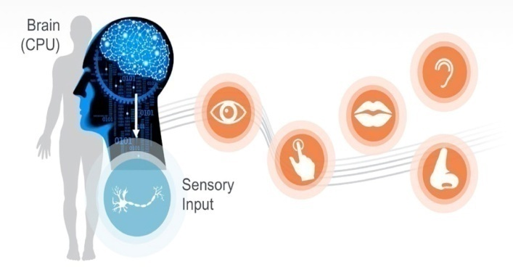
Figure 3: Sensory information (vision, hearing, smell, taste, and touch) is gathered from one's surroundings and travels through the peripheral nervous system to the brain for processing and response [11].

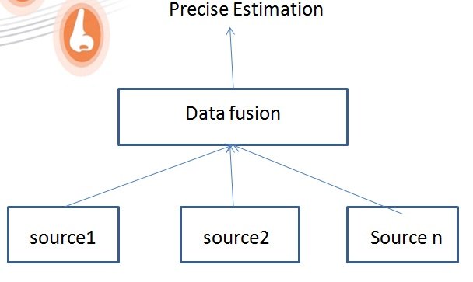
Figure 4: data fusion

3.3 LITERATURE SURVEY

SOME BASIC FUNDAMENTAL CONCEPT OF INFORMATION FUSION
Through the years different terminologies have been used to describe the process of information fusion as per architectures, methodologies and applications namely data fusion, sensor fusion, data aggregation, multisensory integration, information integration. Fig [1] depicts the relationship among fusion these terms. Basically fusion is a process of integrate, join or combine two or more things together to form a single entity to give one reliable, robust, unbiased decision rather than many uncertain decisions. In simple mathematics we can express fusion process as average. Average reduces biased nature and provides a one compact view of bulky data. In data fusion, input to the fusion process is unprocessed data. In this combining and correlating data is done to provide single insights. Information fusion and data fusion can be used alternatively.
Figure 1: The relationship among the fusion terms: multisensor/sensor fusion, multisensor integration, data
aggregation, data fusion, and information fusion [4].

In reference [7] author defined information fusion perfectly as it is a “supervised or semi supervised transformation of information from various sources into single parameter for effective unsupervised decision making.” The input to the information fusion process is processed data, and sources for the input could vary from sensors, images, databases to information generated by humans. Sensor fusion is a subset of information fusion and gets the data from only sensory resources. Sensor fusion provides the better results, better analysis, performance and better decision making because different types of sensors have different strength and weaknesses, the strength of one type can compensate for the weakness of other type. Extra sensors could work as backup if other fails [6]. Data aggregation represents another subset of information fusion where the objective is to summarize or reduce the data volume [7]. Multi sensor integration deals with the application of information fusion to make inferences using sensory devices and other information. Some basic fundamental concepts of information fusion are depicted in fig [2]. It depicts input sources to information fusion process, why we need information fusion, benefits, applications, models of information fusion. As we have seen that input sources for information fusion can vary, it can be sensory input or images. The main objective information fusion is to improve accuracy in results and make the intelligent decisions as per application. Information fusion process takes the unprocessed data as input and converts it into knowledge; it will be useful to take intelligent decisions.
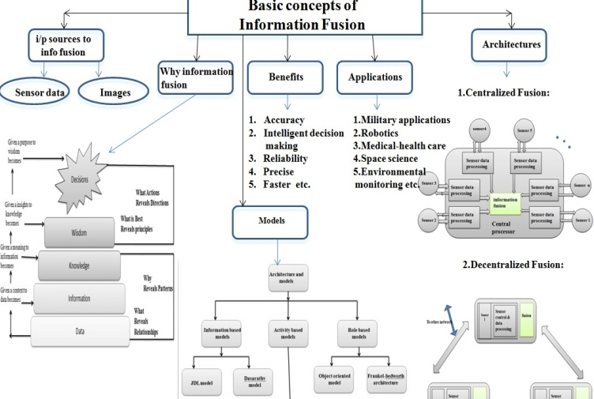
Figure 2: Basic fundamental concepts of information fusion
In current era of information, information fusion is widely used in various domains such as neural network, soft computing, artificial intelligence, machine learning to solve the domain specific problems. Information fusion is beneficial to improve the accuracy, reliability and decision making by reducing uncertainty. Its results are more precise, faster. Additionally information fusion provides one more benefit as the strength of one type source can compensate for the weakness of another type. Information fusion is also important to reduce the overall communication load in the network, by avoiding the transmission of redundant messages [4]. Information fusion is commonly used in detection, classification, and object tracking and estimation tasks in different application domains. Now days it is widely used in military, space science, medical-health care and environmental monitoring applications.
Information fusion architectures are useful to understand that how to place sensor nodes in information fusion system centralized or distributed or combination of both. There are some existing popular models which guide to design information fusion system. The evolution of models and architectures for information fusion system design is described in reference [4]. Taxonomy of models depicted in figure [2]. There are several models, for our proposed system we used JDL model to fuse the data from various sources and dassarthy model for decision making. Two levels are considered as data-in –information out and information or feature-in-decision-out for this system.

4. EXISTING ALGORITHMS AND STANDARD TECHNIQUES FOR INFORMATION FUSION
To fuse the data or information several techniques and algorithms are available such as kalman filter, dempster shafer evidence theory, center limit theorem, baysien belif network, fuzzy logic, neural network. As per author [2] these algorithms can be classified based on some criteria, such as the data abstraction levels, purpose, parameters, type of data and mathematical foundation. According to this criterion, information fusion can be performed with different objectives such as inference, estimation, classification feature maps, abstract sensors, aggregation, and compression. Here we consider the main objective of fusion process is accurate inference generation and intelligent decision making as per application. To get the accurate inference from fusion process, we have to reduce some challenging aspects or we can say some challenging problems to fusion process such as imperfect, incomplete, inconsistent data, ambiguity, uncertainty, conflicts etc. In reference [3] author discussed these aspects in detail. Among existing algorithms baysien network, fuzzy logic and neural network are the best match to proposed algorithm. Proposed algorithm works on both supervised and unsupervised manner and provides greater accuracy in result within less amount of time. It is efficient to process big data. Gap analysis among existing techniques and proposed algorithm is described in table [4]
KALMAN FILTER
Kalman Filter originally proposed in 1960 by the Kalman. Then it became very popular fusion method. The Kalman filter is used to fuse low-level redundant data. Kalman Filter is all about finding almost accurate result between Estimated Value and Data. The kalman filter goes through an iterative process till user is satisfied with the output.
FUZZY LOGIC
The idea of fuzzy logic was first advanced by Dr. Lolfi zadeh the University of California at Berkeley in the 1960s. The modern computer is based on Boolean logic i.e true or false or 1 or 0 logic. Fuzzy logic is reasoning and computing based approach, based on degrees of truth between 1 or 0. The inventor of fuzzy logic, Lofi zadeh, observed that unlike computer, the human decision making includes a range of possibilities between YES and NO. Fuzzy logic is a method of reasoning that resembles human reasoning. The approach of fuzzy logic imitates the way of decision making in humans that involves all intermediate possibilities between digital values YES and NO. Fuzzy logic may not give accurate reasoning, but acceptable reasoning. Fuzzy logic deals with uncertainty, incomplete, ambiguous, distorted or inaccurate inputs.
NEURAL NETWORK
Neural network is a computer system modeled on the human brain and nervous system. It is also referred to as connectionist systems. Neural network is information processing paradigm that is inspired by the way biological nervous systems, such as the brain process information. Neural networks were originated in the early 1960s with supervised learning mechanisms. Neural network take a large number of training examples to develop a system which can learn from those training examples. It also generates the inferences or infer rules from the training examples to improve accuracy. Neural network can work without any human intervention. Neural network is a great way to develop more advanced techniques, such as deep learning.
BAYESIAN THEORY
Bayesian theory also referred as belief theory is based on probability theory. By using Bayesian theory in information fusion or sensor fusion we can addresses the challenges of imperfect data fusion and can find the solution for the same. Basically probabilistic methods expresses data uncertainty problem and it is rely on the probability distribution or density functions to express data uncertainty.

3.4 GAP ANALYSIS

Table 1: Gap analysis of related work
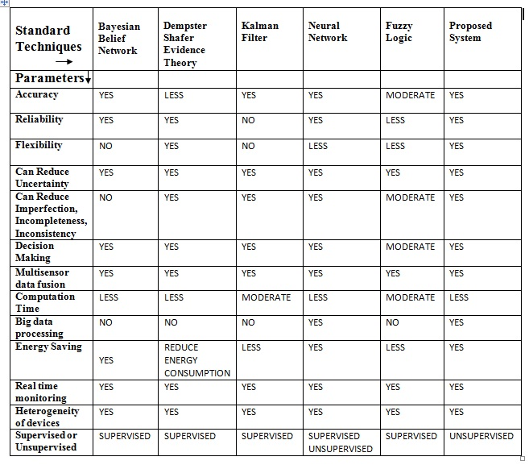

Chapter 4

PROBLEM DEFINITION AND SCOPE

4.1 PROBLEM STATEMENT
The objective of this research project is to address information fusion problem by investigating novel algorithm.
A] To collect data from heterogeneous sources
B] Aggregate data to one uniform resource
C] Fusion with primary focus on accuracy, reliability to make intelligent decisions

Input- Sensory data
Expected output-
Accurate unsupervised decisions as per application
Outcomes
1. Sensory data is generated from sensors by using arduino uno board
2. Data is collected in one resource sql server database.
3. Fusion is done by using mathematical formation
4. Decisions are made by using weka tool.

4.2 TECHNOLOGICAL AND ASSOCIATIVE PLATFORM

SOFTWARE REQUIREMENTS-
C#.net framework
Os- microsoft windows
SQL server databases
Raspberry pi IDE and OS

HARDWARE REQUIREMENTS-
Arduino uno board
Temperature sensor LM35 or DHT11
Pressure sensor
Humidity sensor DHT11
Oxygen sensor
Light sensor
Computer

Chapter 5

DISSERTATION PLAN

5.1 DESIGN AND IMPLEMENTATION CONSTRAINTS

Following are the constraints that will affect the manner in which the software will
Function
User must have basic knowledge of Information fusion.
User must have understanding the computer networks.
User must have basic knowledge of sensors.
User must have basic knowledge of micro-controller n boards.

5.2 DISSERTATION TASKS

Task to be carried out are as follows
1. Requirement Analysis
2. Project Design
3. Implementation
4. Testing
5. Documentation

5.3 FEASIBILITY STUDY

The feasibility study comprise of an initial investigation into personnel will be required. Feasibility study will help you make informed and transparent decisions at crucial points during the development process. All projects are feasible given unlimited times and resources. Unfortunately, the development of computer based system is more likely to be plagued to scarcity of resources. It is both necessary and prudent to evaluate the feasibility of project at earliest possible time.

5.3.1 TECHNICAL FEASIBILITY
The system must be evaluated from the technical point of view first. The assessment of this feasibility must be based on outline design of the system requirement in the terms of input, output, procedure. Having identified an outline of system, the investigation must go on to suggest the type of equipment, required method developing the system , of running the system once it has been designed. The project should be developed such that the necessary functions and performance are achieved within the constraints. The project is developed within latest technology. So there are minimal constraints involved with this project. The system has been developed using c sharp, SQL, c, machine learning technologies and project is technically feasible for development.

5.3.2 ECONOMICAL FEASIBILITY

Economic feasibility looks at the financial aspects of the project. Economic feasibility concerns with the returns from the investments in the project. It determines whether it is worthwhile to invest the money in the proposed system. It is not worthwhile spending a lot of project for no result. To carry out an economic feasibility for a system, it is necessary to place actual money value against any purchases or activities needed to implement the project.

5.3.3 PERFORMANCE FEASIBILITY

The system provides a user friendly graphical interface and is therefore easy to use. User who knows the basic of computer i.e how to operate the computer for the computer can easily use this system.

5.4 RISK MANAGEMENT PLAN

The goal of risk mitigation, monitoring and management plan is to identify as many potential risks as possible. To help determine what the potential risks are, it will be evaluated using the check-list. These check-list help to identify potential risks in a generic sense. When all risks have been identified, they will then be evaluated to determine their probability of occurrence. Plan will then be made to avoid each risk, to track each risk to determine if it is more or less likely to occur and to plan for those risks should they occur. It is the organizations responsibility to perform risk mitigation, monitoring and management in order to produce a quality product. The quicker the risks can be identified and avoided, the smaller the smaller the chances of having to face that particular risks consequence. The fewer consequences soured as a result of good RMMM plan, the better the product and the smoother the development process.

Chapter 6
SOFTWARE REQUIREMENT SPECIFICATION

6.1 PURPOSE AND SCOPE OF DOCUMENT

In this document you will be able to see the entire working of the algorithm with the explanation of the system features in detail. It contains the algorithms, initialization, classification, cluster generation, merging, feature selection. Software requirements specification (SRS) is a comprehensive description of the intended purpose and environment for software under development. The SRS fully describes what the software will do and how it will be expected to perform

6.2 ARCHITECTURE DESIGN OF UGV AS A APPLICATION

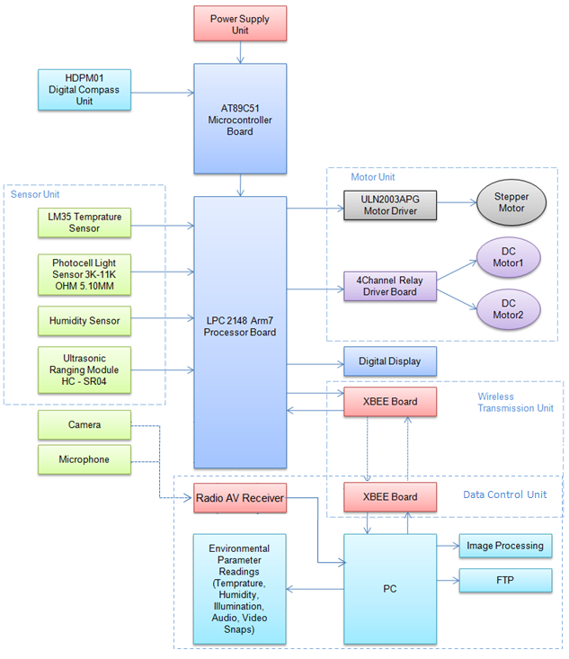
Figure 2.1 architecture design of ugv

Hardware Details

LPC2148 ARM 7 circuit board

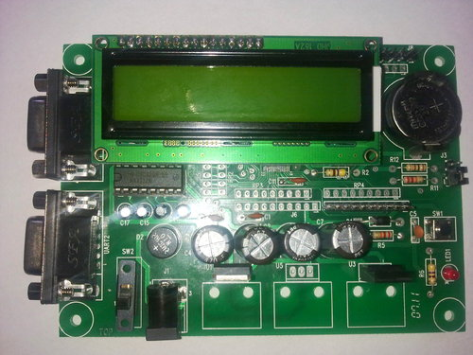
Figure 3.1. LPC2148 ARM 7 circuit board

TECHNICAL SPECIFICATIONS
- Microcontroller: LPC2148 with 512K on chip memory
- Crystal for LPC2148: 12Mhz
- Crystal for RTC: 32.768KHz
- 50 pin Berg header for external interfacing
- Wireless module adapter for 2.4GHz ZigBee (Xbee) / Bluetooth / WiFi connectivity
- On board 512 bytes of I2C external EEPROM
- USB Type B Connector
- SD / MMC card holder with SPI interface
- No separate programmer required(Program with Flash Magic using on-chip boot loader)
- No Separate power adapter required (USB port as power source)
- 10pin(2X5) FRC JTAG connector for Programming and debugging
- 50 Pin Expansion header for easy access to I/O pins
- On board Two Line LCD Display (2x16) (with jumper select option to disable LCD)
- L293D 600mA Dual DC motor Driver
- ULN2003 500mA driver
- Two RS-232 Interfaces (For direct connection to PC’s Serial port)
- Real-Time Clock with Battery Holder
- 2 Analog Potentiometers connected to ADC
- TSOP1738 IR receiver
- 4 USER Switches
- 4 USER LEDs
- Reset and Boot loader switches
- 3V button cell for on chip RTC
- ON/OFF switch
- On Board Buzzer Interface
- Schematics and Application examples in KEIL provided in the documentation CD
- Can be used as main board for developing applications

KIT CONTAINS
- 1 x LPC2148 Pro Development Board
- 1 x DB9 Serial Cable
- 1 x USB Cable
- 10 x Jumper wires
- Documentation CD:
- Schematic
- Programming Software
- Sample Hex Code
- Example Codes

AT 89C51 MICROCONTROLLER BOARD

89C51 microcontroller unit:-This receives the output of electronics compass unit representing the current navigation direction of UGV which is further utilized by this microcontroller to keep the track of already assigned direction.
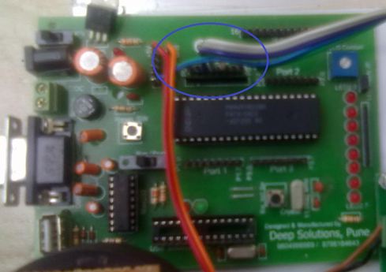
Figure 3.2 AT 89C51 Microcontroller Board
FEATURES
- Primarily used for control oriented applications Helpful in gaining data regarding single bit programming, arithmetic, logic and interfacing of peripherals. Provided with ISP feature Provide ideal development platform for designing of microcontroller based systems User friendly & completely self contained.
- 8051/ 89C51 Microcontroller operating at 12 MHz
- 64KB on-chip internal Flash EEPROM program memory
- 1KB on-chip data RAM
- 64KB External Data RAM
- 32KB EPROM for monitor program
- 32KB RAM for Program/Data memory
- Onchip Programmable Counter Array (PCA) PCA Contains five 16 bit PWM/capture/compare output
- 48 TTL I/O lines using 8255 terminated in two 26 Pin FRC Connectors
- All CPU address, data, and control signals are terminated in a 50 pin FRC Connector (VXT Bus) for Interfacing.
- All connections of the Microcontroller are terminated in a separate connector for expansion.

ZIG-BEE BOARD
The ZigBee Development Board has been developed to meet the standards of the DevCom module, and all connectors and main functions on the board are based on the DevCom. It is possible to use other ZigBee modules on the development board.
Features:
    - 2 dual USB interfaces 2 EEPROM (optional) RX/TX indicators
    - RS232 interface
    - Power supply via Power jack USB 3V lithium battery, type CR2
    - Regulated 3V or 3V3 for logic
    - Regulated 12V for LED
    - 5 Push buttons
    - 5 LED indicators
    - 2 Separate reset buttons
    - 2 Reset LED indicators
    - LED graphic display 96x64 pixels SPI I/F Monochrome 4 bit
    - 30 x 80 mm prototype area 2mm spacing 2.54mm spacing
    - 1 BDM connector
Specifications:
Dimensions: 80x161mm
Power supply: 5-12VDC or 3VDC
The ZigBee Development Board is a fully assembled, fully functional development board for the DevCom module. It is provided with the option of wall plug power supply, USB power or battery power and serial communication either via RS232 or USB. Support software for this development board is provided for Windows 95/98/NT/2000/XP operating systems. The purpose of the development board is to provide the user with an evaluation platform for ZigBee modules, such as the DevCom module.
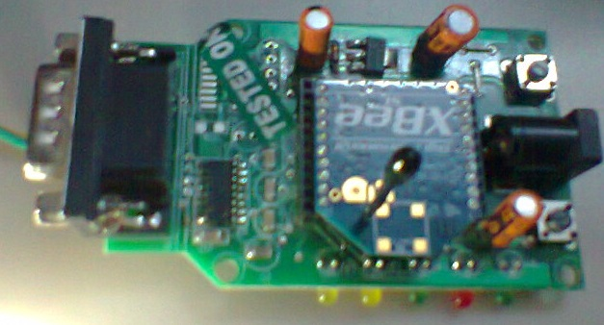
Figure 3.3 zigbee development boards
The USB and COM ports provide access to the UARTs on the development board.
Figure 3.4. Connection Diagram of ZigBee Board
It is possible to use either USB A and USB B or COM1 and USB B. Table 3.1 shows the different possibilities f RX/TX connections.
Table : Connections of ZigBee Board
INTERFACING CIRCUIT BOARDS OF LPC 2148 AND AT89C51

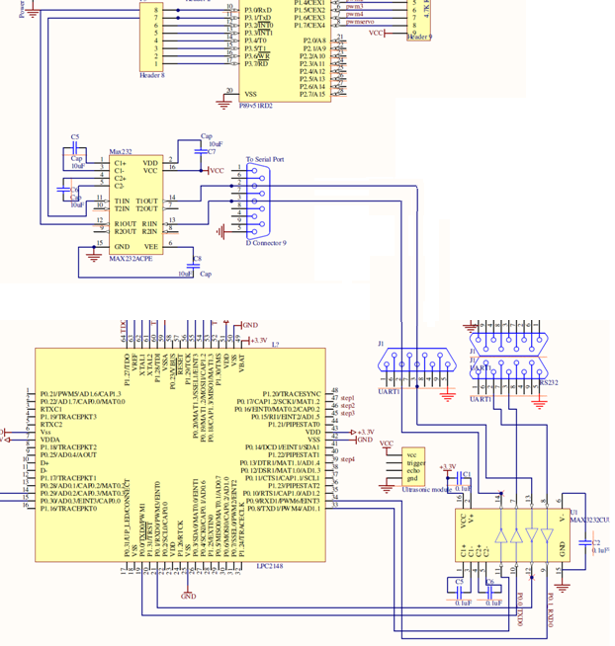

INTERFACING OF LPC 2148 AND ULTRASONIC RANGING MODULE HC – SR04

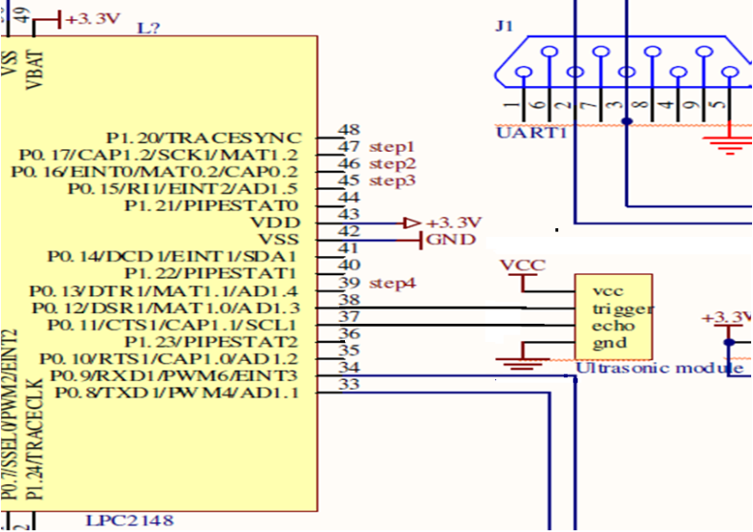

INTERFACING CIRCUIT BOARDS OF AT89C51 AND HDPM 01 ELECTRONIC COMPASS

INTERFACING CIRCUIT BOARDS OF LPC 2148 AND 4 CHANNEL RELAY

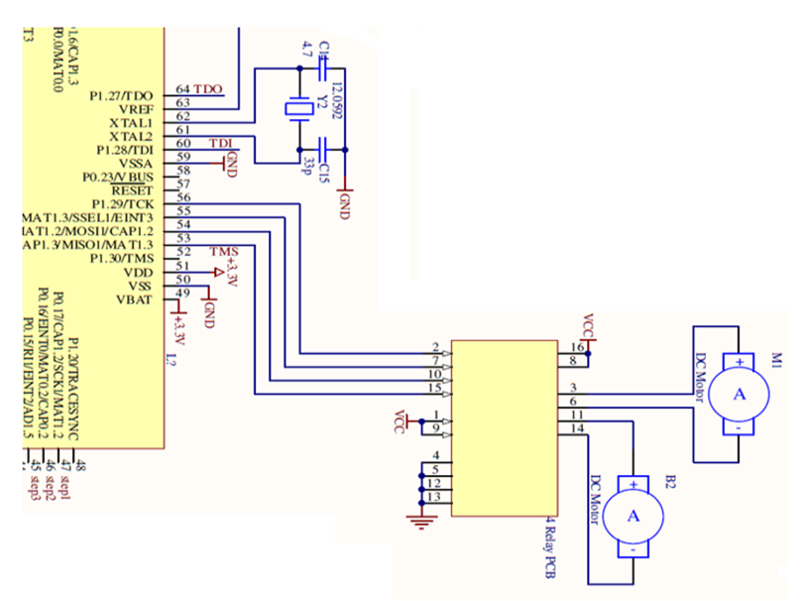

INTERFACING CIRCUIT BOARD OF LPC 2148 AND LM35 TEMPERATURE SENSOR

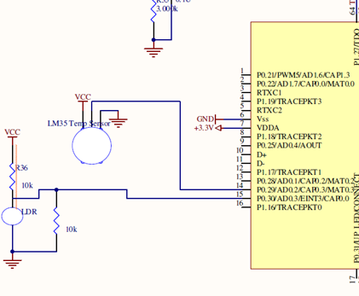

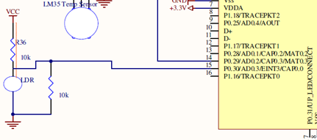
Figure 3.44. Interfacing Circuit Diagram of LPC 2148 and Photo Light Sensor 3K-11K OHM

INTERFACING CIRCUIT BOARDS OF LPC 2148 AND XBEE BOARD

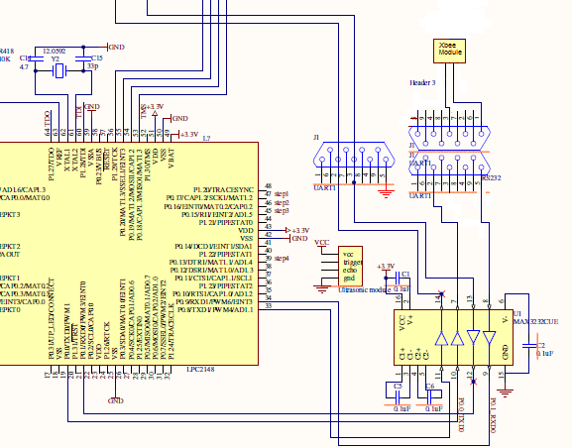

PIN CONNECTIONS:
- Ultrasonic Module and LPC 2148
- Trigger – P0.12
- Echo - P0.11
- Stepper motor and LPC 2148
- Data1 = P0.13
- Data2 = P0.15
- Data3 = P0.16
- Data4 = P0.17
- DC motor and LPC 2148
- DC motor1 dir 1 = P0.18
- DC motor1 dir 2 = P0.19
- DC motor2 dir 1 = P0.20
- DC motor2 dir 2= P0.21
- LPC 2148 and Xbee Module = UART0
- LPC 2148 and AT89C51 = UART1

FLOWCHART OF SYSTEM

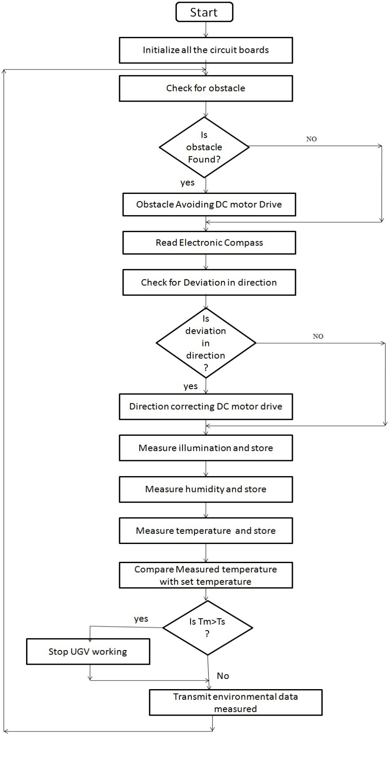
Figure 4.1. Flowchart of system
SOFTWARES USED AND THEIR APPLICATIONS

Sr. No | Softwares | Applications
1 | Keil µ Vision IDE | As C Program Compiler.
2 | Flash Magic | To Load Program in both microcontrollers.
3 | Wing FTP Server v4.0.1 | For Transmission of data files through Internet.
4 | Honestech TVR2.5 | To Observe and Record Video/Audio information.
5 | Terminal | To Observe Environmental Data

Chapter 7

DETAILED DESIGN DOCUMENT

7.1 SYSTEM ARCHITECTURE

The critical data fusion problem is not data collection and analysis of raw sensor data using complex mathematical algorithms and parallel processors. Although these technologies are part of total solutions, the key issue for data fusion is how to convert the initially processed sensor data into information and knowledge to support the decision maker in a timely fashion.

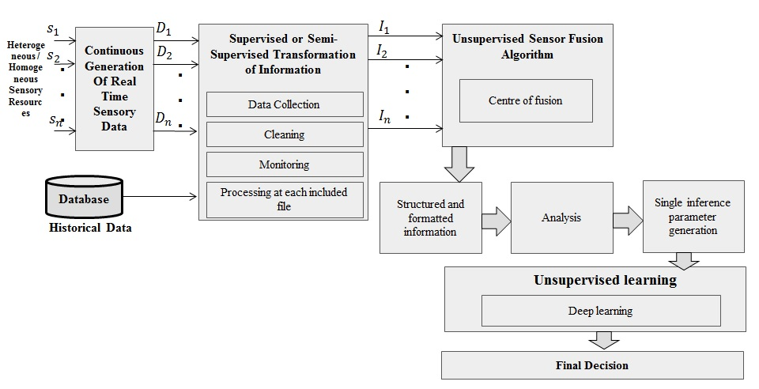
Figure 9: Methodology of proposed system

Proposed mathematical model is based on TOC [Theory of computation], Averages and Probability. To do mathematical formation I have considered one simple scenario of space application; scenario- suppose astronaut wants to go outside the spaceship, he or she should check the temperature, pressure, oxygen, humidity outside the spaceship. Upon that calculations and analysis he or she can take accurate decision. For information fusion part mathematical formulation is done with averages and unsupervised decision making is done with probability. Here, Decision making and fusion process are unsupervised. That is it process its current inputs at every state and it requires output at every given input. Deterministic and nondeterministic finite automata give the output or decision only in YES or NO format i.e. in Boolean logic 1 or 0 logic. We require ranges of decisions as per inputs it’s just like human brain gives decisions. Because of that I consider mealy machine to frame the mathematical modeling with averages and probability.
A Mealy Machine is an FSM whose output depends on the present state as well as the present input.
It can be described by a 6 tuples (Q, ∑, O, δ, X, q₀) where −
1.Q is a finite set of states.
2.∑ is a finite set of symbols called the input alphabet.
3.is a finite set of symbols called the output alphabet.
4.δ is the input transition function where δ: Q × ∑ → Q
5.X is the output transition function where X: Q → O
6.q₀ is the initial state from where any input is processed (q₀ ∈ Q).

1] Real time sensory data is generated from heterogeneous or homogeneous sensory resources.
- Input-
∑- input alphabets
∑= {T_{S,} P_{S,}H_{S,} O_{S,} Total-average, Probability(P)}
Input data may contain some conflicts, ambiguity, uncertainty, incorrectness, and noisy data. Which is denoted as -
X_{n}-noisy data
X_{u}-uncertainty
X_{C}-conflicts
X_{incorrect-data}- incorrect-data
Simply total data collected or generated from sensors as
Sensor 1
S₁₌ ∑ S_{i} + X_{n}+ X_{u}+ X_{C}+ X_{incorrect-data}
Sensor 2
S₂ ₌ ∑ S_{i} + X_{n}+ X_{u}+ X_{C}+ X_{incorrect-data}
in the same way for n number of sensors.
Sensor n
S_{n =} ∑ S_{i} + X_{n}+ X_{u}+ X_{C}+ X_{incorrect-data}
Here consider 4 sensors as Temperature, Humidity, Pressure and Oxygen.
  - Q={Data, Information, Knowledge, Decisions/actions}
  - q0= Data (initial state)
  - O= Decisions (Final state)
  - δ is the input transition function where δ: Q × ∑ → Q
  - X is the output transition function where X: Q → O
2]In the next phase some supervised or semi supervised processing is done on collected sensory data such as cleaning, monitoring, preprocessing etc.

3]After preprocessing and cleaning we get the information from collected sensory data. This information is input to the fusion process or algorithm. Fusion algorithm is based on deep unsupervised technique.

Total number of values to generate from temperature , humidity, pressure and oxygen sensors are = n
This can be set while generating data from sensors by using raspberry pi or aurdiuno kit.

A] Temperature sensor data-
1. T_{s} =∑⁰_{i=1} t_{si}
T_{s} = {t1, t2, t3….tn}
2. Average of temperature sensor data
A t_{si} = ∑⁰_{i=1} t_{si} / n
= T_{s} / n
B] Humidity sensor data-
1. H_{s} =∑⁰_{i=1} h_{si}
H_{s} = {h1, h2, h3….hn}
2. Average of Humidity sensor data
A h_{si}= ∑⁰_{i=1} h_{si} / n
= H_{s} / n
C] Pressure sensor data-
1. P_{s} =∑⁰_{i=1} p_{si}
P_{s} = {p1, p2, p3….pn}
2. Average of Pressure sensor data
A p_{si}= ∑⁰_{i=1} p_{si} / n
= A_{s} / n
D] Oxygen sensor data-
1. O_{s} =∑⁰_{i=1} o_{si}
O_{s} = {o1, 02, o3….on}
2. Average of Pressure sensor data
A o_{si}= ∑⁰_{i=1} o_{si} / n
= O_{s} / n

Total-average = A t_{si}+ A h_{si} + A p_{si}+ A o_{si}

4] After fusion process we will get the structured and formatted information , by analyzing this information we can generate single inference parameter. It is denoted as Inf.

5] We can use generated inference parameter Inf to take intelligent decisions as per applications.
6] Probability is used to formulate the unsupervised decisions.
Conditional probability is used to calculate the weights [wi] as denoted in figure[] assigned to random variables- it is calculated by using bays rule-
P (A and B) = P (A) x P (B|A)
P (A) means "Probability of Event A"
P (B|A) means "Event B given Event A"
P (A) x P (B|A) = P (A and B)
P (B|A) = P (A and B) / P (A)
Weights are checked with threshold value.

Table 3: Network creation

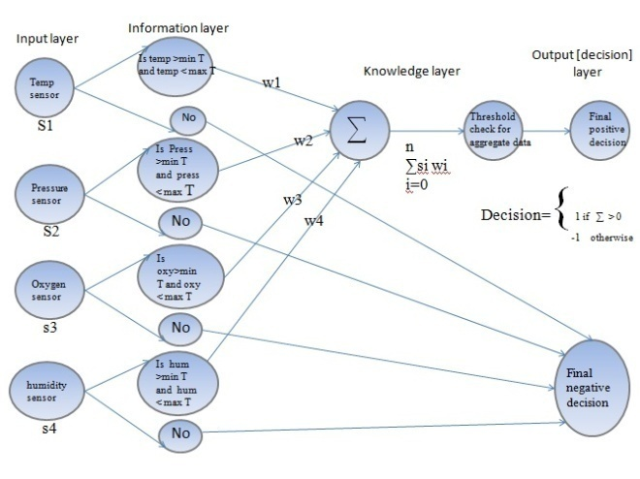
Figure 11: Mathematical Model

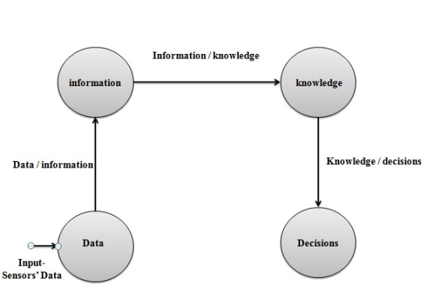
Figure 12: state transition diagram [mathematical model]

Chapter 8
TEST SPECIFICATION

8.1 INTRODUCTION

Testing is an investigation conducted to provide stakeholders with information about the quality of the product or service under test. Software testing also provides an objective, independent view of the software to allow the business to appreciate and understand the risks of software implementation. Test techniques include, but are not limited to, the process of executing a program or application with the intent of finding software bugs. Software testing can also be stated as the process of validating and verifying that a software program or application or product: Meets the business and technical requirements that guided its design and development; Works as expected, Can be implemented with the same characteristics.

Software testing, depending on the testing method employed, can be implemented at any time in the development process. However, most of the test abort occurs after the requirements have been defined and the coding process has been completed. As such, the methodology of the test is governed by the software development methodology adopted. Different software development models will focus the test effort at different points in the development process. Newer development models, such as Agile, often employ test driven development and place an increased portion of the testing in the hands of the developer, before it reaches a formal team of testers. In a more traditional model, most of the test execution occurs after the requirements have been defined and the coding process has been completed.

8.2 TESTING STRATEGIES

8.2.1 Black Box Testing

Black box testing methods focus on the functional requirements in the software. That is, black box testing enables us to derive sets of input conditions that will fully exercise. All functional requirements of the program Black box testing attempts to find errors in the following categories:
Incorrect or missing function
Interface errors
Errors in data structure or external job access
Performance errors
Initialization and termination errors.
In the proposed application with the help of this technique, we do not use the code to determine a test suite; rather, knowing the problem that we are trying to solve, we come up with four types of test data: Easy-to- compute data, Typical data, Boundary / extreme data, Bogus data.But in our application we does not provide any external data, the role of user is only to give number of nodes for formation of clusters and for the formation of sink node.

8.2.2 White Box Testing

White box testing is a set case design method that uses the control structure of the procedural design to derive test cases. Using white box testing methods, we can derive test cases that: Guarantee that all independent paths within a module have been exercised at least once. Exercise all logical decisions on their true and false sides. Execute all loops at their boundaries and within their operational bounds. Exercise internal data structures to ensure their validity. In the proposed application the white box testing is done by the developer implemented the code, the implements code is studied by the coder, determines all legal(valid and invalid) and illegal inputs and verifies the outputs against the expected outcomes, which is also determined by studying the implementation code.
8.3 TESTING TYPES
8.3.1 Unit Testing

Unit testing enables a programmer to detect error in coding. A unit test focuses verification of the smallest unit of software design. This testing was carried out during the coding itself. In this testing step, each module going to be work satisfactorily as the expected output from the module. Project Aspect The front end design consists of various forms. They were tested for data acceptance. Similarly, the back-end also tested for successful acceptance and retrieval of data. The unit testing is done on the developed code. Mainly the unit testing is done on modules.

8.3.2 INTEGRATION TESTING
Through each program work individually, they should work after linking together. This is referred to as interfacing. Data may be lost across the interface; one module can have adverse effect on the other subroutines after linking may not do the desired function expected by the main routine. Integration testing is the systematic technique for con-strutting the program structure while at the same time conducting test to uncover errors associated with the interface. Using integrated test plan prepared in the design phase of the system development as a guide, the integration test was carried out. All the errors found in the system were corrected for the next testing step.

8.3.3 SYSTEM TESTING
After performing the integration testing, the next step is output testing of the pro- posed system. No system could be useful if it does not produce the required output in a specified format. The outputs generated are displayed by the user. Here the output format is considered in to two ways. One in on screen and other in printed format. The entire project was tested and found successful.

8.4 TEST PLAN

Test Plan Identifier: cost-sensitive it is use to identify test plan uniquely.

1. Purpose of the Test Plan Document The main purpose of this document is to particular projects needs. It documents and tracks the necessary information required to effectively define the approach to be used in the testing of the project as product. The Test Plan document is created during the Planning Phase of the project. Its intended audience is the project manager, project team, and testing team.

2. Objective of Test Panning To find as many defects as possible and get them x.

3. Items to be Tested OR Not to be Tested Describe the items/features/functions to be tested that are within the scope of this test plan. Include a description of how they will be tested, when, by whom, and to what quality standards. Also include a description of those items agreed not to be tested.

4. Items to be tested
Overall functionality of the application.
User Interface of the application.

5. Not to be tested
Performance of the application.

6. Test Approach Describe the overall testing approach to be used to test the projects product.
Provide an outline of any planned tests. There are many approaches like:
Black Box Testing White Box Testing Here we used Black Box Testing approach. In Black
Box Testing we just give input to the system and check its output without checking ho system
processes it.

7. Test Pass OR Test Fail Criteria When actual and expected results are same then test will be passed. When actual and expected results are different then test will be failed.

8. Test Entry OR Exit Criteria describe the entry and exit criteria used to start testing and determine when to stop testing.
Entry criteria: As soon as we have requirement we can start testing.
Exit criteria: When bug rate fall below certain level we can stop testing.

9. Test Suspension OR Resumption Criteria describe the suspension criteria that may be used to suspend all or portions of testing. Also describe the resumption criteria that may be used to resume testing. Suspension criteria: If there is large change in application like change in requirements we can suspend work for some time. Resumption criteria: After resolving the respective problem we can resume work.

10. Testing Type It describes which testing types we are going to follow in our testing
Life cycle. Here we are using:
Black ox Testing
Functional Testing
UI Testing
Integration Testing

Chapter 9
DATA TABLE AND DISCUSSION

9.1 SCREEN SHOTS

Testing of UGV for Obstacle Mapping, Obstacle avoidance, Environmental Data and Audio, Video Snap

Obstacles Avoided

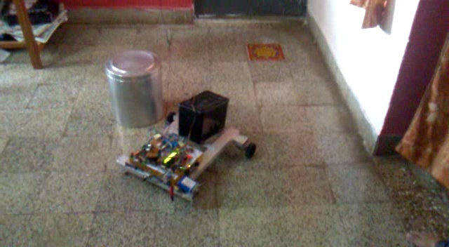

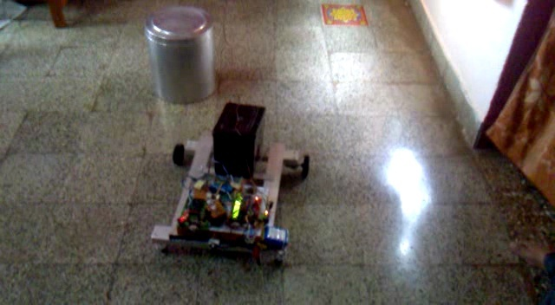
Step 1 – Navigation

Table Summary of Testing results of UGV
Sr. No. | Operational Testing Condition | Readings/Observations
1 | Obstacle Mapping testing  (No Obstacles Identified) | Obstacles beyond 60 cm (at 69cm on right,66cm on left side), No action is taken.
2 | Obstacle Mapping testing  (Obstacles Identified) | Obstacles within 60 cm (at 34cm on right of 9cm diameter,38cm on left side of 10cm diameter),  Action is taken.
3 | Obstacle Mapping and Transmission of Environmental data testing | Obstacle within 60cm( at 30 cm on left of 10 cm diameter, 29cm front of 14cm diameter, 33cm on right of 10 cm diameter).  Temperature is 21st C , Illumination is  185 Lux to 200 Lux, Humidity is 203 to 245 units.  Wireless transmission of above mentioned information to control console .
4 | Transmission of Obstacle Mapping, Obstacle avoidance, Environmental Data, Audio and Video Snap testing | Wireless transmission of Obstacle mapping information, environmental data information , audio & video clips of environment is successfully observed.  Navigation with obstacle avoidance is successfully observed.
5 | Self Cntrol of UGV based on  environmental temperature. | Normal operation for environmental temperature range 28th C to 35th C;  No obstacle mapping, no navigation of UGV for environmental temperature above 35th C.

Table Obstacle Mapping testing results (No Obstacles Identified)
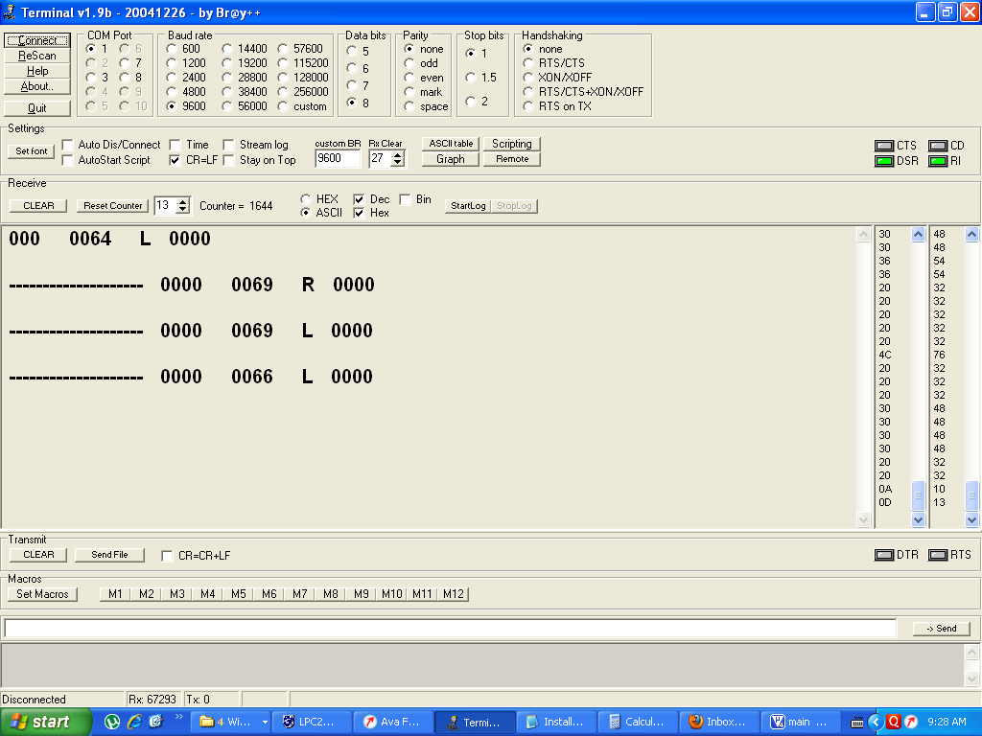

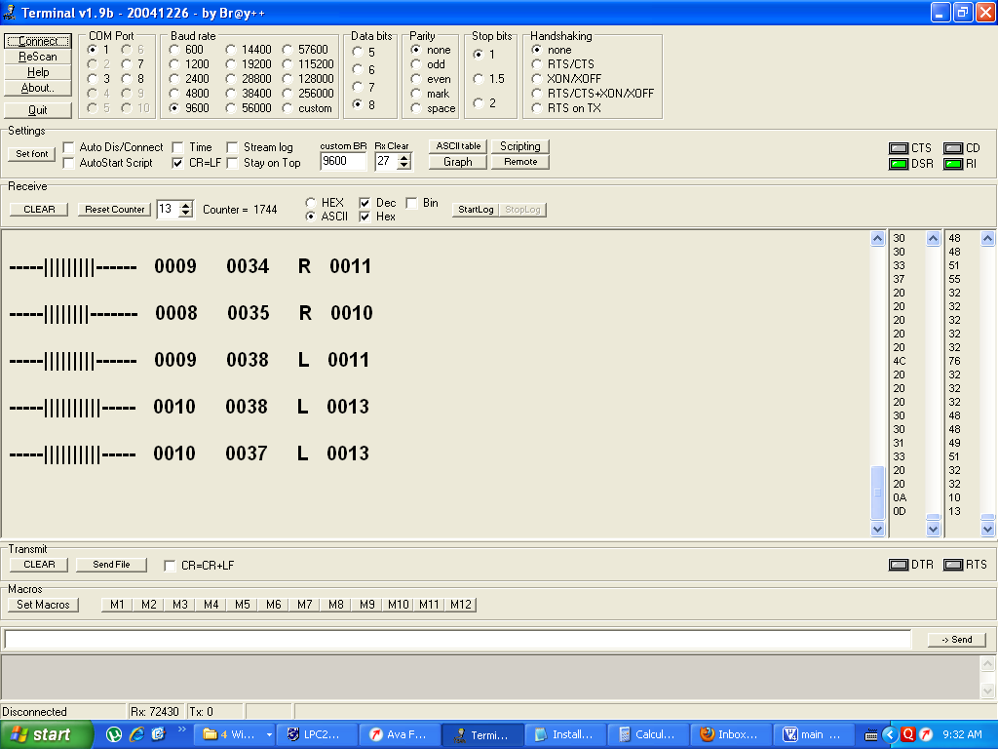

Testing for Obstacle Mapping and Transmission Environmental data

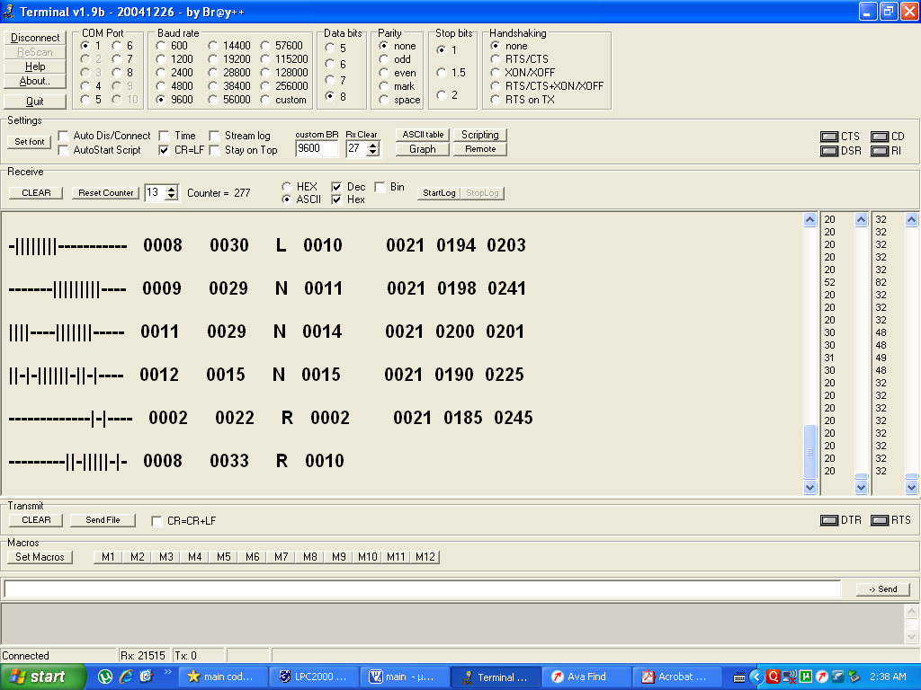

Testing for transmission of Obstacle Mapping, Obstacle avoidance,
Environmental Data, Audio and Video Snap
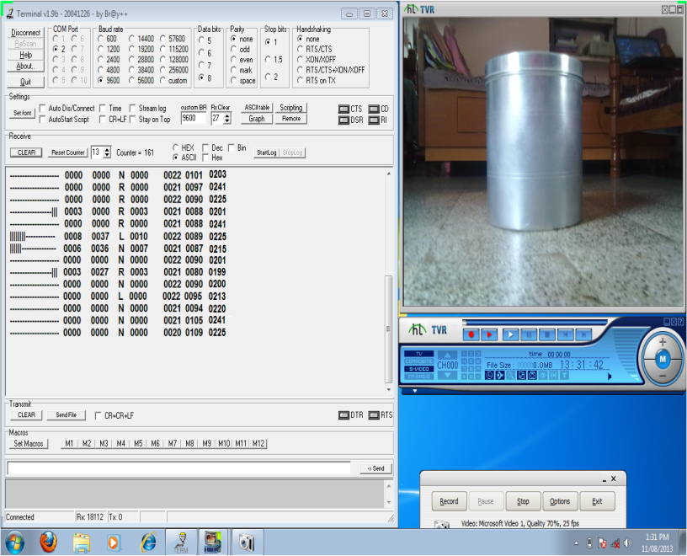

Testing for self control of UGV based on environmental temperature

Testing results for ON-OFF control of obstacle mapping and navigation of UGV based on environmental temperature.
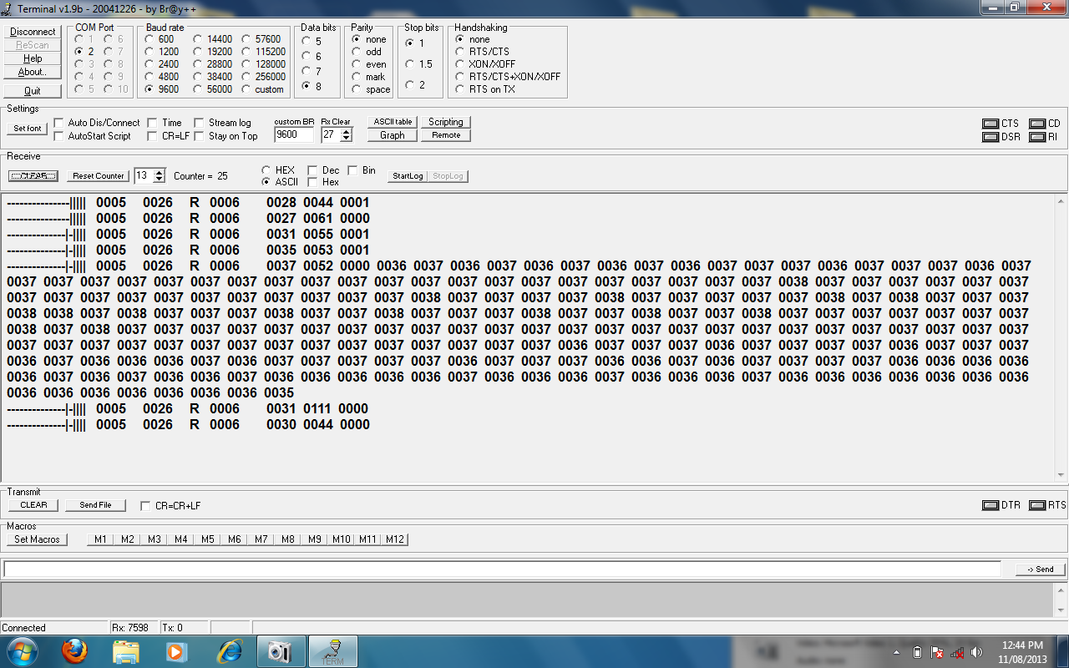

CONCLUSIONS AND FUTURE OUTLOOK
This dissertation report presented information about basic concepts of information fusion. Information fusion technique is used to solve the problems in various domains like artificial intelligence, cognitive computing, machine learning, soft computing and neural network. It provides greater accuracy in results. In this report I have done with methodology and mathematical modeling for sensor fusion. Interesting future work will be to propose an unsupervised reliable and accurate decision making algorithm for space science applications such as planetary exploration by using deep learning techniques.

Bibliography
[1]Henrik Boström, Sten F. Andler, Marcus Brohede, Ronnie Johansson, Alexander Karlsson, Joeri van Laere, Lars Niklasson, Maria Nilsson, Anne Persson, Tom Ziemke, “On the Definition of Information Fusion as a Field of Research” , School of Humanities and Informatics University of Skövde.
[2] Olin H.Bray, “Information Integration for Data Fusion”, Strategic business development sandia national laboratories1997.
[3] Bahador Khaleghi, Alaa Khamis, Fakhreddine O. Karray, “Information Fusion:Multisensor data fusion: A review of the state-of-the-art” , sciverse sciencedirect ,Elsevier 2011.
[4] Eduardo f. Nakamura, antonio a. F. Loureiro federal university of minas gerais –ufmg and alejandro c. Frery federal university of alagoas – ufal , “information fusion for wireless sensor networks: methods, models, and classifications” , acm computing surveys, vol. 39, no. 3, article 9, publication date: august 2007.
[5] Ren C. Luo, Fellow, IEEE, and Chih-Chia Chang, “Multisensor Fusion and Integration: A Review on Approaches and Its Applications in Mechatronics” , IEEE transactions on industrial informatics, vol. 8, no. 1, february 2012.
[6] Feng Zhao,Leonidas J. Guibas, “Wireless Sensor Networks” , Elsevier.
[7] dr. Parikshit n. Mahalle **, prof. Saudagar s. Barde#, prof. Poonam n. Railkar*, “Information fusion towards multi-sensor data using cognitive computing approach.”
[8] Zhi-Jun Lua,b,*, Qian Xiangb , Lan Xub, “An Application Case Study on Multi-sensor Data fusion System for Intelligent Process Monitoring” , sciencedirect.
[9]Mourad Barkat, “Signal Detection and Estimation.
[10] The Role of Sensor Fusion in the Internet of Things | Mouser

