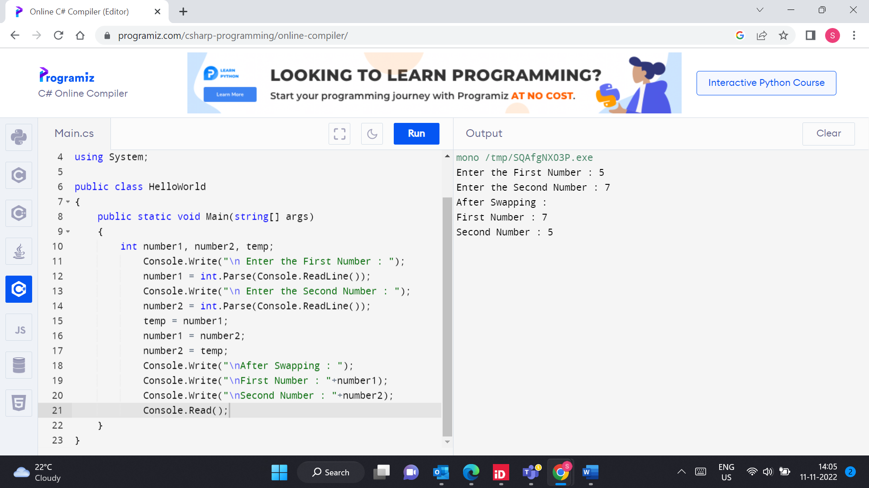

2] Accept average marks of 5 students display the highest marks obtained

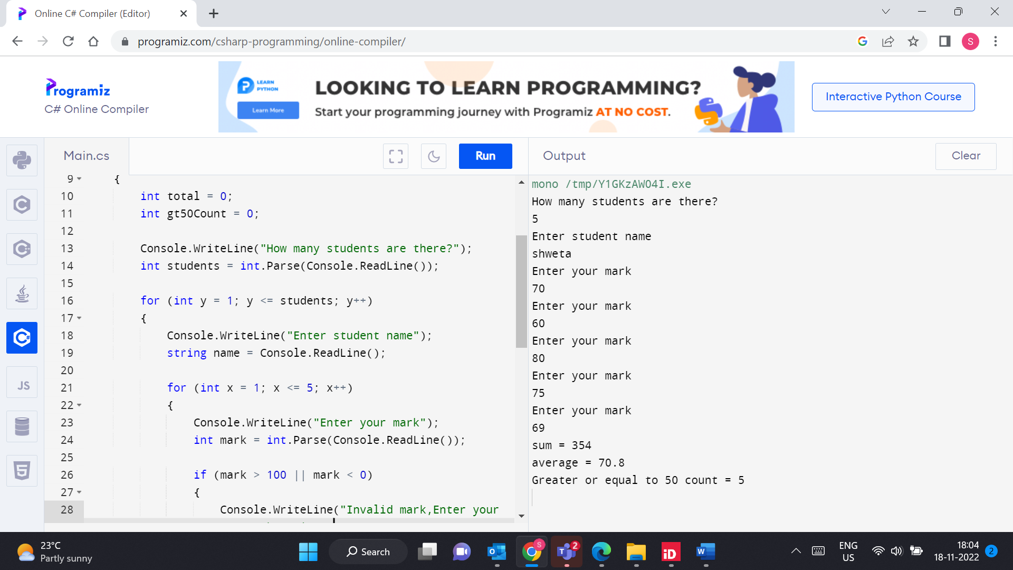

3]write static method to accept param array of integers. The method should find the sum of all the integers passed and display the result. write a client program to call the method.

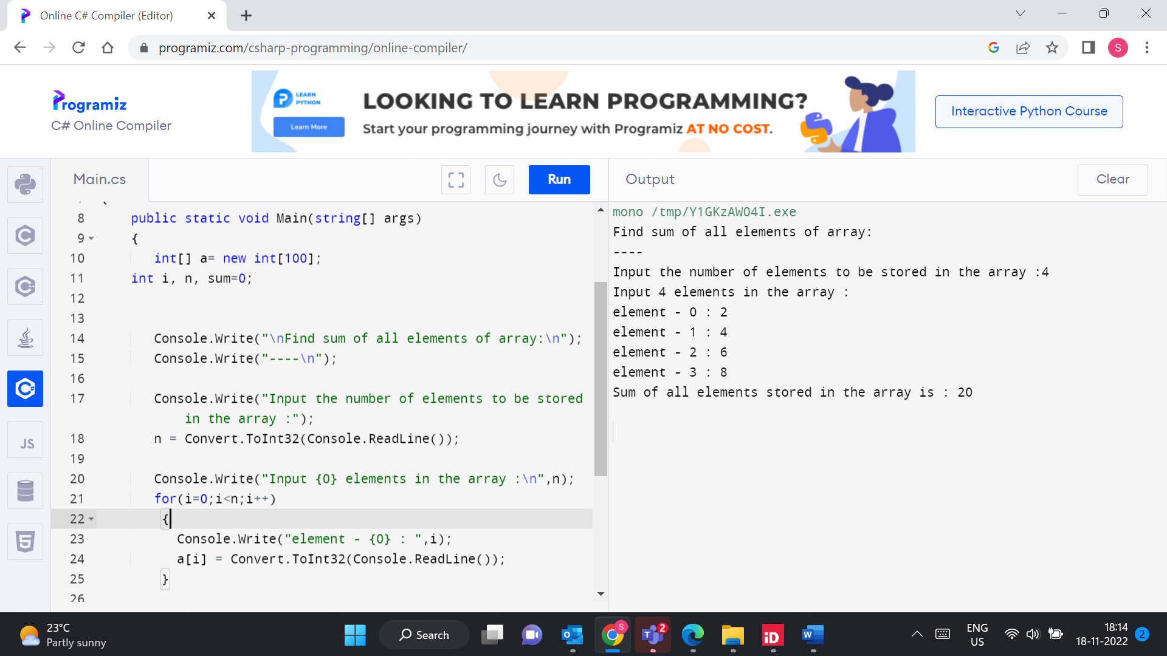

4)Create a custom exception class named StackException. The Push()and Pop() method should throw object of StackException when the stack is full or empty respectively.

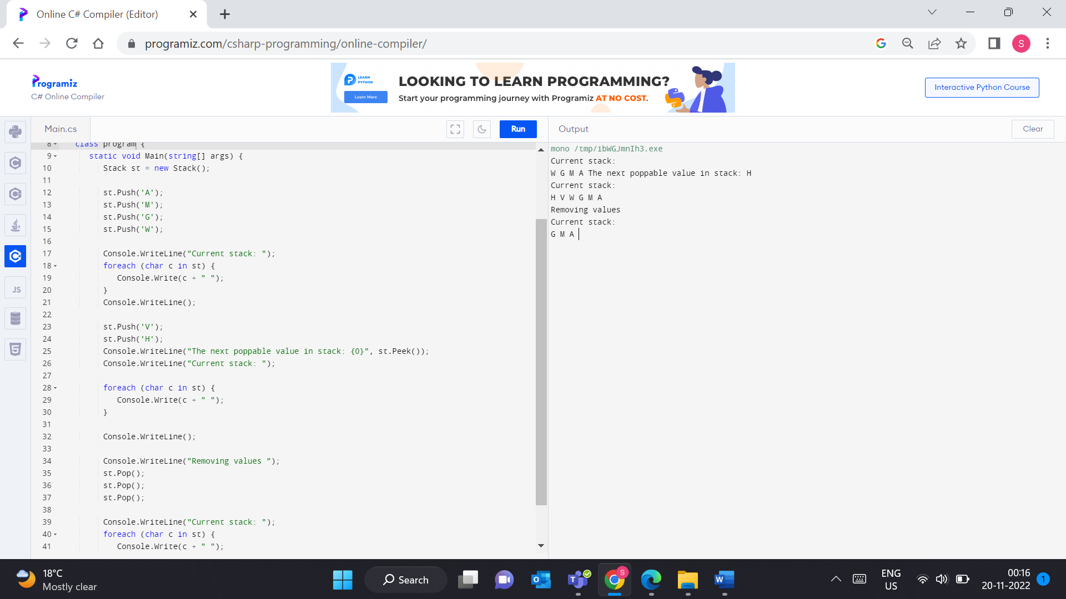

4]Write a method to swap two integers. The client code should call the method and print the swapped value.

