Create a custom exception class named StackException. The Push()and Pop() method should throw object of StackException when the stack is full or empty respectively.

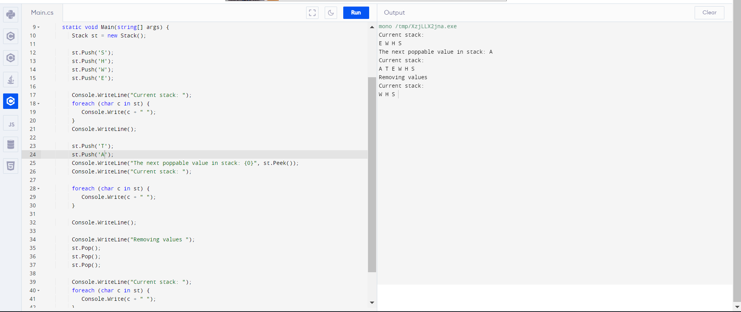

1. Write a class called MyStack with following members.
2. integer array
3. integer variable to store top position
4. size of the array.

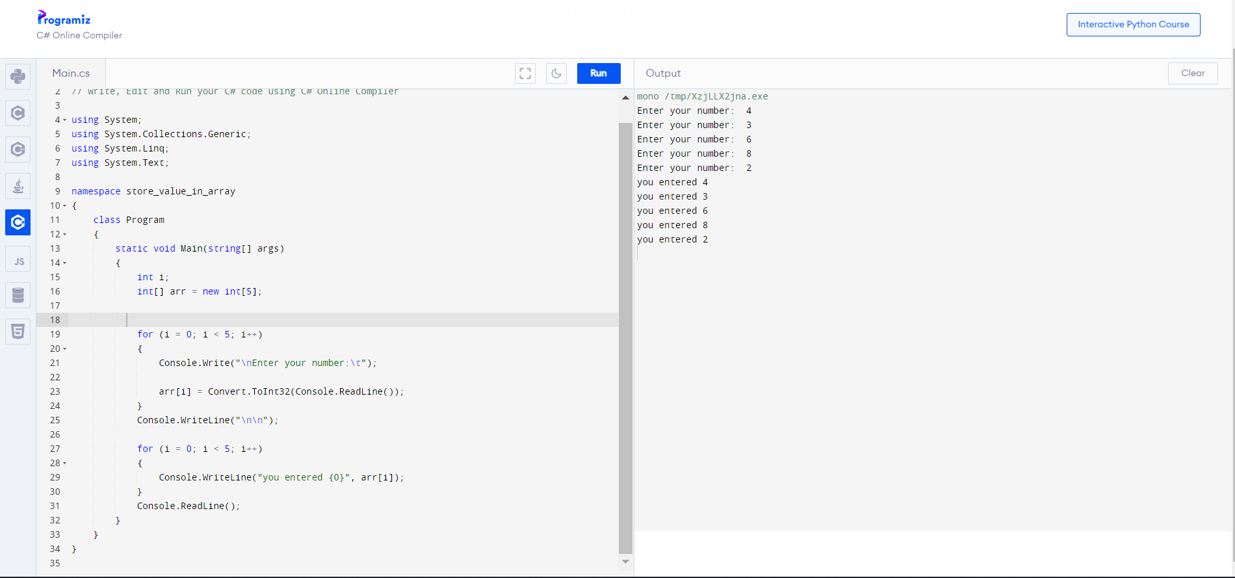

size of the array.

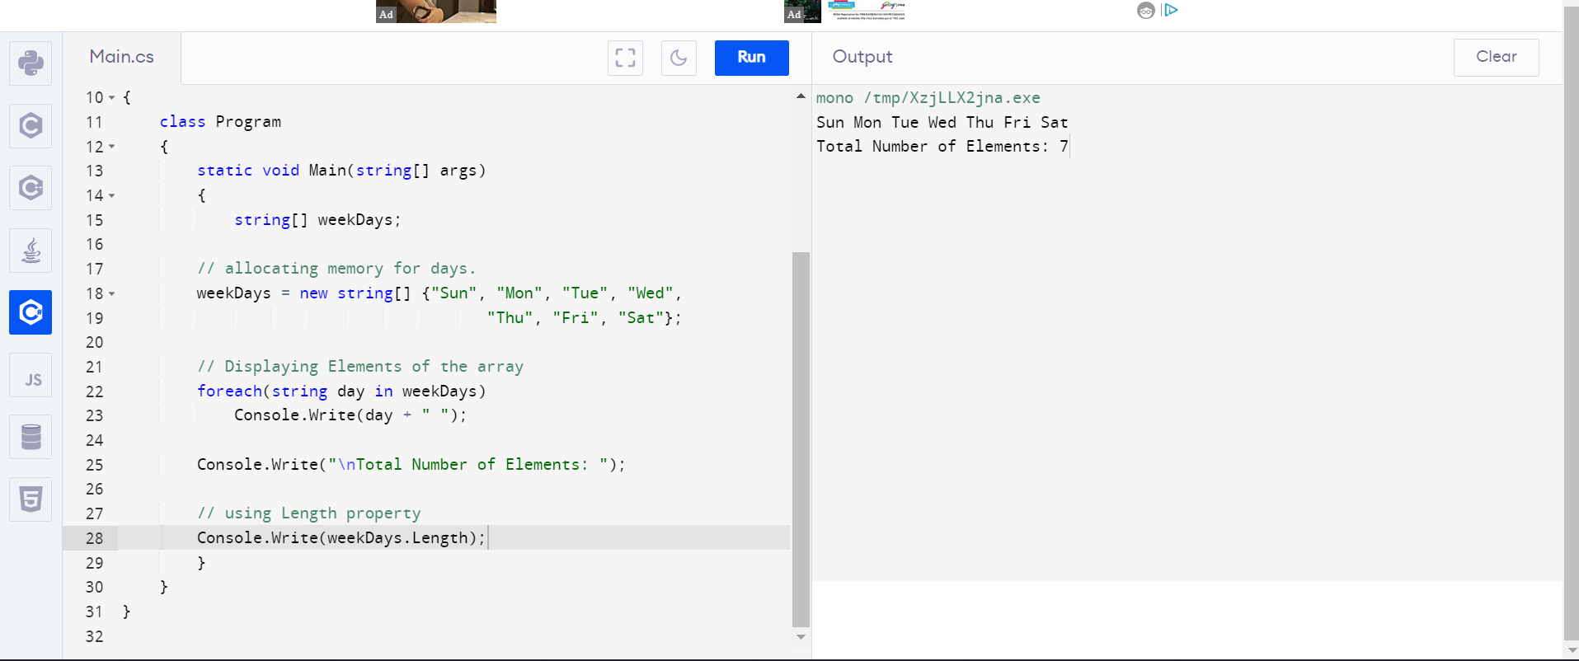

Integer array

