5]

1. Create following types of arrays
2. Integer
3. String

Use System.Array class to perform following operations on them

Copy, Sort, Clear, Reverse

Accept input from user through Console.

i>copy method

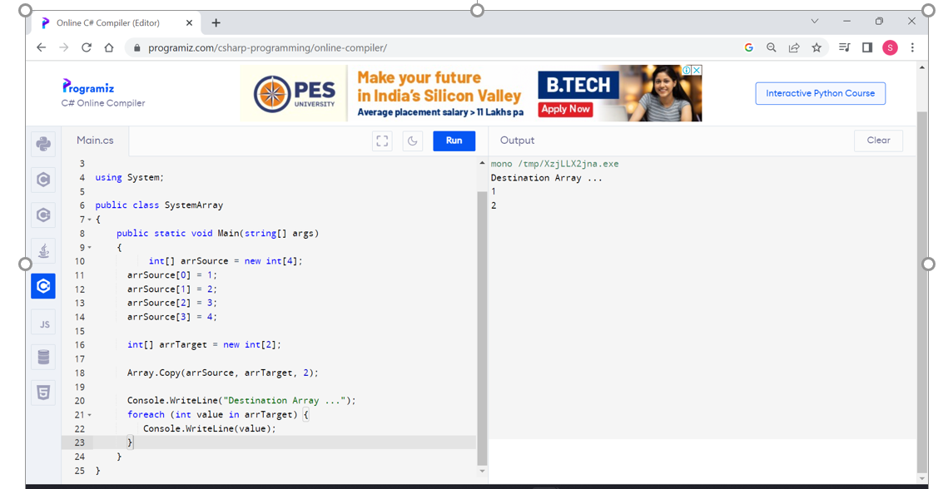

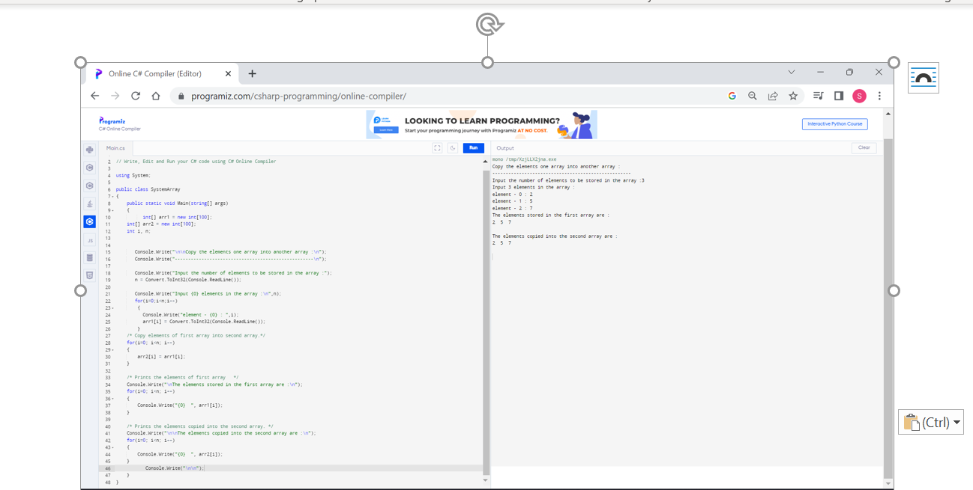

ii>sort iii>reverse

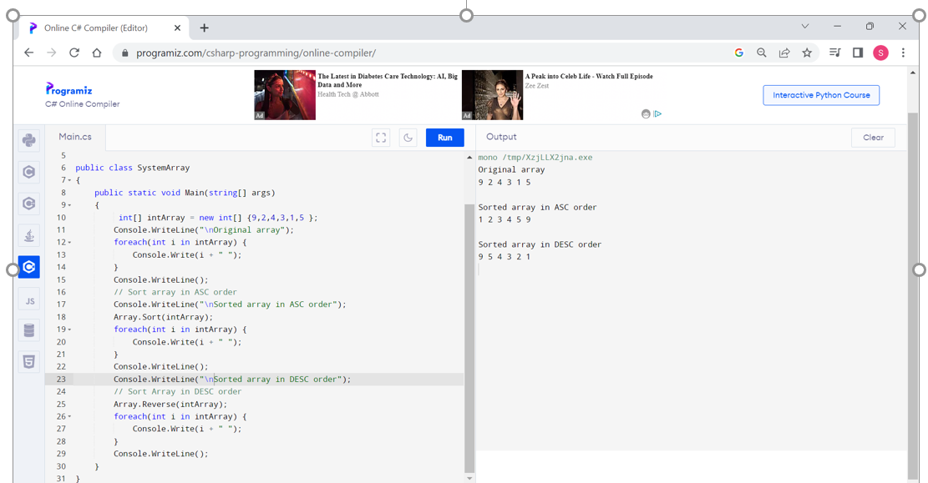

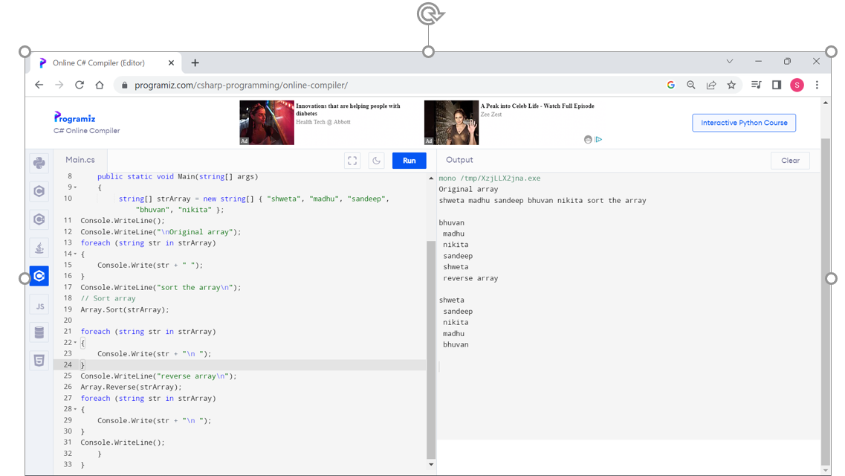

iv>clear()

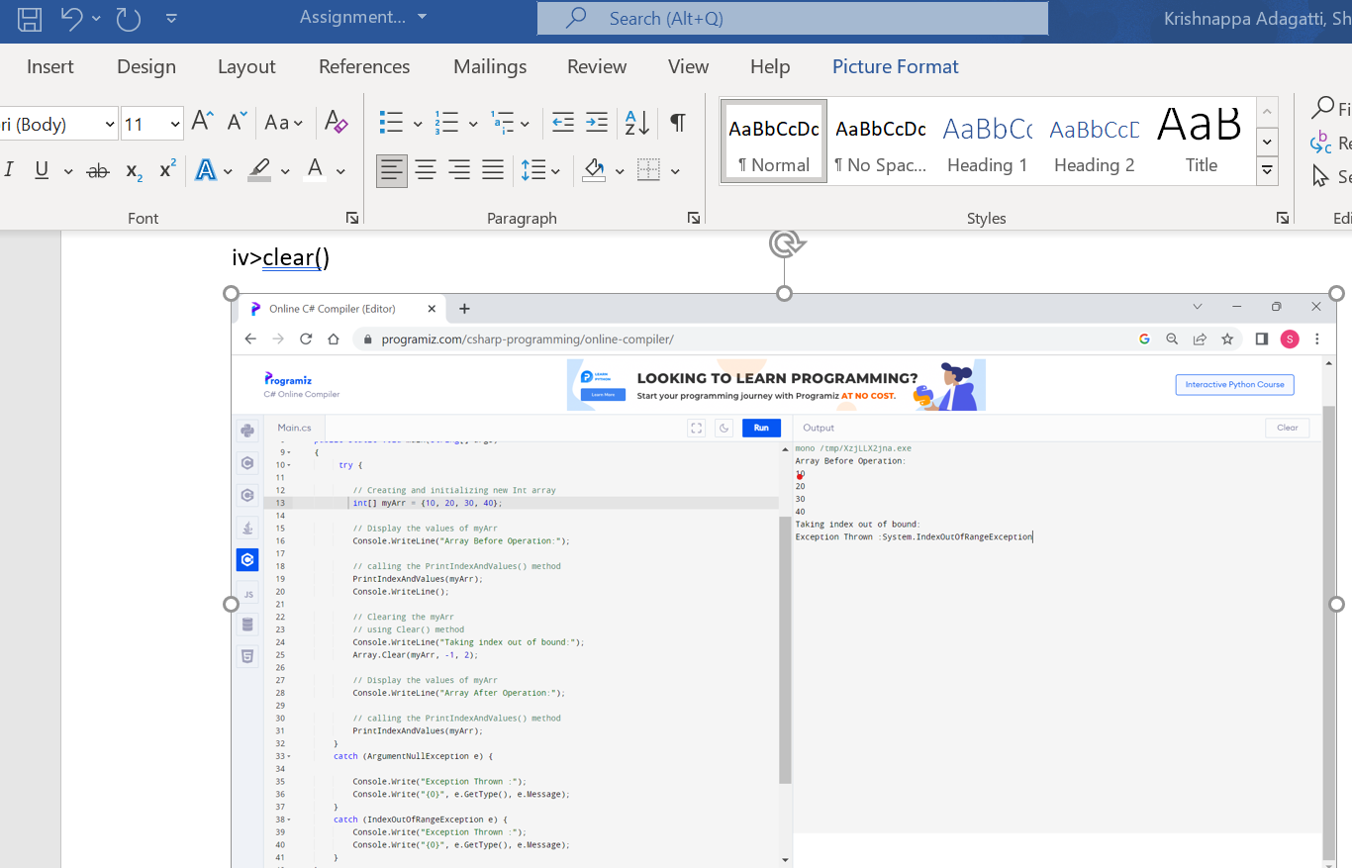

* Use collection class such as ArrayList to hold more than one employee objects in Employee Management application. Display all Employee details which are stored in collection.

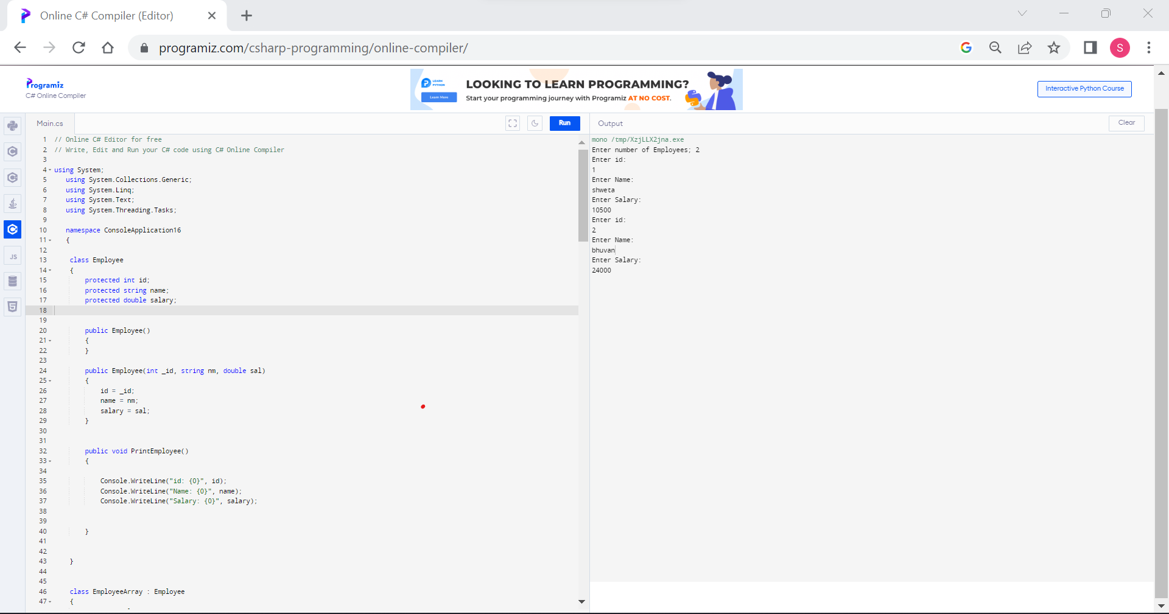

1. Write a console based program to create a linked list of Employee objects using the generic class List<Employee>.Perform following operations on the list:
2. Add a new employee
3. Display the list of employees.
4. Total number of employees in the list

