1. print the details of Managers with the help of delegate

         EmployeeDelegate. (UniCast Delegate)

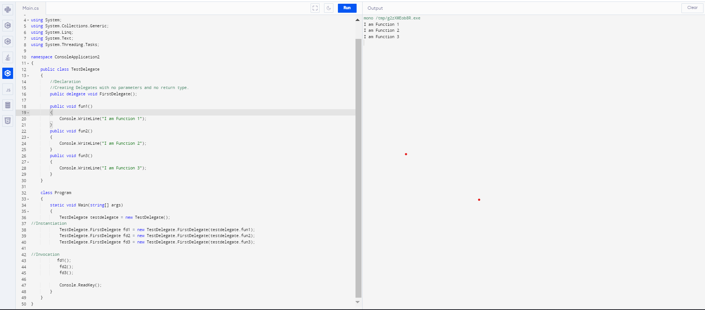

Create a MultiCast Delegate by adding address of another method to the above delegate to list the details of Marketing Executive.

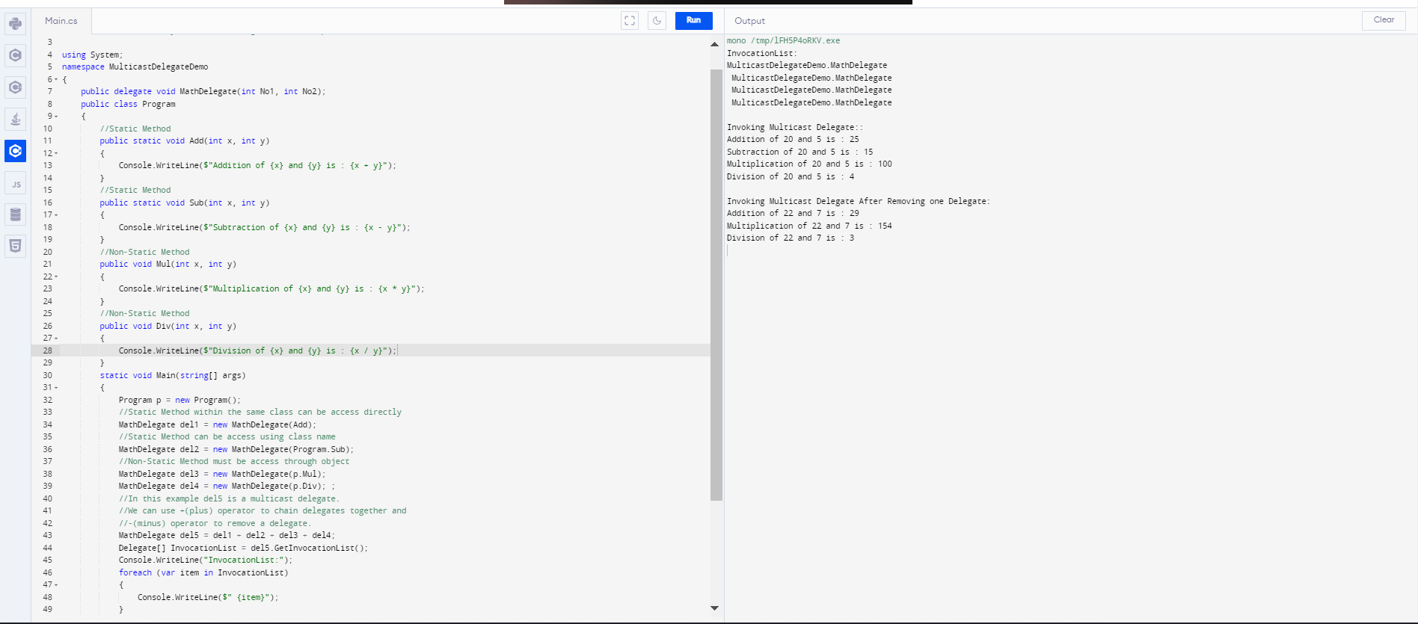

Write a console Application for banking domain, having Account class with data members as account number, customer name, balance . It should have Withdraw and Deposit methods for performing banking transaction. It should also define UnderBalance, BalanceZero events. These events would be raised when balance of account is less than certain amount and equal to zero respectively.

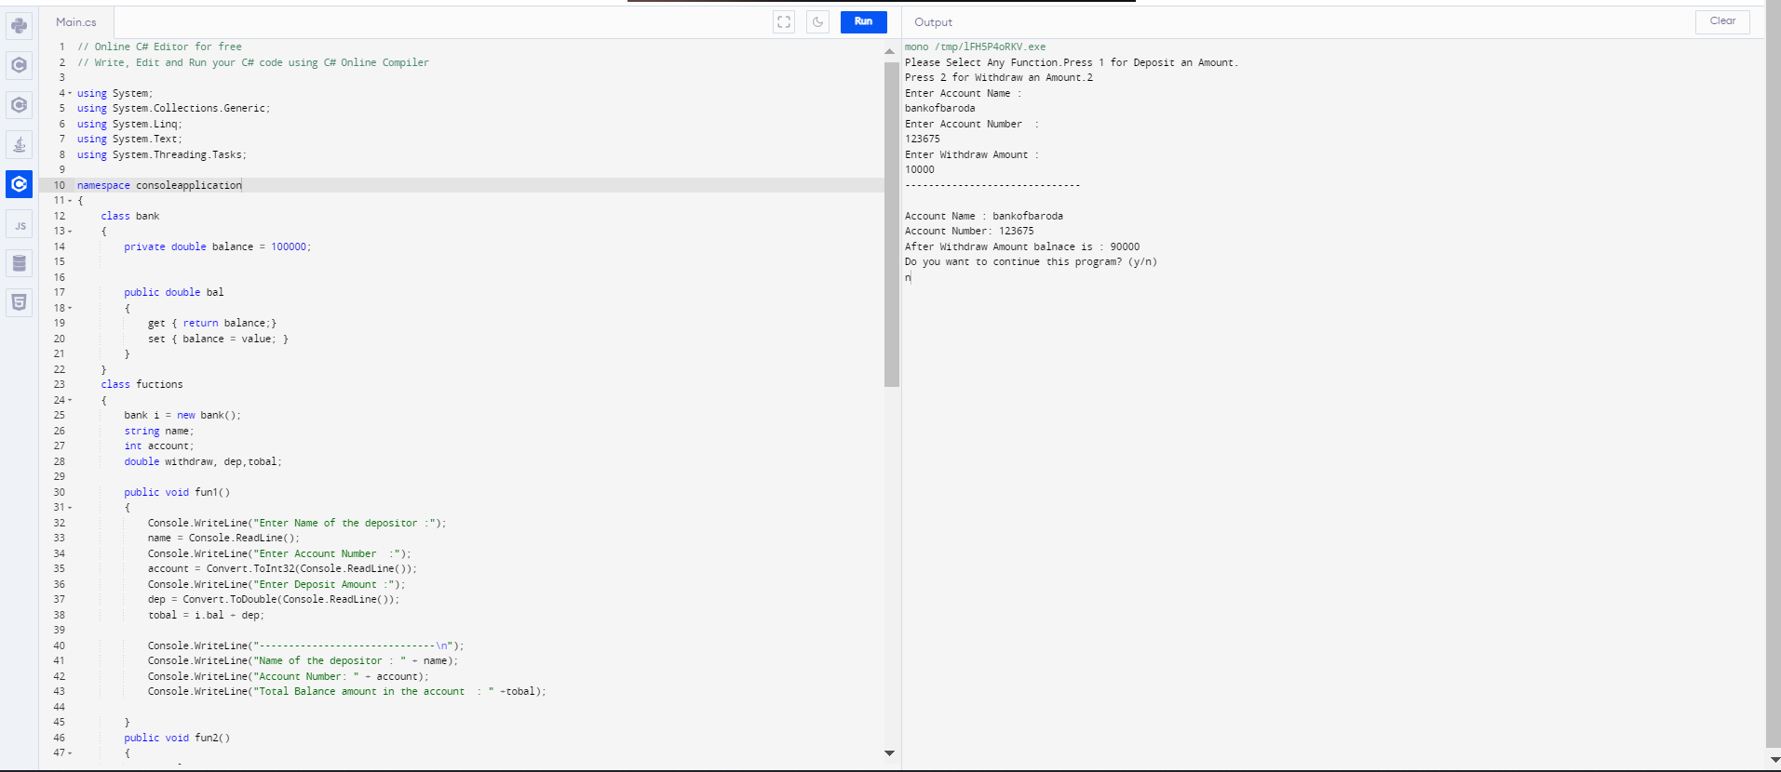

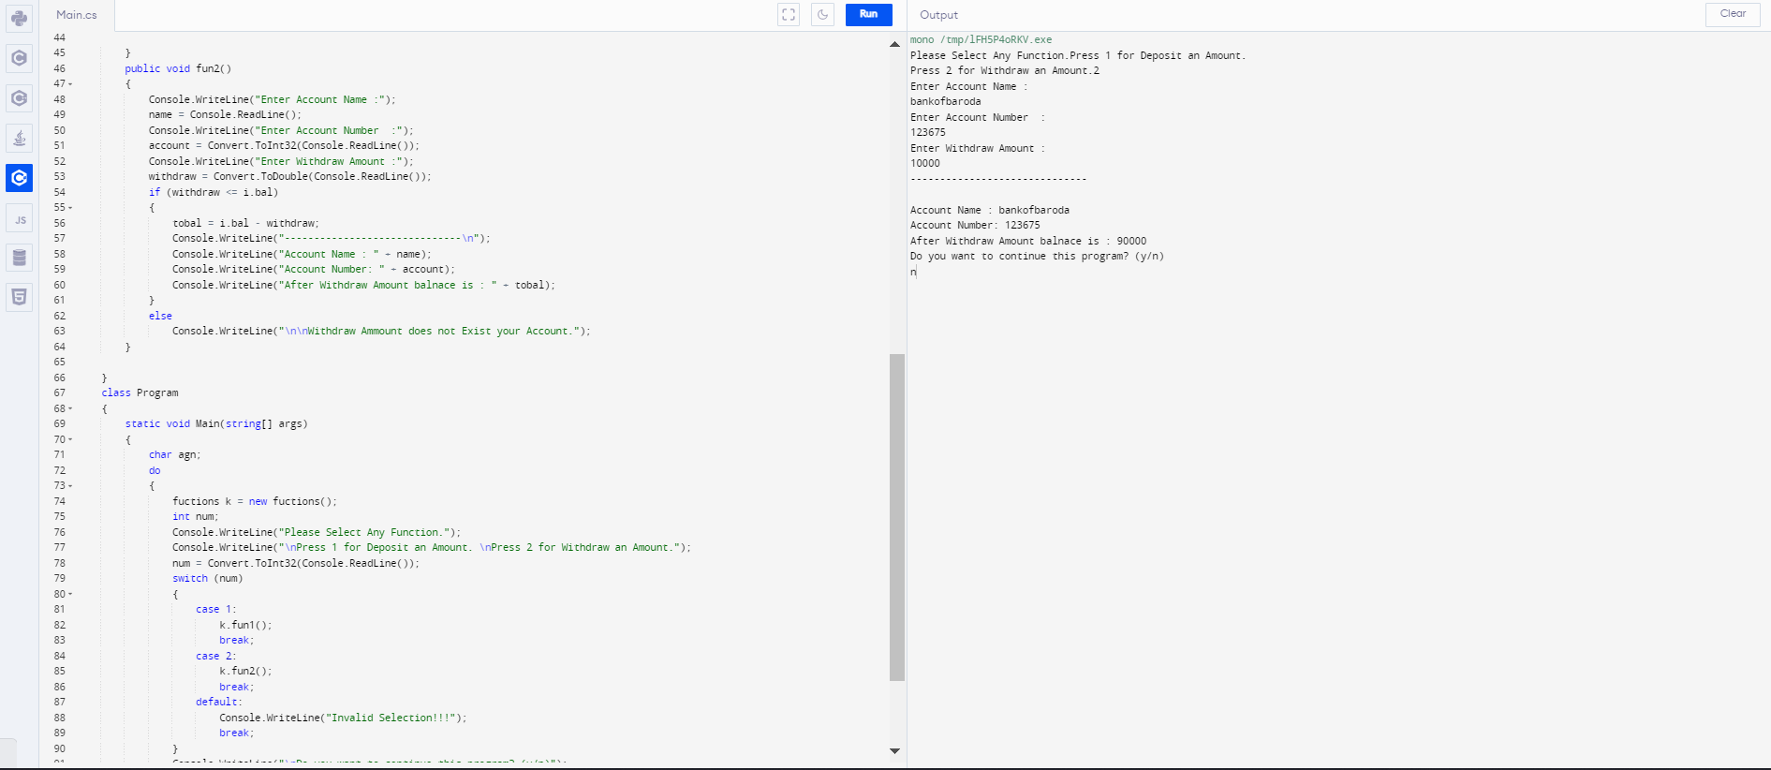

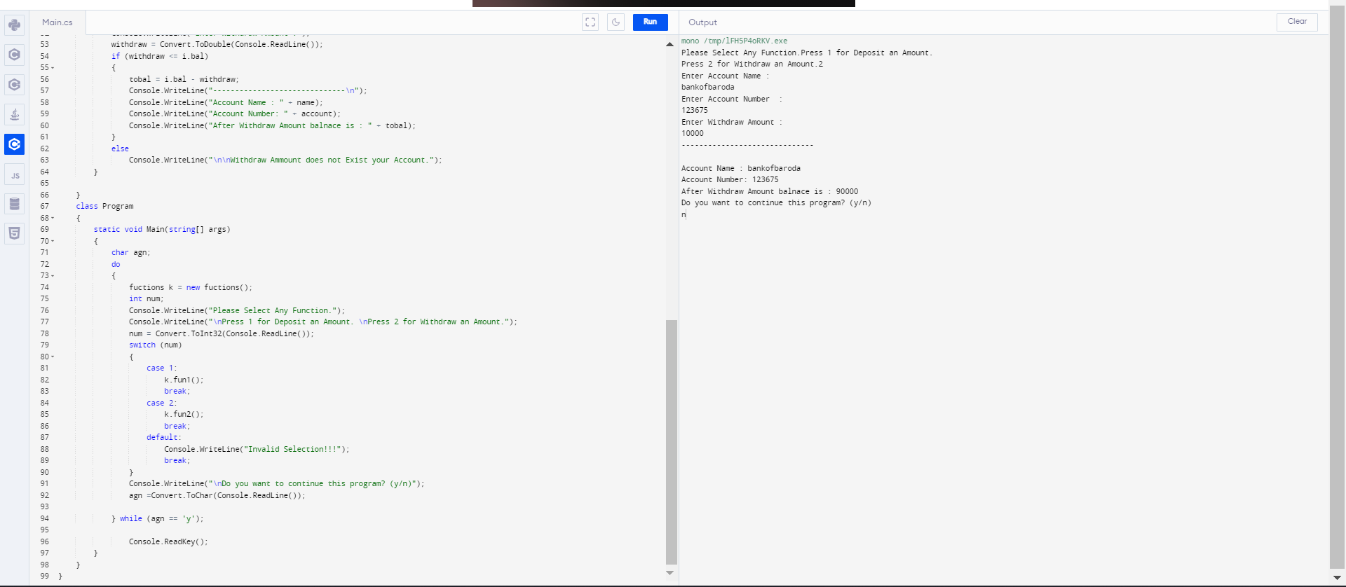

1. Write separate ICICIBank class with EventHandlers for UnderBalance and

BalanceZero Events.

1. Show message "Transaction cannot be continued as balance is insufficient/zero in Account".

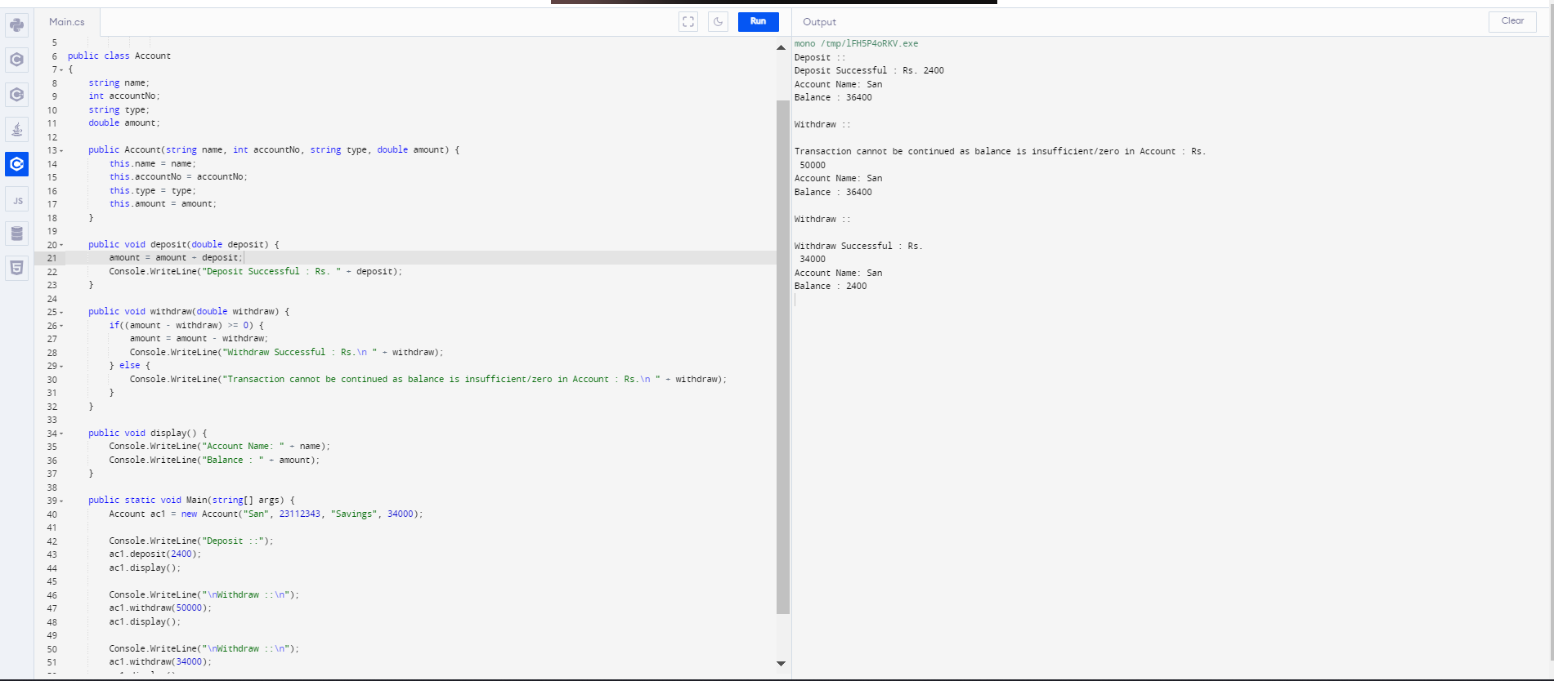

1. Write separate HDFCBank class with EventHandlers for UnderBalance and

BalanceZero Events.

1. EventHandler should allow account holder to withdraw money till balance goes to Rs - 1000;below this show message "Transaction cannot be continued below specified limit of Rs.-1000".

