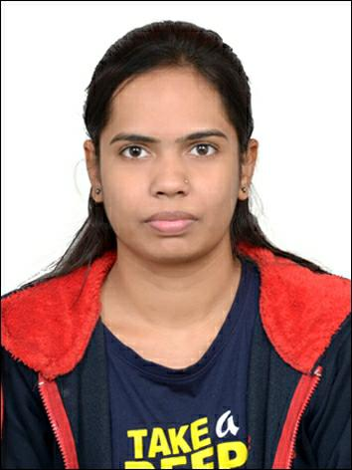

Shweta Kore

Analyst A4

7666603610

shweta.dhanraj-kore@capgemini.com

SUMMARY

-

-

KEY SKILLS

EXPERIENCE

**Analyst A4**

*(*

*APR 2022*

*-*

*Present)*

**CAPGEMINI**

-

Mumbai

**BILL PAYMENT SYSTEM**

* The Bill Payment System project is done in which a way that service providers send invoices to their customers through mail.
* After customer receives the invoice and pay the bill.
* The service software providers have information technology to help customer to pay their bill at their own convenience.

**Achievement**

* Got second rank in the university examination conducted by S.R.T.M. university ,Nanded in post graduation.
* Software Testing-Qspider
* Channel management and retailing, Coursera
* Agile Software Development-Coursera

EDUCATION

**MSC(SE)**

(2019-2021)

**COLLEGE OF COMPUTER SCIENCE AND INFORMATION TECHNOLOGY,LATUR**

**BSC**

*(2016- 2019)*

**DAYANAND SCIENCE COLLEGE,LATUR**

CERTIFICATIONS

•

C , C++

•

ASP .NET

•

HTML , CSS

•

SQL

•

Basic knowledge of Java



I completed my MSC in software engineering with an aggregate of 9.50 CGPA. Along with my degree I’ve done my academic project to enhance my technical skills in a practical manner. This enriched my learnings and competence in the same.