**Project Title**: InvestWise: AI-Powered Stock Market Trend Prediction

**Team Members**:

1. Shwetanshu Bhatt - Co-Developer (Backend, AI/ML Model Development, Data Engineering)
2. Aman Sharma - Co-Developer (Frontend, API Integration, Cloud Infrastructure)

**Abstract**:  
InvestWise is an AI-driven platform aimed at predicting stock market trends using historical data and machine learning. With cloud computing and advanced AI models, InvestWise offers insights into potential market movements, helping users make informed investment decisions. The platform provides real-time data processing, technical indicator analysis, and stock trend forecasts to empower everyday investors with data-backed insights. Our solution focuses on accuracy, simplicity, and accessibility to bridge the gap between sophisticated financial tools and retail investors.

**Problem Statement**:  
Investors often face challenges in analysing stock market trends due to a lack of expertise or access to complex financial tools. This can result in poor investment decisions and financial losses. Our project aims to address this by providing an accessible, AI-powered tool that predicts stock market trends using historical data.

**Proposed Solution**:  
InvestWise will leverage historical stock data and AI models, such as LSTM, to predict market trends and future price movements. Key features of the platform include:

* Stock trend predictions based on historical data analysis.
* Real-time visualizations of trends and technical indicators.

**Use of Vultr Services**:

* **Vultr Compute Instances**: For training machine learning models and running real-time trend predictions.
* **Vultr Object Storage**: For storing processed data, logs, and AI model artifacts.

**Target Audience**:  
Investors and individuals looking for a simple, intuitive tool that helps predict stock market trends to make data-driven decisions.

**Preliminary Diagram**:

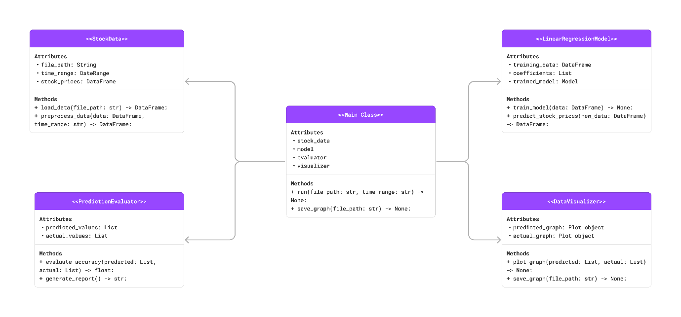

**Expected Outcomes**:

* A functional prototype that predicts stock market trends.
* A real-time AI-driven solution hosted on Vultr's cloud infrastructure.
* Enhanced accessibility for retail investors to make informed financial decisions.