**VISVESVARAYA TECHNOLOGICAL UNIVERSITY**

**“JnanaSangama”, Belgaum -590014, Karnataka.**

**ARTIFICIAL INTELLIGENCE LABREPORT**

***Submittedby***

**SHWETA PATIL(1BM19CS156)**

***Under the Guidance of***

**Dr. Manjunath**

**Associate Professor, BMSCE**

***in partial fulfilment for the award of the degree of***

**BACHELOR OF ENGINEERING**

***In***

**COMPUTER SCIENCE AND ENGINEERING**



**B.M.S. COLLEGE OF ENGINEERING**

**(Autonomous Institution under VTU)**

**BENGALURU-560019**

**Oct-2021 toJan-2022**

**B. M. S. College of Engineering,**

**Bull Temple Road, Bangalore 560019**

(Affiliated To Visvesvaraya Technological University, Belgaum)

**Department of Computer Science and Engineering**



**CERTIFICATE**

This is to certify that the Advance Data Structures Lab for Cycle2(CIE2) carried out by**, SHWETA PATIL(1BM19CS156)** who are Bonafede student of **B.M.S.College of Engineering .**It is inpartial fulfillment for the award of **Bachelor of Engineering in Computer Science and Engineering** of the Visveswaraiah Technological University,Belgaum during the year 2021-2022.The Lab report has been approved as it satisfies the academic requirements in respect of **ARTIFICIAL INTELLIGENCE (20CS5PCAIP)** work prescribed for the said degree.

SignatureoftheGuide SignatureoftheHOD

Dr.Manjunath Dr. UmadeviV

AssociateProfessor AssociateProf.&Head,Dept.ofCSE

BMSCE,Bengalur BMSCE,Bengaluru

**Index**

|  |  |  |
| --- | --- | --- |
| **Serial No.** | **TITLE** | **PAGE NO.** |
| 1 | **Create a knowledgebase using prepositional logic and show that the given query entails the knowledge base or not.** | 03 |
| 2 | **Create a knowledgebase using prepositional logic and prove the given query using resolution** | 08 |
| 3 | **Implement unification in first order logic** | 17 |
| 4 | **Convert given first order logic statement into Conjunctive Normal Form (CNF)** | 21 |
| 5 | **Create a knowledgebase consisting of first order logic statements and prove the given query using forward reasoning.** | 25 |

# Create a knowledgebase using prepositional logic and show that the given query entails the knowledge base ornot.

combinations=[(True,True, True),(True,True,False),(True,False,True),(True,False, False),(False,True, True),(False,True, False),(False, False,True),(False,False, False)] variable={'p':0,'q':1, 'r':2}

kb=''

q=''

priority={'~':3,'v':1,'^':2}

def input_rules(): global kb, q

kb = (input("Knowledge base : ")) q = input("Query : ")

def entailment(): global kb, q

print(''*10+"Truth Table Reference"+''*10) print('kb α')

print('-'*10)

for comb in combinations:

s = evaluatePostfix(toPostfix(kb), comb) f = evaluatePostfix(toPostfix(q), comb) print(s,f)

if s is True and f is False: return False

return True

def isOperand(c):

return c.isalpha() and c!='v'

defisLeftParanthesis(c): return c =='('

def isRightParanthesis(c): return c ==')'

def isEmpty(stack): return len(stack) == 0

def peek(stack): return stack[-1]

def hasLessOrEqualPriority(c1, c2): try:

return priority[c1]<=priority[c2] except KeyError:

return False

def toPostfix(infix): stack = []

postfix = '' for c in infix:

if isOperand(c): postfix += c

else:

if isLeftParanthesis(c): stack.append(c)

elifisRightParanthesis(c): operator =stack.pop()

while notisLeftParanthesis(operator): postfix +=operator

operator = stack.pop()

else:

while (not isEmpty(stack)) and hasLessOrEqualPriority(c, peek(stack)): postfix += stack.pop()

stack.append(c) while (not isEmpty(stack)):

postfix += stack.pop() return postfix

def evaluatePostfix(exp, comb): stack = []

for i in exp:

if isOperand(i):

stack.append(comb[variable[i]]) elifi == '~':

val1 = stack.pop() stack.append(not val1)

else:

val1 = stack.pop() val2 = stack.pop()

stack.append(_eval(i,val2,val1)) return stack.pop()

def _eval(i, val1, val2): if i == '^':

return val2 and val1 return val2 or val1

input_rules()

ans = entailment() if ans:

print("The Knowledge Base entails query") print(" KB |= α ")

else:

print("The Knowledge Base does not entail query") print("\n")

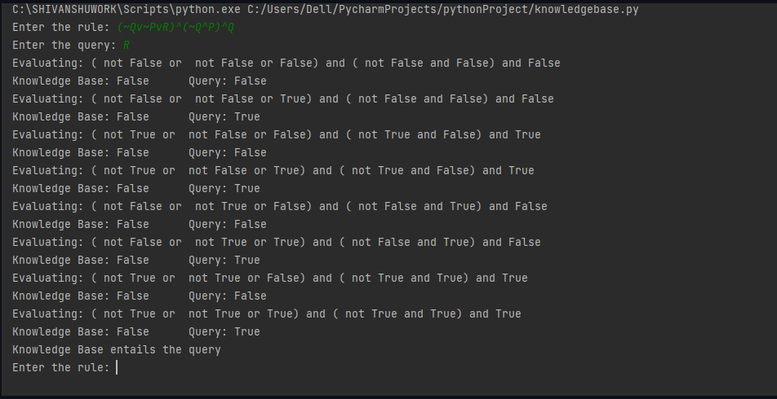

# Create a knowledgebase using prepositional logic and prove the given query usingresolution.

# Global variable kb (knowledge base) kb = []

# Reset kb to an empty list def Clear():

global kb kb = []

# Insert sentence to the kb def AddSentence(sentence):

global kb

# If the sentence is a clause, insert directly. if isClause(sentence):

kb.append(sentence)

# If not, convert to CNF, and then insert clauses one by one. else:

sentenceCNF = convertCNF(sentence) if not sentenceCNF:

print("Illegal input") return

# Insert clauses one by one when there are multiple clauses if isAndList(sentenceCNF):

for s in sentenceCNF[1:]: kb.append(s)

else:

kb.append(sentenceCNF)

# 'Query' the kb whether a sentence is True or not def Query(sentence):

global kb

# Negate the sentence, and convert it to CNF accordingly. if isClause(sentence):

neg = negation(sentence) else:

sentenceCNF = convertCNF(sentence) if not sentenceCNF:

print("Illegal input") return

neg = convertCNF(negation(sentenceCNF))

# Insert individual clauses that we need to ask to ask_list. ask_list = []

if isAndList(neg): for n in neg[1:]:

nCNF = makeCNF(n)

iftype(nCNF).name == 'list': ask_list.insert(0,nCNF)

else:

ask_list.insert(0, nCNF)

else:

ask_list = [neg]

# Create a new list combining the asked sentence and kb. # Resolution will happen between the items in the list. clauses = ask_list + kb[:]

# Recursivly conduct resoltion between items in the clauses list # until it produces an empty list or there's no more pregress. while True:

new_clauses = [] for c1 in clauses:

for c2 in clauses: if c1 is not c2:

resolved = resolve(c1, c2) if resolved == False:

continue

if resolved == []: return True

new_clauses.append(resolved)

if len(new_clauses) == 0: return False

new_in_clauses = True for n in new_clauses:

if n not in clauses: new_in_clauses = False clauses.append(n)

if new_in_clauses: return False

return False

# Conduct resolution on two CNF clauses. def resolve(arg_one, arg_two):

resolved = False

s1 = make_sentence(arg_one) s2 = make_sentence(arg_two)

resolve_s1 = None resolve_s2 = None

# Two for loops that iterate through the two clauses. for i in s1:

if isNotList(i): a1 = i[1]

a1_not = True else:

a1 = i

a1_not = False

for j in s2:

if isNotList(j): a2 = j[1]

a2_not = True else:

a2 = j

a2_not = False

# cancel out two literals such as 'a' $ ['not', 'a'] if a1 == a2:

if a1_not != a2_not:

# Return False if resolution already happend # but contradiction still exists.

if resolved: return False

else:

resolved = True resolve_s1 = i resolve_s2 = j break

# Return False if not resolution happened if not resolved:

return False

# Remove the literals that are canceled s1.remove(resolve_s1) s2.remove(resolve_s2)

# # Remove duplicates

result = clear_duplicate(s1 + s2)

# Format the result. if len(result) == 1: return result[0]

eliflen(result) > 1: result.insert(0, 'or')

return result

# Prepare sentences for resolution. def make_sentence(arg):

if isLiteral(arg) or isNotList(arg): return [arg]

if isOrList(arg):

return clear_duplicate(arg[1:]) return

# Clear out duplicates in a sentence. def clear_duplicate(arg):

result = []

for i in range(0, len(arg)): if arg[i] not in arg[i+1:]:

result.append(arg[i]) return result

# Check whether a sentence is a legal CNF clause. def isClause(sentence):

if isLiteral(sentence): return True

if isNotList(sentence):

if isLiteral(sentence[1]): return True

else:

return False

if isOrList(sentence):

for i in range(1, len(sentence)): if len(sentence[i]) > 2:

returnFalse

elif not isClause(sentence[i]): returnFalse

return True return False

# Check if a sentence is a legal CNF. def isCNF(sentence):

if isClause(sentence): return True

elifisAndList(sentence): for s in sentence[1:]:

if not isClause(s): return False

return True return False

# Negate a sentence. def negation(sentence):

if isLiteral(sentence): return ['not', sentence]

if isNotList(sentence): return sentence[1]

# DeMorgan:

if isAndList(sentence): result = ['or']

for i in sentence[1:]:

if isNotList(sentence): result.append(i[1])

else:

result.append(['not', sentence]) return result

if isOrList(sentence): result = ['and']

for i in sentence[:]:

if isNotList(sentence): result.append(i[1])

else:

result.append(['not', i]) return result

return None

# Convert a sentence into CNF. def convertCNF(sentence):

while not isCNF(sentence): if sentence is None:

return None

sentence = makeCNF(sentence) return sentence

def makeCNF(sentence): if isLiteral(sentence): return sentence

if(type(sentence).name == 'list'): operand = sentence[0]

ifisNotList(sentence):

if isLiteral(sentence[1]): return sentence

cnf = makeCNF(sentence[1]) if cnf[0] == 'not':

return makeCNF(cnf[1]) if cnf[0] == 'or':

result = ['and']

for i in range(1, len(cnf)): result.append(makeCNF(['not', cnf[i]]))

return result

if cnf[0] == 'and':

result = ['or']

for i in range(1, len(cnf)): result.append(makeCNF(['not', cnf[i]]))

return result return "False: not"

# Implication Elimination:

if operand == 'implies' and len(sentence) == 3:

return makeCNF(['or', ['not', makeCNF(sentence[1])], makeCNF(sentence[2])]) # Biconditional Elimination:

if operand == 'biconditional' and len(sentence) == 3: s1 = makeCNF(['implies', sentence[1], sentence[2]]) s2 = makeCNF(['implies', sentence[2], sentence[1]]) return makeCNF(['and', s1,s2])

if isAndList(sentence): result = ['and']

for i in range(1, len(sentence)): cnf = makeCNF(sentence[i]) # Distributivity:

if isAndList(cnf):

for i in range(1, len(cnf)): result.append(makeCNF(cnf[i]))

continue result.append(makeCNF(cnf))

return result

if isOrList(sentence): result1 = ['or']

for i in range(1, len(sentence)): cnf = makeCNF(sentence[i]) #Distributivity:

ifisOrList(cnf):

for i in range(1, len(cnf)): result1.append(makeCNF(cnf[i]))

continue result1.append(makeCNF(cnf)) #Associativity:

while True: result2 =['and']

and_clause = None for r inresult1:

if isAndList(r): and_clause = r break

# Finish when there's no more 'and' lists # inside of 'or' lists

if not and_clause: return result1

result1.remove(and_clause)

for i in range(1, len(and_clause)): temp = ['or', and_clause[i]]

for o in result1[1:]: temp.append(makeCNF(o))

result2.append(makeCNF(temp)) result1 = makeCNF(result2)

return None return None

# Below are 4 functions that check the type of a variable def isLiteral(item):

iftype(item).name == 'str': returnTrue

return False

def isNotList(item):

iftype(item).name == 'list': if len(item) ==2:

if item[0] == 'not': return True

return False

def isAndList(item):

iftype(item).name == 'list': if len(item) >2:

if item[0] == 'and': return True

return False

def isOrList(item):

iftype(item).name == 'list': if len(item) >2:

if item[0] == 'or': return True

return False

AddSentence(['and', 'p', 'q'])

AddSentence(['or', 'r', 's']) print(Query(['and',['or','p','r'], ['or', 'q', 's']]))

**OUTPUT SCREEN**

Test Case 1:

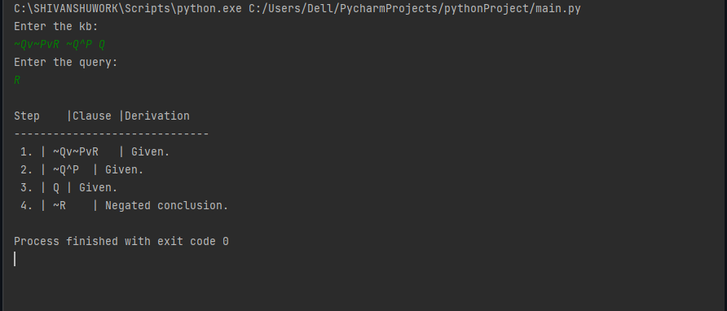

NEGATED CONCLUSION🡪NULL SET🡪PROVED.

# Implement unification in first orderlogic.

import re

def getAttributes(expression): expression = expression.split("(")[1:] expression = "(".join(expression) expression = expression[:-1]

expression = re.split("(?<!\(.),(?!.\))", expression) return expression

def getInitialPredicate(expression): return expression.split("(")[0]

def isConstant(char):

return char.isupper() and len(char) == 1

def isVariable(char):

return char.islower() and len(char) == 1

def replaceAttributes(exp, old, new): attributes = getAttributes(exp)

for index, val in enumerate(attributes): if val == old:

attributes[index] = new predicate = getInitialPredicate(exp)

return predicate + "(" + ",".join(attributes) + ")"

def apply(exp, substitutions):

for substitution in substitutions: new, old = substitution

exp = replaceAttributes(exp, old, new) return exp

def checkOccurs(var, exp): if exp.find(var) == -1:

return False return True

def getFirstPart(expression):

attributes = getAttributes(expression) return attributes[0]

def getRemainingPart(expression):

predicate = getInitialPredicate(expression) attributes = getAttributes(expression)

newExpression = predicate + "(" + ",".join(attributes[1:]) + ")" return newExpression

def unify(exp1, exp2): if exp1 == exp2:

return []

if isConstant(exp1) and isConstant(exp2): if exp1 != exp2:

return False

if isConstant(exp1): return [(exp1,exp2)]

if isConstant(exp2): return [(exp2,exp1)]

if isVariable(exp1):

if checkOccurs(exp1, exp2): return False

else:

return [(exp2, exp1)]

if isVariable(exp2):

if checkOccurs(exp2, exp1): return False

else:

return [(exp1, exp2)]

if getInitialPredicate(exp1) != getInitialPredicate(exp2): print("Predicates do not match. Cannot be unified") return False

attributeCount1 = len(getAttributes(exp1)) attributeCount2 = len(getAttributes(exp2))

if attributeCount1 != attributeCount2: return False

head1 = getFirstPart(exp1) head2 = getFirstPart(exp2)

initialSubstitution = unify(head1, head2) if not initialSubstitution:

return False

if attributeCount1 == 1: return initialSubstitution

tail1 = getRemainingPart(exp1) tail2 = getRemainingPart(exp2)

if initialSubstitution != []:

tail1 = apply(tail1, initialSubstitution) tail2 = apply(tail2, initialSubstitution)

remainingSubstitution = unify(tail1, tail2) if not remainingSubstitution:

return False

initialSubstitution.extend(remainingSubstitution) return initialSubstitution

print("\n\nTest Case 1:\n") exp1 = "knows(A,x)" exp2 ="knows(y,Y)"

substitutions = unify(exp1, exp2) print("Substitutions:") print(substitutions)

print("\n\nTest Case 2:\n") exp1 = "knows(A,x)"

exp2 = "knows(y,mother(y))" substitutions = unify(exp1, exp2) print("Substitutions:") print(substitutions)

**OUTPUT SCREEN**

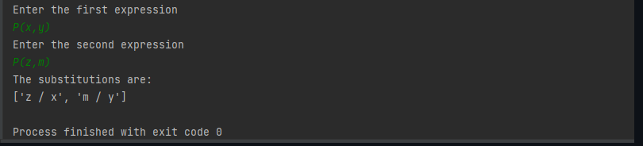

# Convert given first order logic statement into ConjunctiveNormal Form(CNF).

def getAttributes(string): expr = '\([^)]+\)'

matches = re.findall(expr, string)

return [m for m in str(matches) if m.isalpha()]

def getPredicates(string):

expr = '[a-z~]+\([A-Za-z,]+\)' return re.findall(expr, string)

def DeMorgan(sentence):

string = ''.join(list(sentence).copy()) string = string.replace('~~','')

flag = '[' in string

string = string.replace('~[','') string = string.strip(']')

for predicate in getPredicates(string):

string = string.replace(predicate, f'~{predicate}') s = list(string)

for i, c in enumerate(string): if c == '|':

s[i] = '&' elif c == '&': s[i] = '|'

string = ''.join(s)

string = string.replace('~~','')

return f'[{string}]' if flag else string

def Skolemization(sentence):

SKOLEM_CONSTANTS = [f'{chr(c)}' for c in range(ord('A'), ord('Z')+1)] statement = ''.join(list(sentence).copy())

matches = re.findall('[∀∃].', statement) for match in matches[::-1]:

statement = statement.replace(match, '') statements = re.findall('\[\[[^]]+\]]', statement) for s in statements:

statement = statement.replace(s, s[1:-1]) for predicate in getPredicates(statement):

attributes = getAttributes(predicate) if ''.join(attributes).islower():

statement = statement.replace(match[1],SKOLEM_CONSTANTS.pop(0)) else:

aU = [a for a in attributes if not a.islower()][0] statement = statement.replace(aU,

f'{SKOLEM_CONSTANTS.pop(0)}({match[1]})')

return statement

import re

def fol_to_cnf(fol):

statement = fol.replace("<=>", "_") while '_' in statement:

i = statement.index('_')

new_statement = '[' + statement[:i] + '=>' + statement[i+1:] + ']&['+ statement[i+1:] + '=>' + statement[:i] + ']'

statement = new_statement

statement = statement.replace("=>", "-") expr = '\[([^]]+)\]'

statements = re.findall(expr, statement) for i, s in enumerate(statements):

if '[' in s and ']' not in s: statements[i] += ']'

for s in statements:

statement = statement.replace(s, fol_to_cnf(s)) while '-' in statement:

i = statement.index('-')

br = statement.index('[') if '[' in statement else 0 new_statement = '~' + statement[br:i] + '|' + statement[i+1:]

statement = statement[:br] + new_statement if br> 0 else new_statement while '~∀' in statement:

i = statement.index('~∀') statement = list(statement)

statement[i], statement[i+1], statement[i+2] = '∃', statement[i+2], '~' statement = ''.join(statement)

while '~∃' in statement:

i = statement.index('~∃') s = list(statement)

s[i], s[i+1], s[i+2] = '∀', s[i+2], '~' statement = ''.join(s)

statement = statement.replace('~[∀','[~∀')

statement = statement.replace('~[∃','[~∃') expr = '(~[∀|∃].)'

statements = re.findall(expr, statement) for s in statements:

statement = statement.replace(s, fol_to_cnf(s)) expr = '~\[[^]]+\]'

statements = re.findall(expr, statement) for s in statements:

statement = statement.replace(s, DeMorgan(s)) return statement

print("\n Test Case: 1") print(Skolemization(fol_to_cnf("animal(y)<=>loves(x,y)"))) print("\n Test Case:2")

print(Skolemization(fol_to_cnf("∀x[∀y[animal(y)=>loves(x,y)]]=>[∃z[loves(z,x)]]"))) print("\n Test Case:3")

print(Skolemization(fol_to_cnf("[american(x)&weapon(y)&sells(x,y,z)&hostile(z)]=>crim inal(x)")))

print("\n \n ")

**OUTPUT SCREEN**

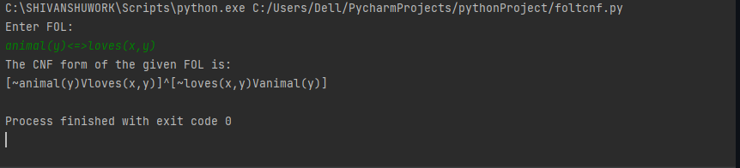

# Create a knowledgebase consisting of first order logic statements and prove the given query using forwardreasoning.

import re

def isVariable(x):

return len(x) == 1 and x.islower() and x.isalpha()

def getAttributes(string): expr = '\([^)]+\)'

matches = re.findall(expr, string) return matches

def getPredicates(string): expr = '([a-z~]+)\([^&|]+\)'

return re.findall(expr, string)

class Fact:

definit(self, expression): self.expression = expression

predicate, params = self.splitExpression(expression) self.predicate = predicate

self.params = params

self.result = any(self.getConstants())

def splitExpression(self, expression): predicate = getPredicates(expression)[0]

params = getAttributes(expression)[0].strip('()').split(',') return [predicate, params]

def getResult(self): return self.result

def getConstants(self):

return [None if isVariable(c) else c for c in self.params]

def getVariables(self):

return [v if isVariable(v) else None for v in self.params]

def substitute(self, constants): c = constants.copy()

f = f"{self.predicate}({','.join([constants.pop(0) if isVariable(p) else p for p in self.params])})"

return Fact(f)

class Implication:

definit(self, expression): self.expression = expression l = expression.split('=>')

self.lhs = [Fact(f) for f in l[0].split('&')] self.rhs = Fact(l[1])

def evaluate(self, facts): constants = {} new_lhs = []

for fact in facts:

for val in self.lhs:

if val.predicate == fact.predicate:

for i, v in enumerate(val.getVariables()): if v:

constants[v] = fact.getConstants()[i] new_lhs.append(fact)

predicate, attributes = getPredicates(self.rhs.expression)[0], str(getAttributes(self.rhs.expression)[0])

for key in constants: if constants[key]:

attributes = attributes.replace(key, constants[key]) expr = f'{predicate}{attributes}'

return Fact(expr) if len(new_lhs) and all([f.getResult() for f in new_lhs]) else None

class KB:

definit(self): self.facts = set() self.implications = set()

def tell(self, e): if '=>' in e:

self.implications.add(Implication(e)) else:

self.facts.add(Fact(e)) for i in self.implications:

res = i.evaluate(self.facts)

if res:

self.facts.add(res)

def query(self, e):

facts = set([f.expression for f in self.facts]) i = 1

print(f'Querying {e}:') for f in facts:

if Fact(f).predicate == Fact(e).predicate: print(f'\t{i}. {f}')

i += 1

def display(self): print("All facts: ")

for i, f in enumerate(set([f.expression for f in self.facts])): print(f'\t{i+1}. {f}')

print("\n \n Test Case 1:") kb = KB()

kb.tell('missile(x)=>weapon(x)')

kb.tell('missile(M1)') kb.tell('enemy(x,America)=>hostile(x)') kb.tell('american(West)') kb.tell('enemy(Nono,America)') kb.tell('owns(Nono,M1)') kb.tell('missile(x)&owns(Nono,x)=>sells(West,x,Nono)')

kb.tell('american(x)&weapon(y)&sells(x,y,z)&hostile(z)=>criminal(x)') kb.query('criminal(x)')

kb.display()

print("\n \n Test Case 2:") kb_ = KB()

kb_.tell('king(x)&greedy(x)=>evil(x)') kb_.tell('king(John)') kb_.tell('greedy(John)') kb_.tell('king(Richard)') kb_.query('evil(x)')

**OUTPUT SCREEN**

