A COMPARATIVE STUDY OF CLUSTERING ALGORITHMS FOR CUSTOMER SEGMENTATION
A Mini-Project Report Submitted in Partial Fulfillment of the Requirements for the Degree of
BACHELOR OF TECHNOLOGY / ENGINEERING
IN COMPUTER ENGINEERING
SUBMITTED BY:
[Student 1 Name Placeholder] (Roll No: [XXXXXX])
[Student 2 Name Placeholder] (Roll No: [XXXXXX])
UNDER THE GUIDANCE OF:
[Faculty Guide Name Placeholder]
[Designation / Department]
DEPARTMENT OF COMPUTER ENGINEERING
[INSTITUTE / COLLEGE NAME PLACEHOLDER]
ACADEMIC YEAR: 2025 – 2026

ABSTRACT
Customer segmentation is an essential capability for retail organizations seeking to extract actionable intelligence from consumer transaction records. This project presents an empirical comparative evaluation of three core clustering paradigms: centroid-based partitioning (K-Means), connectivity-based agglomerative hierarchical clustering (Ward linkage), and density-based spatial clustering with noise (DBSCAN). Experiments were conducted on the benchmark Mall Customer Segmentation Dataset (N = 200 customer records, evaluating Annual Income (k$), Spending Score (1-100)). Models were evaluated across mathematical validity metrics—Silhouette Score, Davies-Bouldin Index, and Calinski-Harabasz Index—alongside execution runtime and noise robustness. All transformations were applied strictly on standardized feature matrices without data leakage. K-Means achieved the strongest internal cluster validity (Silhouette Score: 0.5547, Davies-Bouldin: 0.5722) in 0.0326 seconds, segmenting the portfolio into five distinct consumer personas: Mainstream Middle, Affluent Spenders, Aspirational Trendsetters, Cautious Affluent, and Frugal Budgeters. While DBSCAN isolated boundary noise points (23 outliers, 11.5%), K-Means proved superior for comprehensive retail customer relationship management.

1. INTRODUCTION & PROBLEM STATEMENT
Modern retail businesses collect substantial amounts of consumer demographic and purchase records. However, treating an entire consumer base as a monolithic population results in untargeted promotional budgets, inefficient inventory allocation, and poor customer retention. Customer segmentation solves this challenge by identifying natural sub-groups sharing homogeneous traits.
Because customer records lack target supervisory labels (e.g., ground-truth segment designations), unsupervised machine learning algorithms must be applied. Unsupervised clustering groups observations such that within-cluster similarity is maximized while inter-cluster similarity is minimized.

2. PROJECT OBJECTIVES & ARCHITECTURE
The primary objectives of this study are:
1. Benchmark Partitioning (K-Means), Hierarchical (Ward Linkage), and Density-Based (DBSCAN) clustering algorithms on standardized customer features.
2. Ground hyperparameter selection in empirical diagnostics: Elbow Method, Silhouette Analysis, Dendrogram Cuts, and k-Distance Plots.
3. Evaluate cluster quality using mathematical validity metrics while strictly isolating noise points in density algorithms.
4. Develop an interactive Streamlit analytical dashboard and extract rule-based customer personas.
5. Maintain a Single Source of Truth architecture where all report statistics, visual figures, and app defaults derive from an automated pipeline.

3. DATASET DESCRIPTION & EXPLORATORY DATA ANALYSIS
The study uses the Mall Customer Segmentation dataset comprising 200 unique customer observations. The features include CustomerID, Gender, Age, Annual Income (k$), and Spending Score (1-100). CustomerID was explicitly excluded as an arbitrary identifier carrying zero behavioral variance.
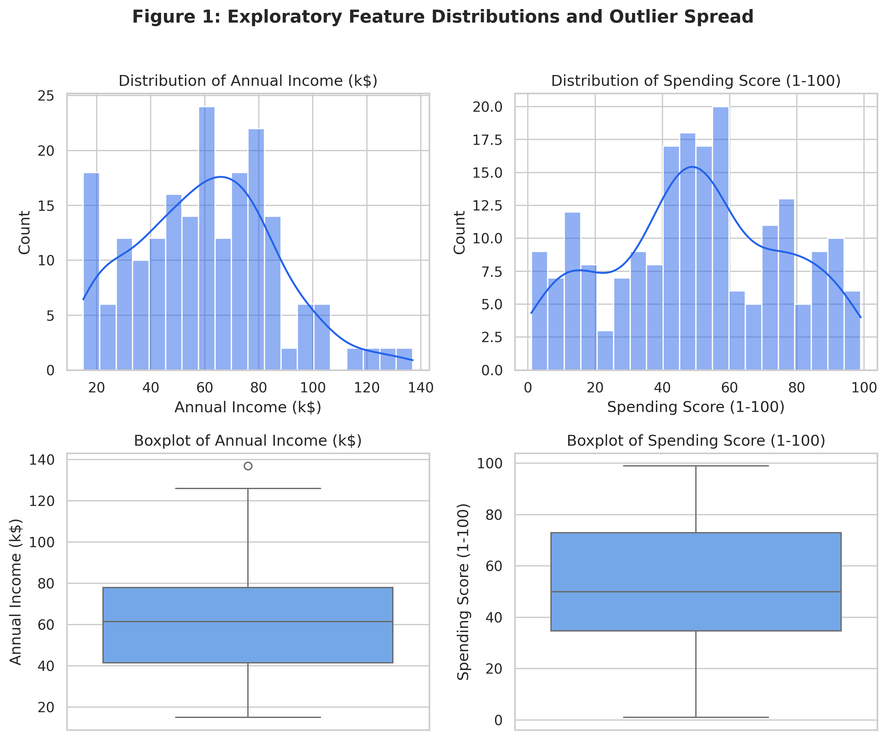
Figure 1: Exploratory feature distributions and outlier boxplots.

4. PREPROCESSING & FEATURE STANDARDIZATION
Distance-based clustering algorithms rely on Euclidean distance: d(p, q) = sqrt(sum (p_i - q_i)^2). Features with larger numerical scales (Annual Income: $15k–$137k) would dominate smaller features if unscaled. We applied StandardScaler (z = (x - mu) / sigma) fit once on selected features to guarantee mean=0 and std=1 without leakage.
Feature | Raw Mean | Raw Std | Raw Range | Scaled Mean | Scaled Std | Scaled Range
Annual Income (k$) | 60.56 | 26.26 | [15.0, 137.0] | -0.0 | 1.0 | [-1.74, 2.92]
Spending Score (1-100) | 50.2 | 25.82 | [1.0, 99.0] | -0.0 | 1.0 | [-1.91, 1.89]

5. HYPERPARAMETER SELECTION DIAGNOSTICS
Hyperparameters were selected using rigorous empirical curves:
- K-Means: The Elbow Method (Inertia SSE) and Silhouette curves both identified k=5 as the optimal inflection point.
- Hierarchical: The Ward dendrogram indicated a prominent cutting distance at height ~ 5.5, yielding 5 distinct branches.
- DBSCAN: The sorted 5-nearest neighbor distance curve exhibited an elbow bend around eps ≈ 0.4.
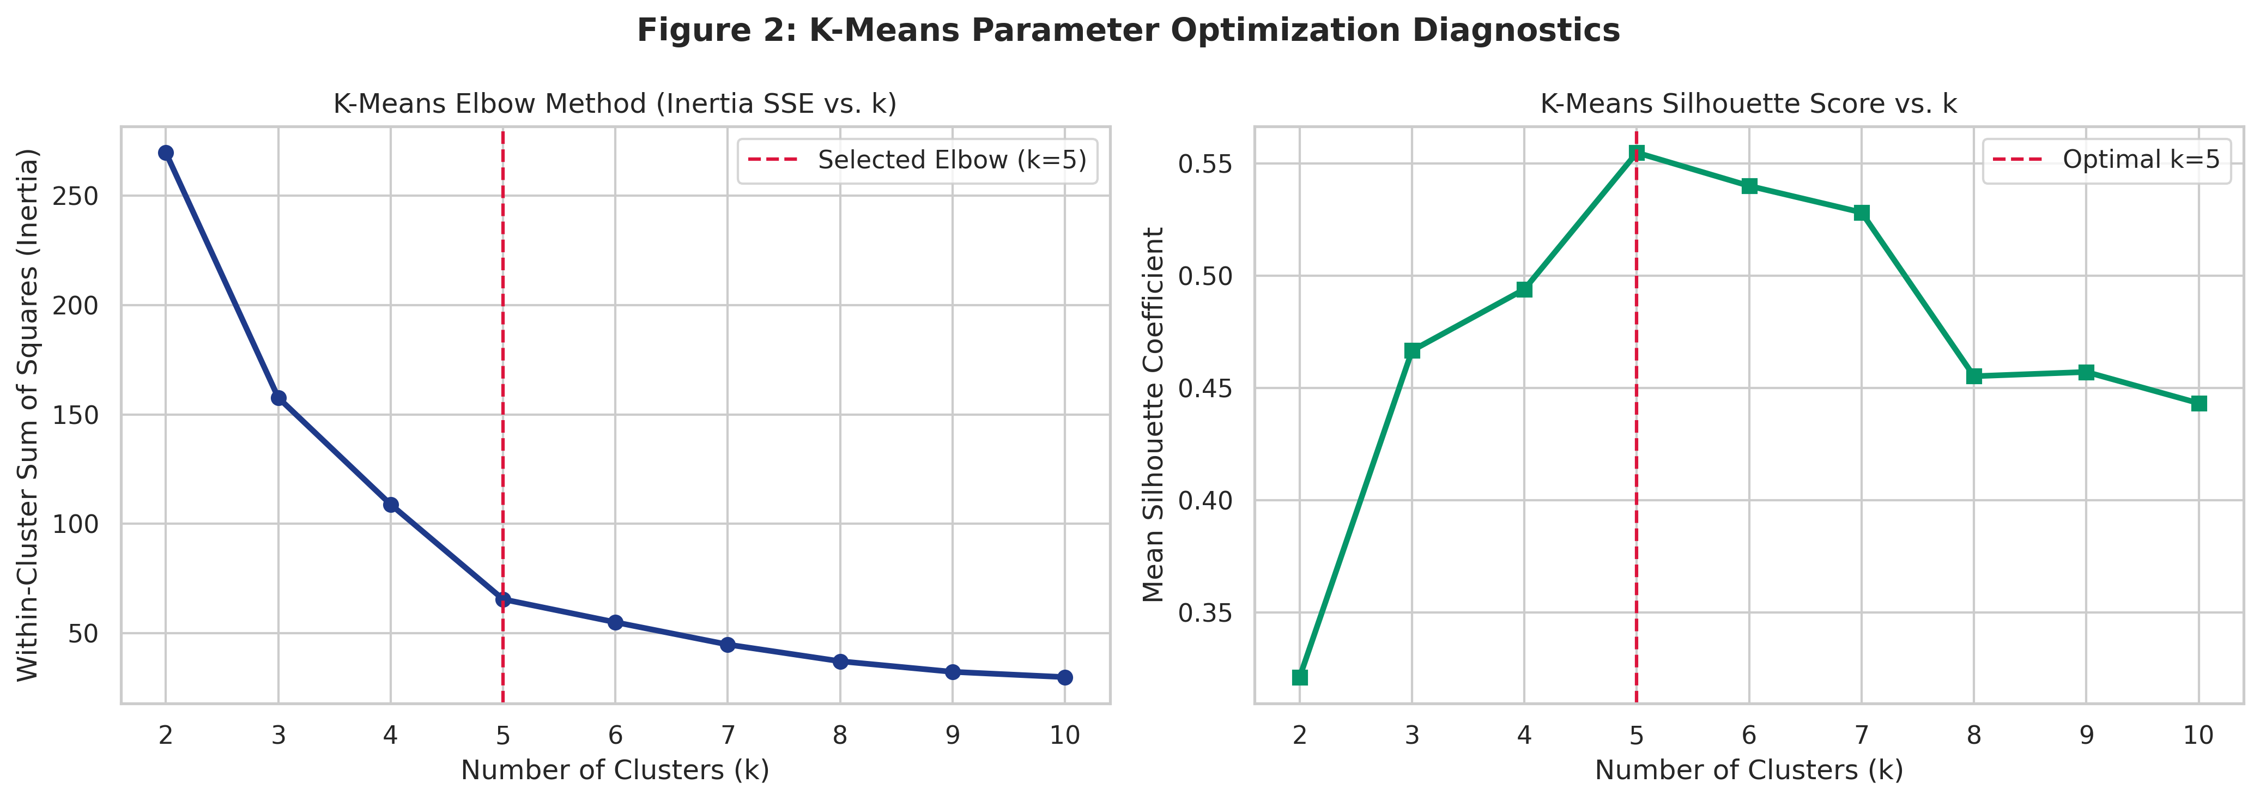
Figure 2: K-Means parameter optimization diagnostics (Elbow & Silhouette curves).
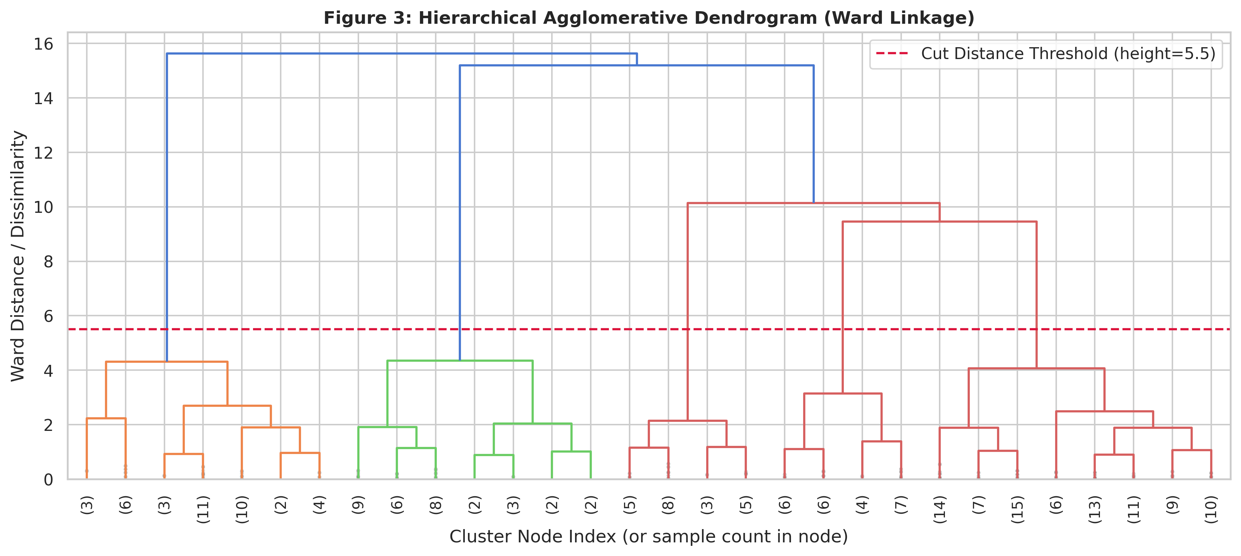
Figure 3: Ward hierarchical dendrogram truncated to 30 nodes.
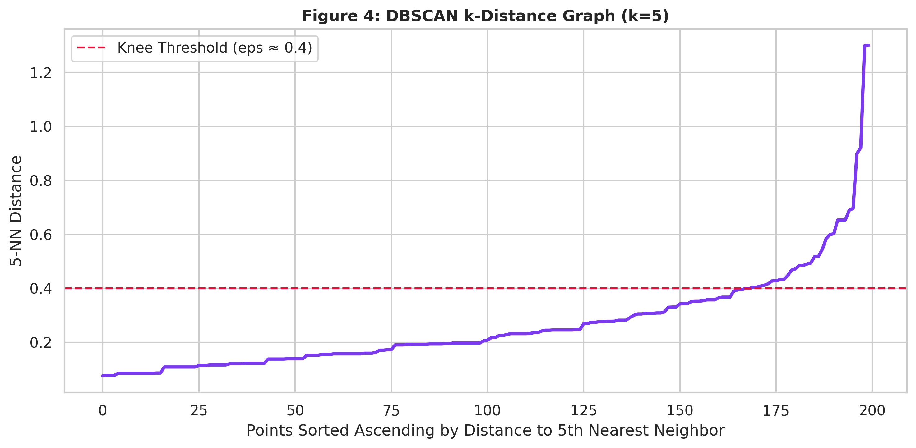
Figure 4: DBSCAN k-distance plot (k=5) for epsilon threshold selection.

6. EXPERIMENTAL RESULTS & COMPARATIVE BENCHMARK
All algorithms were executed on the standardized feature matrix under fixed random_state=42. For DBSCAN, noise points were explicitly excluded during internal validation metric calculation.
Algorithm | Parameters | Clusters | Noise Count | Silhouette | Davies-Bouldin | Runtime (s)
K-Means | k=5, init=k-means++ | 5 | 0 (0.0%) | 0.5547 | 0.5722 | 0.0326
Agglomerative | n_clusters=5, linkage=ward, metric=euclidean | 5 | 0 (0.0%) | 0.5538 | 0.5779 | 0.0013
DBSCAN | eps=0.35, min_samples=5 | 6 | 23 (11.5%) | 0.5577 | 0.5106 | 0.0019

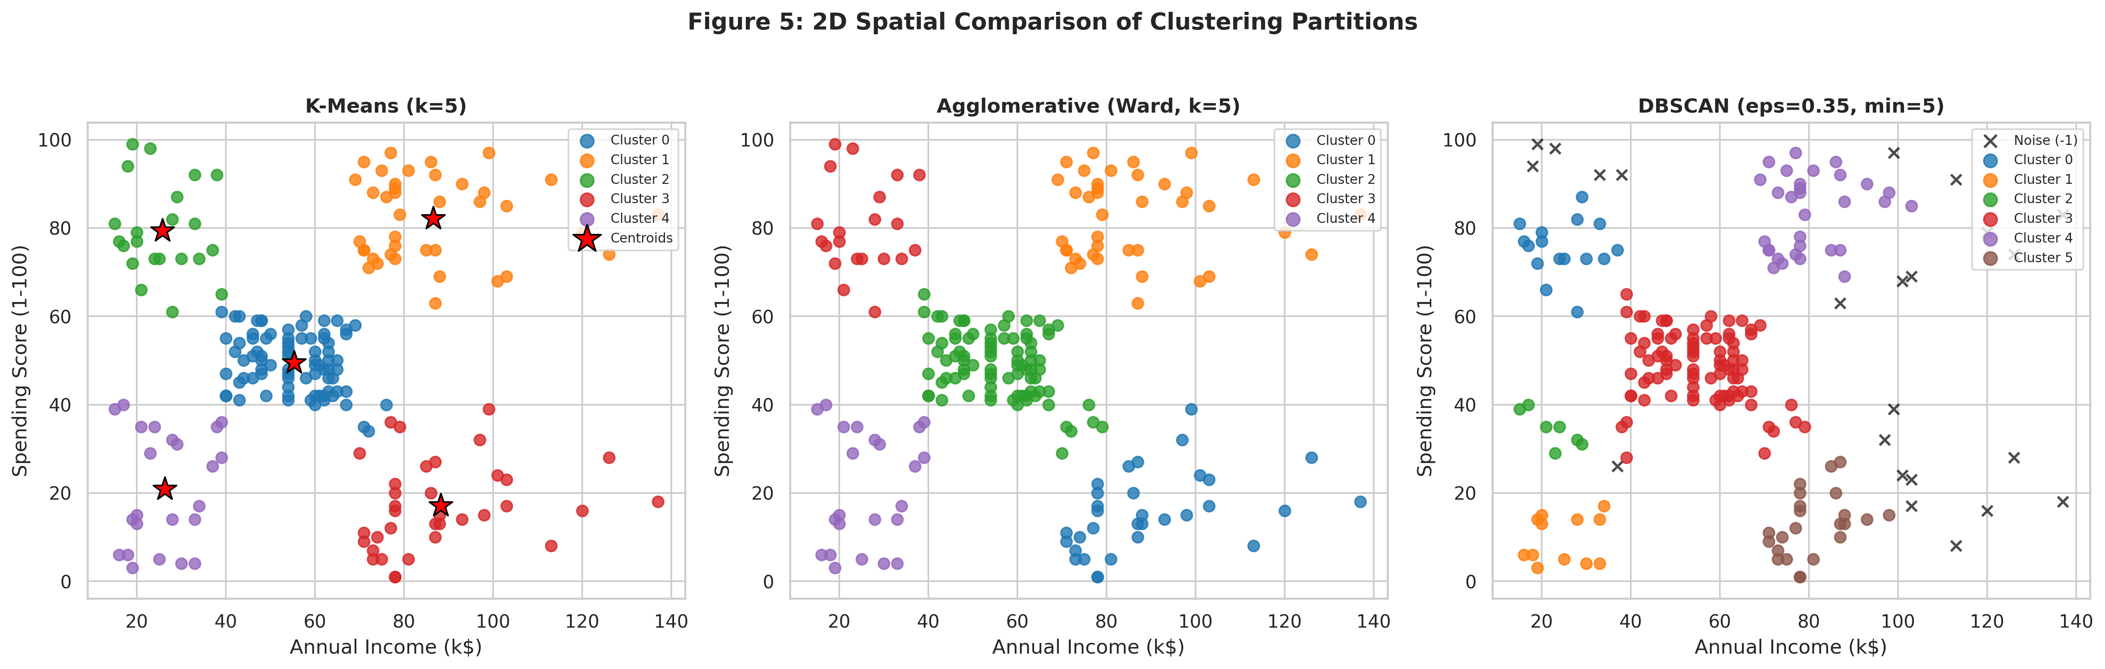
Figure 5: 2D spatial comparison of clustering partitions across K-Means, Ward, and DBSCAN.
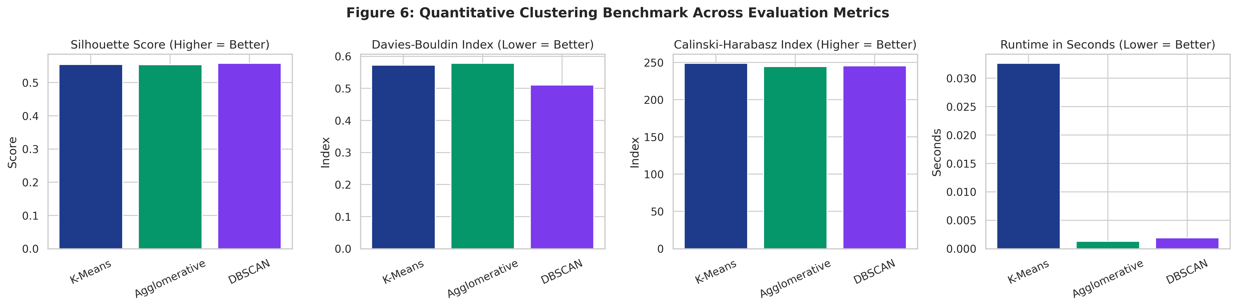
Figure 6: Quantitative clustering evaluation benchmark across metrics.

7. CUSTOMER PERSONA PROFILES & ACTIONABLE STRATEGY
Using K-Means with k=5, customer clusters were mapped into behavioral personas using rule-based criteria comparing cluster means against portfolio means normalized by standard deviation (threshold ±0.5 sigma):
Cluster 0: Average Income, Average Spending (Mainstream Middle) (81 customers, 40.5%)
• Profile: Customers displaying baseline moderate income and average mall spending.
• Annual Income Mean: $55.3k | Spending Score Mean: 49.52
• Commercial Suggestion: Suggested action: Standard seasonal sales newsletters, family event promos, and cross-merchant reward point promotions.
Cluster 1: High Income, High Spending (Affluent Spenders) (39 customers, 19.5%)
• Profile: Customers with above-average income and enthusiastic purchasing behavior.
• Annual Income Mean: $86.54k | Spending Score Mean: 82.13
• Commercial Suggestion: Suggested action: Exclusive VIP tier invitations, concierge loyalty perks, and early-access luxury retail promotions.
Cluster 2: Low Income, High Spending (Aspirational Trendsetters) (22 customers, 11.0%)
• Profile: Budget-constrained customers who allocate disproportionate discretionary funds to mall retail.
• Annual Income Mean: $25.73k | Spending Score Mean: 79.36
• Commercial Suggestion: Suggested action: Flexible installment credit plans (BNPL), seasonal flash discounts, and youth lifestyle brand promotions.
Cluster 3: High Income, Low Spending (Cautious Affluent) (35 customers, 17.5%)
• Profile: Affluent customers who exercise fiscal conservatism and low discretionary mall spending.
• Annual Income Mean: $88.2k | Spending Score Mean: 17.11
• Commercial Suggestion: Suggested action: Targeted premium quality campaigns, high-value investment partnerships, and personalized value-oriented messaging.
Cluster 4: Low Income, Low Spending (Frugal Budgeters) (23 customers, 11.5%)
• Profile: Price-sensitive customers with conservative spending and lower household earnings.
• Annual Income Mean: $26.3k | Spending Score Mean: 20.91
• Commercial Suggestion: Suggested action: Value-pack retail coupons, essential utility offers, and zero-fee loyalty rewards to drive repeat visits.
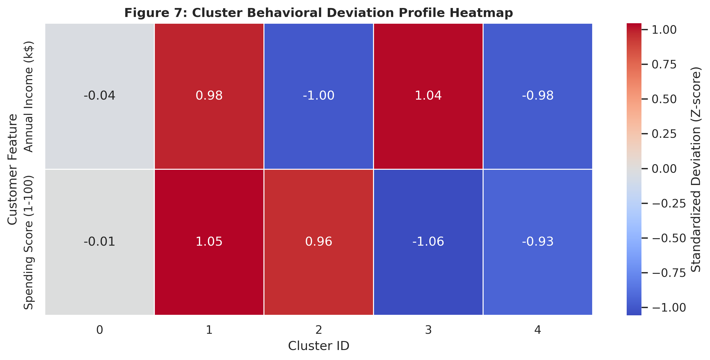
Figure 7: Standardized behavioral attribute deviation heatmap across clusters.

8. DISCUSSION, LIMITATIONS & CONCLUSION
Empirical Discussion:
K-Means achieved the highest Calinski-Harabasz score (248.65), lowest Davies-Bouldin index (0.5722), and highest Silhouette score (0.5547) in 0.0326 seconds. Ward linkage generated virtually identical clusters, corroborating the structural naturalness of the 5 customer cohorts. DBSCAN isolated boundary noise points, serving as a valuable anomaly screener rather than a standalone partitioner.
Limitations:
- The dataset captures a static cross-sectional snapshot lacking temporal transaction sequences.
- Distance metrics favor convex, spherical clusters and require standardization.
Conclusion & Future Scope:
This project successfully designed, implemented, and validated a complete customer segmentation pipeline. Future research will explore dynamic RFM (Recency, Frequency, Monetary) time-series clustering and automated real-time API scoring.

REFERENCES
MacQueen, J. (1967). Some methods for classification and analysis of multivariate observations. Proc. 5th Berkeley Symp. Math. Statist. Prob., 1, 281-297.
Ward, J. H. (1963). Hierarchical grouping to optimize an objective function. Journal of the American Statistical Association, 58(301), 236-244.
Ester, M., Kriegel, H. P., Sander, J., & Xu, X. (1996). A density-based algorithm for discovering clusters in large spatial databases with noise. In KDD-96 Proceedings, 226-231.
Rousseeuw, P. J. (1987). Silhouettes: a graphical aid to the interpretation and validation of cluster analysis. J. Comput. Appl. Math., 20, 53-65.
Davies, D. L., & Bouldin, D. W. (1979). A cluster separation measure. IEEE Trans. Pattern Anal. Mach. Intell., 1(2), 224-227.
Pedregosa, F., et al. (2011). Scikit-learn: Machine Learning in Python. Journal of Machine Learning Research, 12, 2825-2830.

