**A**

**PROJECT REPORT**

**ON**

**“UNIVERSITY MANAGEMENT SYSTEM”**

**SUBMITTED TO**

**SHIVAJI UNIVERSITY, KOLHAPUR**

**IN THE PARTIAL FULFILLMENT OF THE REQUIREMENT**

**FOR THE AWARD OF DEGREE**

**BACHELOR OF TECHNOLOGY IN COMPUTER SCIENCE AND ENGINEERING**

**SUBMITTED BY**

|  |  |  |
| --- | --- | --- |
| **MISS.** | **SHWETA SURVE** | **22UAD063** |
| **MISS.** | **NISHIKA SWAMI** | **22UAD065** |
|  |  |  |
|  |  |  |

**UNDER THE GUIDANCE OF**

**Mr. S. P. Pise**

 



**DEPARTMENT OF ARTIFICIAL INTELLIGENCE AND DATA SCIENCE ENGINEERING**

**DKTE SOCIETY’S TEXTILE AND ENGINEERING INSTITUTE, ICHALKARANJI**

**(AN EMPOWERED AUTONOUMOUS INSTITUTE)**

**2024-2025**

**D.K.T.E. SOCIETY’S**

**TEXTILE AND ENGINEERING INSTITUTE, ICHALKARANJI**

**(AN EMPOWERED AUTONOUMOUS INSTITUTE)**

**DEPARTMENT OF ARTIFICIAL INTELLIGENCE AND DATA SCIENCE ENGINEERING**



**CERTIFICATE**

**This is to certify that, project work entitled**

**“UNIVERSITY MANAGEMENT SYSTEM”**

**is a bonafide record of project work carried out in this college by**

|  |  |  |
| --- | --- | --- |
| **MR.** | **SHWETA SURVE** | **22UAD063** |
| **MISS.** | **NISHIKA SWAMI** | **22UAD065** |
|  |  |  |
|  |  |  |

**is in the partial fulfillment of award of degree Bachelor of Technology in Artificial Intelligence and Data Science Engineering prescribed by Shivaji University, Kolhapur for the academic year 2024-2025.**

**MR. S. P. PISE**

**(PROJECT GUIDE)**

**PROF. (DR.) T. I. BAGBAN PROF.(DR.) L.S.ADMUTHE**

**(HOD AI & DS DEPT.) (DIRECTOR)**

**EXAMINER: ________________**

**DECLARATION**

We hereby declare that, the project work report entitled **“UNIVERSITY MANAGEMENT** **SYSTEM”** which is being submitted to D.K.T.E. Society’s Textile and Engineering Institute Ichalkaranji, affiliated to Shivaji University, Kolhapur is in partial fulfillment of degree B.Tech.(AI & DS). It is a bonafide report of the work carried out by us. The material contained in this report has not been submitted to any university or institution for the award of any degree. Further, we declare that we have not violated any of the provisions under Copyright and Piracy / Cyber / IPR Act amended from time to time.

|  |  |  |  |
| --- | --- | --- | --- |
| **Title** | **Name of the Student** | **PRN** | **Signature** |
| MISS. | SHWETA SURVE | 22UAD063 | <<SIGNATURE>> |
| MISS. | NISHIKA SWAMI | 22UAD065 | <<SIGNATURE>> |
|  |  |  |  |
|  |  |  |  |

**ACKNOWLEDGEMENT**

With great pleasure we wish to express our deep sense of gratitude to Mr. S. P. Pise for his valuable guidance, support, and encouragement in the completion of this project report.

Also, we would like to take the opportunity to thank our head of department Dr. T. I. Bagban for his cooperation in preparing this project report.

We feel gratified to record our cordial thanks to other staff members of the Artificial Intelligence and Data Science Department for their support, help, and assistance which they extended as and when required.

Thank you,

|  |  |  |
| --- | --- | --- |
| **Title** | **Name of the Student** | **PRN** |
| MISS. | SHWETA SURVE | 22UAD063 |
| MISS | NISHIKA SWAMI | 22UAD065 |
|  |  |  |
|  |  |  |

**ABSTRACT**

The **“University Management System”** is a comprehensive web-based application developed using HTML, CSS, JavaScript, PHP, and MySQL. This system is designed to streamline and manage essential administrative tasks within a university environment, focusing primarily on student and faculty data management.

The project features modules for **student and faculty registration**, **editing**, and **updating records**, ensuring efficient handling of academic and personal information. Users can input details through user-friendly forms, which are securely stored and dynamically managed in the backend database using MySQL. The PHP scripts facilitate server-side logic, enabling data validation, retrieval, and updates, while JavaScript enhances interactivity on the client side.

**INDEX**

1. **Introduction 1** 
   1. Problem definition 1
   2. Aim and objective of the project 1
   3. Scope and limitation of the project 1
2. **Background study and literature overview 2**
   1. Literature overview 2
   2. Investigation of current project and related work 2
3. **Requirement analysis 3**

a. Requirement Gathering 3

b. Requirement Specification 3

c. Use case Diagram 4

1. **System design 5**
   1. Architectural Design 5
   2. Flow Chart 6
   3. System Modeling 7
      1. Dataflow Diagram
2. **Implementation 8**

a. Agile Methodologies 8

b. Development Model 8

1. **Future Scope 9**
2. **References (Public repository GitHub source code links) 10**

**1. Introduction**

1. **Problem definition**

In many universities, administrative tasks such as student and faculty registration, record maintenance, and information updates are still performed manually or using outdated systems. This can lead to errors, data redundancy, inefficiency, and difficulty in retrieving information when needed. The lack of a centralized and automated platform makes it challenging for the administration to manage data effectively and ensure accuracy.

1. **Aim and objective of the project**

The main aim of this project is to develop a **University Management System** that simplifies and automates the management of student and faculty information. The objectives include:

* Creating user-friendly forms for student and faculty registration.
* Enabling edit and update functionality for existing records.
* Storing and managing data securely in a MySQL database.
* Ensuring real-time data handling and accuracy with PHP backend logic.

This system is designed to improve operational efficiency, reduce paperwork, and provide quick access to essential information for administrative purposes.

1. **Scope and limitation of the project**

**Scope:**

* The system allows registration of both students and faculty members.
* Provides functionality to edit and update individual records.
* Ensures secure and structured data storage using MySQL.
* Offers a responsive and interactive interface using HTML, CSS, and JavaScript.

**Limitations:**

* The system currently does not include features such as login authentication or role-based access control.
* It is limited to basic CRUD (Create, Read, Update, Delete) operations.
* The system is designed for small to medium-scale use and may need optimization for handling very large datasets.
* No integration with mobile platforms or external systems is implemented at this stage.

**2. Background study and literature overview**

1. **Literature overview**

With the rapid growth of educational institutions, managing administrative tasks has become more complex and data-driven. Various research studies and existing solutions highlight the importance of automation in university environments. Web-based management systems have proven to be efficient tools in handling records, reducing human error, and ensuring centralized access to data.

In this project, we adopted a technology stack comprising **HTML, CSS, JavaScript, PHP, and MySQL**—a widely used and effective combination for building dynamic, secure, and interactive web applications. Previous studies show that such systems improve data management, reduce administrative workload, and enable faster decision-making.

1. **Investigation of current project and related work**

Existing university management systems vary in complexity and scope. Some institutions use ERP (Enterprise Resource Planning) systems that cover a wide range of functions from admissions to alumni relations. However, these systems are often expensive and complex to implement, especially for smaller institutions.

The proposed project focuses on the **core functionalities** such as student and faculty registration, record editing, and updating data. Compared to existing high-end solutions, this system is **simpler, cost-effective, and tailored to basic administrative needs**.

Similar projects have been developed by students and educational startups, primarily focusing on backend functionality using PHP and MySQL. While those projects often include features like login systems or report generation, our system emphasizes **a clean, interactive front-end interface with basic but essential database operations**, making it an ideal starting point for institutions seeking to digitize their processes with minimal resources.

**3. Requirement analysis**

1. **Requirement Gathering**

* **Observation**: Understanding how manual student/faculty registration is carried out in educational institutions.
* **Discussion**: Interacting with students and administrative staff to know what features are most needed.
* **Research**: Studying existing systems to identify essential functionalities for registration and record management.

Based on this, the core requirements identified were:

* Registration forms for students and faculty.
* Ability to edit and update records.
* Secure storage of data in a centralized database.
* Simple and user-friendly interface.
* Proper field validation using JavaScript.
* Backend logic using PHP to process forms.

1. **Requirement Specification**

Functional Requirements:

* The system must allow student registration with fields like name, roll number, department, email , course , branch etc.
* The system must allow faculty registration with fields like name, faculty ID, department, education and email.
* The system should provide functionality to edit and update existing records.
* All form data must be stored in a MySQL database.
* JavaScript should be used for form validation before submission.

Non-Functional Requirements:

* The system must be responsive and accessible via modern web browsers.
* The user interface should be intuitive and easy to use.
* The system should ensure data consistency and integrity.
* The application should be lightweight and optimized for performance.

1. **Use case Diagram**

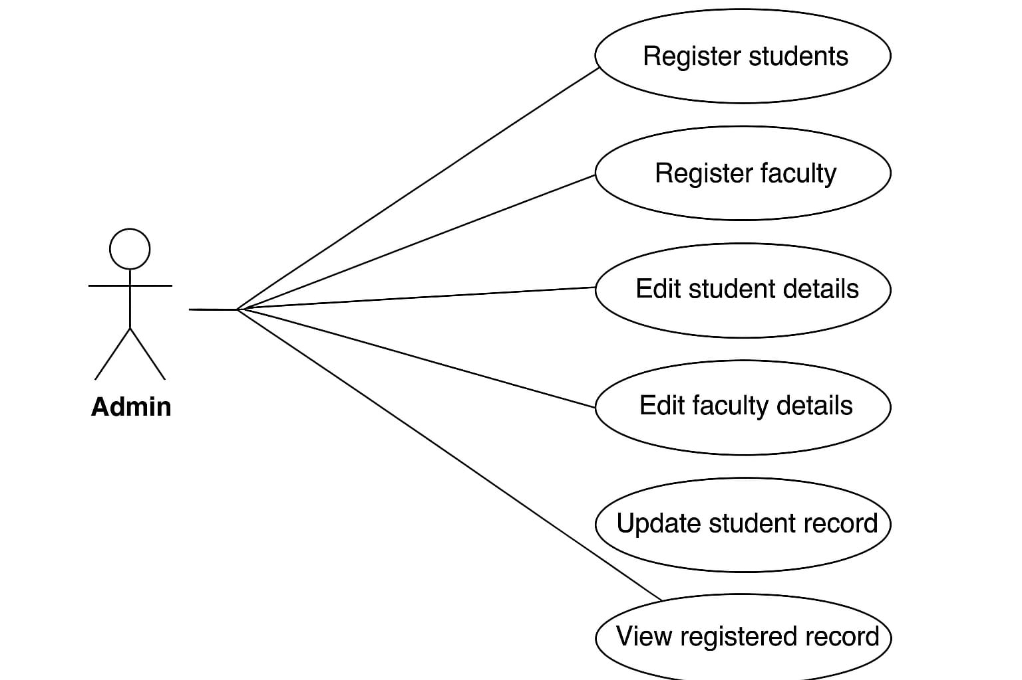

**4. System design**

1. **Architectural Design**

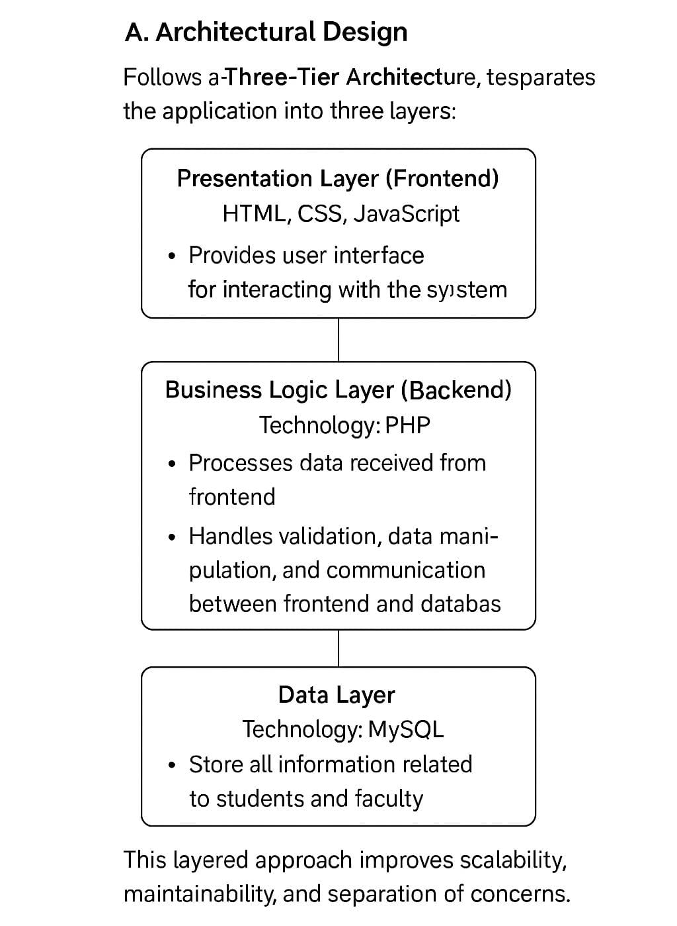

1. **Flow Chart**

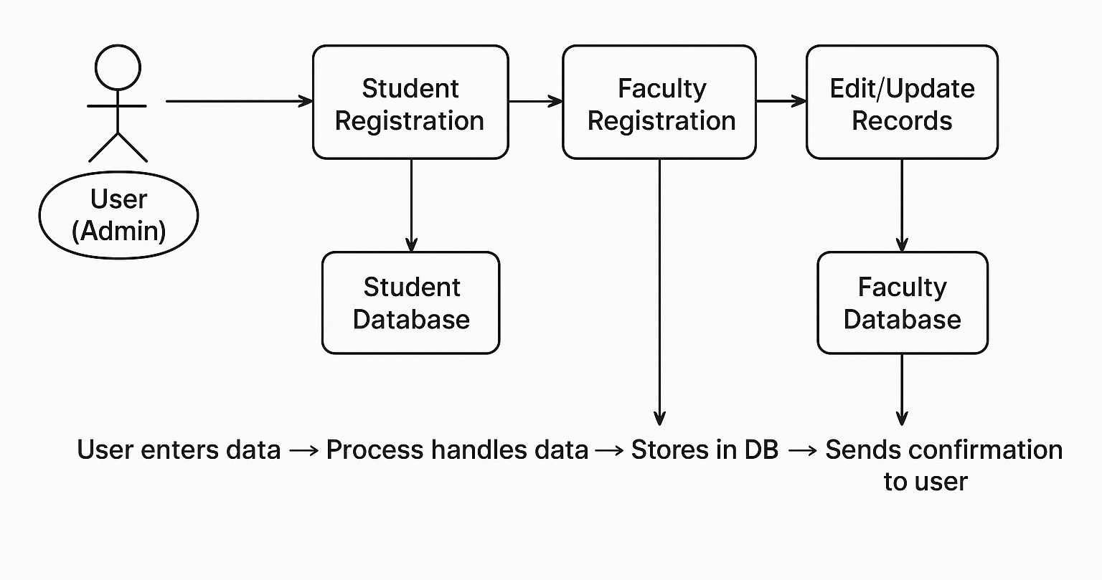

1. **System Modeling**

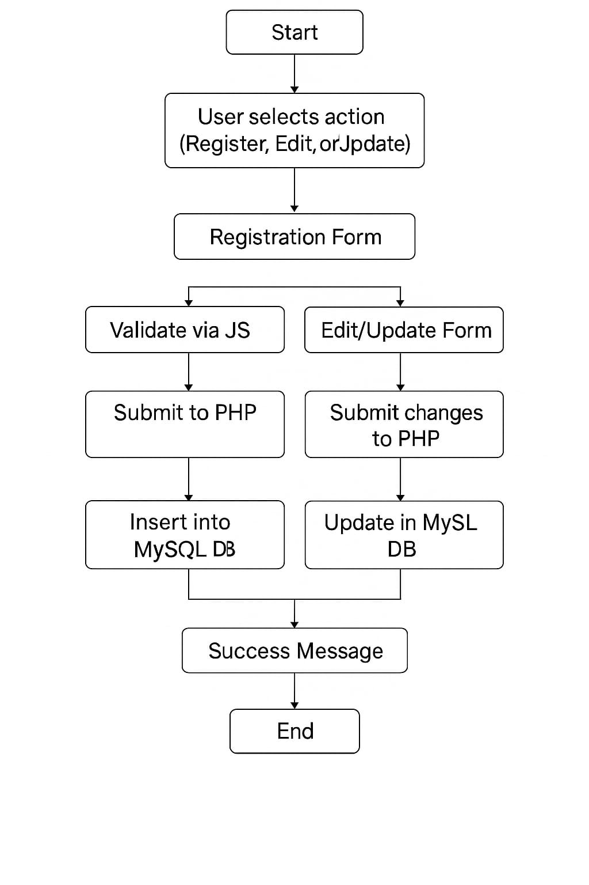

**5. Implementation**

1. **Agile Methodologies**

* Daily Stand-ups (Informal): Brief progress checks on what's done and what's next.
* Iterative Development: Features like student registration, faculty form, edit/update functionalities were developed in separate sprints.
* Continuous Feedback: After each sprint, the application was tested, and feedback was gathered for improvement.
* User-Centric Design: User experience was constantly refined based on input from test users.

1. **Development Model**

The Incremental Development Model was adopted during the implementation phase. In this model, the system was developed and delivered in parts, where each part represents a functional module of the system.

1. Requirement Analysis – Basic features were identified such as registration and editing.
2. Design – UI was designed first using HTML and CSS.
3. Development – PHP and MySQL were used to create the backend logic in stages.
4. Testing – Each module was tested after its development before integrating with others.
5. Integration – Modules were combined to form a complete working system.
6. Maintenance & Updates – Bugs were fixed, and minor enhancements were made based on feedback.

**6. Future Scope**

The current registration module in the University Management System captures essential student and faculty details effectively. In future updates, a login system can be integrated so that registered users can securely access and manage their profiles. Email verification can be added to ensure authenticity and prevent fake registrations. The system can also allow users to upload documents like ID proofs and certificates during registration.

To enhance data accuracy, backend validation and duplicate record checks can be implemented. An admin approval workflow can be introduced, where new registrations require confirmation before activation. A feature to generate and download a PDF confirmation slip after registration can be useful for users. The interface can be made fully responsive to support mobile and tablet devices.

CAPTCHA integration may also help prevent bot registrations. Lastly, email or SMS notifications can be sent upon successful registration to keep users informed. These enhancements will make the registration process more secure, user-friendly, and scalable.

**7. References (public repository GitHub source code links)**

**GitHub Link :-** <https://github.com/Shwetasurve378/University_management_system>