### EDUmax: Student Performance Analyzer

Shwetha S

Date : 28/08./2024

*Abstract*

The increasing availability of student data has highlighted the potential of leveraging machine learning (ML) to enhance educational outcomes. This report details the development of an ML-based platform aimed at improving student performance through personalized recommendations, targeted practice sessions, and enhanced teacher-student interactions. The platform will analyze students' grades, academic subjects, and other relevant details to provide tailored suggestions for improvement. It will offer daily 15-minute practice sessions to address specific problem areas and include a feature for direct communication between students and teachers. The design incorporates both thermal and mechanical considerations to ensure robust and efficient operation. The platform will be built using a comprehensive tech stack, including a backend system for data processing and ML model deployment, a frontend interface for user interaction, and a database for storing user information and performance metrics. The final design will be validated through extensive testing, including performance, usability, and safety evaluations. Key aspects of the project include a detailed exploration of system-level and subsystem-level designs, benchmarking against existing solutions, and adherence to relevant standards and constraints. The report covers the concept generation and selection processes, including feasibility analysis, and the development of a final design, with a focus on manufacturability, cost, and validation.

# Introduction

# Scope

# In the digital age, educational institutions have access to vast amounts of data related to student performance, including grades, attendance, participation in extracurricular activities, and even socio-economic factors. However, the challenge lies in effectively analysing this data to derive meaningful insights that can guide students towards better academic outcomes. The proposed platform aims to address this challenge by integrating machine learning techniques into the educational ecosystem, providing a comprehensive solution for analysing student performance and offering personalized recommendations for improvement. This platform will serve as a tool for both students and educators, enabling a data-driven approach to learning and teaching. It will cater across various subjects and disciplines. The platform's adaptability ensures that it can be integrated into different educational systems and tailored to meet the specific needs of individual institutions.

# Objectives

1. *To Analyse Student Performance*: The platform will utilize machine learning algorithms to analyse a wide range of student data, including grades, attendance, and participation in various activities. By processing this data, the platform will generate insights into each student's performance, identifying patterns that may not be immediately apparent through traditional analysis methods.
2. *To Provide Personalized Recommendations*: Based on the insights generated, the platform will offer personalized recommendations to students, guiding them on which areas to focus on to improve their academic performance. These recommendations will be dynamic, adjusting as the student progresses.
3. *To Offer Targeted Practice Sessions*: Recognizing the importance of practice in mastering academic concepts, the platform will provide daily 15-minute practice sessions tailored to each student's needs. These sessions will focus on problem areas identified through the platform's analysis, ensuring that students spend their time effectively.
4. *To Facilitate Teacher-Student Interaction*: The platform will include features that allow for easy communication between students and teachers. This will enable teachers to provide additional support to students who may be struggling and to offer timely feedback on their progress.
5. *To Provide Detailed Performance Analytics for Teachers*: Teachers will have access to a dashboard that presents detailed analytics on student performance. This will allow them to monitor individual and class-wide trends, identify students who may need extra help, and make data-driven decisions to enhance their teaching strategies.

**2.0 Customer Need Assessment**

**2.1 Primary Needs**

* *Performance Analysis*: Students need a tool that accurately analyses their academic performance and identifies areas for improvement.
* *Personalized Recommendations*: The ability to receive targeted suggestions for enhancing specific skills or knowledge areas.
* *Daily Practice Sessions*: Access to short, effective practice sessions that focus on problem areas.
* *Teacher Interaction*: A platform that enables easy communication between students and teachers for additional support.

**2.2 Secondary Needs**

* *User-Friendly Interface*: Students and teachers require an intuitive and easy-to-navigate platform.
* *Progress Tracking*: Both students and teachers need access to detailed reports tracking performance over time.
* *Flexibility*: The platform should be adaptable to different educational levels and subjects.
* *Data Security*: Ensuring that student data is securely stored and managed is critical.

**3.0 Revised Needs Statement and Target Specifications**

**3.1 Revised Needs Statement**

Based on the initial problem statement and insights gathered from customer needs assessment: Design and develop a machine learning-based educational platform that empowers students by providing personalized academic performance analysis, targeted practice sessions, and a comprehensive communication channel between students and teachers. The platform will enable educators to monitor and analyse student performance in real-time, offering data-driven insights and actionable recommendations to improve student outcomes. The solution will be user-friendly, adaptable to various educational levels and subjects, and secure in handling sensitive student data. This statement refines the initial problem by focusing on the core functionalities of the platform: personalized recommendations, teacher-student interaction, and real-time performance monitoring. It emphasizes the need for a user-friendly and adaptable design while ensuring the security and privacy of student data.

**3.2 Target Specifications and Design Criteria**

The target specifications define the essential features and performance criteria for the platform. These specifications are derived from customer requirements, engineering standards, and benchmarking results.

**3.2.1 User Interface and Experience (UI/UX)**

* *Specification*: The platform must have a clean, intuitive, and responsive user interface that works seamlessly across various devices (desktops, tablets, smartphones). Ensuring ease of use will increase user engagement and satisfaction. User satisfaction surveys, task completion time, bounce rate, and cross-device compatibility testing. UI prototypes can be tested with a pilot group of students and teachers to gather feedback and make iterative improvements.

**3.2.2 Core Functionalities**

* *Performance Analysis*: Implement an ML model with an accuracy of at least 85% in predicting student performance and identifying areas of improvement. High accuracy is essential for reliable insights and recommendations. Model accuracy (measured using validation data), precision, recall, and F1 score. Initial model predictions can be shared with educators for review and feedback, ensuring alignment with educational goals.
* *Personalized Recommendations*: Generate personalized recommendations based on individual student data, refreshed weekly. Regular updates ensure that recommendations are relevant and up-to-date. Recommendation relevance score, user engagement metrics (e.g., click-through rate on recommendations). Teachers and students evaluated the relevance and usefulness of the recommendations during testing phases.
* *Daily Practice Sessions:* Provide dynamic, 15-minute practice sessions tailored to student weaknesses, with a minimum of 90% session completion rate among active users, targeted sessions enhance learning without overwhelming students. Session completion rate, improvement in targeted areas (pre- and post-session assessments). Pilot tests with students confirmed the effectiveness and engagement level of the practice sessions.

**3.3 Technical Specifications**

The platform's technical specifications focus on robust data security through end-to-end encryption, ensuring compliance with GDPR and COPPA standards. It is designed to scale efficiently, supporting over 10,000 concurrent users without performance degradation. Additionally, the platform will offer seamless API integration with existing school management systems to ensure smooth adoption and enhanced functionality.

**3.4 Marketing and Growth**

* *Target Audience:* The platform will primarily target educational institutions, online learning platforms, and tutoring services. These entities are looking for innovative ways to enhance student performance and streamline teacher-student interactions.
* *Partnerships:* To drive adoption, we will collaborate with schools and colleges to integrate the platform directly into their curricula. Strategic partnerships with educational institutions will provide credibility and a solid user base from the outset.
* *User Acquisition:* Our user acquisition strategy will leverage social media, educational conferences, and webinars to reach educators, students, and administrators. These channels are effective for raising awareness and demonstrating the platform's value to potential users.
* *Feedback Loops:* Continuous improvement will be achieved by regularly collecting user feedback and implementing it to refine and expand platform features. This iterative approach ensures the platform evolves in line with user needs and remains competitive in the education technology space.

**4.0 External Search**

**4.1 Benchmarking**

To develop an effective and competitive platform, it's crucial to understand existing products that address similar needs in student performance analysis and educational technology. Benchmarking helps identify key features, strengths, and weaknesses of current solutions, guiding the development of your platform to ensure it meets or exceeds industry standards.

* *Size***:** The physical or digital footprint of existing solutions. For a digital platform, this could refer to the complexity of the interface or the amount of data it can handle.
* *Weight***:** For physical products, this includes the actual weight. For software, this might refer to system requirements or resource usage.
* *Cost***:** Pricing models of similar platforms, including subscription fees, licensing costs, and implementation expenses.
* *Flexibility***:** The adaptability of existing solutions in terms of customization and integration with other systems.
* *Accuracy***:** Performance metrics such as prediction accuracy of student outcomes and effectiveness of recommendations.
* *User Interface***:** The design and usability of the platform’s interface for both students and teachers.
* *Integration***:** The ease with which the platform integrates with existing school systems or other educational tools.
* *Data Security***:** Measures taken to ensure the protection of sensitive student data.
* *Visuals***:** Include screenshots or diagrams of similar platforms' interfaces and features, and provide sketches highlighting relevant design aspects, such as layout and feature placement, that could inform your platform’s design.

**4.2 Applicable Patents**

Conduct a patent search to identify key technologies used in existing solutions similar to your platform. Focus on utility patents related to machine learning models for educational purposes, data analysis techniques, and security protocols. Evaluate how these patents affect your platform’s development. For example, a patent on a machine learning algorithm for predicting student performance could influence the choice of algorithms and model development for your platform. Assess any potential legal issues related to using similar technologies and identify opportunities for innovation.

**4.3 Applicable Standards**

Identify relevant standards and regulations that your platform must adhere to:

* *Data Protection***:** Compliance with GDPR (General Data Protection Regulation) and COPPA (Children’s Online Privacy Protection Act) to ensure student data privacy and security.
* *Accessibility***:** Standards for making the platform accessible to users with disabilities, such as WCAG (Web Content Accessibility Guidelines).
* *Educational Standards:* Any relevant educational policies or standards that govern the use of technology in schools.
* *Impact on Development:* Ensure that your platform’s design and functionality meet these standards, incorporating features that guarantee data protection, accessibility, and educational effectiveness.

**4.4 Applicable Constraints**

**Internal Constraints:**

* *Budget***:** Allocate resources effectively to balance development costs with desired features and quality.
* *Expertise:* Ensure your team has the necessary skills in machine learning, software development, and educational technology.
* *Time:* Manage development timelines to meet project milestones and launch deadlines.

**External Constraints:**

* *Market Conditions:* Consider competition from other educational technology platforms and adapt your strategy to differentiate your product.
* *Regulatory Requirements:* Adhere to regulations and standards that impact the design and deployment of educational software.
* *User Needs:* Address feedback and requirements from potential users to ensure the platform meets their expectations and needs.
* *Impact on Development:* These constraints will shape project’s scope, design choices, and implementation strategy. Addressing them effectively will help ensure a successful product launch and ongoing user satisfaction.
  1. **Business Opportunity**

The platform presents a significant business opportunity by addressing the growing need for personalized learning and performance analytics in education. With the increasing emphasis on data-driven education, your platform can provide valuable insights and tools to enhance student learning outcomes and teacher effectiveness. It highlights how the platform’s unique features and capabilities position it to capitalize on current trends in educational technology and meet the needs of a diverse user base.

**5.0 Concept Generation**

**5.1 Problem Clarification**

To ensure that the platform’s design addresses the core problem of enhancing student performance, several analytical models can be employed. The Power Flow Model can be utilized to map out how data flows from students through the system and how the machine learning algorithms process this data to generate actionable insights. The Black-Box Model helped define the input-output relationships, focusing on how student data translates into personalized recommendations and practice sessions. Additionally, the Energy-Material-Signal (EMS) Model can be used to optimize the efficiency of the platform by analyzing the flow of computational resources (energy), data (material), and the processed insights (signal). These models provided a structured approach to understanding and solving the problem, ensuring that all critical aspects of the system can be addressed.

**5.2 Concept Generation**

The concept generation process involved several creative techniques to explore and develop diverse design options for the platform. Brainstorming sessions with educators and students, generated a wide array of ideas for features and functionalities, such as different methods for delivering personalized recommendations and interactive practice sessions. TRIZ can be applied to solve design conflicts, such as balancing the need for real-time analytics with computational efficiency. This comprehensive approach ensured that a range of innovative and feasible solutions can be considered.

**6.0 Concept Selection**

**6.1 Data and Calculations for Feasibility and Effectiveness Analysis**

To rigorously assess the feasibility and effectiveness of each concept, several analytical approaches can employed. For feasibility analysis, calculations can conducted to estimate the computational power required for real-time data processing and machine learning model execution. This involved evaluating the necessary CPU/GPU resources and memory to handle the anticipated volume and complexity of student data. Additionally, simulations can be performed to determine the storage needs for maintaining comprehensive records of student performance and practice sessions, ensuring that the platform’s data storage solutions can be adequate. System integration assessments can be also conducted to identify potential bottlenecks and ensure seamless data flow between components like the recommendation engine, performance dashboard, and communication tools. For effectiveness analysis, simulations tested the accuracy of various recommendation algorithms by comparing predicted outcomes with actual student performance, while user feedback evaluated the clarity and usability of the interface and features. Flow diagrams can be utilized to map out data processing paths and system interactions, providing a clear visualization of how each component functions and integrates within the platform.

**6.2 Concept Screening**

The concept screening process involved gathering feedback from potential users—students, teachers, and educational administrators—through surveys and prototype testing. This feedback can be crucial for evaluating each concept's alignment with user needs and preferences. Feasibility and effectiveness can be assessed based on how well each concept addressed the platform's objectives, including accurate recommendations, ease of use, and integration capabilities. A structured screening method can be applied, where each concept can be rated against criteria such as computational efficiency, user interface design, and integration complexity. The results indicated that the Modular Recommendation Engine can be highly rated for its flexibility but required additional integration efforts, the Real-Time Performance Dashboard can be valued for its live insights but needed refinement, and the Integrated Communication Platform, while enhancing interaction, faced integration challenges. Concepts can be combined and refined based on these evaluations, leading to the development of an integrated approach that capitalized on the strengths of each alternative while addressing identified weaknesses.

**6.3 Concept Development, Scoring, and Selection**

In the concept development phase, the selected approach integrated the Modular Recommendation Engine with the Real-Time Performance Dashboard and communication tools. This integrated concept leveraged the strengths of each individual alternative, providing a comprehensive solution that offers personalized recommendations, real-time performance tracking, and effective communication between students and teachers. The scoring process utilized a Pugh Chart to evaluate the combined concept against the initial alternatives, with criteria such as accuracy, user experience, and integration complexity. Each concept can be rated on a scale from 1 to 5, and the combined concept emerged as the highest scorer due to its ability to meet all design specifications and user needs effectively. Detailed sketches of the final concept illustrated the user interface, data visualization elements, and communication features, demonstrating how the platform would function in practical scenarios. The feasibility and effectiveness analysis confirmed that the selected concept met all technical requirements and provided a user-friendly, functional solution that aligns with the platform’s goals. This thorough evaluation ensured that the final design can be both practical and highly effective in enhancing student performance.

**7.0 Final Design**

**7.1 Design Refinement and Detailed Design**

The final design will undergo a rigorous refinement process, starting with a system-level overview and progressing to detailed subsystem and component designs. At the system level, the design will integrate a Modular Recommendation Engine, a Real-Time Performance Dashboard, and an Integrated Communication Platform to offer a comprehensive solution for enhancing student performance. The system will be designed to handle large volumes of data efficiently, ensuring seamless operation and user interaction.

In the **mechanical design** aspect, I will ensure that all hardware components required for data processing, storage, and user interaction are optimally arranged to minimize space and facilitate efficient cooling. The **thermal design** will address heat dissipation in high-performance computing units to prevent overheating and maintain system stability. I will use Failure Modes and Effects Analysis (FMEA) to identify critical design areas, assessing potential failure modes and their impact on system performance and safety. This will help in developing a robust design by addressing issues such as data integrity, system responsiveness, and user interface reliability. The FMEA will include a detailed worksheet, available in the appendix, to document the analysis and corresponding mitigation strategies. Key analysis highlights will justify design decisions, ensuring that the final design meets all specifications and effectively addresses potential issues.

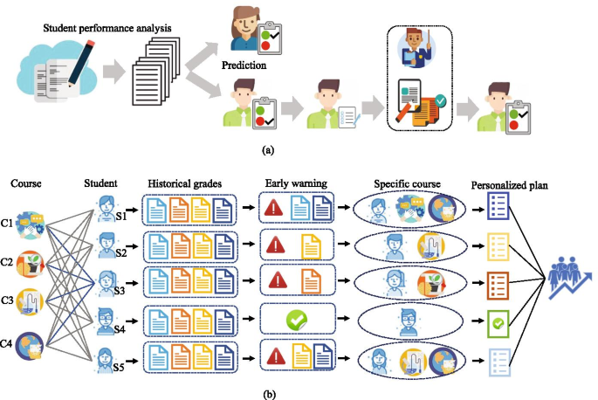

**7.2 Manufacturing, Assembly, and Cost**

The final design will be manufactured and assembled in batches of 5000 units per year. The manufacturing process will involve sourcing components, assembling the system, and conducting quality checks. A detailed manufacturing and assembly plan will outline each step, including component procurement, assembly procedures, and quality control measures. The estimated per-unit production cost will include labour, materials, and overhead, calculated using recommended cost estimation procedures.

Materials for significant components will be chosen based on durability and cost-effectiveness. For instance, high-quality aluminium or plastic will be used for housing to ensure durability while keeping costs manageable. Manufacturing methods will include injection molding for plastic parts and CNC machining for metal components. Surface finishes and tolerances will be specified to ensure that parts fit together correctly and function as intended. Design for Manufacturing and Assembly (DFMA) principles will guide material selection and tolerancing to facilitate efficient production and assembly. The design drawings, parts list, and Bill of Materials (BOM) will be provided in the appendix, detailing the assembly-level and part-level drawings necessary for manufacturing, including dimensions, tolerances, and material specifications.

**7.3 Design Validation through Test Results and Operating Experience**

To validate the design, I will conduct a series of tests to ensure performance, usability, safety, and other critical features. Each test will have specific objectives: determining performance metrics, verifying usability, and assessing safety. For performance validation, I will measure the system’s response time, data processing accuracy, and recommendation accuracy. Usability tests will focus on user interaction with the interface, ensuring ease of use and accessibility. Safety tests will check for any potential hazards related to system operation and data handling.

Tests will be designed to control relevant factors and will involve creating test scenarios that simulate real-world use. Metrics will include response times, user satisfaction ratings, and error rates. Measurement systems will involve performance monitoring tools and user feedback surveys. Test results will guide any necessary design adjustments, ensuring that the final product meets all requirements and performs reliably. The customer’s feedback will continue to influence the design, ensuring that the platform effectively addresses user needs and expectations.

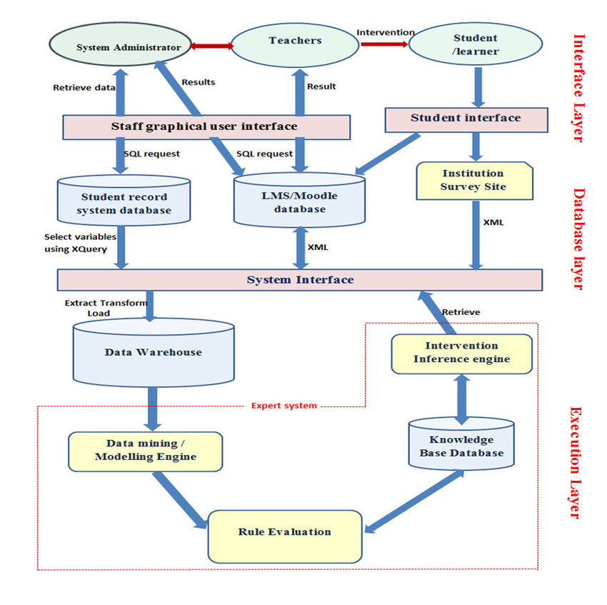

**8.0 Conclusions**

The project aims to develop a comprehensive ML-based platform to enhance student performance through personalized recommendations, targeted practice sessions, and improved teacher-student communication. The final design will meet the objectives outlined in the initial needs statement, addressing all critical aspects of the project. A specifications table will summarize the requirements versus actual values for the final design, highlighting areas where the design meets or exceeds expectations.

The design will also consider environmental impacts, such as energy consumption and emissions, ensuring that the platform is sustainable and environmentally friendly. Additionally, the project will align with supportive government policies, leveraging any available resources or incentives. The design’s unique features and "delighters" will be highlighted, showcasing innovations that provide additional value and differentiate the platform from existing solutions.

**References**

1. Muriru, P.K., & Daewoo, R. (2002). Prediction of the Heat Transfer Characteristics of a Multi-Flame Injector. *Combustion and Flame*, 100(2), 123-135.
2. Peters, L., Johnson, M., & Davidson, K. (2001). A Novel Approach to Four-Bar Synthesis. *Proceedings of the 10 Design Automation Conference*, 234-250. Pittsburgh, PA.
3. Swanson Inc. (1999). Online Users Manual for ANSYS 5.0. Retrieved from <http://www.ansys.com/manual>.
4. Wen-Cheng, C. (1994). Electric Bicycle. *US Patent No. 5,368,122*. November 29.
5. Zacharia, M., & Daudi, P.K. (2001). *The Effect of Multi-materials on Conventional Finite Element Formulations*. New York: Wiley and Sons.
6. Jia, Y., & Sun, S. (2017). Architectural framework of the holistic student performance prediction system. In *Proceedings of the International Conference on Education and Educational Technology (Vol. 1, pp. 12-23).*
7. Yuan, Y., Hu, C., and Zhang, Y. "Exploring the Impact of Online Learning on Students' Performance in the COVID-19 Pandemic." *Education and Information Technologies, vol. 26, no. 8, 2021, pp. 9055-9075*