**1.1: <<TODO>> Create XML files for storing Email data**

Data need to be stored are:

To

From CC BCC

Subject Body

**Solution:**

**Step 1:** Write your code using Visual Web Developer 2008\Eclipse.

**Step 2:** Save this file as **email.xml**.

**Step 3:** View the output in Internet Explorer

**1.2: <<TODO>> Create an XML file for storing employee details as given in table**

The following table describes the employee details.

The employee details should be stored inside the root element “**EmployeeDetails”**.

|  |  |  |  |  |  |  |  |  |  |  |  |  |  |  |  |  |  |  |  |  |  |  |  |  |  |  |  |  |  |  |  |  |  |  |  |  |  |  |
| --- | --- | --- | --- | --- | --- | --- | --- | --- | --- | --- | --- | --- | --- | --- | --- | --- | --- | --- | --- | --- | --- | --- | --- | --- | --- | --- | --- | --- | --- | --- | --- | --- | --- | --- | --- | --- | --- | --- |
|  | **Employ** |  | **Employee Name** | | **DOJ** |  | **Total** |  |  | **Department** | | | |  |  | **Designation** | | | | | | | | | | | **Sal** |  | **Grade** | | | | | | | | |  |
|  | **ee code** |  |  |  |  |  | **Experie** |  |  |  |  |  |  |  |  |  |  |  |  |  |  |  |  |  |  |  |  |  |  |  |  |  |  |  |  |  |  |  |
|  |  | **First** | **Last** |  |  |  |  | **Unit** |  |  | **loc** |  |  | **1** |  |  | **2** |  |  | **3** |  | **4** |  | **5** |  |  | **A** |  |  | **b** |  |  | **c** |  | **d** |  |
|  |  |  |  |  | **nce** |  |  |  |  |  |  |  |  |  |  |  |  |  |  |  |  |  |  |  |  |
|  |  |  | **Name** | **Name** |  |  |  |  |  |  |  |  |  |  |  |  |  |  |  |  |  |  |  |  |  |  |  |  |  |  |  |  |  |  |  |  |  |
|  |  |  |  |  |  |  |  |  |  |  |  |  |  |  |  |  |  |  |  |  |  |  |  |  |  |  |  |  |  |  |  |  |  |  |  |  |
| 1111 | |  | Seema | Dalvi | 09/08/97 | 12 | |  | 3d | | | Mumbai | | |  |  |  |  |  |  |  |  | * | |  |  | 21000 |  |  |  | * | |  |  |  |  |  |  |
|  | |  |  |  |  |  | |  |  | | |  | | |  | | |  | |  |  |  |  |  |  |  |  |  | |  |  |  |  |  |  |  |  |  |
| 222 | |  | Bharati | Mantri | 12/01/99 | 5 | |  | 4a | | | Pune | | |  |  |  | * | |  |  |  |  |  |  |  | 12000 | * | |  |  |  |  |  |  |  |  |  |
|  |  |  |  |  |  |  |  |  |  |  |  |  |  |  |  |  |  |  |  |  |  |  |  |  |  |  |  |  |  |  |  |  |  |  |  |  |  |  |

1.3 **Create an XML file to store employee details.**

Payroll department has decided to use XML files as a rich data source, so the existing EMP table has to be converted into XML data source i.e. XML file need to be created for the below EMP table representing entire data (To Do)

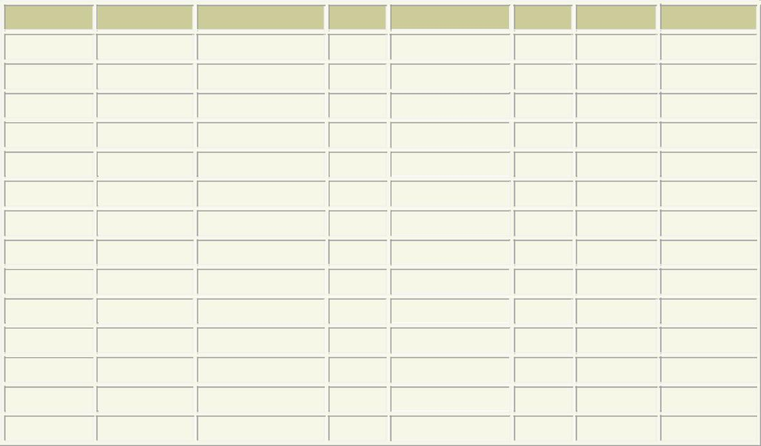

|  |  |  |  |  |  |  |
| --- | --- | --- | --- | --- | --- | --- |
| **EMPNO** | **ENAME** | **JOB** | **MGR HIREDATE** | **SAL** | **COMM** | **DEPTNO** |
| 7369 | SMITH | CLERK | 7902 17‐DEC‐80 | 1100 | 200 | 20 |
| 7499 | ALLEN | SALESMAN | 7698 20‐FEB‐81 | 1600 | 24820 | 30 |
| 7521 | WARD | SALESMAN | 7698 22‐FEB‐81 | 1375 | 19700 | 30 |
| 7566 | JONES | MANAGER | 7839 02‐APR‐81 | 3175 |  | 20 |
| 7654 | MARTIN | SALESMAN | 7698 28‐SEP‐81 | 1375 | 20600 | 30 |
| 7698 | BLAKE | MANAGER | 7839 01‐MAY‐81 | 2850 |  | 30 |
| 7782 | CLARK | MANAGER | 7839 09‐JUN‐81 | 2450 |  | 10 |
| 7788 | SCOTT | ANALYST | 7566 19‐APR‐87 | 2000 |  | 20 |
| 7839 | KING | PRESIDENT | 17‐NOV‐81 | 5000 |  | 10 |
| 7844 | TURNER | SALESMAN | 7698 08‐SEP‐81 | 1650 | 23000 | 30 |
| 876 | ADAMS | CLERK | 7788 23‐MAY‐87 | 1430 | 200 | 20 |
| 7900 | JAMES | CLERK | 7698 03‐DEC‐81 | 1045 | 200 | 30 |
| 7902 | FORD | ANALYST | 7566 03‐DEC‐81 | 3200 |  | 20 |
| 7934 | MILLER | CLERK | 7782 23‐JAN‐82 | 1430 | 200 | 10 |