1. Write a Python program to find those numbers which are divisible by 7 and multiple of 5, between 1500 and 2700 (both included). 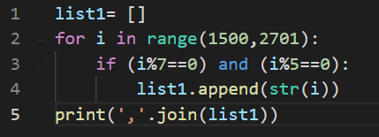

Output:



1. Python program to add two numbers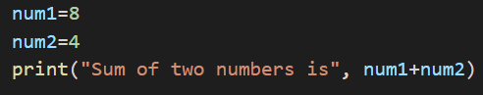

Output:



1. Maximum of two numbers in Python

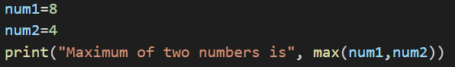

Output:



1. Python Program for factorial of a number

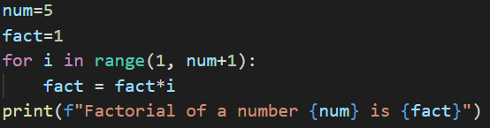

Output:



1. Python Program for simple interest

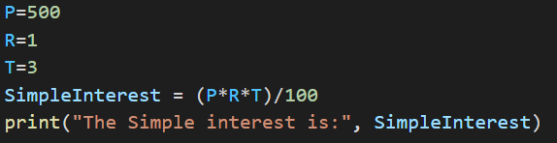

Output:



1. Python Program for compound interest

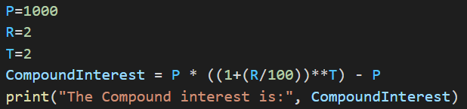

Output:



1. Python Program to check Armstrong Number

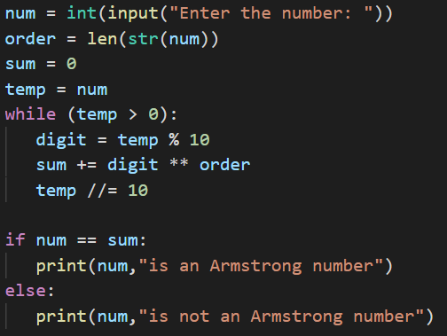

Output:





1. Python Program for Program to find area of a circle

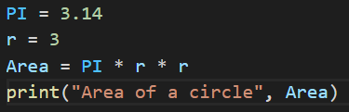

Output:



1. Python program to print all Prime numbers in an Interval

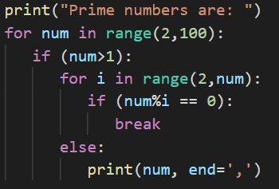

Output:



1. Python program to check whether a number is Prime or not

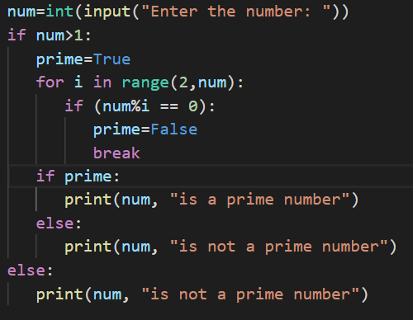

Output:





