**DAILY ONLINE ACTIVITIES SUMMARY**

|  |  |  |  |  |  |  |  |  |
| --- | --- | --- | --- | --- | --- | --- | --- | --- |
| **Date:** | 04-06-2020 | | | | | **Name:** | SHWETHA M S | |
| **Sem & Sec** | 6th and B | | | | | **USN:** | 4AL17CS093 | |
| **Online Test Summary** | | | | | | | | |
| **Subject** | | OS (3RD IA TEST) | | | | | | |
| **Max. Marks** | | 30 | | **Score** | | | 24 | |
| **Certification Course Summary** | | | | | | | | |
| **Course** | THE COMPLETE PYTHON COURSE | | | | | | | |
| **Certificate Provider** | | | UDEMY | | **Duration** | | | 35.5 HOURS |
| **Coding Challenges** | | | | | | | | |
| **Problem Statement:** GIVEN 3 PROBLEMS | | | | | | | | |
| **Status:** Completed | | | | | | | | |
| **Uploaded the report in Github** | | | | | Yes | | | |
| **If yes Repository name** | | | | | https://github.com/ShwethaKhadri/Shwetha-M-S.git | | | |
| **Uploaded the report in slack** | | | | | Shwetha M S  Yes, I uploaded the report in slack | | | |

**SNAPSHOT OF THIRD IA MARKS:**

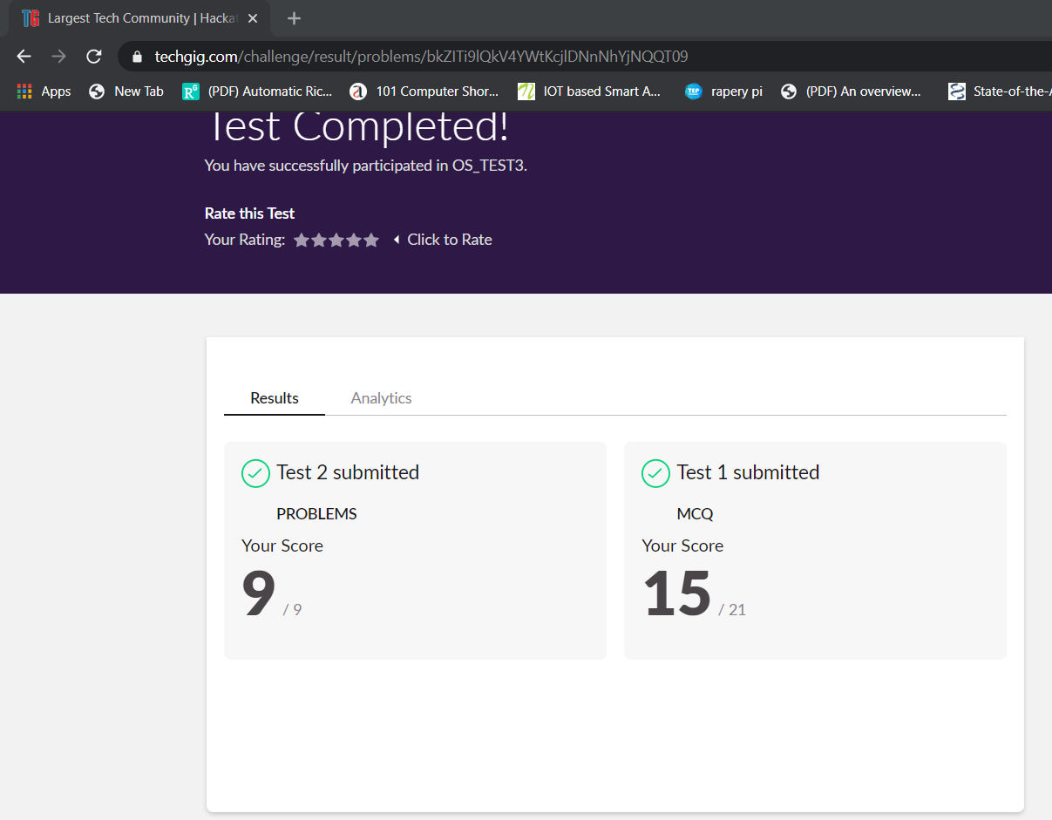

**SNAPSHOT OF ONLINE CERTIFICATION COURSE:**

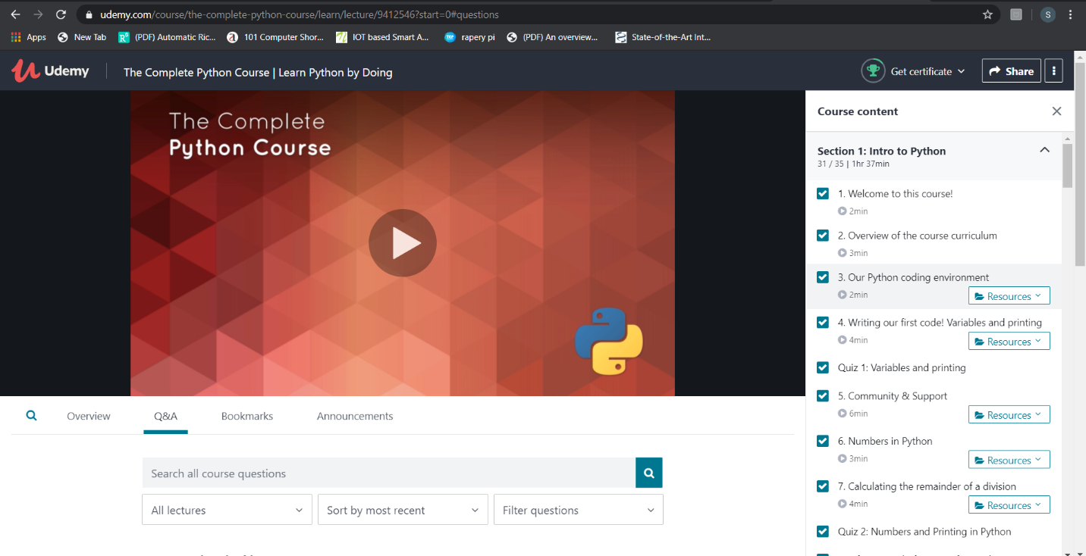

**SNAPSHOT OF ONLINE CODING:**

**PYTHON PROGRAM 1:**

Take two strings, return a string of the form short+long+short, with the shorter string on the outsides and the longer string on the inside. The strings will not be the same length, but they may be empty (length 0).

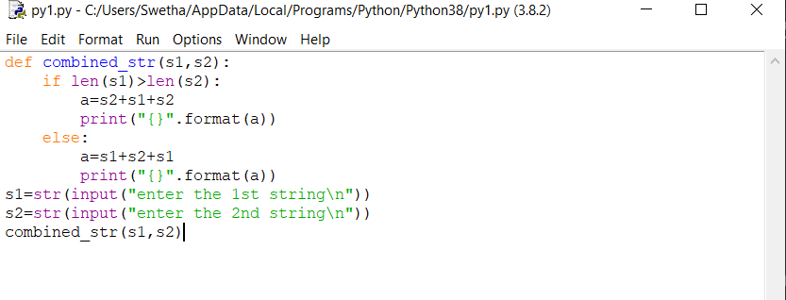

**OUTPUT:**

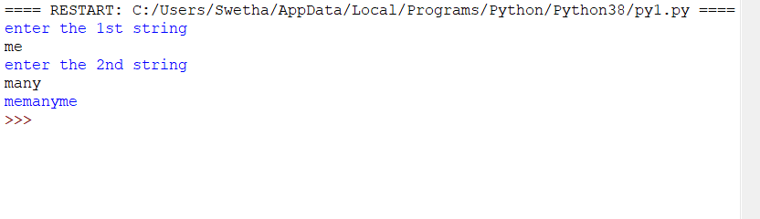

**JAVA PROGRAM 2:**

Write a Java program to implement Queue Using Array And Class

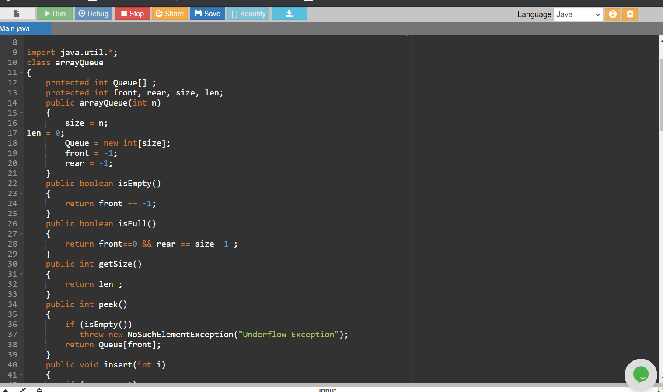

**OUTPUT:**

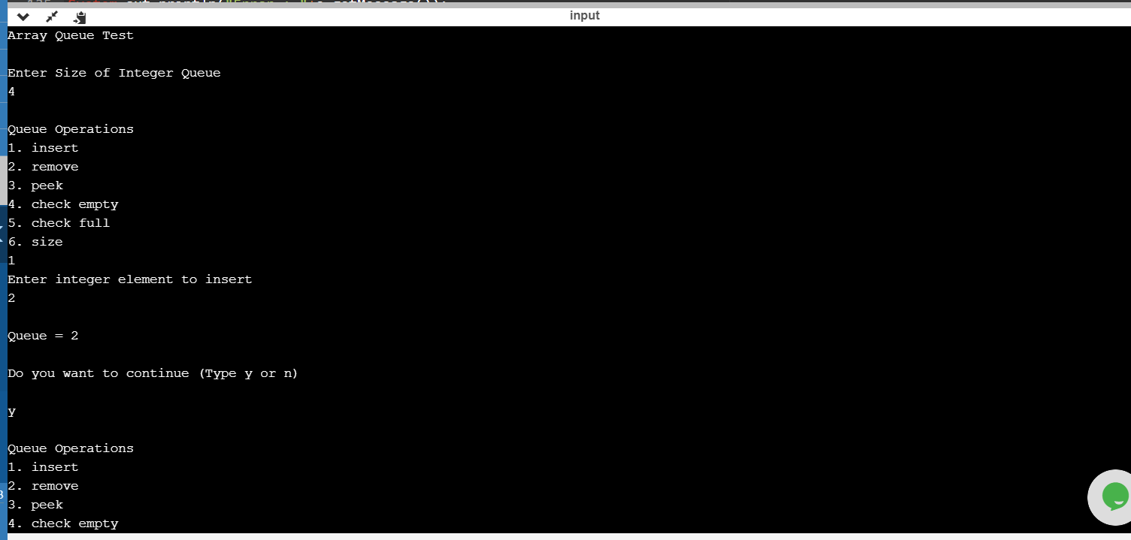

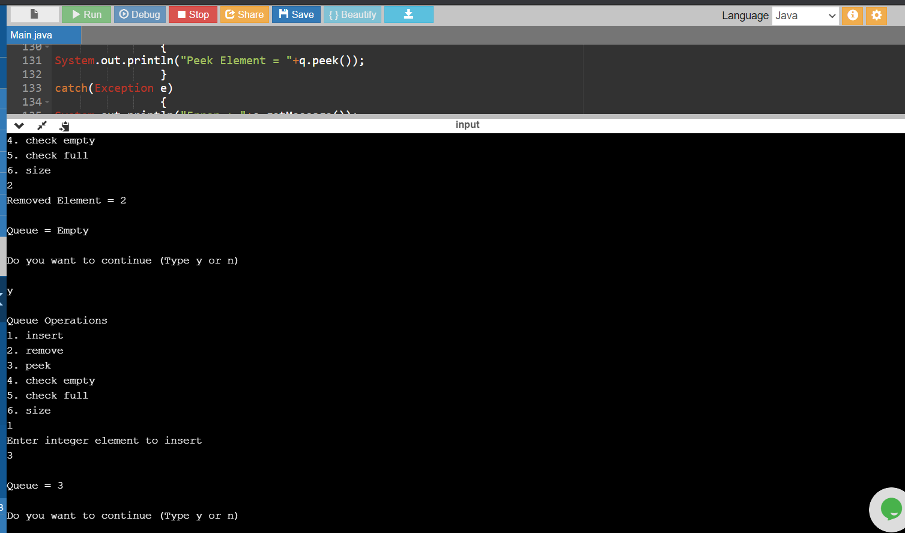

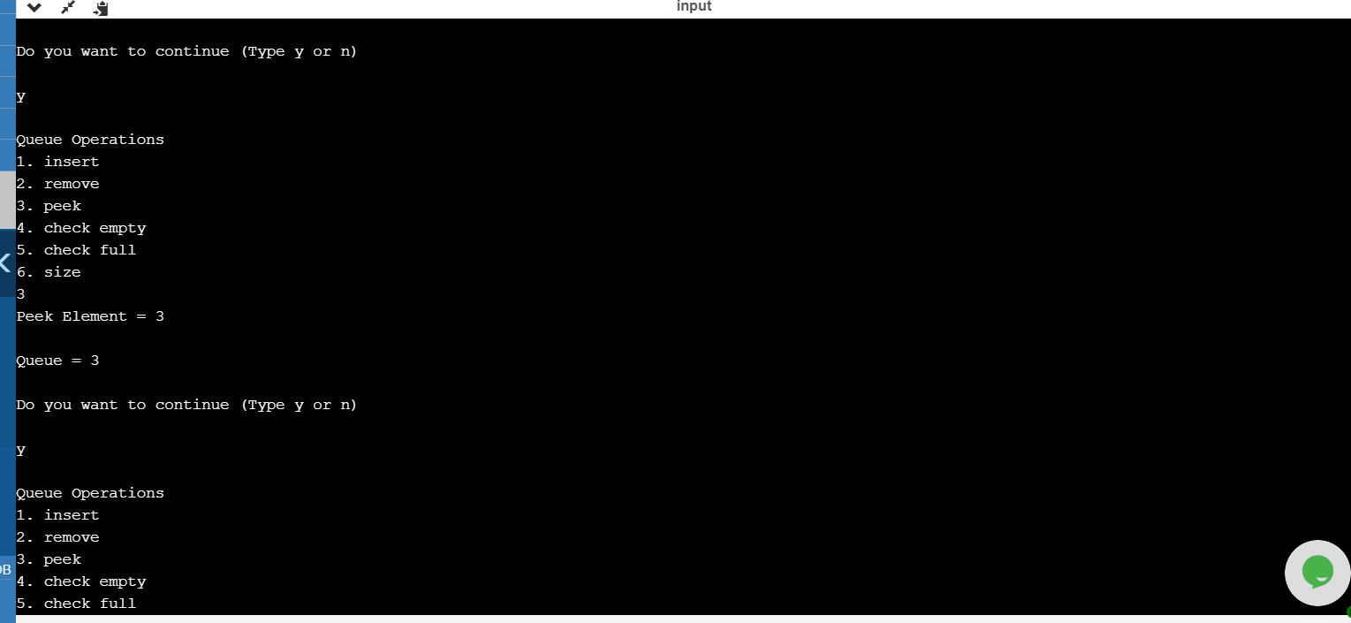

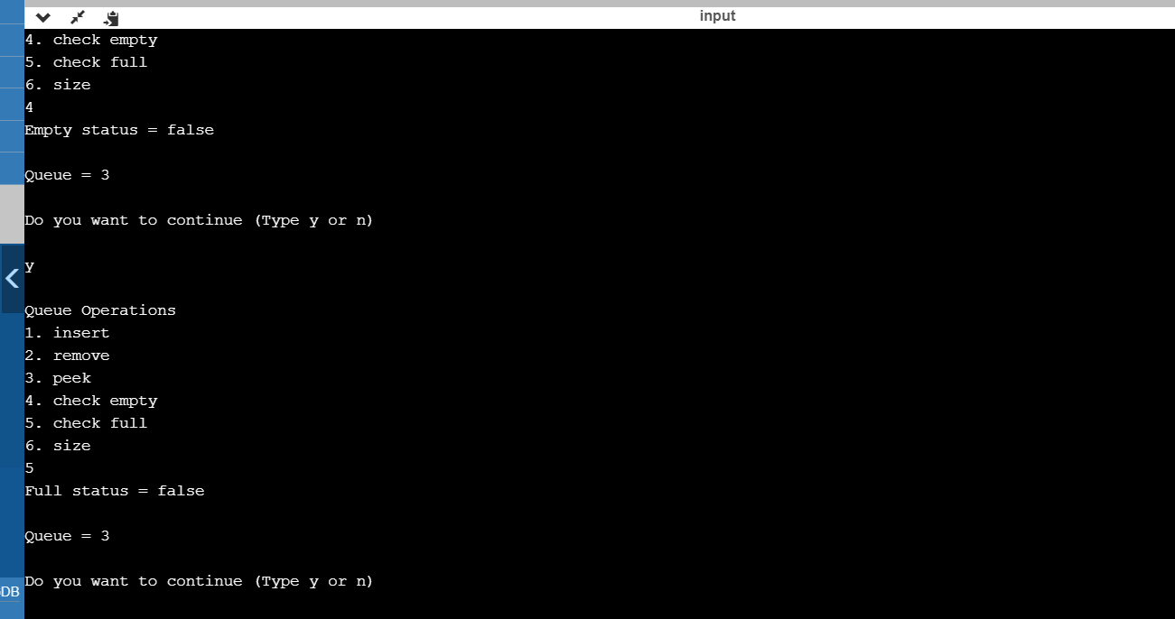

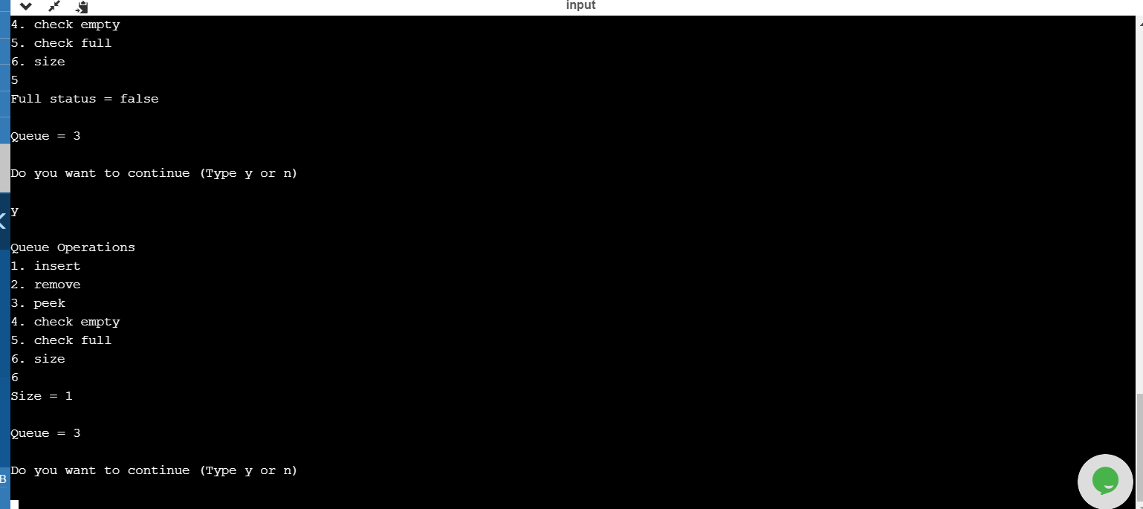

**PYTHON PROGRAM 3:**

**Python Program to Accept a Hyphen Separated Sequence of Words as Input and Print the Words in a Hyphen-Separated Sequence after Sorting them Alphabetically.**

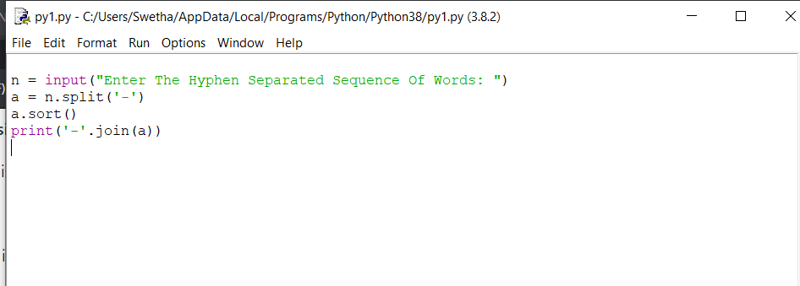

**OUTPUT:**

