**PYTHON PROGRAM1:**

**The program takes a string and removes the nth index character from the non-empty string.**

s=input("enter the string:")

n=int(input("enter index position (starts from 0) To remove character:"))

print ("The final string-",s[:n]+s[n+1:])

**OUTPUT:**

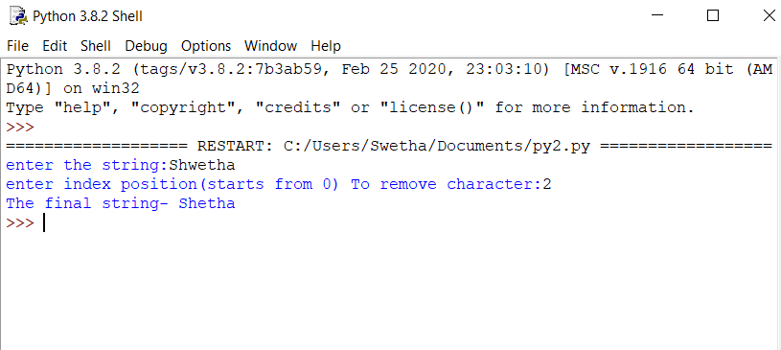

**JAVA PROGRAM 2:**

**Write a Java program to implement Circular Linked List Using Array and Class.**

 public class CreateList {

    //Represents the node of list.

    public class Node{

        int data;

        Node next;

        public Node(int data) {

            this.data = data;

        }

    }

    //Declaring head and tail pointer as null.

    public Node head = null;

    public Node tail = null;

    //This function will add the new node at the end of the list.

    public void add(int data){

        //Create new node

        Node newNode = new Node(data);

        //Checks if the list is empty.

        if(head == null) {

             //If list is empty, both head and tail would point to new node.

            head = newNode;

            tail = newNode;

            newNode.next = head;

        }

        else {

            //tail will point to new node.

            tail.next = newNode;

            //New node will become new tail.

            tail = newNode;

            //Since, it is circular linked list tail will point to head.

            tail.next = head;

        }

    }

    //Displays all the nodes in the list

    public void display() {

        Node current = head;

        if(head == null) {

            System.out.println("List is empty");

        }

        else {

            System.out.println("Nodes of the circular linked list: ");

             do{

                //Prints each node by incrementing pointer.

                System.out.print(" "+ current.data);

                current = current.next;

             } while(current != head);

            System.out.println();

        }

    }

    public static void main(String[] args) {

        CreateList cl = new CreateList();

        //Adds data to the list

        cl.add(1);

        cl.add(2);

        cl.add(3);

        cl.add(4);

        //Displays all the nodes present in the list

        cl.display();

    }

}

**OUTPUT:**

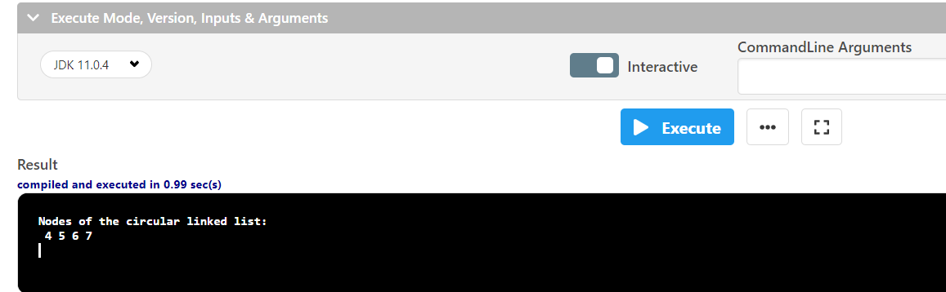

**PYTHON PROGRAM 3:**

**Take a list of numbers and square each odd number in the list. Print output as comma separated sequence.**

L1=[2,4,5,6,7,8,9]

even_sq,odd_sq = [],[]

for i in L1:

(even_sq if i%2==0 else odd_sq).append (i*i)

print(odd_sq)

**OUTPUT:**

