**DAILY ONLINE ACTIVITIES SUMMARY**

|  |  |  |  |  |  |  |  |  |
| --- | --- | --- | --- | --- | --- | --- | --- | --- |
| **Date:** | 08-07-2020 | | | | | **Name:** | SHWETHA M S | |
| **Sem & Sec** | 6th and B | | | | | **USN:** | 4AL17CS093 | |
| **Online Test Summary** | | | | | | | | |
| **Subject** | | ______ | | | | | | |
| **Max. Marks** | | ____ | | **Score** | | | ____ | |
| **Certification Course Summary** | | | | | | | | |
| **Course** | PYTHON DATA STRUCTURE | | | | | | | |
| **Certificate Provider** | | | COURSERA | | **Duration** | | | 7 WEEKS |
| **Coding Challenges** | | | | | | | | |
| **Problem Statement:** GIVEN 1 PROBLEMS | | | | | | | | |
| **Status:** Completed | | | | | | | | |
| **Uploaded the report in Github** | | | | | Yes | | | |
| **If yes Repository name** | | | | | https://github.com/ShwethaKhadri/Shwetha-M-S.git | | | |
| **Uploaded the report in slack** | | | | | Shwetha M S  Yes, I uploaded the report in slack | | | |

**SNAPSHOT OF ONLINE COURSE CERTIFICATION:**

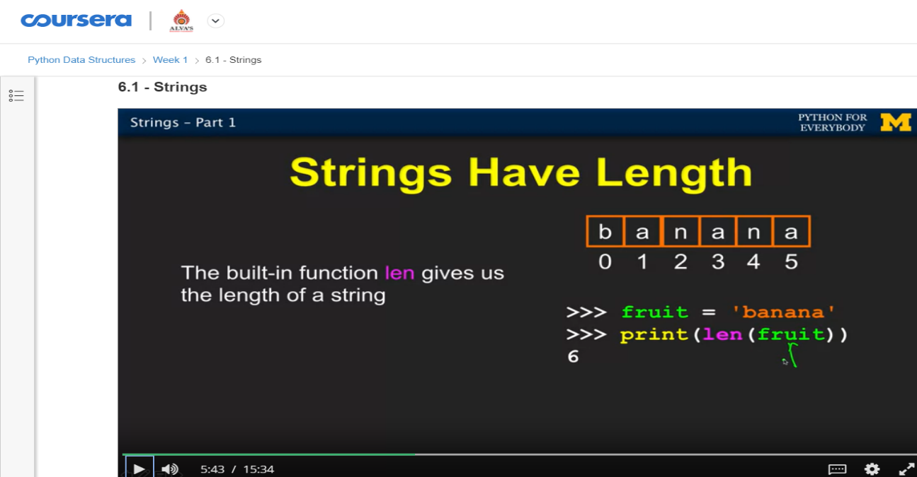

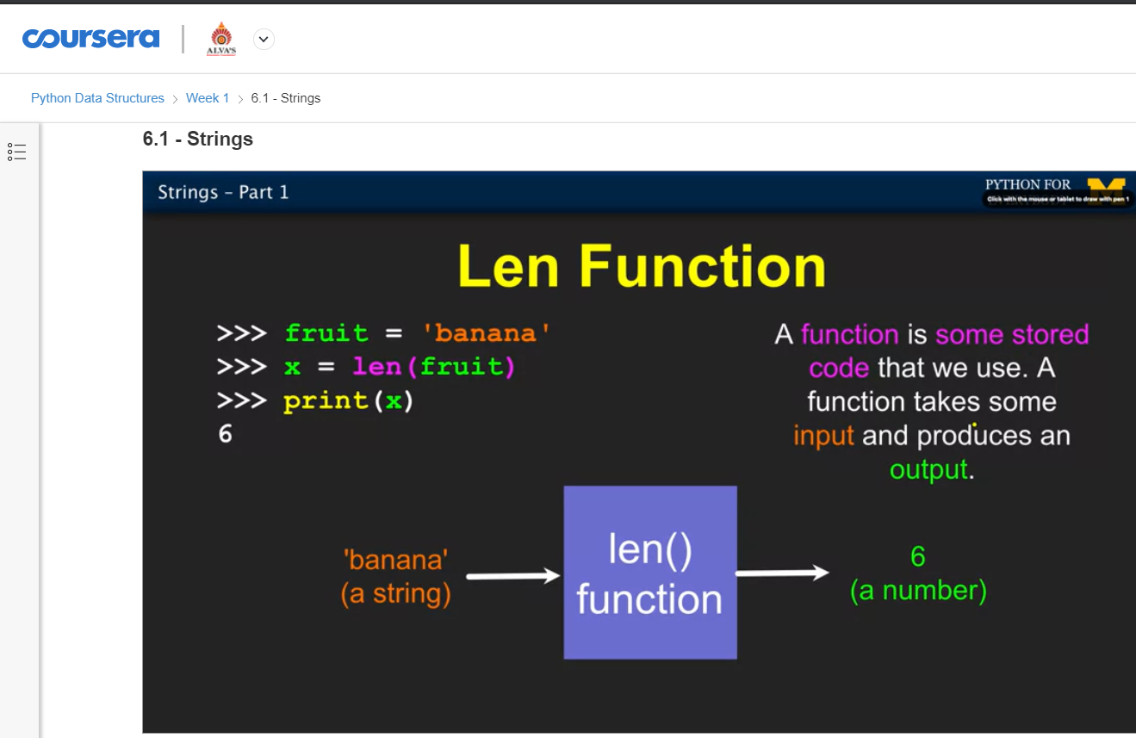

**SNAPSHOT OF ONLINE CODING:**

**PYTHON PROGRAM 1:**

**Python | Check for URL in a String.**

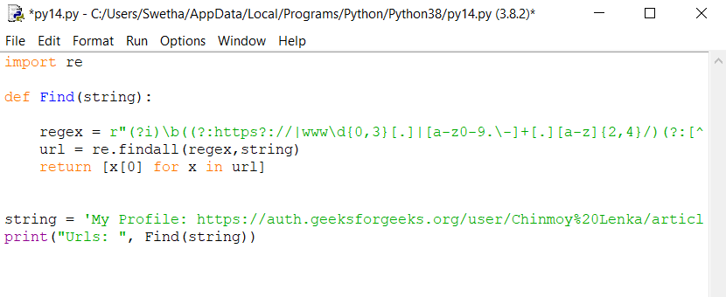

**OUTPUT:**

