**PYTHON PROGRAM 1:**

**Python Program to Copy the Contents of One File into Another.**

print("Contents Of File-1:\n\r",(open("shwe.txt", "r")).read())

print("Before Coping Contents Of File-2: \n", (open("khadri.txt", "r")).read())

f1 = open("shwe.txt", "r")

f2 = open("khadri.txt", "w")

for l in f1:

f2.write(l)

f2.close()

print("After Coping Contents Of File-2: \n", (open("khadri.txt", "r")).read())

**OUTPUT:**

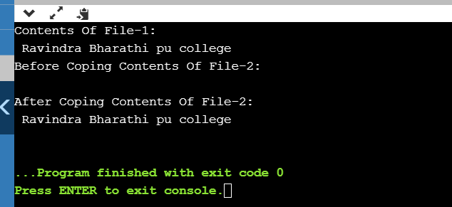

**JAVA PROGRAM 2:**

**Java program to delete a node from the middle of the singly linked list.**

class Main

{

static class Node

{

int data;

Node next;

}

static Node deleteMid(Node head)

{

if (head == null)

return null;

if (head.next == null)

{

return null;

}

Node slow_ptr = head;

Node fast_ptr = head;

Node prev = null;

while (fast_ptr != null && fast_ptr.next != null)

{

fast_ptr = fast_ptr.next.next;

prev = slow_ptr;

slow_ptr = slow_ptr.next;

}

prev.next = slow_ptr.next;

return head;

}

static void printList(Node ptr)

{

while (ptr != null)

{

System.out.print(ptr.data + "->");

ptr = ptr.next;

}

System.out.println("NULL");

}

static Node newNode(int data)

{

Node temp = new Node();

temp.data = data;

temp.next = null;

return temp;

}

public static void main(String[] args)

{

Node head = newNode(1);

head.next = newNode(2);

head.next.next = newNode(3);

head.next.next.next = newNode(4);

System.out.println("Given Linked List");

printList(head);

head = deleteMid(head);

System.out.println("Linked List after deletion of middle");

printList(head);

}

}

**OUTPUT:**

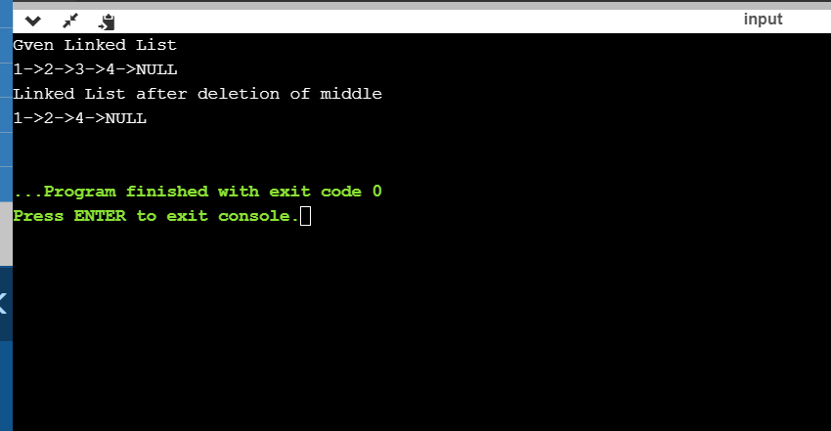

**PYTHON PROGRAM 3:**

**Write a python function that will take a string and checks whether it is a palindrome or not. Return If it a palindrome, print true else print false.**

def isPalindrome(s):

return s == s[::-1]

s = input("Enter the string: ")

ans = isPalindrome(s)

if ans:

print("True")

else:

print("False")

**OUTPUT:**

