**PYTHON PROGRAM 1:**

**Python Program to Check Whether a String is a Palindrome or not Using Recursion**

def pal(s):

if len(s) <= 1:

return True

else:

if s[0] == s[-1]:

return pal(s[1:-1])

else:

return False

a = input("Enter String:").lower()

if pal(a):

print("String Is A Palindrome")

else:

print("String Isn't A Palindrome")

**OUTPUT:**

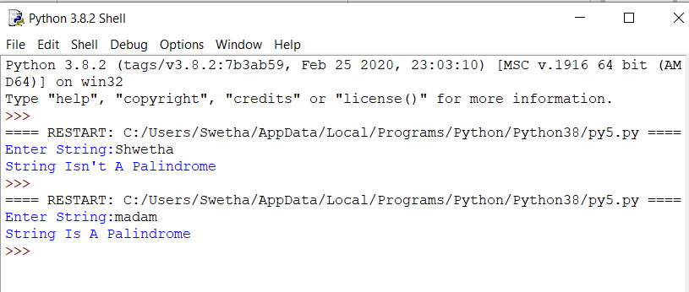

**C PROGRAM 2:**

**Write a C Program to rotate the matrix by K times.**

#include <stdio.h>

#include <stdlib.h>

int main()

{

int a[100][100],m,n,k,i,j,x,y,z;

printf("Enter The Size Of The Matrix:\n");

scanf("%d%d",&m,&n);

printf("Enter The Elements Into Matrix:\n");

for(i=0;i<m;i++)

{

for(j=0;j<n;j++)

{

scanf("%d",&a[i][j]);

}

}

printf("Enter The K Value For Rotation:\n");

scanf("%d",&k);

int f,g;

printf("Matrix Before The Rotation:\n");

for(f=0;f<m;f++)

{

for(g=0;g<n;g++)

{

printf("%d\t",a[f][g]);

}

printf("\n");

}

for(x=0;x<m;x++)

{

for(z=0;z<k;z++)

{

int temp=a[x][0];

for(y=0;y<n-1;y++)

{

a[x][y]=a[x][y+1];

}

a[x][n-1]=temp;

}

}

printf("Matrix After The Rotation:\n");

int c,d;

for(c=0;c<m;c++)

{

for(d=0;d<n;d++)

{

printf("%d\t",a[c][d]);

}

printf("\n");

}

}

**OUTPUT:**

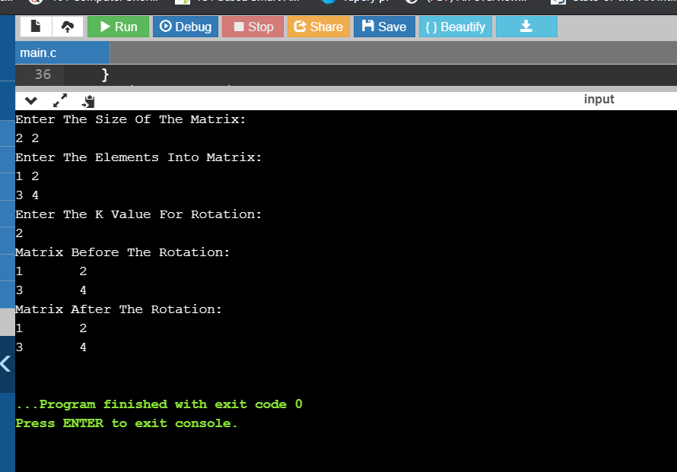

**PYTHON PROGRAM 3:**

**Python Program to Reverse a String Using Recursion.**

def rev(s):

if len(s) == 0:

return s

else:

return rev(s[1:]) + s[0]

a = input("Enter String: ").lower()

print("The Reversed String: ", rev(a))

**OUTPUT:**

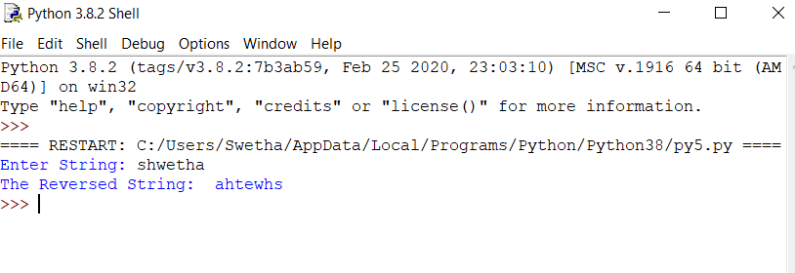

**PYTHON PROGRAM 4:**

**Write a Python to implement Perfect Sum Problem.**

def printAllSubsetsRec(arr, n, v, sum):

if (sum == 0):

for value in v:

print(value, end=" ")

print()

return

if (n == 0):

return

printAllSubsetsRec(arr, n - 1, v, sum)

v1 = [] + v

v1.append(arr[n - 1])

printAllSubsetsRec(arr, n - 1, v1, sum - arr[n - 1])

def printAllSubsets(arr, n, sum):

v = []

printAllSubsetsRec(arr, n, v, sum)

n = int(input("Enter Number Of Elements: "))

a = []

print("Enter The Elements Into List:")

for i in range(n):

a.append(int(input()))

sum = int(input("Enter The K value: "))

print("Subsets with sum", sum, "are:")

print(printAllSubsets(a, n, sum))

**OUTPUT:**

