**DAILY ONLINE ACTIVITIES SUMMARY**

|  |  |  |  |  |  |  |  |  |
| --- | --- | --- | --- | --- | --- | --- | --- | --- |
| **Date:** | 09-06-2020 | | | | | **Name:** | SHWETHA M S | |
| **Sem & Sec** | 6th and B | | | | | **USN:** | 4AL17CS093 | |
| **Online Test Summary** | | | | | | | | |
| **Subject** | | CGV (4TH IA MARKS)  CNSC (3RD IA MARKS) | | | | | | |
| **Max. Marks** | | 30  60 | | **Score** | | | 24  53 | |
| **Certification Course Summary** | | | | | | | | |
| **Course** | THE COMPLETE PYTHON COURSE | | | | | | | |
| **Certificate Provider** | | | UDEMY | | **Duration** | | | 35.5 HOURS |
| **Coding Challenges** | | | | | | | | |
| **Problem Statement:** GIVEN 4 PROBLEMS | | | | | | | | |
| **Status:** Completed | | | | | | | | |
| **Uploaded the report in Github** | | | | | Yes | | | |
| **If yes Repository name** | | | | | https://github.com/ShwethaKhadri/Shwetha-M-S.git | | | |
| **Uploaded the report in slack** | | | | | Shwetha M S  Yes, I uploaded the report in slack | | | |

**SNAPSHOT OF FOURTH IA MARKS:**

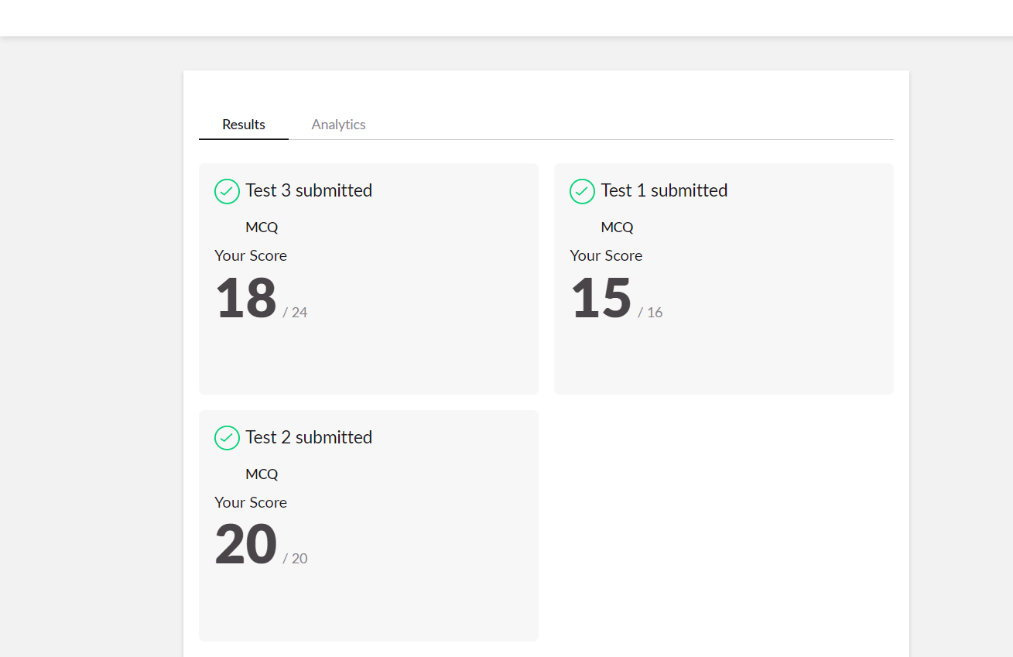

**SNAPSHOT OF THIRD IA MARKS:**

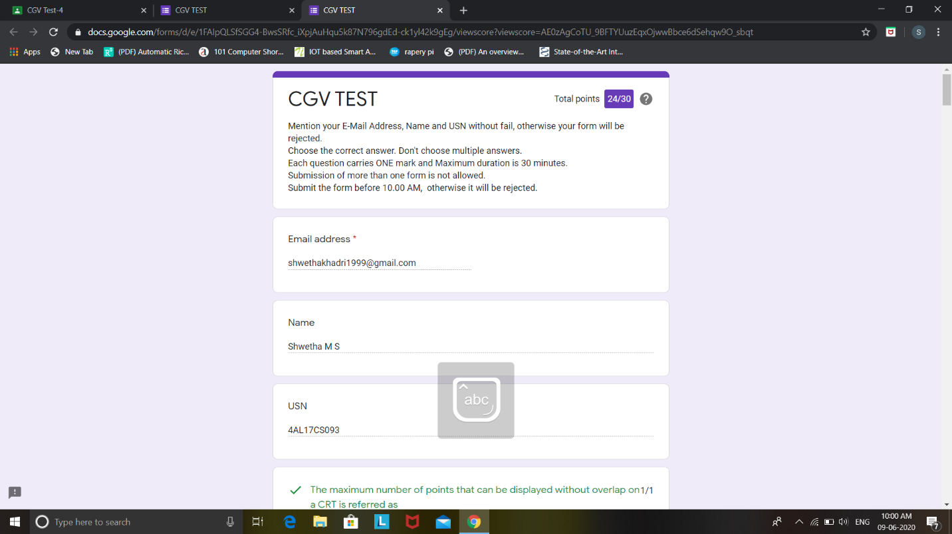

**SNAPSHOT OF ONLINE CERTIFICATION COURSE:**

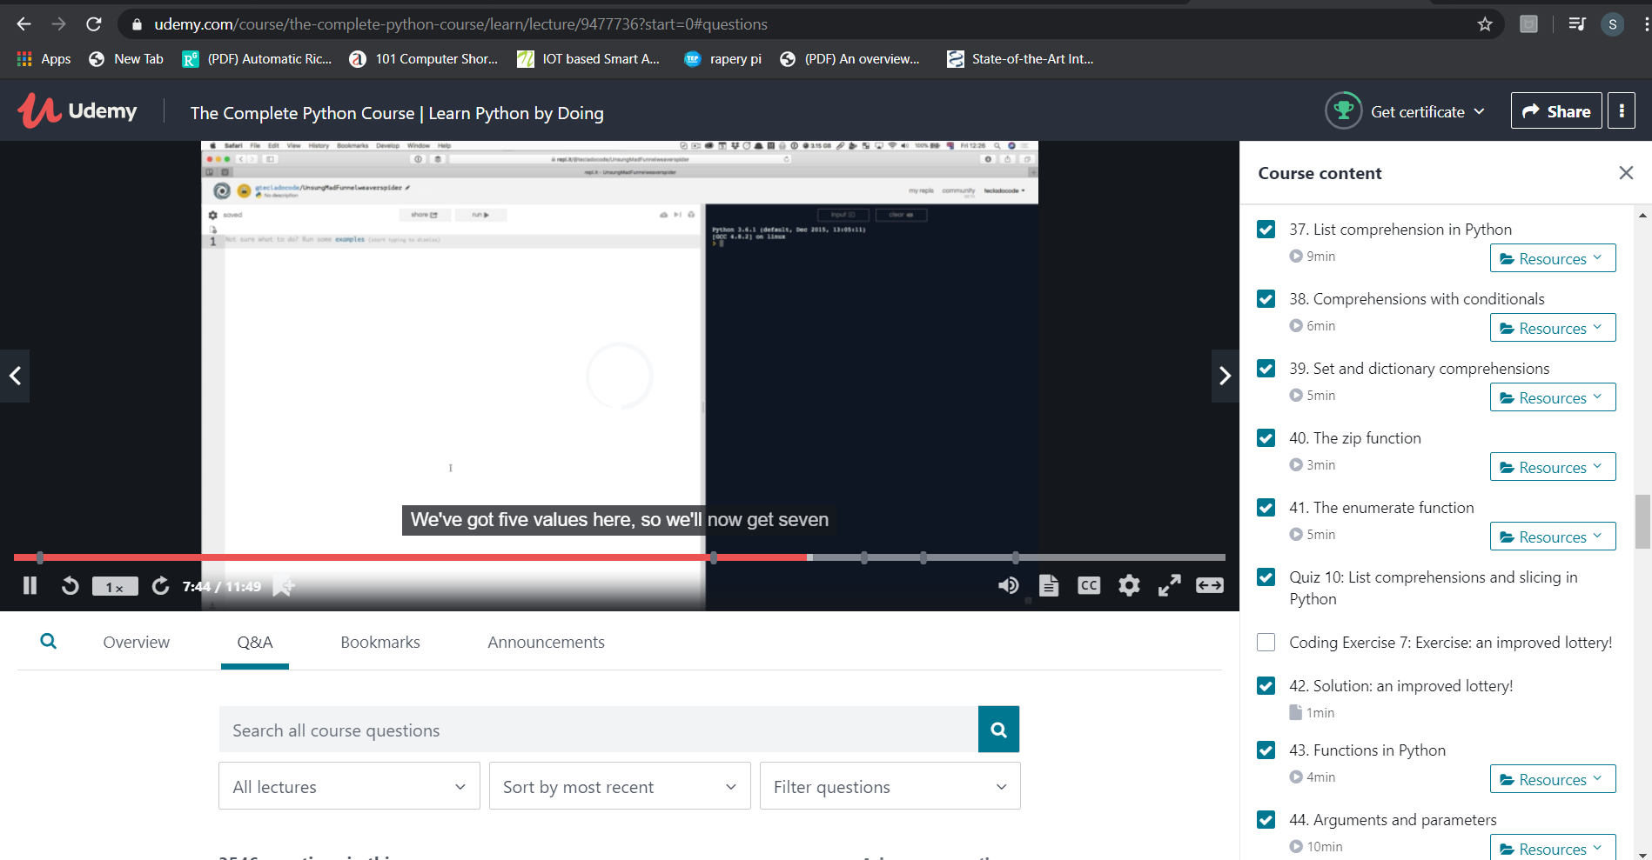

**SNAPSHOT OF ONLINE CODING:**

**PYTHON PROGRAM 1:**

**Python Program to Check Whether a String is a Palindrome or not Using Recursion.**

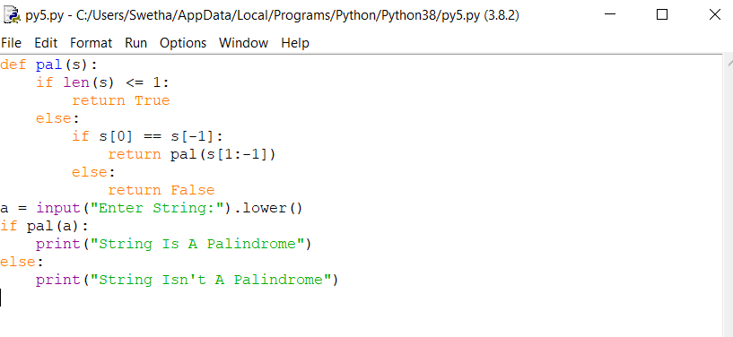

**OUTPUT:**

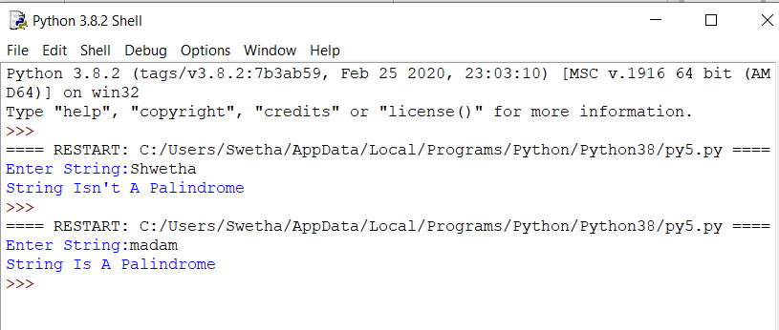

**C PROGRAM 2:**

**Write a C Program to rotate the matrix by K times.**

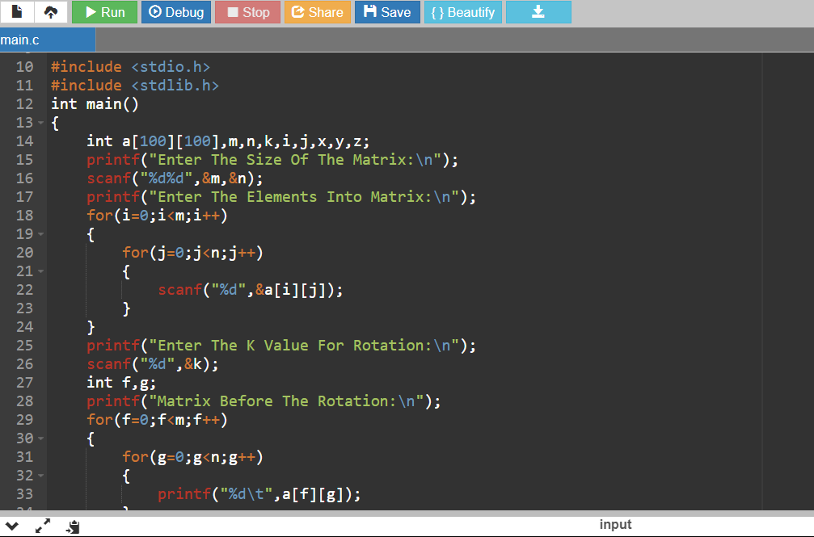

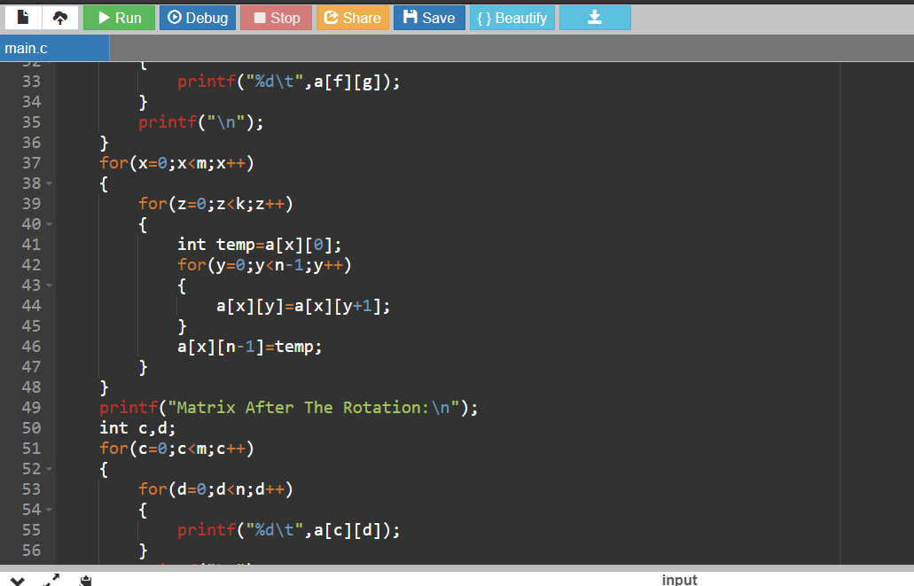

**OUTPUT:**

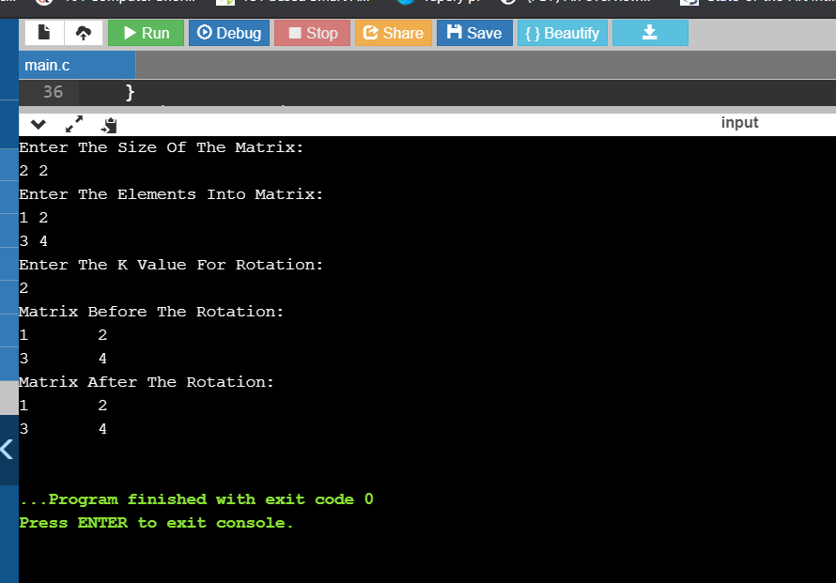

**PYTHON PROGRAM 3:**

**Python Program to Reverse a String Using Recursion.**

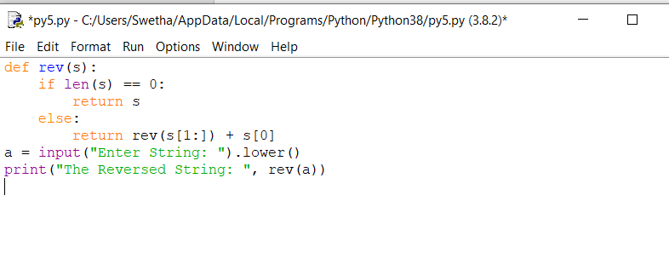

**OUTPUT:**

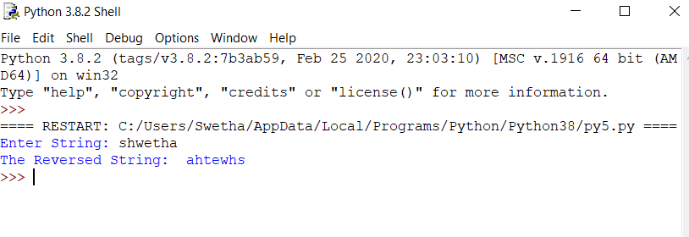

**PYTHON PROGRAM 4:**

**Write a Python to implement Perfect Sum Problem.**

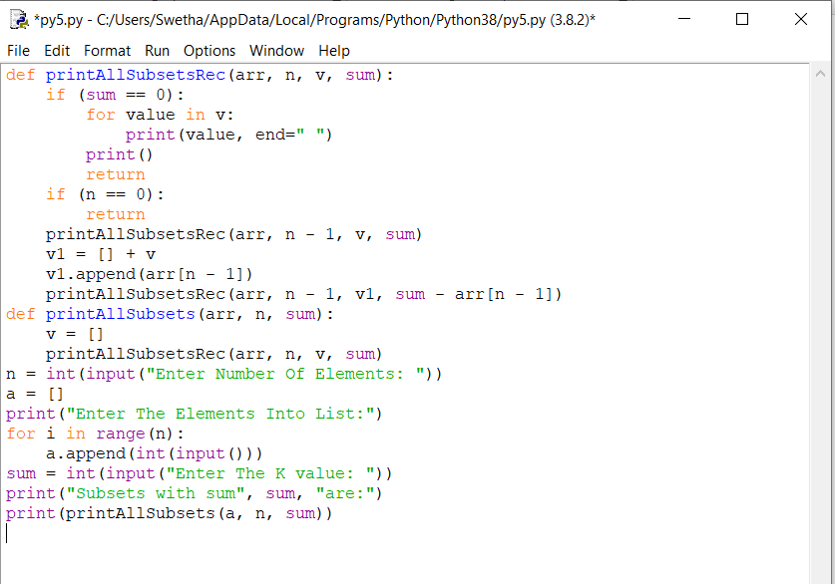

**OUTPUT:**

