**DAILY ONLINE ACTIVITIES SUMMARY**

|  |  |  |  |  |  |  |  |  |
| --- | --- | --- | --- | --- | --- | --- | --- | --- |
| **Date:** | 11-06-2020 | | | | | **Name:** | SHWETHA M S | |
| **Sem & Sec** | 6th and B | | | | | **USN:** | 4AL17CS093 | |
| **Online Test Summary** | | | | | | | | |
| **Subject** | | PAP (3RD ASSIGNMENT MARKS) | | | | | | |
| **Max. Marks** | | 20 | | **Score** | | | 20 | |
| **Certification Course Summary** | | | | | | | | |
| **Course** | THE COMPLETE PYTHON COURSE | | | | | | | |
| **Certificate Provider** | | | UDEMY | | **Duration** | | | 35.5 HOURS |
| **Coding Challenges** | | | | | | | | |
| **Problem Statement:** GIVEN 3 PROBLEMS | | | | | | | | |
| **Status:** Completed | | | | | | | | |
| **Uploaded the report in Github** | | | | | Yes | | | |
| **If yes Repository name** | | | | | https://github.com/ShwethaKhadri/Shwetha-M-S.git | | | |
| **Uploaded the report in slack** | | | | | Shwetha M S  Yes, I uploaded the report in slack | | | |

**SNAPSHOT OF THIRD ASSIGNMENT MARKS:**

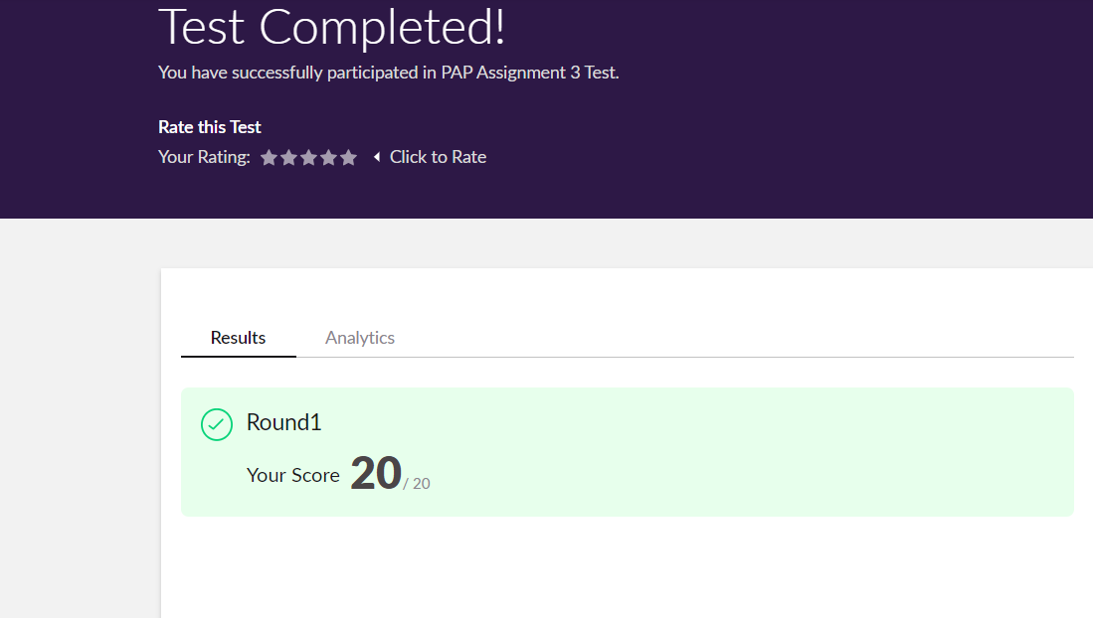

**SNAPSHOT OF ONLINE CERTIFICATION COURSE:**

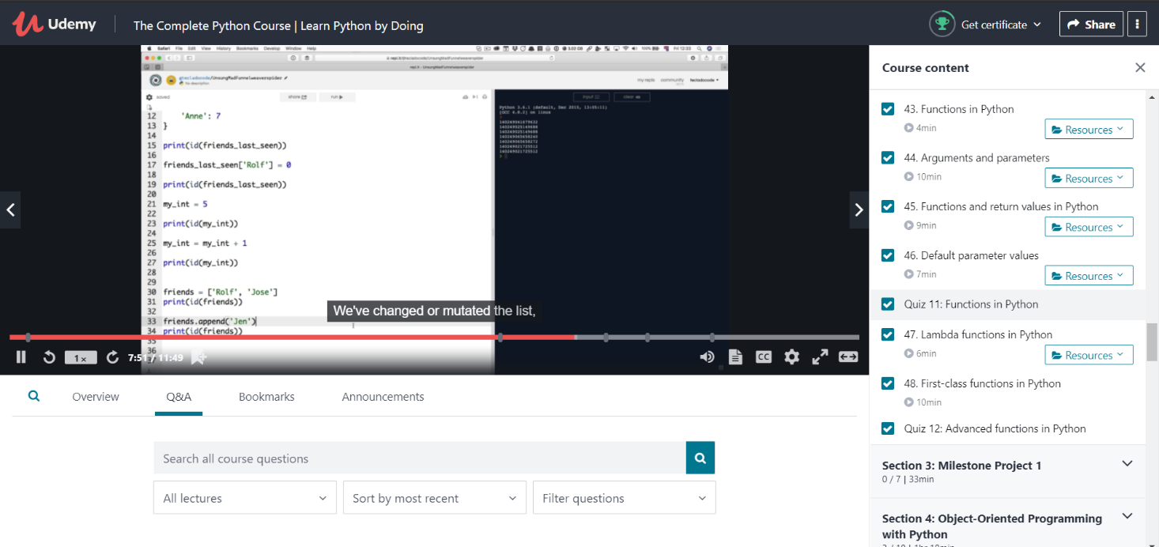

**SNAPSHOT OF ONLINE CODING:**

**PYTHON PROGRAM 1:**

**Python Program to find the average of all Items in a Dictionary Step1: Get the name as key and marks as value for n students Step2: find the average of the marks of all the students and print it.**

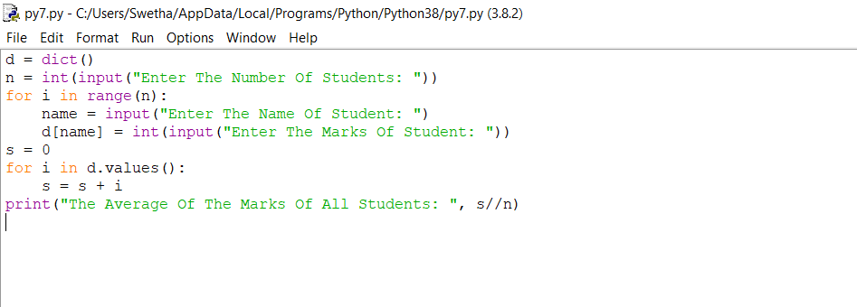

**OUTPUT:**

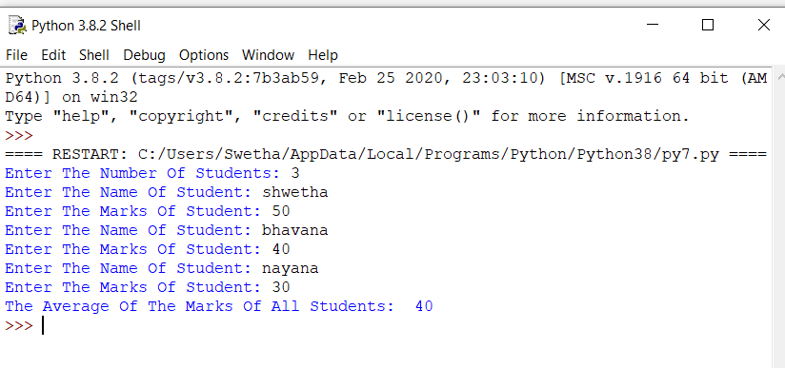

**JAVA PROGRAM 2:**

**Write a Java program to find the nodes which are at the maximum distance in a Binary Tree**

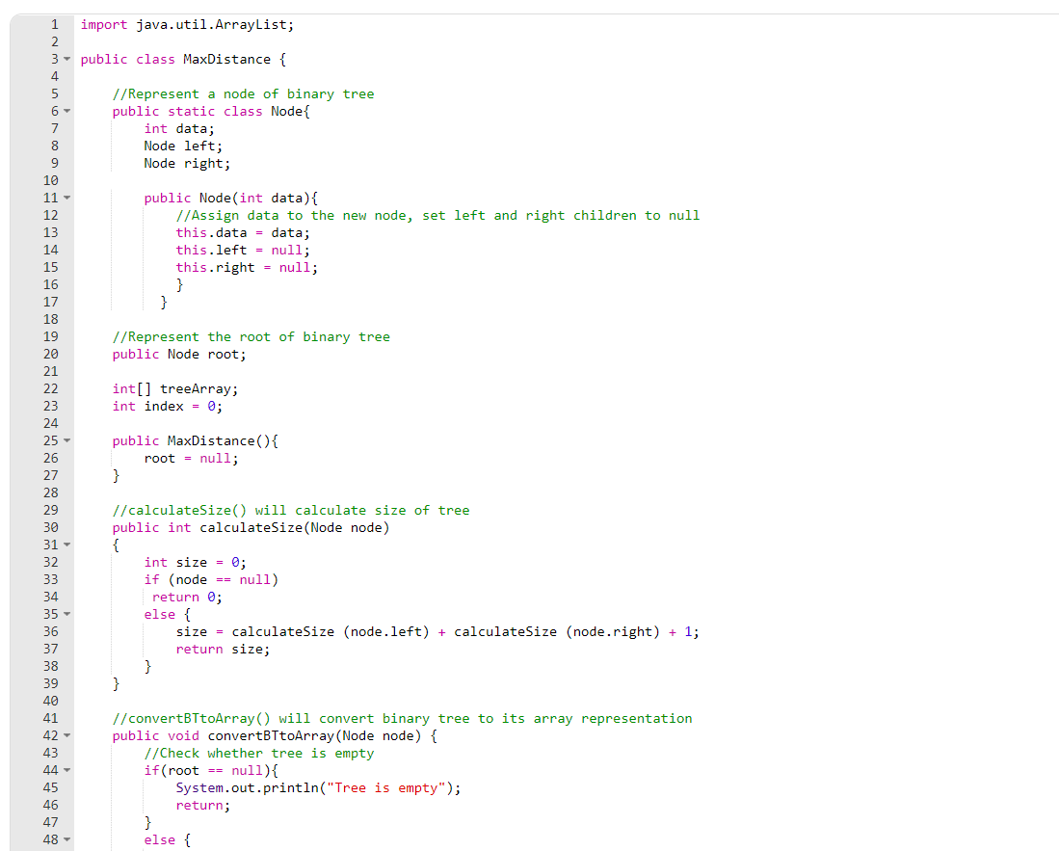

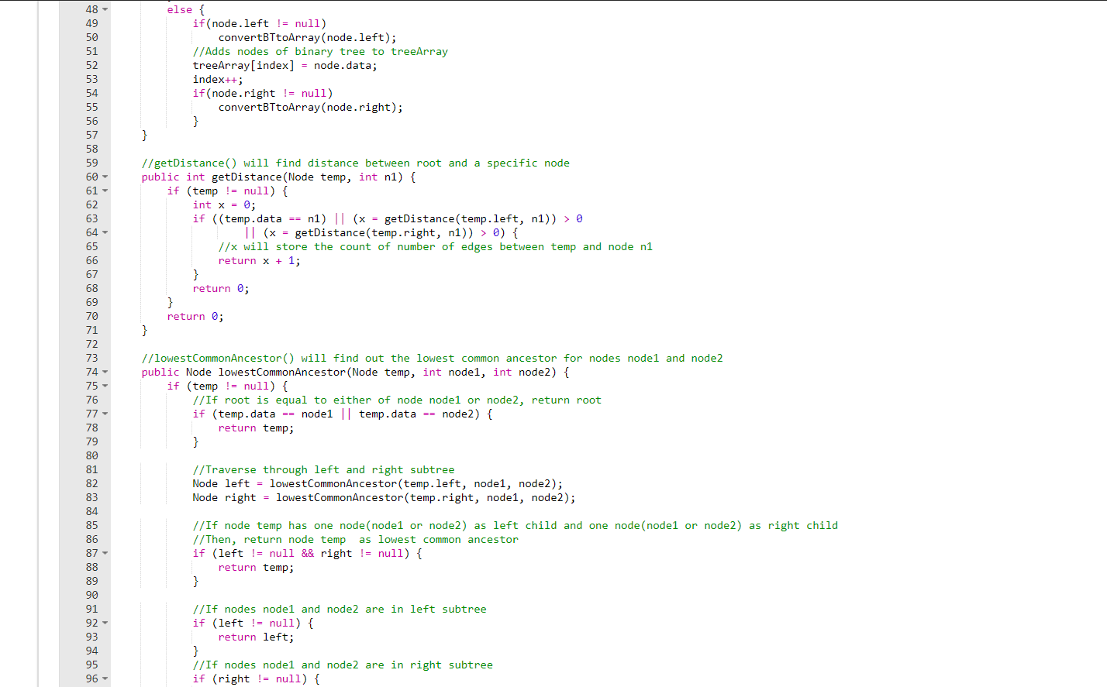

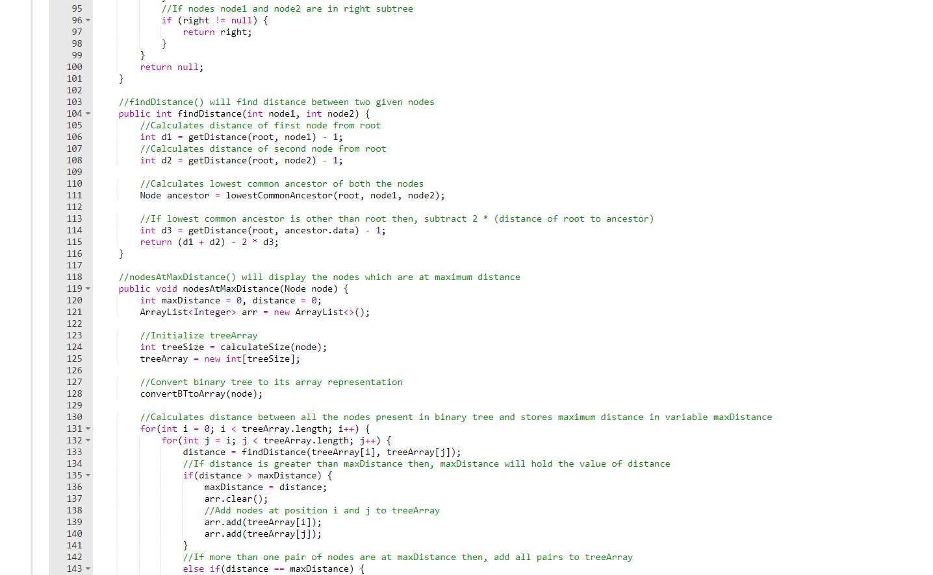

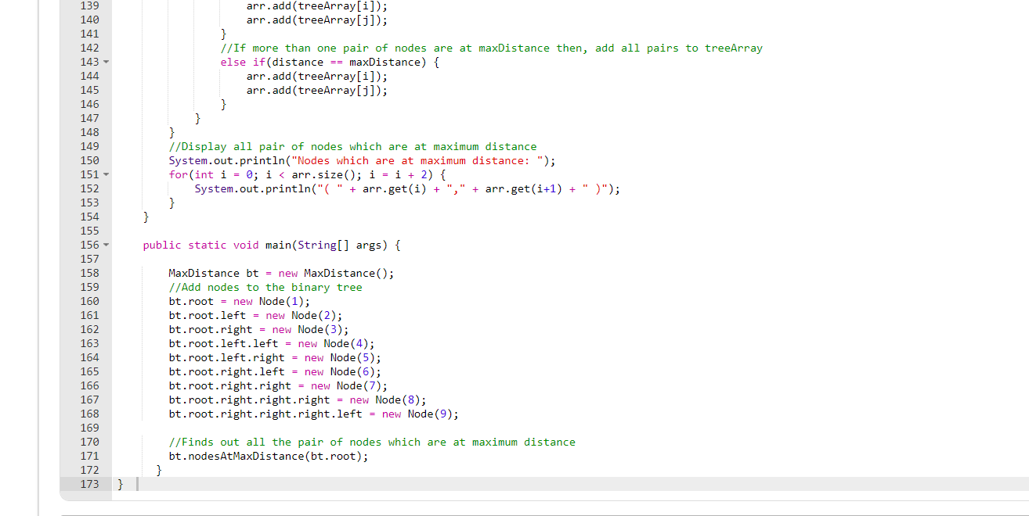

**OUTPUT:**

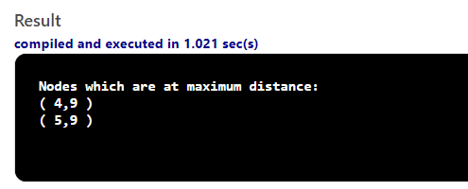

**PYTHON PROGRAM 3:**

**Write a python function that converts a string to all uppercase, provided it contains at least 2 uppercase characters in the first 4 characters. Else print the string as it is**

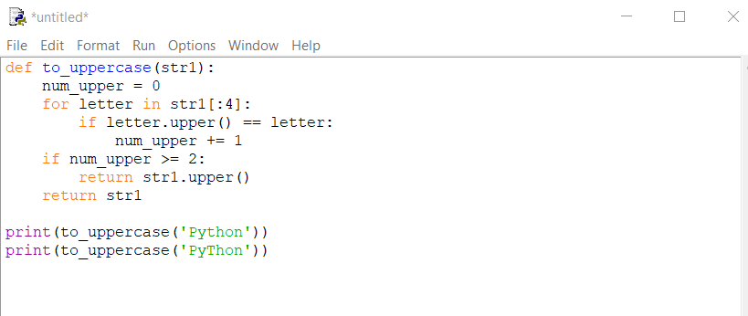

**OUTPUT:**

