**PYTHON PROGRAM 1:**

**Python Program to Take in a String and Replace Every Blank Space with Hyphen.**

s = input("Enter The String: ")

print(s.replace(" ", "-"))

**OUTPUT:**

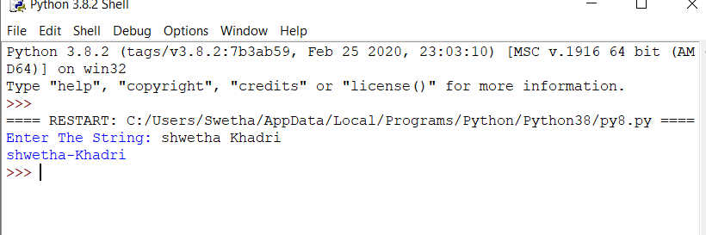

**PYTHON PROGRAM 2:**

**Python Program to Calculate the Length of a String Without Using a Library Function.**

c = 0

for i in input("Enter The String: "):

c += 1

print(f'The Length Of String Is: {c}')

**OUTPUT:**

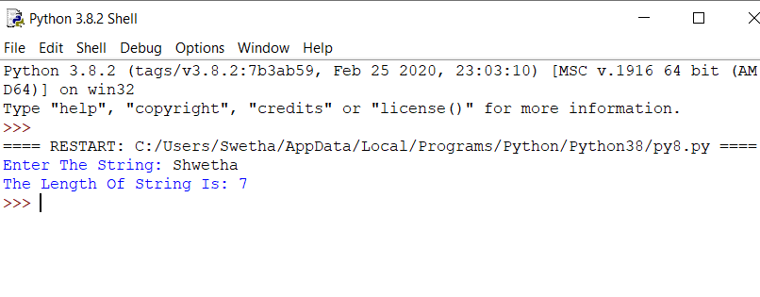

**C PROGRAM 3:**

**Write a C Program to implement the Binary Reversal.**

#include <stdio.h>

int main ()

{

int n = 0, num = 0, count = 0, rev_bits = 0;

printf ("Enter the number: ");

scanf ("%d", &n);

while (n > 0)

{

rev_bits = rev_bits << 1;

if (n & 1 == 1)

{

rev_bits = rev_bits ^ 1;

}

n = n >> 1;

}

printf ("\nThe reversed resultant = %d\n", rev_bits);

return 0;

}

**OUTPUT:**

