**DAILY ONLINE ACTIVITIES SUMMARY**

|  |  |  |  |  |  |  |  |  |
| --- | --- | --- | --- | --- | --- | --- | --- | --- |
| **Date:** | **15/06/2020** | | | | | **Name:** | **SHWETHA M S** | |
| **Sem & Sec** | **6th sem & A sec** | | | | | **USN:** | **4AL17CS093** | |
| **Online Test Summary** | | | | | | | | |
| **Subject** | | **Python (Workshop quiz)** | | | | | | |
| **Max. Marks** | | **20** | | **Score** | | | **17** | |
| **Pre-Placement Training Summary** | | | | | | | | |
| **Pre placement training** | **9:00 am to 11:00 am - Programming in C**  **11:00 am to 1:00pm - Applications of python in DA and ML** | | | | | | | |
| **Faculty** | | | **Vivek Sharma**  **Dr.Mohideen Badusha** | | **Duration** | | | **4 hr** |
| **Assessments** | | | | | | | | |
| **Problem Statement:**   1. C program to count number of distinct elements in an array. 2. Examples and Exercises on python. | | | | | | | | |
| **Status: Completed** | | | | | | | | |
| **Uploaded the report in Github** | | | | | **Yes** | | | |
| **If yes Repository name** | | | | | https://github.com/ShwethaKhadri/Shwetha-M-S.git | | | |
| **Uploaded the report in slack** | | | | | **Yes** | | | |

**SNAPSHOT OF PYTHON WORKSHOP QUIZ:**

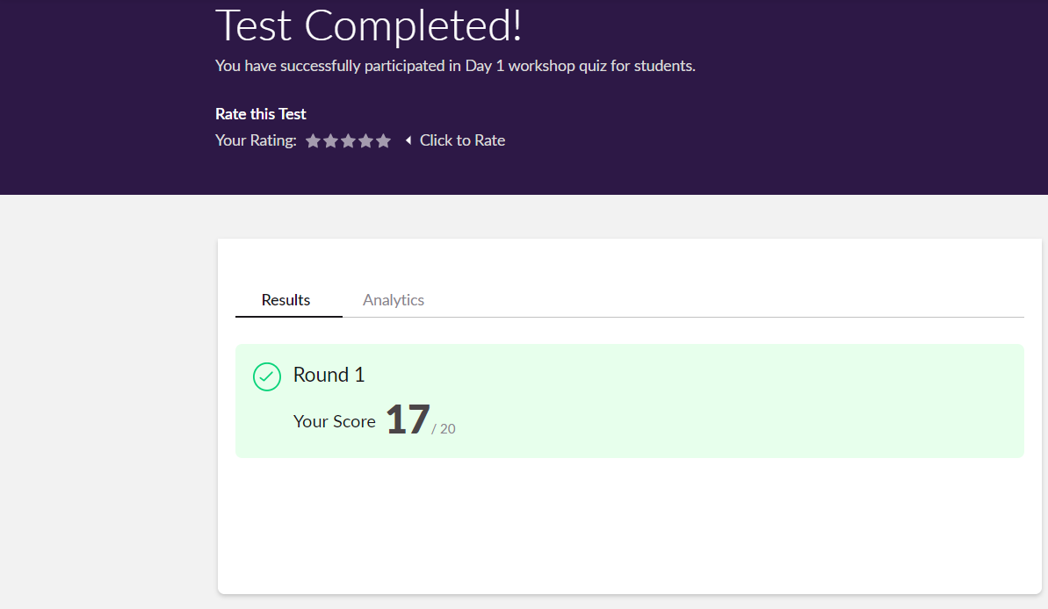

**TRAINING SNAPSHOT:**

**PROGRAMMING IN C**

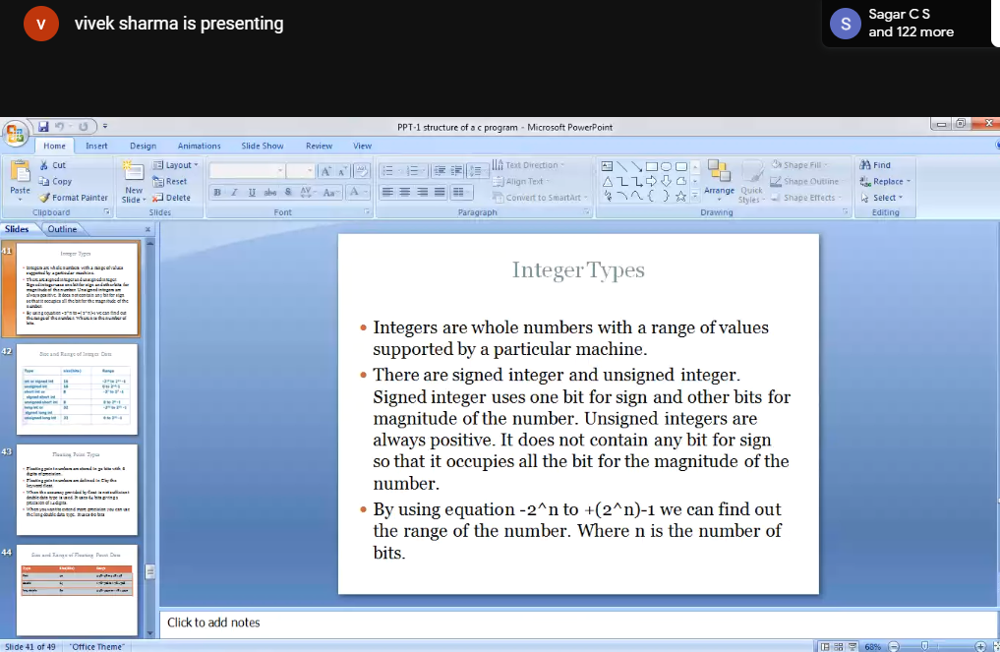

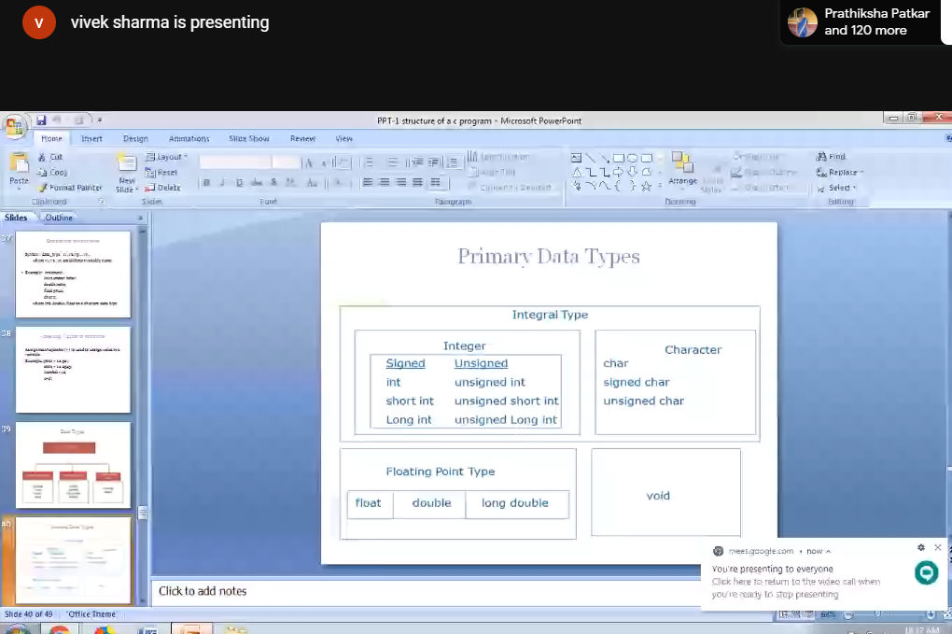

**APPLICATION OF PYTHON PROGRAMMING IN DATA ANAYTICS AND MACHINE LEARNING.**

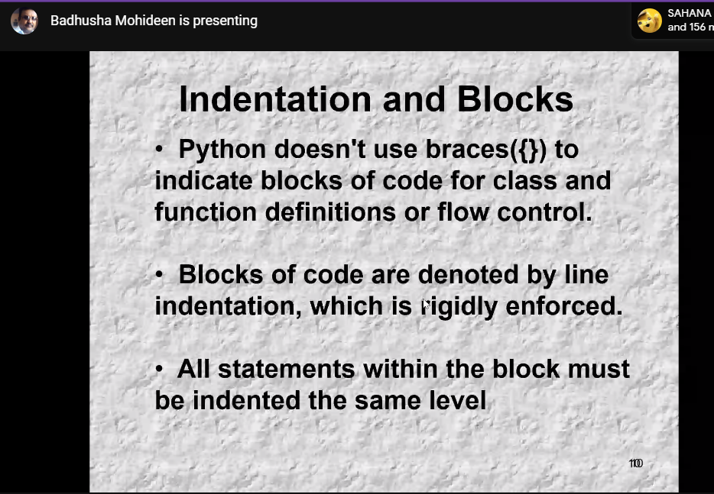

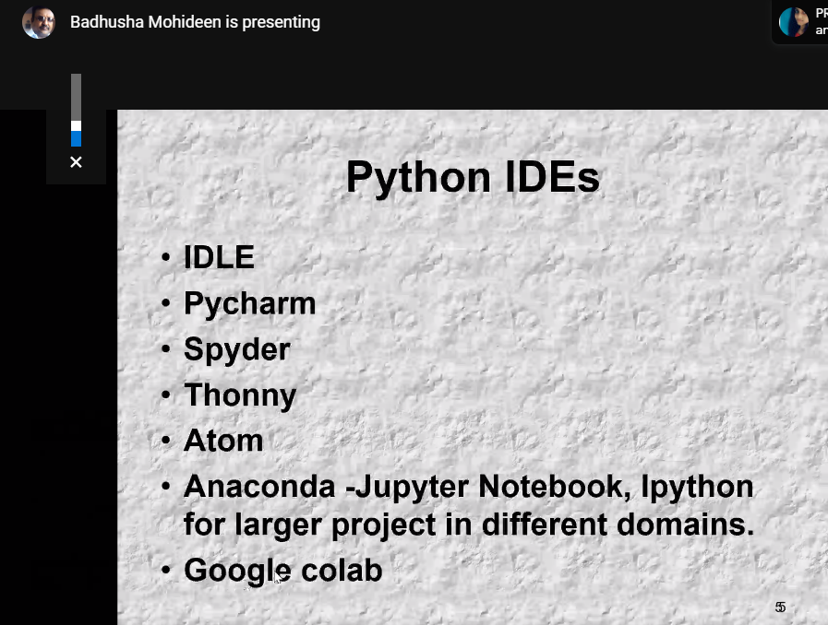

**ASSESSMENTS:**

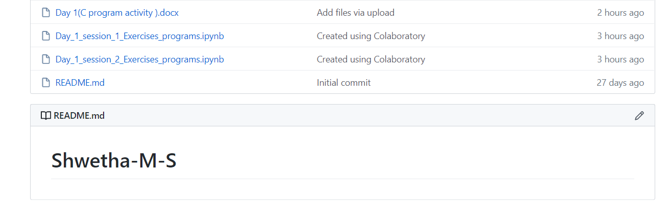

**C PROGRAM:**

**Write a C program to count distinct elements in an array.**

include <stdio.h>

void distict_elements(int a[], int n);

int main()

{

int size_array, i, arr[20];

scanf(“%d”, &size_array);

for(i=0; i<size_array; i++)

{

scanf(“%d”, &arr[i]);

}

distict_elements(arr, size_array);

return 0;

}

void distict_elements(int a[], int n)

{

int i, j;

for (i=0; i<n; i++)

{

for (j=0; j<i; j++)

{

if (a[i] == a[j])

break;

}

if (i == j)

printf(“%d “, a[i]);

}

}

**SNAPSHOT OF C PROGRAM:**

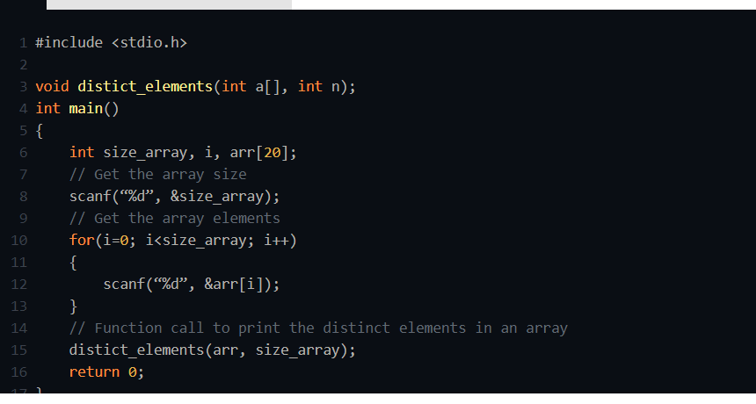

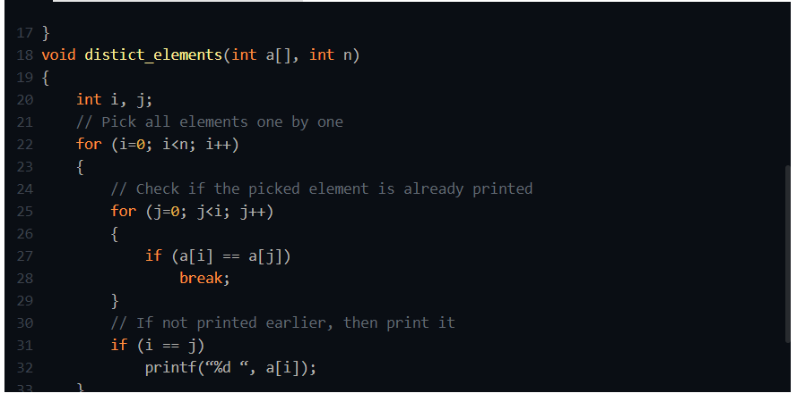

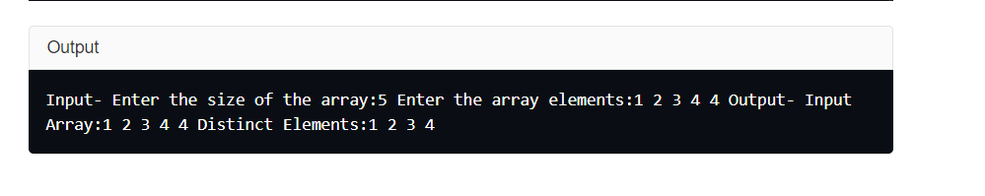

**ALOGRITHM:**

**STEP1:** Declare and input the array elements.

**STEP2:** Traverse the array from the beginning.

**STEP3:** Check if the current element is found in the array again.

**STEP4:** if it is found, then do not print the element.

**STEP5:** Else, print that element and continue.

**FLOWCHART:**

