**DAILY ONLINE ACTIVITIES SUMMARY**

|  |  |  |  |  |  |  |  |  |
| --- | --- | --- | --- | --- | --- | --- | --- | --- |
| **Date:** | **19/06/2020** | | | | | **Name:** | **SHWETHA M S** | |
| **Sem & Sec** | **6th sem & B sec** | | | | | **USN:** | **4AL17CS093** | |
| **Online Test Summary** | | | | | | | | |
| **Subject** | | **_________** | | | | | | |
| **Max. Marks** | | **__** | | **Score** | | | **___** | |
| **Pre-Placement Training Summary** | | | | | | | | |
| **Pre placement training** | **9:00 am to 11:00 am - Programming in C**  **11:00 am to 1:00pm - Applications of python in DA and ML** | | | | | | | |
| **Faculty** | | | **Merlyn Mathias**  **Dr.Mohideen Badusha** | | **Duration** | | | **4 hr** |
| **Assessments** | | | | | | | | |
| **Problem Statement:**  1. To swap 2 numbers using pointer and function concept, return value from user defined function and print the swapped values in main() function.  **2.** Given a positive integer n, count the total number of set bits in binary representation of all numbers from 1 to n.  3. Examples and Exercises on python. | | | | | | | | |
| **Status: Completed** | | | | | | | | |
| **Uploaded the report in Github** | | | | | **Yes** | | | |
| **If yes Repository name** | | | | | https://github.com/ShwethaKhadri/Shwetha-M-S.git | | | |

**TRAINING SNAPSHOT:**

**APPLICATION OF PYTHON PROGRAMMING IN DATA ANAYTICS AND MACHINE LEARNING.**

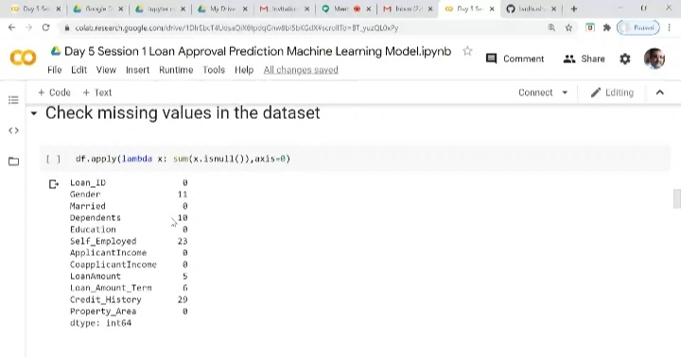

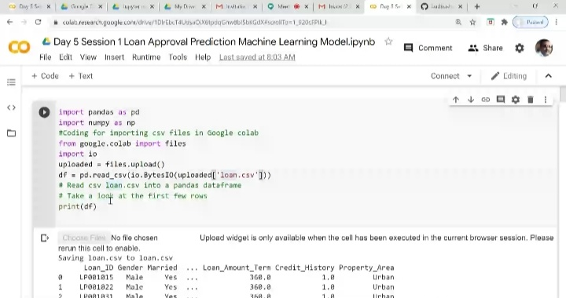

**PROGRAMMING IN C:**

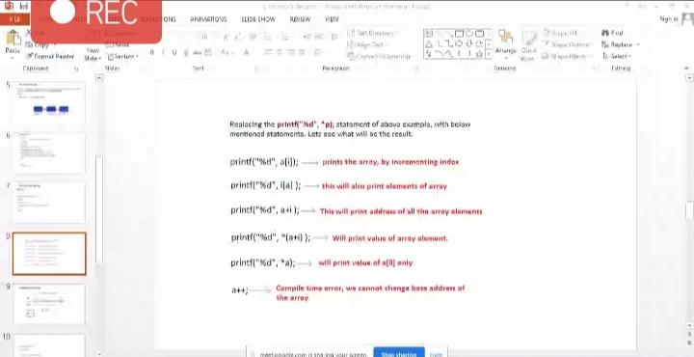

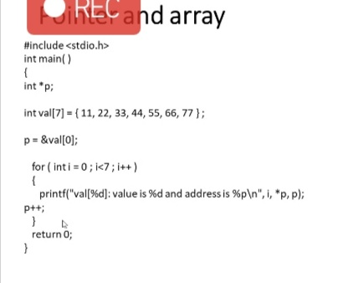

**SNAPSHOT OF C PROGRAM:**

**To swap 2 numbers using pointer and function concept, return value from user defined function and print the swapped values in main() function.**

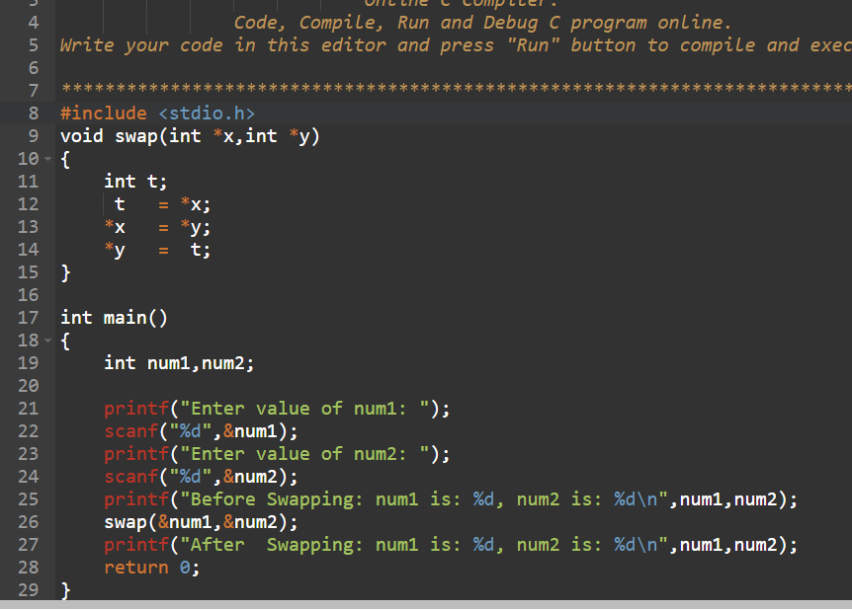

**OUTPUT:** 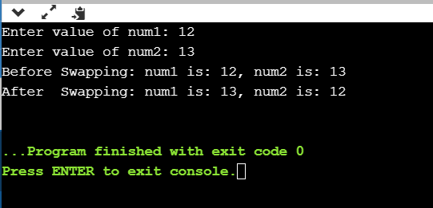

**SNAPSHOT OF C PROGRAM:**

**Given a positive integer n, count the total number of set bits in binary representation of all numbers from 1 to n.**

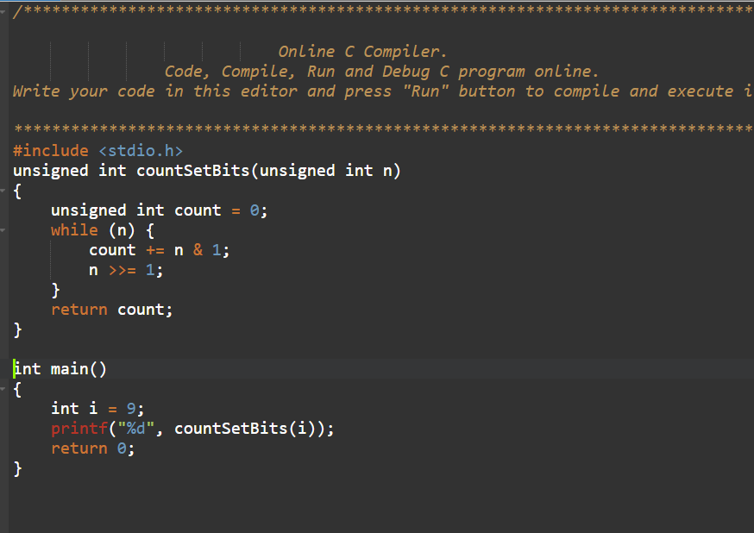

**OUTPUT:**

