**C++ PROGRAM 1:**

**Write a C++ program to rotate an array by K position.**

#include <iostream>

using namespace std;

int main()

{

int no_of_elements, no_of_rotations, no_to_display;

cout<<"Enter the number of elements of the array : ";

cin >> no_of_elements;

cout<<"Enter the number of rotations of the array : ";

cin>>no_of_rotations;

cout<<"Enter the number of indexes to be displayed : " ;

cin>>no_to_display;

int arr[no_of_elements];

cout<<"\n Input the array elements\n";

for(int i = 0; i < no_of_elements; i++)

{

cin>>arr[i];

}

cout<<"\nThe Array Elements are\n";

for(int i = 0; i < no_of_elements; i++)

{

cout<<arr[i];

cout<<"\t";

}

no_of_rotations %= no_of_elements; // Remove the number of full array rotations from k

for(int i = 0; i < no_to_display; i++)

{

int index;

cout<<"\nEnter the index of the array to be displayed : ";

cin>>index;

cout<<"\nThe element in the array is ";

cout<<arr[(no_of_elements + index - no_of_rotations) % no_of_elements]<<"\n"; // Calculate the new index

}

return 0;

}

**OUTPUT:**

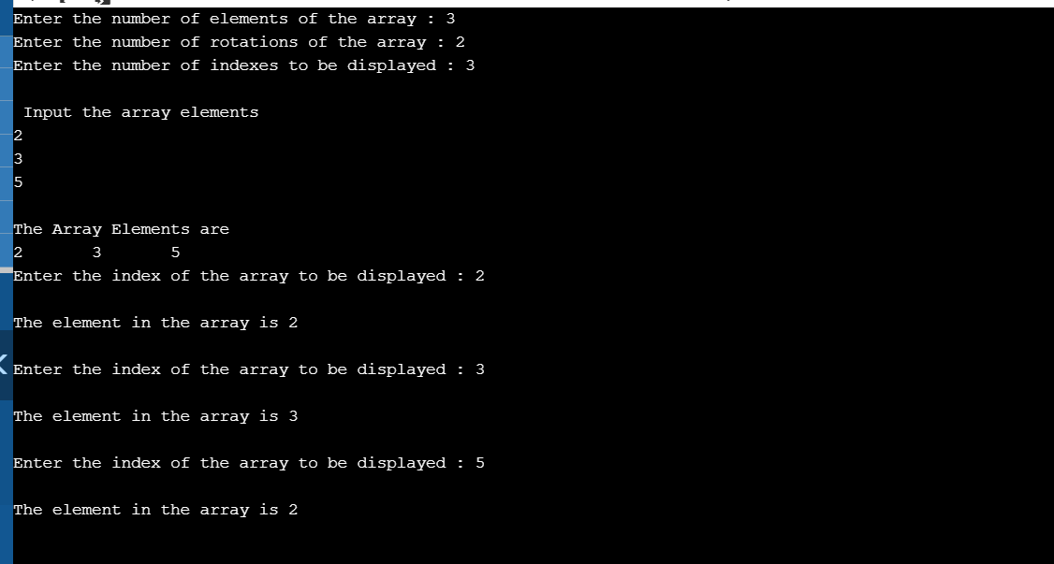

**JAVA PROGRAM 2:**

**Write a Java Program to find area of Square, Rectangle and Circle using Method Overloading.**

class OverloadDemo

{

void area(float x)

{

System.out.println("the area of the square is "+Math.pow(x, 2)+" sq units");

}

void area(float x, float y)

{

System.out.println("the area of the rectangle is "+x*y+" sq units");

}

void area(double x)

{

double z = 3.14 * x * x;

System.out.println("the area of the circle is "+z+" sq units");

}

}

class Overload

{

public static void main(String args[])

{

OverloadDemo ob = new OverloadDemo();

ob.area(5);

ob.area(11,12);

ob.area(2.5);

}

}

**OUTPUT:**

