**DAILY ONLINE ACTIVITIES SUMMARY**

|  |  |  |  |  |  |  |  |  |
| --- | --- | --- | --- | --- | --- | --- | --- | --- |
| **Date:** | **20/06/2020** | | | | | **Name:** | **SHWETHA M S** | |
| **Sem & Sec** | **6th sem & B sec** | | | | | **USN:** | **4AL17CS093** | |
| **Online Test Summary** | | | | | | | | |
| **Subject** | | **_________** | | | | | | |
| **Max. Marks** | | **__** | | **Score** | | | **___** | |
| **Pre-Placement Training Summary** | | | | | | | | |
| **Pre placement training** | **9:00 am to 11:00 am - Programming in C++**  **11:00 am to 1:00pm - Programming in C++** | | | | | | | |
| **Faculty** | | | **Ankitha**  **Pradeep nayak** | | **Duration** | | | **4 hr** |
| **Assessments** | | | | | | | | |
| **Problem Statement:**  1. Write a Java Program to find area of Square, Rectangle and Circle using Method Overloading.  **2.** Write a C++ program to rotate an array by K position.  3. Examples and Exercises on python. | | | | | | | | |
| **Status: Completed** | | | | | | | | |
| **Uploaded the report in Github** | | | | | **Yes** | | | |
| **If yes Repository name** | | | | | https://github.com/ShwethaKhadri/Shwetha-M-S.git | | | |

**TRAINING SNAPSHOT:**

**PROGRAMMING IN C++ (FORENOON SESSION 1)**

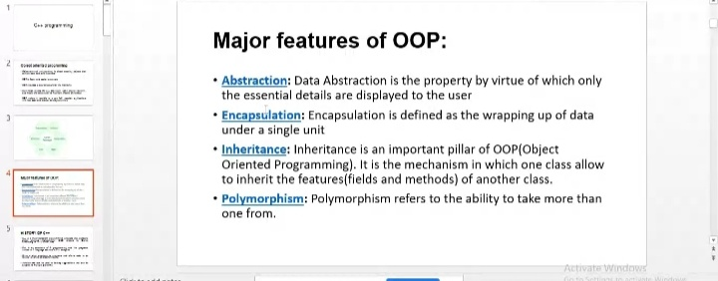

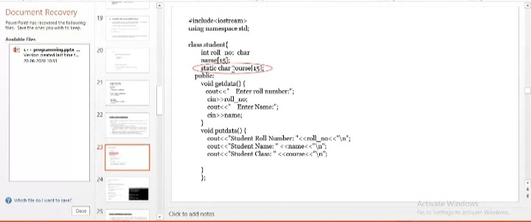

**PROGRAMMING IN C++:**

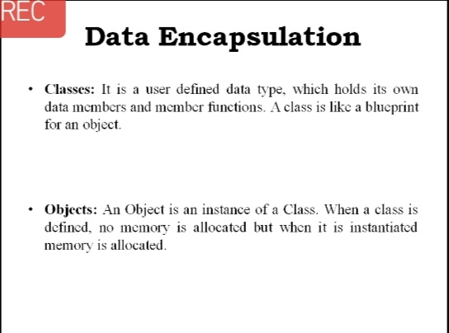

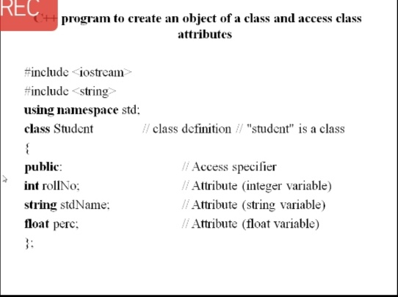

**SNAPSHOT OF C++ PROGRAM:**

**Write a C++ program to rotate an array by K position.**

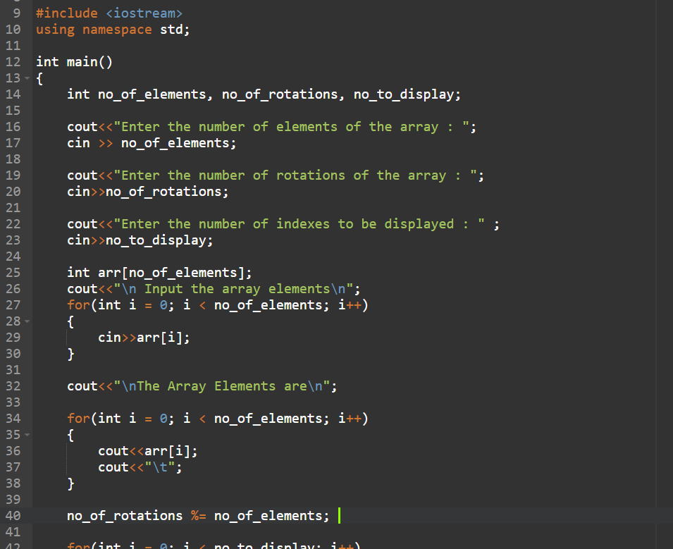

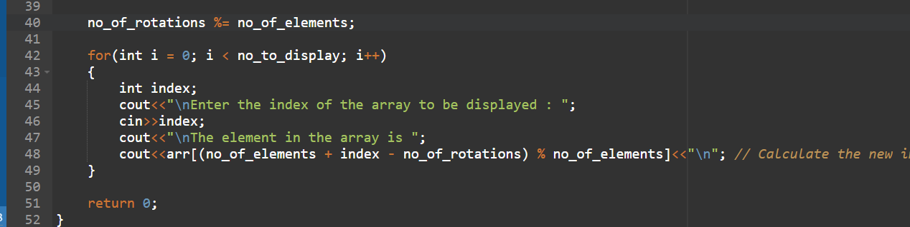

**OUTPUT:**

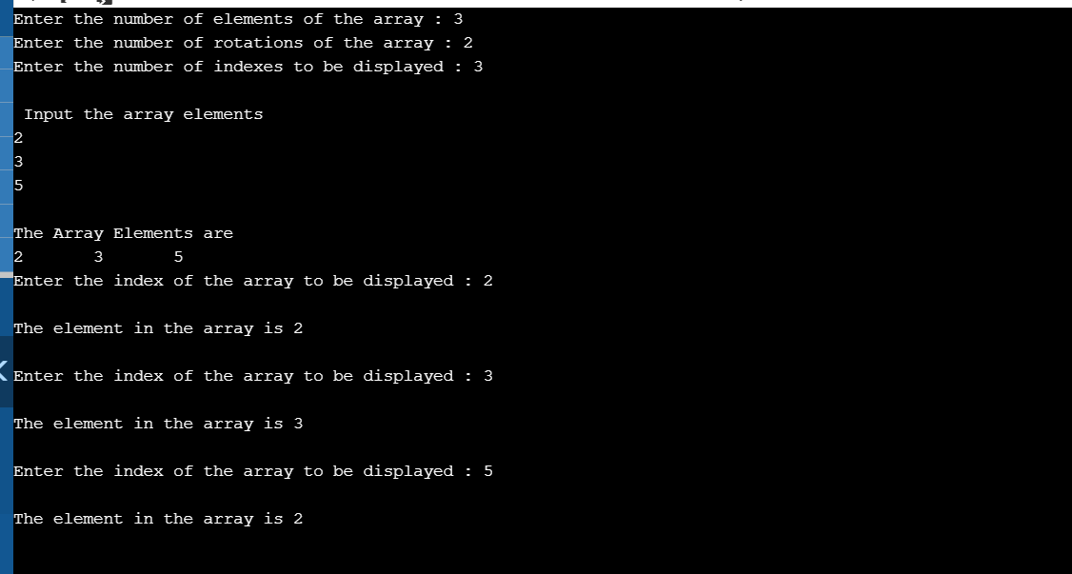

**SNAPSHOT OF JAVA PROGRAM:**

**Write a Java Program to find area of Square, Rectangle and Circle using Method Overloading.**

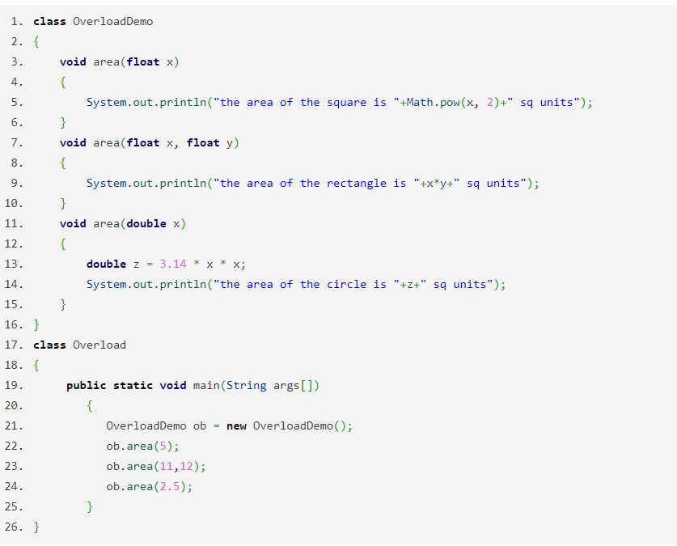

**OUTPUT:**

