**DAILY ONLINE ACTIVITIES SUMMARY**

|  |  |  |  |  |  |  |  |  |
| --- | --- | --- | --- | --- | --- | --- | --- | --- |
| **Date:** | 27-05-2020 | | | | | **Name:** | SHWETHA M S | |
| **Sem & Sec** | 6th and B | | | | | **USN:** | 4AL17CS093 | |
| **Online Test Summary** | | | | | | | | |
| **Subject** | | SSCD (2ND IA TEST) | | | | | | |
| **Max. Marks** | | 30 | | **Score** | | | 22 | |
| **Certification Course Summary** | | | | | | | | |
| **Course** | PYTHON FOR MACHINE LEARNING | | | | | | | |
| **Certificate Provider** | | | Greatlearning academy | | **Duration** | | | 1 WEEK |
| **Coding Challenges** | | | | | | | | |
| **Problem Statement:** Given an array of the positive integers of size N, the task is to find the largest element on the left side of each index which is smaller than the element present at that index. Note: If no such element is found then print -1. | | | | | | | | |
| **Status:** Completed | | | | | | | | |
| **Uploaded the report in Github** | | | | | Yes | | | |
| **If yes Repository name** | | | | | https://github.com/ShwethaKhadri/Shwetha-M-S.git | | | |
| **Uploaded the report in slack** | | | | | Shwetha M S  Yes, I uploaded the report in slack | | | |

**SNAPSHOT OF SECOND IA TEST MARKS:**

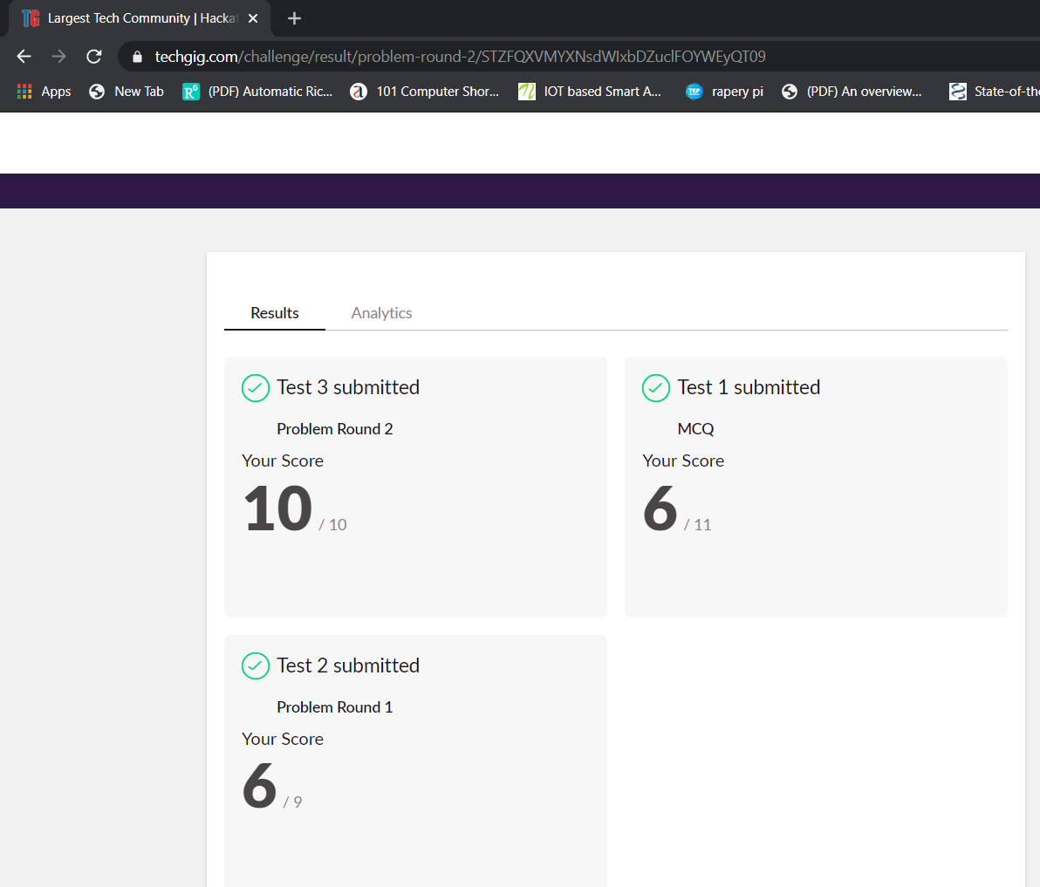

**SNAPSHOT OF ONLINE CERTIFICATION COURSE:**

**SCREENSHOT1:**

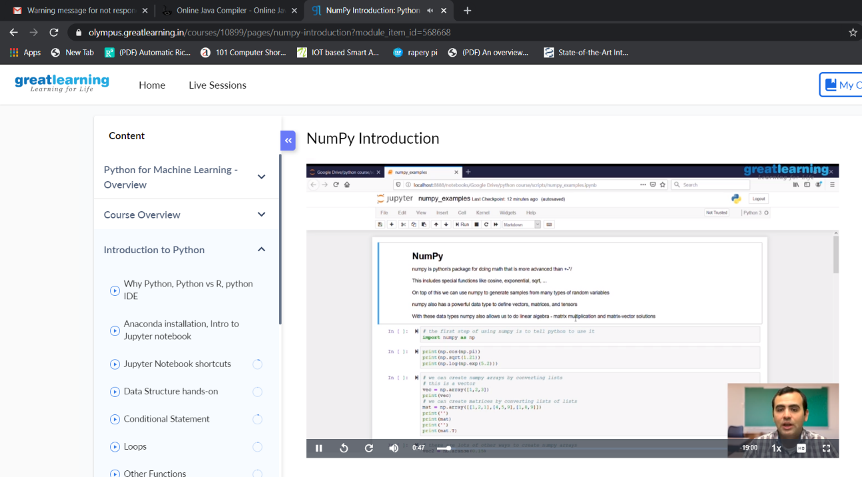

**SCREENSHOT2:**

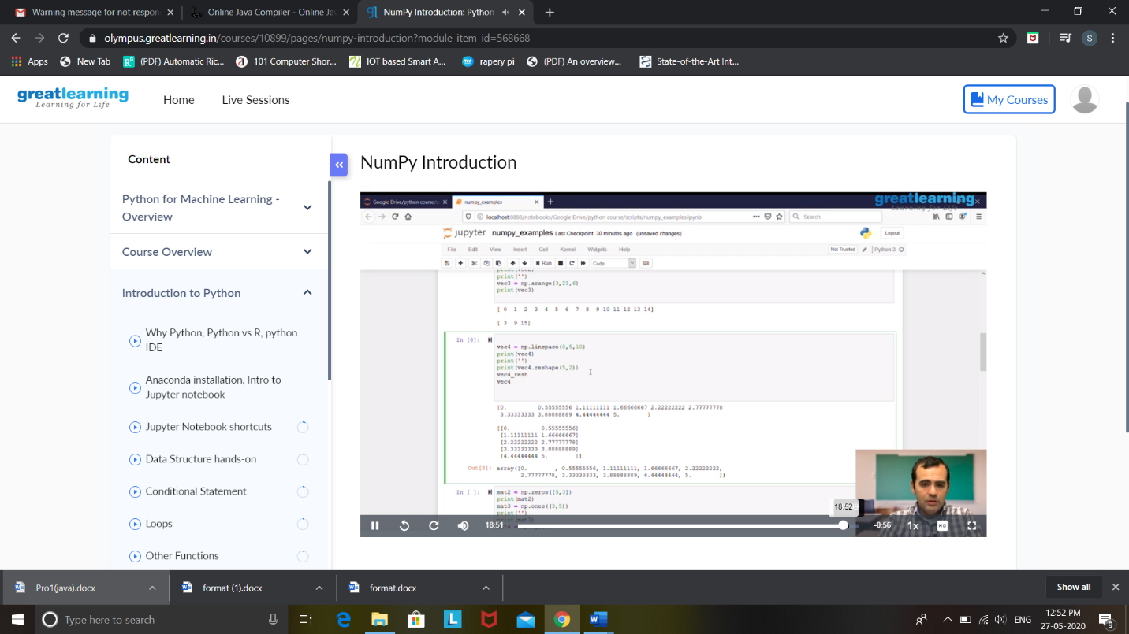

**SNAPSHOT OF ONLINE CODING:**

JAVA PROGRAM 1:

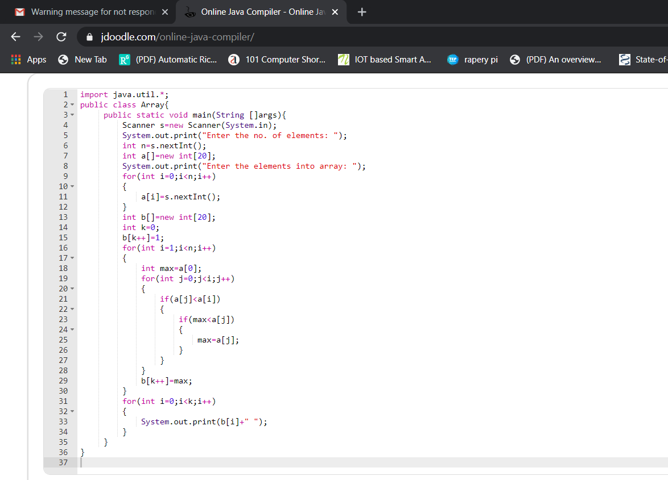

**OUTPUT:**

