**DAILY ONLINE ACTIVITIES SUMMARY**

|  |  |  |  |  |  |  |  |  |
| --- | --- | --- | --- | --- | --- | --- | --- | --- |
| **Date:** | 30-05-2020 | | | | | **Name:** | SHWETHA M S | |
| **Sem & Sec** | 6th and B | | | | | **USN:** | 4AL17CS093 | |
| **Online Test Summary** | | | | | | | | |
| **Subject** | | PAP (2ND IA TEST) | | | | | | |
| **Max. Marks** | | 30 | | **Score** | | | 14 | |
| **Certification Course Summary** | | | | | | | | |
| **Course** | PYTHON FOR MACHINE LEARNING | | | | | | | |
| **Certificate Provider** | | | Greatlearning academy | | **Duration** | | | 1 WEEK |
| **Coding Challenges** | | | | | | | | |
| **Problem Statement:** GIVEN 2 PROBLEMS | | | | | | | | |
| **Status:** Completed | | | | | | | | |
| **Uploaded the report in Github** | | | | | Yes | | | |
| **If yes Repository name** | | | | | https://github.com/ShwethaKhadri/Shwetha-M-S.git | | | |
| **Uploaded the report in slack** | | | | | Shwetha M S  Yes, I uploaded the report in slack | | | |

**SNAPSHOT OF SECOND IA TEST MARKS:**

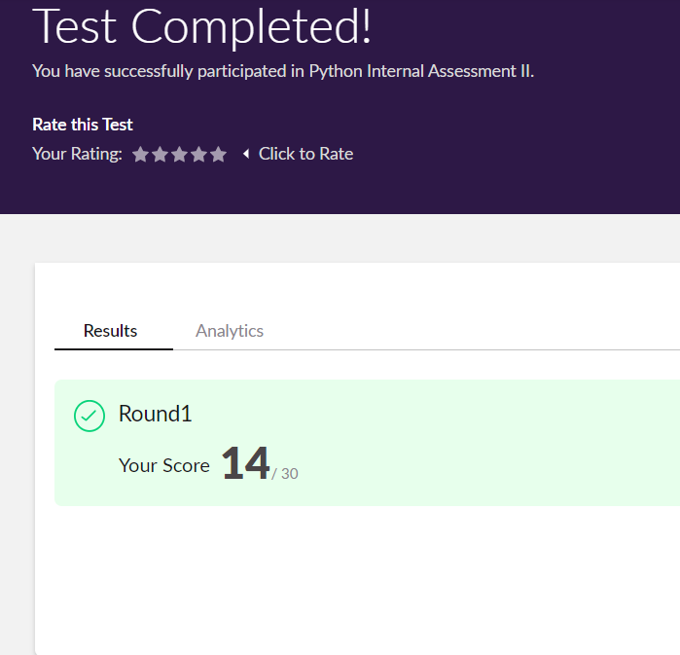

**SNAPSHOT OF ONLINE CERTIFICATION COURSE:**

**SCREENSHOT1:**

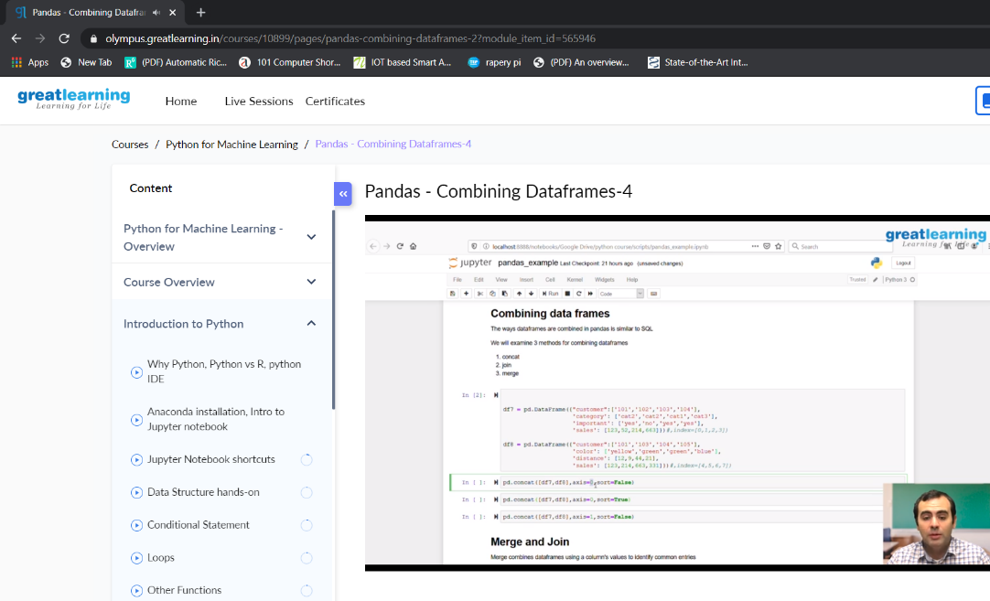

**SCREENSHOT2:**

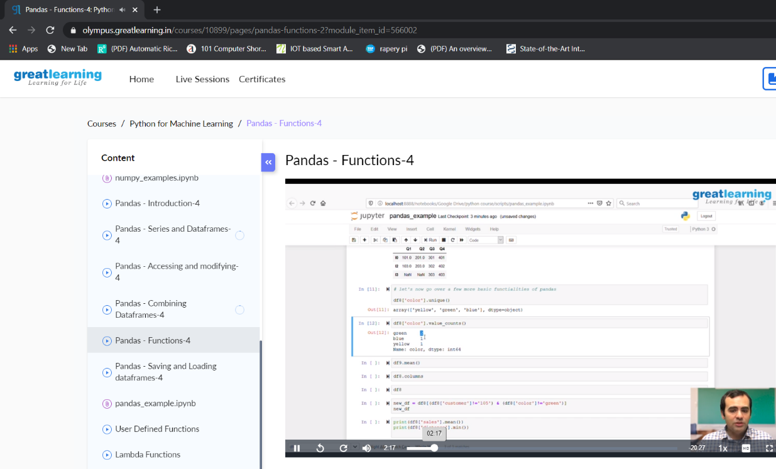

**SNAPSHOT OF ONLINE CODING:**

**PYTHON PROGRAM 1:**

take a number n and print the following pattern of the desired size.

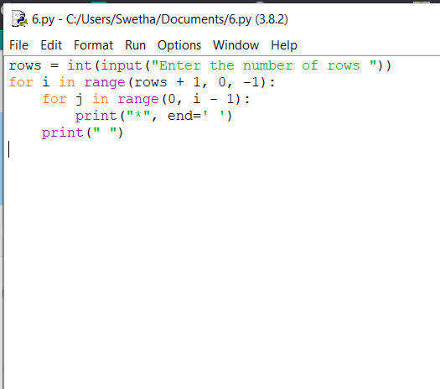

**OUTPUT:**

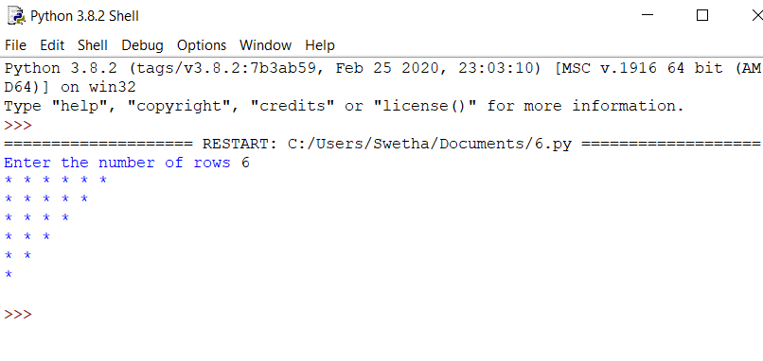

**JAVA PROGRAM2:**

A simple solution is simply multiply and count trailing 0s in product. This solution may cause integer overflow. A better solution is based on the fact that zeros are formed by a combination of 2 and 5. Hence the number of zeros will depend on the number of pairs of 2’s and 5’s that can be formed.

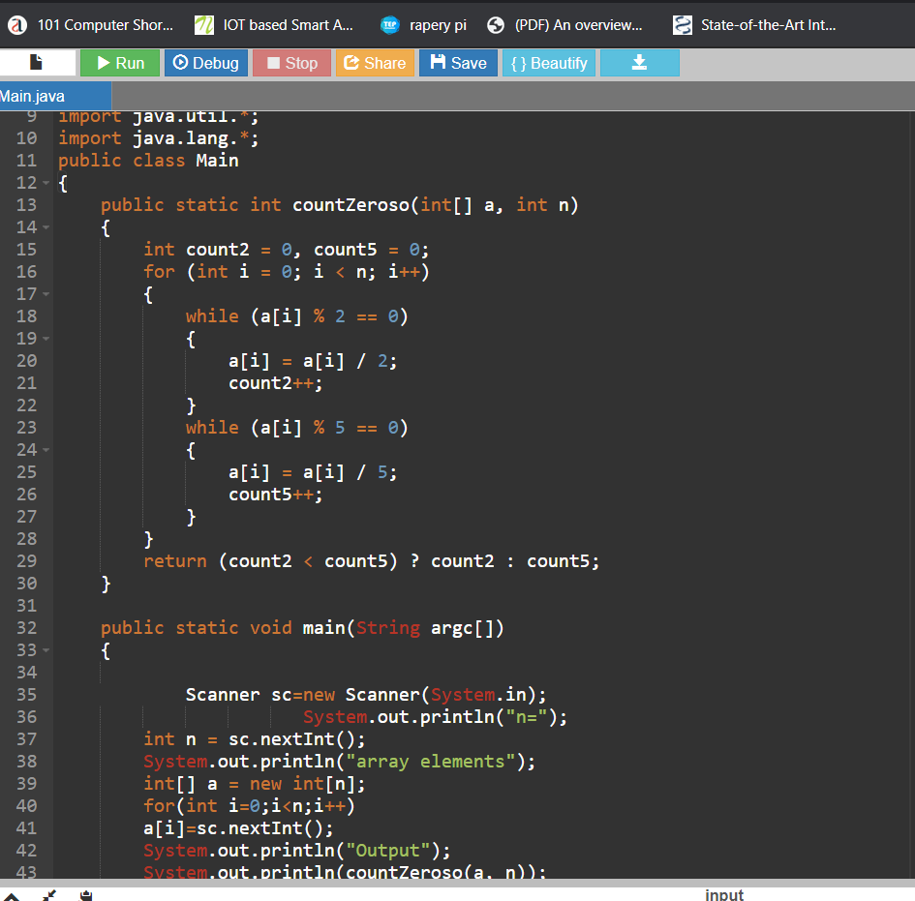

**OUTPUT:**

