**PROJECT NAME: AI BASED DIABETES PREDICTION SYSTEM**

**AIM:**

The aim of an AI-based diabetes prediction system is to use artificial intelligence and machine learning techniques to analyze medical data and predict the likelihood of an individual developing diabetes. This system aims to:

**Early Detection:** Identify individuals at risk of developing diabetes before clinical symptoms appear, allowing for early intervention and prevention.

**Personalized Medicine**: Tailor interventions and treatment plans based on an individual’s specific risk factors, genetics, and lifestyle.

**Improve Healthcare Efficiency:** Assist healthcare providers in allocating resources more effectively by identifying high-risk patients who need closer monitoring.

**Patient Education:** Empower individuals with information about their diabetes risk factors, encouraging healthier lifestyle choices.

**Reduce Healthcare Costs:** Preventing or managing diabetes at an early stage can potentially reduce the economic burden associated with diabetes-related complications.

**ABSTRACT**:

**The AI-Powered Diabetes Prediction System is a cutting-edge healthcare solution designed to analyze medical data and provide predictive insights into an individual’s likelihood of developing diabetes. Leveraging machine learning algorithms, this system empowers proactive health management by offering early risk assessment and personalized recommendations for preventive measures. Building an AI-powered diabetes prediction system is a valuable endeavor that can have a significant impact on public health. Here are the steps you can follow to develop such a system. An AI-based diabetes prediction system is a valuable tool that utilizes artificial intelligence (AI) algorithms and machine learning techniques to analyze data and make predictions about an individual’s risk of developing diabetes. Such a system can assist healthcare professionals in identifying at-risk individuals, enabling early intervention and personalized healthcare strategies.**

**PROBLEM :**

The problem is to build an AI-powered diabetes prediction system that uses machine learning algorithms to analyze medical data and predict the likelihood of an individual developing diabetes. The system aims to provide early risk assessment and personalized preventive measures, allowing individuals to take proactive actions to manage their health.

**ALGORITHM:**

We found that the model with Logistic Regression (LR) and Support Vector Machine (SVM) works well on diabetes prediction system.

**PROBLEM IN DIABETIES PREDICTION SYSTEM:**

Potential drawback in an AI diabetes prediction system is its reliance on historical data. If the training data used to develop the system is not representative of the population it aims to serve, the predictions may be inaccurate for certain demographic groups or new trends in diabetes prevalence. Additionally, AI models can sometimes make predictions that are statistically significant but not clinically useful, leading to unnecessary alarm or complacency in patients. Ethical concerns, such as data privacy and bias, should also be carefully addressed in such systems. Lastly, AI models may not consider all relevant factors, and real-world medical diagnosis often requires a holistic approach that considers a patient’s entire medical history and context, which AI systems may struggle to replicate fully.

**WAYS TO FIX THOSE PROBLEMS:**

Updating an AI-based diabetic prediction system involves several steps to ensure its continued accuracy and effectiveness. Here’s a high-level overview of the process:

**Data Collection and Preprocessing:**Gather new data relevant to diabetes prediction. This could include medical records, lab results, lifestyle data, and more.

Preprocess the data to clean and format it appropriately. Ensure consistency with the existing dataset.

**Model Reevaluation:**  Reevaluate the performance of your existing AI model on the new data. This includes assessing metrics like accuracy, precision, recall, and F1-score.

Determine if the current model is still suitable for the task or if a new model architecture is required.

**Model Retraining:** If needed, update the AI model. This may involve retraining the existing model on the combined old and new datasets or developing a new model from scratch.Fine-tune hyperparameters to improve model performance.

**Validation and Testing:**Split the data into training, validation, and test sets to evaluate the model’s performance.Perform rigorous testing to ensure the model’s accuracy and reliability.

**Feature Engineering:**Consider if new features or data sources should be included to enhance the model’s predictive capabilities.

**Ethical Considerations:**Ensure that the updated system adheres to ethical and privacy standards, especially when dealing with sensitive medical data.

**Deployment**:If the updated model performs well, deploy it in a controlled environment, such as a healthcare system or a mobile app.

**Monitoring and MMaintenance** Continuously monitor the model’s performance in the real-world environment.Implement mechanisms for feedback and improvement as new data becomes available.Regularly update the model to adapt to changing trends and patient demographics.

**User Feedback:**Collect feedback from healthcare professionals and users to identify areas for improvement and fine-tuning.

**Regulatory Compliance:**Ensure compliance with any relevant regulations or standards in the healthcare and AI fields.

**DESIGN:**

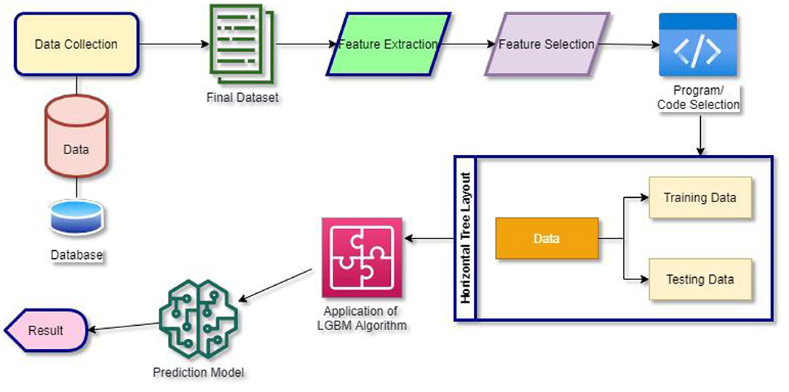

**CONCLUSION:**

The outlined process is a standard framework for building and improving machine learning models for diabetes prediction. It emphasizes the importance of data quality, feature selection, model choice, and iterative refinement to develop an accurate and reliable predictive model for diabetes risk assessment**.**