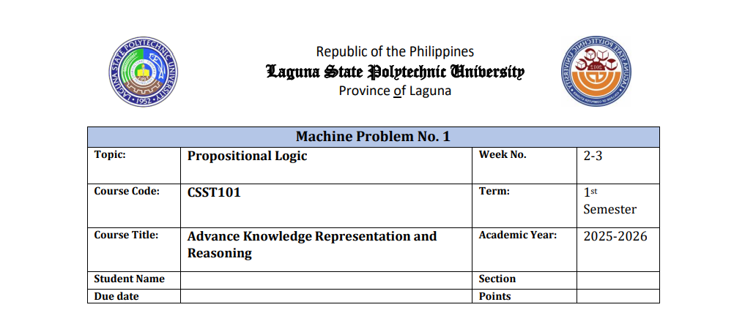  
  
  
  
  
  
  
  
  
  
  
  
  
**Propositional Logic Activity Puzzle**

**2**

**Propositional Logic- Syntax, Semantics, and Truth Tables**

**Name: Shaila Patrice D. Avellaneda**

**Section BSCS 3A**

**Puzzle 1: The Broken Lamp**

**Given:**

* **P:** The lamp is plugged in.
* **Q:** The bulb is working.
* **R:** The lamp gives light.

**Rules:**

1. (P∧Q)→R(P ∧ Q) → R(P∧Q)→R  
   → If the lamp is plugged in **and** the bulb is working, then the lamp gives light.
2. ¬R  
   → The lamp does **not** give light.

**Conclusion:**

* We can conclude that **either the lamp is not plugged in or the bulb is not working (or both).**

**Puzzle 2: The Late Bus**

**Given:**

* **P:** The bus arrived on time.
* **Q:** The students arrived on time.
* **R:** The exam started on time.

**Rules:**

1. ¬P → ¬Q  
   → If the bus did **not** arrive on time, then the students did **not** arrive on time.
2. ¬Q → ¬R  
   → If the students did **not** arrive on time, then the exam did **not** start on time.
3. ¬R  
   → The exam did **not** start on time.

**Conclusion:**

* The bus **did not arrive on time.**

**Puzzle 3: The Locked Door**

**Given:**

* **P:** The key is available.
* **Q:** The door is unlocked.
* **R:** The students enter the classroom.

**Rules:**

1. P→Q  
   → If the key is available, then the door is unlocked.
2. Q→RQ → RQ→R  
   → If the door is unlocked, then the students can enter the classroom.
3. ¬R¬R¬R  
   → The students did **not** enter the classroom.

**Conclusion:**

* The **key was not available** (¬P).

**Puzzle 4: The Basketball Game**

**Given:**

* **P:** The gym lights are working.
* **Q:** The referee is present.
* **R:** The basketball game takes place.

**Rules:**

1. (P∧Q)→R  
   → If the gym lights are working **and** the referee is present, then the basketball game takes place.
2. ¬R¬R¬R  
   → The basketball game did **not** take place.

**Conclusion:**

At least one of the following conditions failed:

* The **gym lights were not working**
* The **referee was not present**.