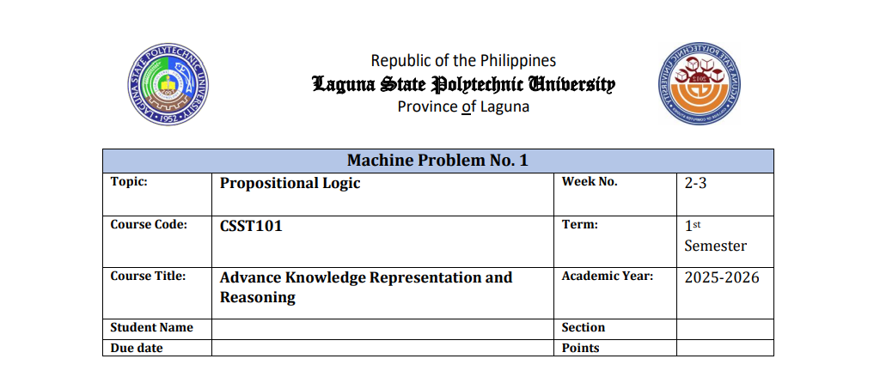  
  
  
  
  
  
  
  
  
  
  
  
  
**Individual Case Study: Who Gets the Scholarship?**

**5**

**Predicate Logic**

**Name: Shaila Patrice D. Avellaneda**

**Section BSCS 3A**

**Scenario**

The Dean’s Office follows these logical rules:

1. If a student has **high grades**, is a **student leader**, and **applied**, then they are **Eligible**.  
   → (HighGrades(x) ∧ Leader(x) ∧ Applied(x)) → Eligible(x)
2. If a student is **Eligible**, then they get a **Scholarship**.  
   → Eligible(x) → Scholarship(x)
3. If a student has a **Scholarship**, then they receive **FinancialSupport**.  
   → Scholarship(x) → FinancialSupport(x)

**Facts:**

* **Juan:** HighGrades, Applied
* **Maria:** HighGrades, DidNotApply
* **Carlos:** StudentLeader, NoHighGrades
* **Ana:** HighGrades, StudentLeader, Applied

**Part 1: Unification**

**Given:** Eligible(x) → Scholarship(x)  
**Fact:** Eligible(Ana)

**Substitution Set:** { x / Ana }

*(Replace variable x with Ana to unify both expressions.)*

**Part 2: Forward Chaining**

**Step 1: Apply Rule**

* **Ana:** Has HighGrades, Leader, Applied → **Eligible(Ana)**
* **Juan:** Missing Leader → Not Eligible
* **Maria:** Did not Apply → Not Eligible
* **Carlos:** No HighGrades → Not Eligible

**Step 2: Apply Rule 2**

* From **Eligible(Ana)** → **Scholarship(Ana)**

**Step 3:**

* From **Scholarship(Ana)** → **FinancialSupport(Ana)**

**New Facts Derived**

* + **Ana:** Eligible(Ana), Scholarship(Ana), FinancialSupport(Ana)
  + **Juan:** No new facts

**Explanation**

* **Maria** is not eligible because she **did not apply**.
* **Carlos** is not eligible because he **has no high grades**.

**Part 3. Backward Chaining**

**Goal: Scholarship (Maria)**

1. Not in facts.
2. Apply rule Eligible(x) → Scholarship(x) → need Eligible(Maria).
3. Apply rule (HighGrades ∧ Leader ∧ Applied) → Eligible.
4. HighGrades(Maria) = True, but Leader(Maria) = missing and Applied(Maria) = False.
5. Antecedent fails → cannot prove Eligible(Maria) → **Goal fails**.

**Conclusion:** Scholarship(Maria) is **Not Proven.**

**Goal: FinancialSupport (Ana)**

1. Not in facts.
2. Apply rule Scholarship(x) → FinancialSupport(x) → need Scholarship(Ana).
3. Apply rule Eligible(x) → Scholarship(x) → need Eligible(Ana).
4. From rule (HighGrades ∧ Leader ∧ Applied) → Eligible, all true for Ana.
5. Infer Eligible(Ana) → Scholarship(Ana) → FinancialSupport(Ana).

**Conclusion:** FinancialSupport(Ana) is **Proven.**

**Part 4. Validity Check**

**Truth Table:**

**Rule: (HighGrades ^ Leader ^ Applied)** → Eligible

|  |  |  |  |  |  |
| --- | --- | --- | --- | --- | --- |
| High Grades | Leader | Applied | Antecedent | Eligible | A - E |
| T | T | T | T | Depends | True if E=T; False if E=F |
| T | T | F | F | - | True |
| T | F | T | F | - | True |
| T | F | F | F | - | True |
| F | T | T | F | - | True |
| F | T | F | F | - | True |
| F | F | T | F | - | True |
| F | F | F | F | - | True |

**Student Evaluation:**

|  |  |  |  |  |  |
| --- | --- | --- | --- | --- | --- |
| ****Student**** | ****HighGrades**** | ****Leader**** | ****Applied**** | ****Eligible**** | ****Rule Result**** |
| ****Juan**** | **T** | **F** | **T** | **F** | **Vacuously True** |
| ****Maria**** | **T** | **F** | **F** | **F** | **Vacuously True** |
| ****Carlos**** | **F** | **T** | **F** | **F** | **Vacuously True** |
| ****Ana**** | **T** | **T** | **T** | **T** | **True (satisfies rule)** |

**Part 5. Reflection**

* Logical reasoning is essential in both AI and real-life decisions because it ensures that conclusions follow clear and consistent rules. In AI, it allows systems to make explainable and transparent decisions based on given facts. In everyday life, reasoning helps people identify missing information and make fair, evidence-based judgments. It bridges the gap between data and sound decision-making.