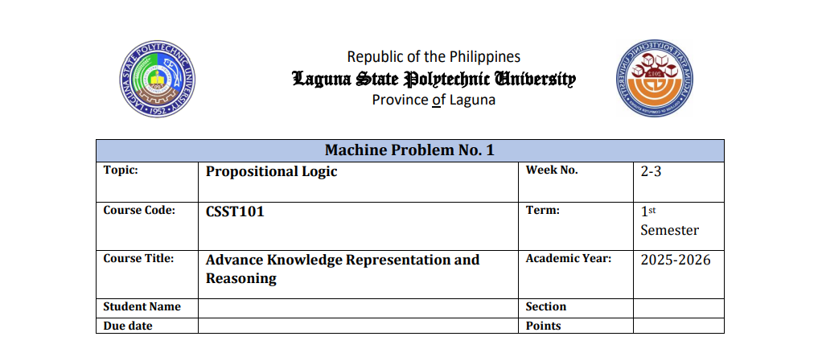

**Propositional Logic**

**Advance Knowledge Representation and Reasoning**

**Name: Shaila Patrice D. Avellaneda**

**Section BSCS 3A**

1. **Introduction**

The **Mini Expert System** is a rule-based program made using Python. It evaluates students based on their academic performance and classroom behavior. The system uses a set of logical rules to decide results such as exam eligibility, grades, login access, and bonus points. It also records all the results in a CSV file named **logic_results.csv** for documentation and review.

This project shows how an expert system can help make decisions automatically by following defined rules, instead of depending only on human judgment.

1. **Rules Tested**
2. **Attendance Rule**

This rule evaluates whether a student is eligible to take examinations based on attendance percentage.

* If the attendance is **75% or higher**, the student is marked as **“Eligible to take exams.”**
* Otherwise, the result is **“Not eligible to take exams.”**

1. **Grading Rule**

This rule assesses a student’s academic performance.

* **90 and above:** *Excellent*
* **75–89:** *Passed*
* **Below 75:** *Failed*

1. **Login System Rule**

This rule simulates a school login verification process.

* If the student has an account and enters the correct password →  **Login successful**
* If the password is wrong → **Incorrect password**
* If the student has no account → **No account found**

1. **Bonus Point Rule**

This rule checks whether a student qualifies for extra points.

* If the student participated in class and submitted **2 or more projects**, they receive **Bonus points awarded**
* If they participated but submitted fewer projects → **Partial bonus**
* If not active → **No bonus points**

1. **New Rule Added**

**Library Borrowing Rule**

This is the additional rule introduced to the system. It checks if a student has a valid library ID.

* If **valid ID → 📚 Allowed to borrow books**
* If **no valid ID → 🚫 Borrowing not allowed**

This rule reflects how school systems verify student eligibility before granting access to library services.

1. 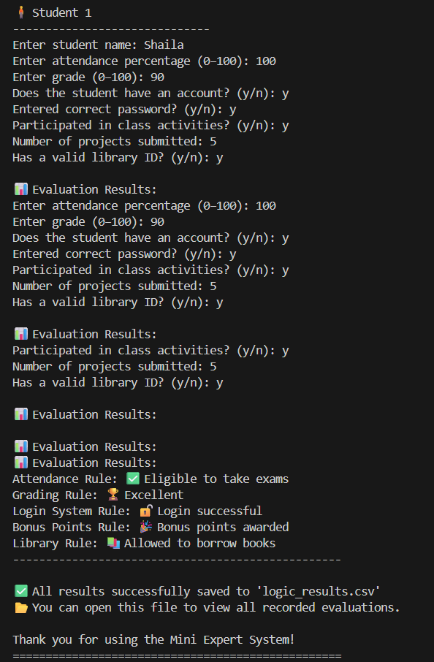**Sample Output**
2. **Conclusion**

The Mini Expert System successfully applies multiple logical rules to evaluate students based on various conditions. By using if–else logic and CSV storage, it demonstrates how expert systems can automate routine academic decisions efficiently. The addition of the **Library Borrowing Rule** enhances the system’s practicality by simulating a real-world student management feature.