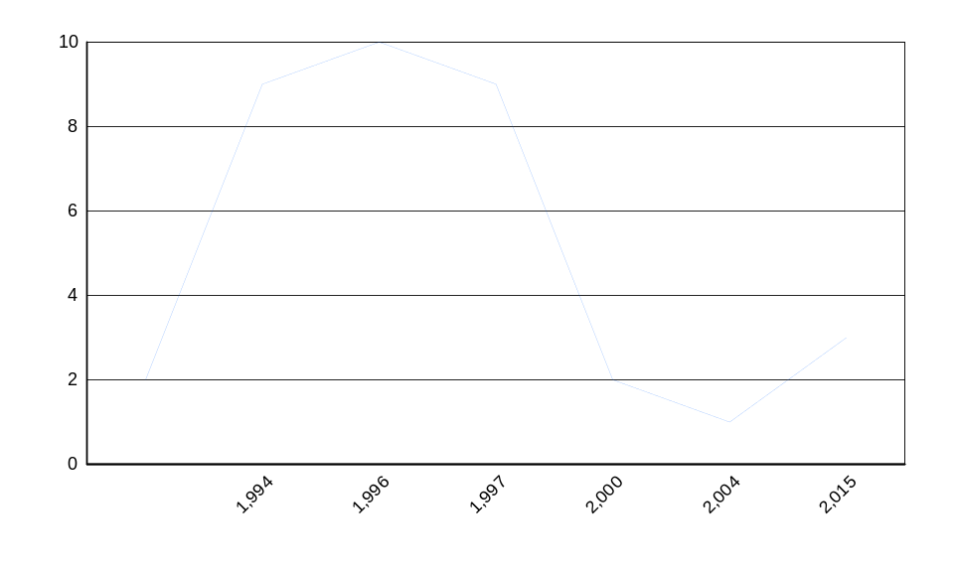
Work Order Statistics

Year-Month:
Type:
Trade:
IsComplete:

Count:
EstimatedCost:

ActualCost:

Estimated -Actual Cost:

OD
Complete
2
0.00
0.00
0.00
2.00
0.00
0.00
0.00
2.00
0.00
0.00
0.00
5.56%
0.00
0.00
0.00
1,994
OD
Complete
9
0.00
465.00
51.67
9.00
0.00
465.00
51.67
9.00
0.00
465.00
51.67
25.00%
0.00
465.00
51.67
1,994
1,996
EQPM
Complete
3
48.00
24.00
-8.00
3.00
48.00
24.00
-8.00
3.00
48.00
24.00
-8.00
OD
Complete
7
456.00
102.00
-50.57
7.00
456.00
102.00
-50.57
7.00
456.00
102.00
-50.57
27.78%
504.00
126.00
-58.57
1,996
1,997
EQPM
Complete
8
2,008.00
1,998.00
-1.25
8.00
2,008.00
1,998.00
-1.25
8.00
2,008.00
1,998.00
-1.25
OD
Complete
1
0.00
0.00
0.00
1.00
0.00
0.00
0.00
1.00
0.00
0.00
0.00
25.00%
2,008.00
1,998.00
-1.25
1,997
2,000
OD
Complete
2
0.00
86.00
43.00
2.00
0.00
86.00
43.00
2.00
0.00
86.00
43.00
5.56%
0.00
86.00
43.00
2,000
2,004
OD
Complete
1
450.00
0.00
-450.00
1.00
450.00
0.00
-450.00
1.00
450.00
0.00
-450.00
2.78%
450.00
0.00
-450.00
2,004
2,015
OD
Complete
1
908.00
0.00
-908.00
1.00
908.00
0.00
-908.00
CARPENTER-I
Complete
2
929.00
0.00
-464.50
2.00
929.00
0.00
-464.50
3.00
1,837.00
0.00
-1,372.50
8.33%
1,837.00
0.00
-1,372.50
2,015
4,799.00
2,675.00
-1,787.65
36.00
Grand Total:

